**Introduction**

The first lab period contains a pre-lab lecture and about three hours of experimental work. During this first week, students are expected to couple at least two amino acids onto Tentagel Rink amide resin. The second and third weeks have four hours allocated for each lab period. The peptides are elongated and amino acid couplings are finished in the second lab period. The last week is dedicated to resin cleavage, amino acid side chain deprotection, peptide isolation and solution preparation for submission of peptide samples for LC-MS and bioassay analysis. Initially, the peptides were isolated following rotary evaporation of the TFA solution and precipitation from cold diethyl ether, but it was observed that the bioassay was tolerant of residual solvents, including methanol, DCM, DMF and TFA. Therefore, the current protocol has students rotary evaporate their TFA-peptide solution after cleavage, and they prepare a solution of their peptide in 0.1% TFA in acetonitrile for LC-MS analysis and activity testing against *E. coli*. Instructors run the LC-MS samples using an autosampler. Instructors and teaching assistants run the bioassay (described below). Both LC-MS and bioassay results are given to the students for analysis.

**Notes on Laboratory Preparation**

Reaction Columns and Vacuum Adapters

The SPPS reactions are performed in chromatography columns that contain a frit (Bio-Rad 732-6008). These resin columns come with caps to seal the reaction space and outflow tip. PTFE stopcocks (Biotage 121-0009) are used during the washing, deprotection and filtration steps. The PTFE stopcocks are removed and vessel caps are sealed with parafilm during the coupling step that takes place in a 65 °C water bath (Figure 1). While amino acid couplings can readily take place at room temperature, in our experience, elevated temperature can benefit difficult syntheses, including syntheses that involve coupling five or more amino acids onto the resin.1

Custom vacuum adapters are made using rubber stoppers, septa, syringe barrels and needles. These adapters are used to vacuum filter spent reagents and solvents after the washing, deprotection and coupling steps, and also to isolate the cleaved peptide solution at the end of the synthesis (Figure 2).

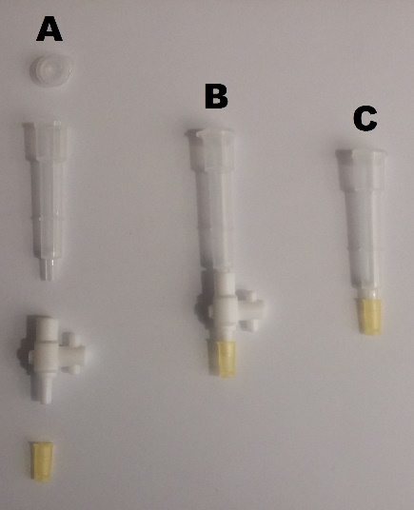

**Figure 1. (**A) The resin column with upper/lower caps and PTFE stopcock. (B) Assembled reaction apparatus. (C) The reaction vessel for the couplings that take place in a 65 °C water bath.

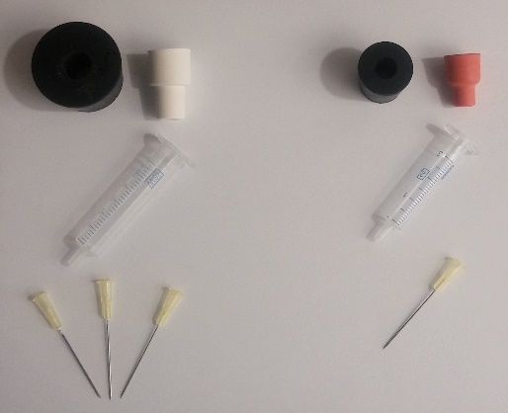 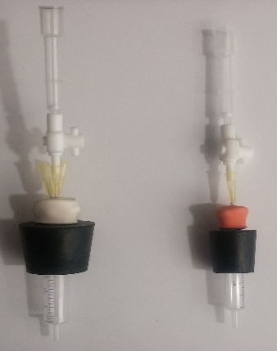

**B**

**A**

**Figure 2.** (A) Left: components for the waste filtration column adapters - #7 rubber stopper, 14/20 rubber septum, 5 mL syringe barrel and needles. Right: components for the filtration of the cleaved peptide - #5 rubber stopper, 10/30 septum, 3 mL syringe barrel and a needle. (B) Assembled filtration apparatus with columns and PTFE stopcocks attached.

Modular Stations for Experiment

This laboratory experiment was designed to be modular in nature in order to facilitate expedient and facile peptide synthesis. The laboratory was split into several stations for washing, deprotection, coupling, cleavage and final sample preparation.

**Washing Station:** Syringes are used at the washing station to dispense dicholormethane (DCM) and dimethylformamide (DMF) from 1 L round bottom flasks affixed with septa (Figure 3). This station also has a 500 mL vacuum filtration flask affixed with an adapter in order to vacuum filter waste solvents and reagents.

**Deprotection / Coupling Station:** Deprotection and amino acid coupling solutions are dispensed with syringes (Figure 4). This station includes 1 L round bottom flasks containing DMF and 20% piperidine in DMF, both affixed with septa. This station also contains a solution of 30% diisopropylethylamine (DIEA) in DMF prepared in a 250 mL reagent bottle, and another 500 mL vacuum flask to drain reagents and washes.

This station has solutions of ninhydrin in ethanol, phenol in ethanol, and aqueous potassium cyanide in pyridine for the Kaiser tests; these reagents are dispensed via dropper bottles. The Kaiser test station also contains microcentrifuge tubes, a mini-vortexer, a mini-centrifuge and a 95 °C heating block affixed with an aluminum holder to facilitate microcentrifuge tube heating.

All other reagents for the peptide synthesis, which were solids, are weighed on the bench top using analytical balances; these reagents are used directly from the manufacturers’ bottles. The amino acid coupling reactions are run in 65 °C water baths. The resin columns float in the water baths (Figure 5).

During week three of the experiment, the main dispensing hood had an additional station added: **Peptide Cleavage and LC-MS / Bioassay Sample Preparation Station**. This station contains a 500 mL round bottom flask of methanol, affixed with a septum. The cleavage station also contains an aqueous solution of 95% TFA, prepared in a 250 mL reagent bottle. Additionally, solutions of 0.1% TFA in acetonitrile in 500 mL reagent bottles are at these stations for sample preparation for the LC-MS and bioassay analysis. All solutions at this station are dispensed via syringes (Figure 6).

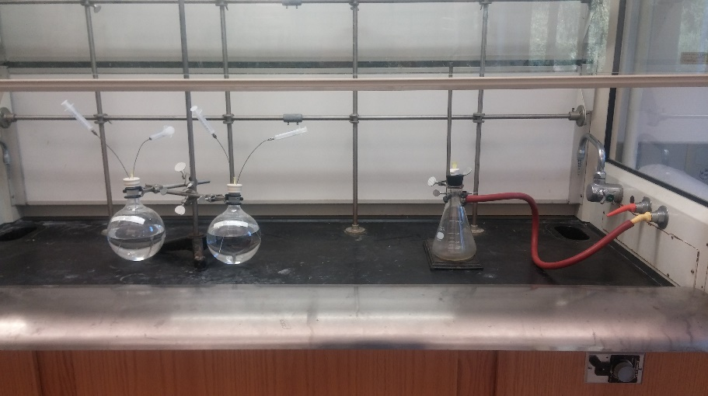

**A**

**B**

**Figure 3.** Washing Station. (A) The wash solvents DCM and DMF are dispensed via syringes. (B) Waste vacuum filtration flask with column adapter.

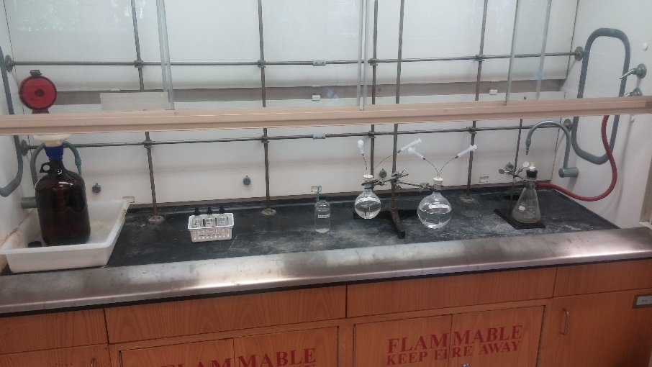

**B**

**A**

**C**

**Figure 4.** Deprotection / Coupling Station. (A) Kaiser Test solutions: ninhydrin in ethanol, phenol in ethanol and aqueous potassium cyanide in pyridine. (B) Solvents for deprotection and coupling: DMF, 30% DIEA in DMF, and 20% piperidine in DMF. (C) Waste vacuum filtration flask with column adapter.

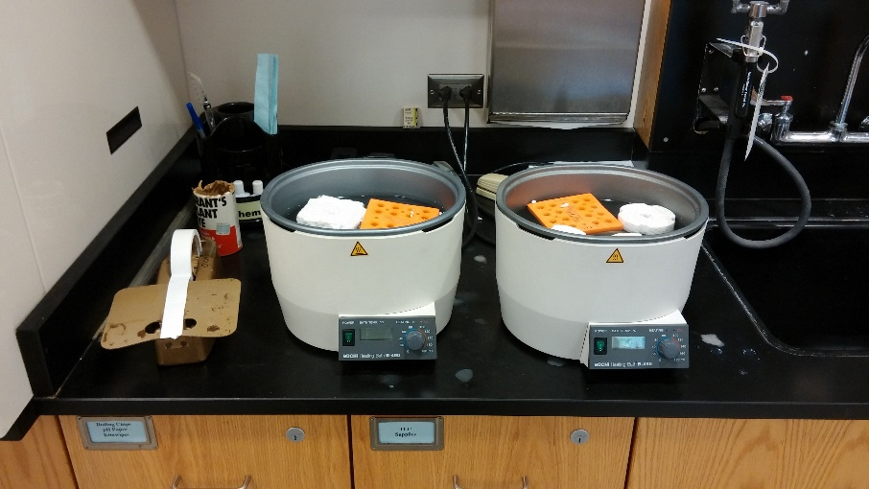

**Figure 5.** Rotary evaporator water baths set to 65 °C are used to expedite amino acid couplings. Foam microcentrifuge tube floatation devices are used to keep the resin columns upright during coupling.

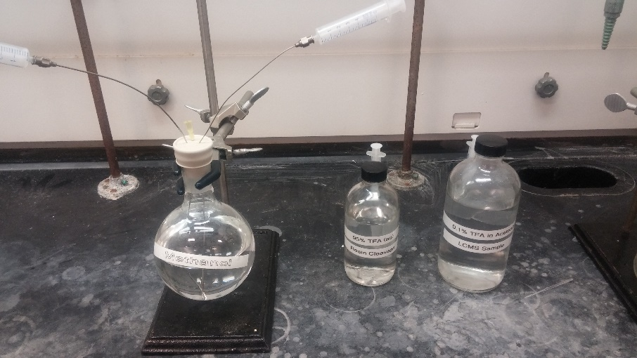

**Figure 6.** Peptide Cleavage and LC-MS / Bioassay Sample Preparation Station with solutions dispensed via syringes: methanol, 95% aqueous TFA for peptide cleavage, and 0.1% TFA in acetonitrile for preparation of samples for LC-MS analysis and bioassays.

Kaiser Test Solution Preparation and Instructions

**Preparing Kaiser Test Solutions:**

Solution 1 – 5 g ninhydrin in 100 mL absolute ethanol

Solution 2 – 80 g phenol in 100 mL absolute ethanol

Solution 3 – 2 mL of 0.001 M aqueous KCN in 98 mL of pyridine

**Kaiser Test Instructions:** A few resin beads are placed in a microcentrifuge tube using a spatula. Two to five drops of each Kaiser Test solution are placed in the tube and the tube is mixed using a vortex. The microcentrifuge tube is centrifuged briefly and then placed in a 95 °C heating block for 5 minutes. A successful coupling is characterized by clear-yellow beads after the test. Coupling was unsuccessful if the beads are a dark blue. In the case where the solution was light blue but the beads were not, the reaction was considered successful.

**Notes on Bioassay Protocol**

Background

All peptides synthesized by the students are evaluated for antimicrobial activity against the Gram-negative bacterium *Escherichia coli* DH5, a common BSL1 laboratory strain. Activity is determined by measuring the minimum inhibitory concentration (MIC, µg/mL), which is the lowest test concentration that completely inhibits microorganism growth.2

Varying concentrations of the peptide (e.g. 0-200 µg/mL) are mixed with a culture of *E. coli*. The mixtures are allowed to incubate overnight at 37 °C. The use of a 96-well plate allows for multiple peptides at multiple concentrations to be easily assayed in an organized format. Having one person, either an instructor or TA perform all of the assays for one lab section allows for consistency with regard to the assay and for up to six peptides to be assayed on one 96-well plate. The following day, negative controls and any samples that contain peptides that do not inhibit microbial growth will exhibit robust *E. coli* growth, as indicated by the culture medium being cloudy and opaque. Positive controls and any samples that contain peptides that do inhibit growth can be identified by bacterial cultures that are less cloudy and clearer than the negative controls. The amount of *E. coli* growth can be quantitatively measured using a spectrophotometer to obtain the absorbance of each culture at 600 nm (also known as the optical density at 600 nm, OD600). Lower OD600 values are indicative of inhibited *E. coli* growth. By plotting OD600 vs. peptide concentration, the MIC may be determined. Peptides with an MIC > 200 µg/mL are generally considered to be non-inhibitory. Peptides with an MIC < 200 µg/mL represent promising leads.



**Figure 7.** An example of data collected using the antimicrobial bioassay. Technical replicates of a known antimicrobial peptide (Peptide X), a negative control (DMSO) and a positive control (streptomycin, Sm) at varying concentrations (0-200 mg/mL) were tested against *E. coli* DH5. Based on this data alone, both Peptide X and Sm have a MIC ≤ 25 µg/mL.

Setting Up the Bioassay

*Materials*

For each lab section, obtain

* 50 mL tube of LB (rich medium for the bacteria)
* 2 x 15 mL tube of 1:100 dilution of grown *E. coli*
* 1 large microcentrifuge rack
* 60 microcentrifuge tubes (1.5 mL size)
* Two 96-well plates (with lids) [Costar 96-well flat bottom microplates]
* Marker(s)
* p200 and p1000 micropipettes and tips

*Prepare peptides*

1. The students have already made up a 10 mg/mL stock solution of their peptide in ACN/TFA in 1.5 mL microcentrifuge tube. You should have Peptides 1-10 for each lab day.
2. For each peptide, and the negative (ACN/TFA) and positive (Sm) control, you will need to make a series of 5 dilutions, A-E. Start by labeling* your microcentrifuge tubes: 1-A, 1-B, 1-C…. 2-A, 2-B, 2-C, etc.
3. Make the dilution series for each peptide, and the negative (ACN/TFA) and positive (Sm) controls, using the table below. (If you have two microplates, you’ll need twice as much ACN/TFA and Sm.) I suggest first pipetting LB into each tube, and then add stock peptide to each “A” tube, and lastly make the dilutions for each peptide (tubes B-E).

|  |  |  |  |  |  |
| --- | --- | --- | --- | --- | --- |
| Tube | Vol stock (µL) | Vol (µL)  (Tube #) | Vol LB (µL) | Total Vol (µL) | Final Conc (µg/mL) |
| **A** | 40** | -- | 960 | 1000 | 400 |
| **B** | -- | 250  Tube A | 250 | 500 | 200 |
| **C** | -- | 250  Tube B | 250 | 500 | 100 |
| **D** | -- | 250  Tube C | 250 | 500 | 50 |
| **E** | -- | 250  Tube D | 250 | 500 | 25 |

*Label: Peptide Name-Tube #

**Stock refers to student peptide, 10 mg/mL stock; streptomycin (Sm), 10 mg/mL stock; also have ACN/TFA control (just add 40 µL ACN/TFA stock)

*Set up assay*

1. In each well, pipet 100 µL 1:100 dilution of *E. coli*. Note: well A1 should be in the top left corner
2. Pipet 100 µL peptide from indicated tube # (or pure LB) into each well, following the scheme shown below. Note: there are technical duplicates for each peptide
3. Cover each plate with its lid, tape closed, and place in 37 °C incubator, overnight.

|  |  |  |  |  |  |  |  |  |  |  |  |  |
| --- | --- | --- | --- | --- | --- | --- | --- | --- | --- | --- | --- | --- |
| **Tube :** | **A** | **B** | **C** | **D** | **E** | **LB** | **A** | **B** | **C** | **D** | **E** | **LB** |
| Pept 1 |  |  |  |  |  |  |  |  |  |  |  |  |
| Pept 2 |  |  |  |  |  |  |  |  |  |  |  |  |
| Pept 3 |  |  |  |  |  |  |  |  |  |  |  |  |
| Pept 4 |  |  |  |  |  |  |  |  |  |  |  |  |
| Pept 5 |  |  |  |  |  |  |  |  |  |  |  |  |
| Pept 6 |  |  |  |  |  |  |  |  |  |  |  |  |
| DMSO |  |  |  |  |  |  |  |  |  |  |  |  |
| Sm |  |  |  |  |  |  |  |  |  |  |  |  |

1. Following day, measure A600: Using a Biotek Synergy 4 plate reader, plates were shaken at slow speed for 2 minutes, followed by absorbance reading at 600 nm.
2. Provide data (in the form of an Excel spreadsheet that lists wells and OD600 values) to students via the Sakai course management site.

Instructor Prep Notes for Setting up the Bioassay

*Materials*

Prepare for the entire group:

* 1 mL ACN/TFA, ice
* 1 mL Sm 10 mg/mL, ice
* 5 x 30 mL LB
* Bacteria (see below)
* Microcentrifuge tubes and racks
* Micropipettes and tips
* Markers

*Bacteria*

1. Grow *E. coli* DH5 to mid-log phase (OD600 ~ 0.5, about 108 CFU/mL) in LB
2. Dilute *E. coli* 1:100 in LB (prep 10 x 12 mL – 120 µL *E. coli* to 12 mL LB)

**References**

(1) Bacsa, B.; Desai, B.; Dibó, G.; Kappe, C. O. *J. Pept. Sci.* **2006**, *12* (10), 633–638.

(2) Sharma, R. K. R.; Sundriyal, S. S.; Wangoo, N. N.; Tegge, W. W.; Jain, R. R. *ChemMedChem* **2010**, *5* (1), 86–95.