Supporting Information

Movie M1. The mpeg movie M1 (see separate file) demonstrates the rapid equilibration of a tenside/polymer-loaded C/Cu film in contact to ethanol vapor. The fast reaction to changing vapor concentrations agrees with the theoretically determined diffusion time (equation 2) of below 1 second. The sequence is given in real time.

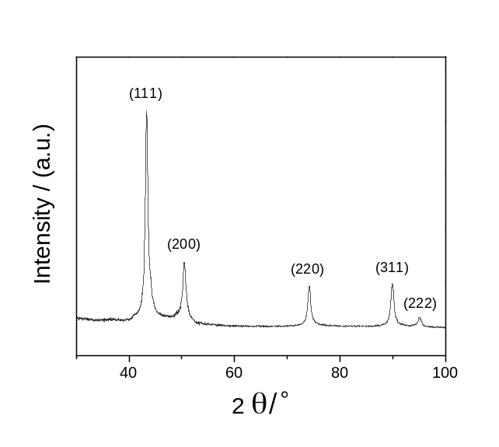

Figure S1. X-ray diffraction pattern of C/Cu after reducing flame synthesis. The nanoparticles consist of crystalline copper cores. The carbon content and layer thickness are too small to provoke measurable XRD signals.

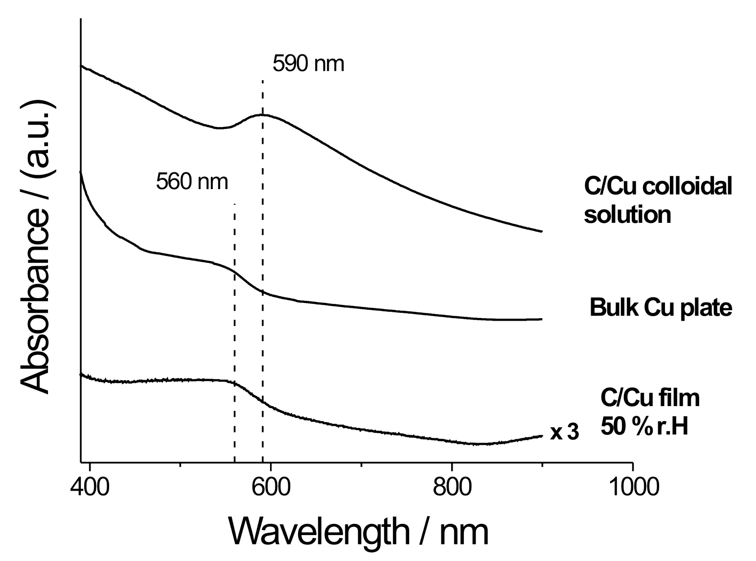

Figure S2. The colloidal solution absorption spectrum of carbon coated copper nanoparticles reveals the localized SPR band at 590 nm. As a reference, a bulk copper plate revealed a similar absorption spectrum as the nanoporous C/Cu film at 50 % r.H and agrees with the copper-metal like appearance of these hybrid films (Figure 2a).

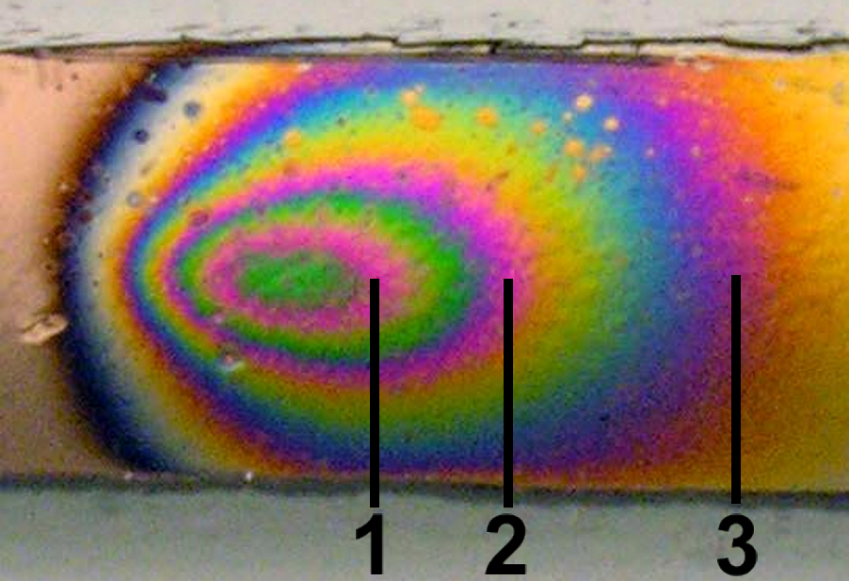

Figure S3. Magnification of the C/Cu film during exposure to a stream of ethanol vapor. The rapid, reversible and repetitive coloration at high vapor pressure could be attributed to thin film interference.

