Supporting Information for
Biomimetic growth of biomorphic CaCO₃ with hierarchically ordered cellulosic structures

Zhi Zheng*, †‡, Baojun Huang†, Huiqiang Ma†, Xiaoping Zhang†, Manying Liu†, Zhuang Liu‡, Ka Wai Wong‡ and Woon Ming Lau *^{,‡δ}

†Institute of Surface Micro and Nano Materials, Xuchang University, Xuchang, Henan Province, 461000, China.
‡Department of Physics, The Chinese University of Hong Kong, Shatin, Hong Kong, P.R. China.
^{δ}Surface Science Western, The University of Western Ontario, London, Ontario, Canada.
Fax: 86-374-4369209; Tel: 86-374-4369209;
*Address correspondence to these authors. E-mail: zhengzhi9999@yahoo.com.cn, llau22@uwo.ca

Figure S1 SEM morphologies of (a) virgin cotton templates and (b) the fresh prepared sample prior to calcinations.

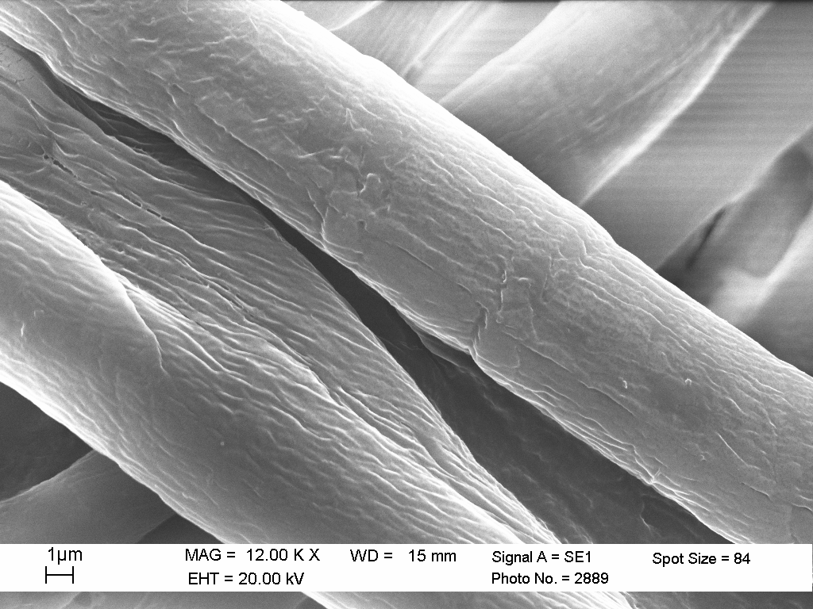
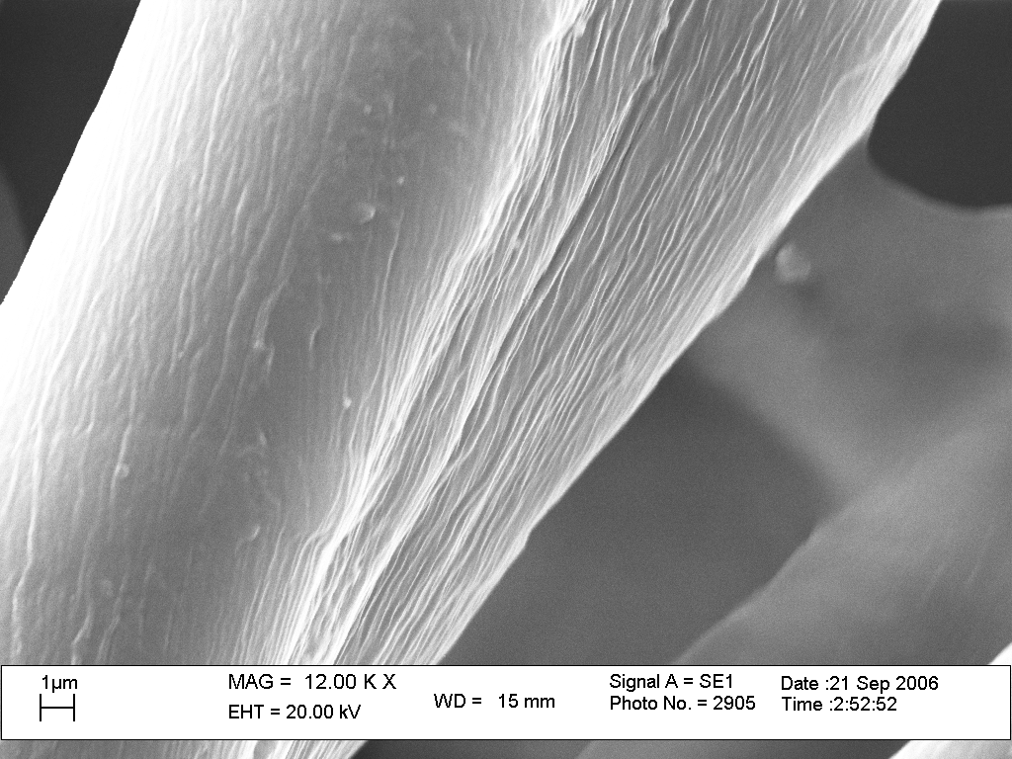

Figure S2 XPS survey spectrum of the typical “cloth CaCO₃” prior to calcinations.



