Role of Locked Nucleic Acid (LNA) modified complementary strand on Quadruplex-WC duplex equilibrium
Niti Kumar and Souvik Maiti

Proteomics and Structural Biology Unit, Institute of Genomics and Integrative Biology, CSIR, Mall Road, New Delhi 110 007, India
Phone +91-11-27666156, Fax: +91-11-27667471
E-mail: souvik@igib.res.in

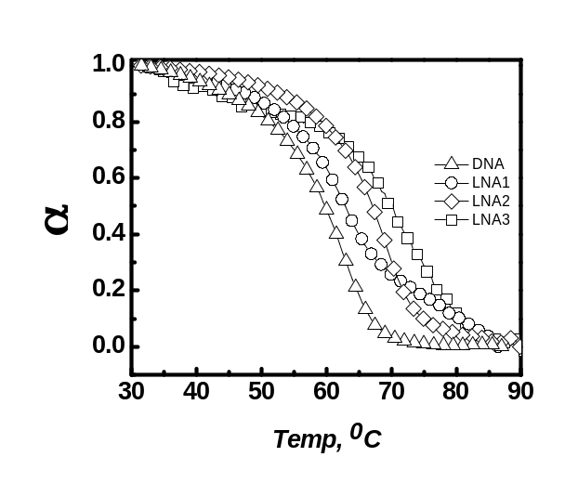

SI Figure 1: UV annealing profile obtained for duplex formation for G-rich (1 µM) and C-rich (10 µM) strand and was monitored at 260 nm in 50 mM MES buffer pH 7, 100 mM KCl.

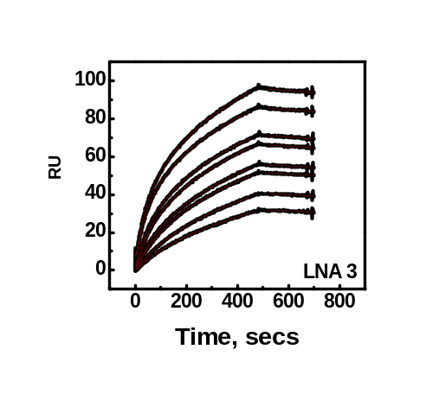
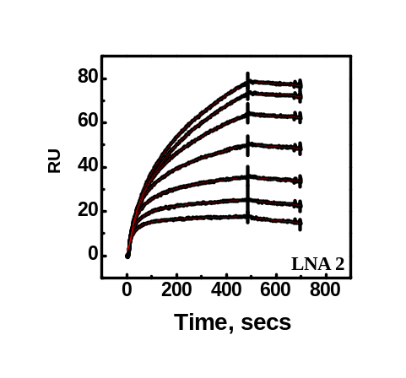
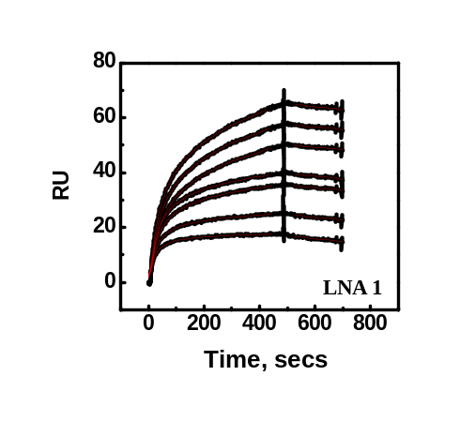
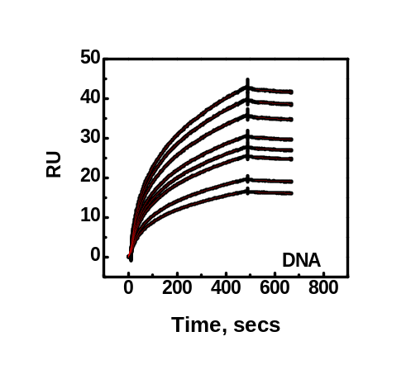

SI Figure 2: Sensorgrams obtained upon hybridization of 30 mer 5′- biotinylated telomeric quadruplex-K⁺ to its unmodified and LNA modified complementary strand (1.25 nM – 100 nM) in 10 mM HEPES with 100 mM KCl and 0.005% surfactant IGEPAL

