Supporting Information
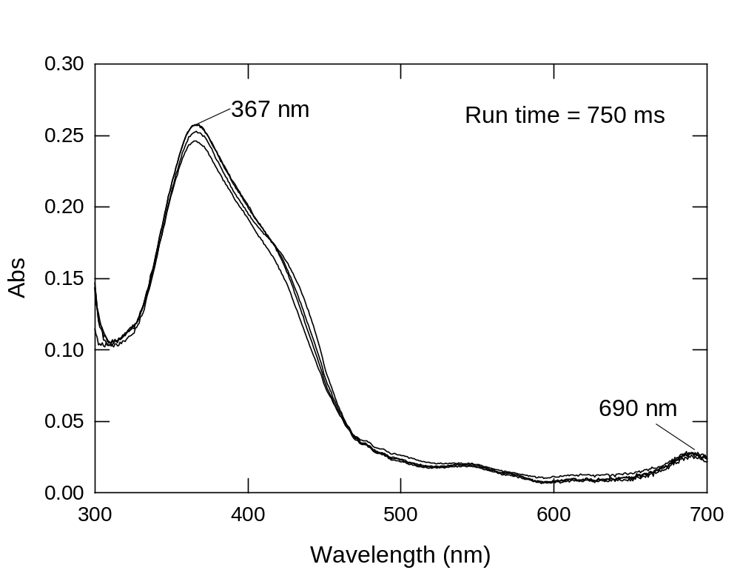

Figure S-1. Stability of CCPO-I after reaction of ferric CCPO with H₂O₂ (run time = 750 ms) in 100 mM potassium phosphate solution, pH 3.6 and 4 °C. The concentrations upon final mixing are 5 μM CCPO and 500 μM H₂O₂.

Discussion
The formation rate of CCPO-I is too fast to measure under our experimental conditions. However, the absorption spectra of CCPO-I remain unchanged for 750 – 1000 ms.
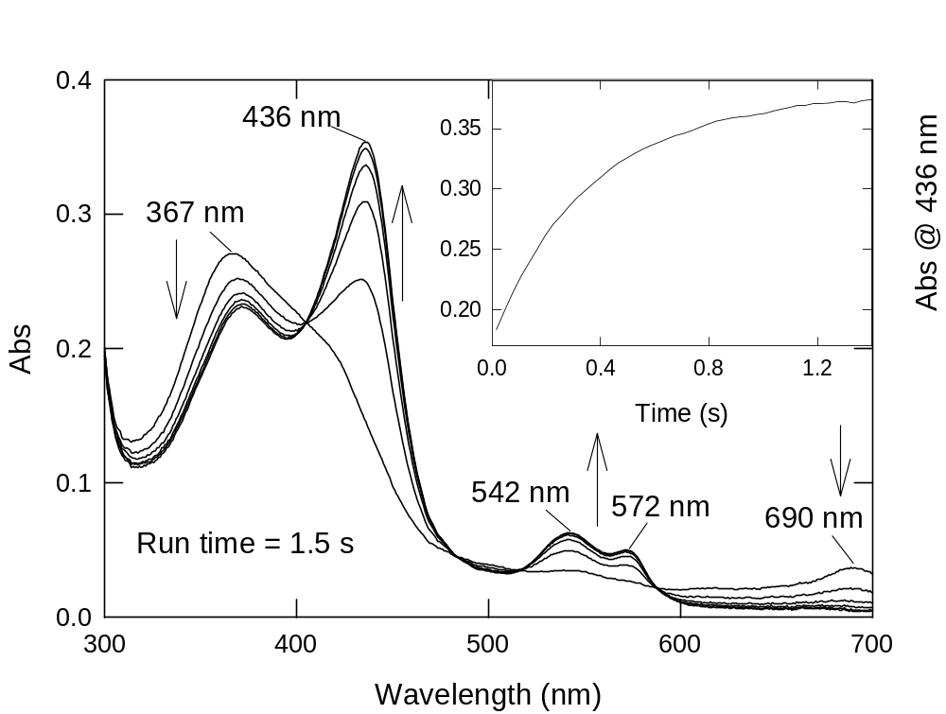

Figure S-2. Formation of CCPO-II following reaction of ferric CCPO with a solution containing H₂O₂ and ascorbate (run time = 1.5 s) in 100 mM potassium phosphate solution, pH 3.6 and 4 °C. The concentrations upon final mixing are 5 μM CCPO, 500 μM H₂O₂ and 1.5 mM ascorbate. Inset: Kinetic trace at 436 nm for this reaction.

Discussion
CCPO-I (λ_{max} 367 and 690 nm) is formed within the dead time of the instrument. Conversion to CCPO-II (λ_{max} = 436, 542 and 572 nm) is completed within 1-1.5 s. Well-defined isosbestic points suggest a direct conversion of CCPO-I to CCPO-II.

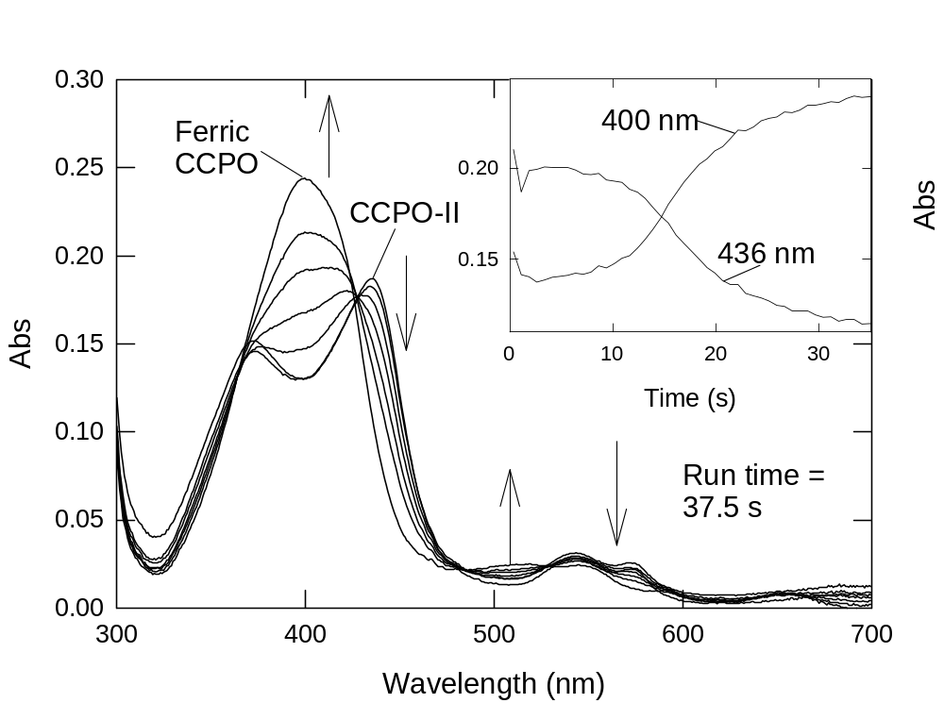

Figure S-3. Persistence of CCPO-II, in the absence of an organic substrate, after reaction of ferric CCPO with a solution containing H₂O₂ and ascorbate (age time = 1 s) in 100 mM potassium phosphate solution, pH 3.6 and 4 °C following reaction with deionized water (run time = 37.5 s). The concentrations upon final mixing are 3 μM CCPO, 250 μM H₂O₂ and 750 μM ascorbate. Inset: Kinetic traces at 400 and 436 nm for decomposition of CCPO-II to ferric CCPO.

Discussion
CCPO-II is completely generated within ~ 1 s (Figure S-2) and the spectrum remains unchanged for ~ 10 s (inset). This figure shows the time for decay of CCPO-II to ferric CCPO in the absence of substrate.

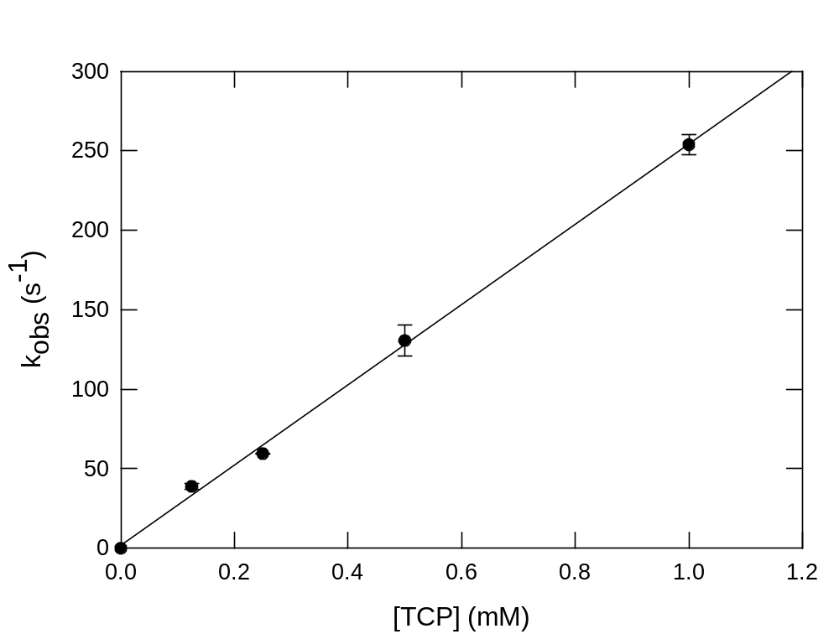

Figure S-4. Observed rate constants for reaction of CCPO-I with 2,4,6-trichlorophenol. The rate constants were obtained by monitoring the formation of CCPO-II as a result of reaction of 2,4,6-trichlorophenol (TCP) with CCPO-I (see Figure 1 of main text). For each concentration of TCP, four to six independent kinetic runs were collected and averaged to determine k_{obs} values.

Discussion:
The data demonstrate that the rate of conversion of CCPO-I to CCPO-II is first-order with respect to [TCP].
.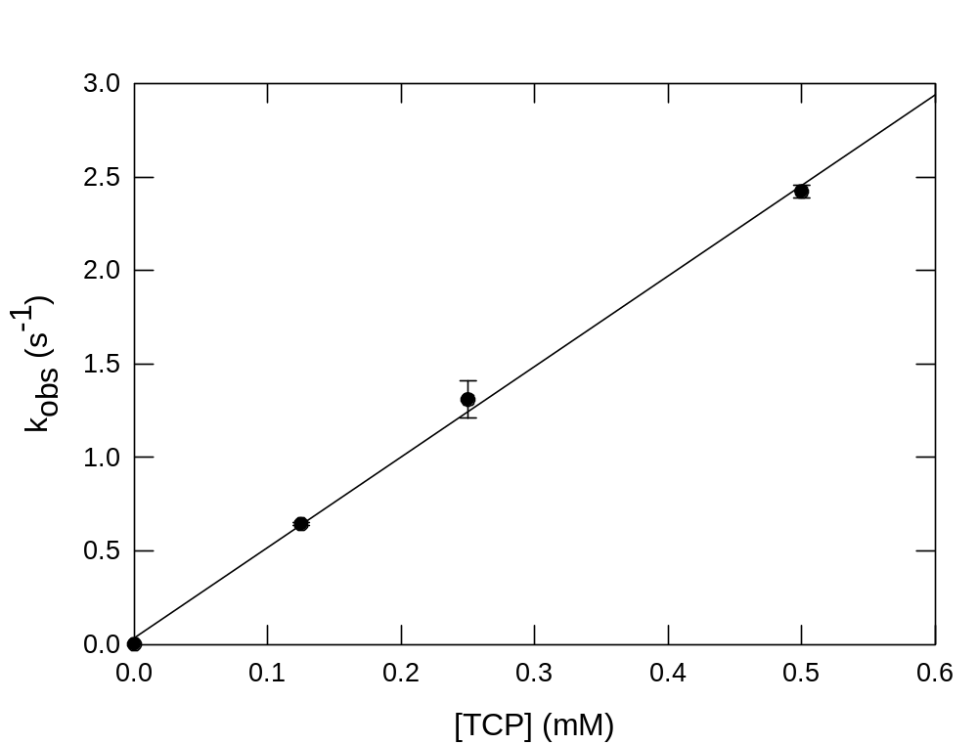

Figure S-5. Observed rate constants for reaction of CCPO-II with 2,4,6-trichlorophenol. The rate constants were obtained by monitoring the formation of ferric CCPO as a result of reaction of 2,4,6-trichlorophenol with CCPO-II (see Figure 2 of main text). For each concentration of TCP, four to six independent kinetic runs were collected and averaged to determine the k_{obs}.

Discussion
The data demonstrate that the rate of conversion of CCPO-II to ferric CCPO is first-order with respect to [TCP].
The plot begins to level off at [TCP] ≥ 1 mM.

