SUPPORTING INFORMATION

Alkaloids from the Roots of Stemona aphylla (Stemonaceae)

Pitchaya Mungkornasawakul,*†,‡,┴ Sukanda Chaiyong,§ Thanapat Sastraruji,§ Araya Jatisatienr,§ Chaiwat Jatisatienr,§ Stephen G. Pyne,† Alison T. Ung,† John Korth,† and Wilford Lie†
Department of Chemistry, University of Wollongong, Wollongong, New South Wales, 2522, Australia, Division of Environmental Sciences, Chiang Mai University, Chiang Mai 50202, Thailand, Department of Biology, Chiang Mai University, Chiang Mai 50202, Thailand, and Department of Chemistry, Chiang Mai University, Chiang Mai 50202, Thailand
------------------------------------------------------------------------------------------------------
† School of Chemistry, University of Wollongong.
‡ Division of Environmental Sciences, Chiang Mai University.
┴Department of Chemistry, Chiang Mai University.
§Department of Biology, Chiang Mai University.

Table of Contents:

¹H NMR (CDCl₃) of 4 SI-2
¹H NMR (CDCl₃) of 5 SI-3
Table of HMBC correlations for Compounds 4 and 5 SI-4
GC-MS trace of the crude CH₂Cl₂ extract SI-5
Table of EIMS details SI-5
Tables of the biological activities of the CH₂Cl₂ extract and 4 SI-6

SI-1
¹H NMR (CDCl₃) of 4
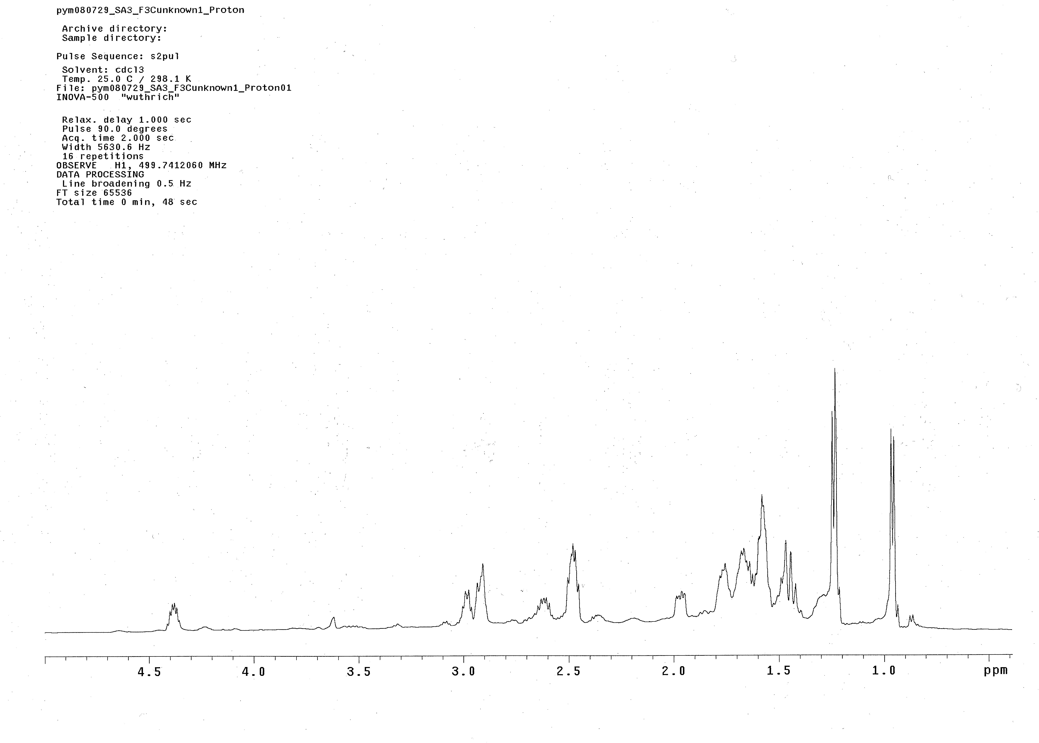
SI-2

¹H NMR (CDCl₃) of 5

Table of HMBC correlations for Compounds 4 and 5.

position | HMBC
position | 4 | 5
1  2  3  5  6  7  8  9  9a  10  11  12  13  14  15  16  17 | H-2, H-3  -  -  H-3  -  H-5  -  H-17  H-3,H-5, H-6  H-8, H-9, H-11  -  H-10, H-11, H-13  H-14  H-13,H-16  H-13, H16  -  - | H-3  H-9a  H-5  H-8  H-5  H-5  H-9a  H-17  -  H-17, H-8  -  H-11, H-13  H-14, H-16  H-16  H-16  -  -

SI-4
GC-MS trace of the crude CH₂Cl₂ extract

Total ion current
22.5
25.0
27.5
30.0
32.5
35.0
37.5
40.0
42.5
45.0
0.25
0.50
0.75
1.00
1.25
(x10,000,000)
1

2
3

42
1

551

6

Time (min)

Table of EIMS details
SI-5

peak no. [RT (min)] | M^{∙+} (m/z) | fragment ions (m/z) | compound
1 [28.3] | 277 | 262 (2%), 180 (100%) | 11
2 [29.0] | 279 | 264 (14%), 180 (25%), 166 (76%), 138 (24%) | 4
3 [30.5] | 258 | 277 (5%), 137 (15%), 121 (95%) | 12
4 [39.2] | 403 | 387 (28%), 232 (25%), 204 (93%), 162 (95%) | 2
5 [44.1] | 385 | 230 (9%), 202 (32%), 160 (95%) | 3
6 [45.1] | 387 | 232 (26%), 204 (95%), 162 (94%) | 1

Tables of the biological activities of the CH₂Cl₂ extract and 4

Table1 Minimum Concentration of Sample Required to Inhibit AChE as Indicated by a White Zone of Inhibition.
compound | minimum inhibitory requirement
compound | ng nmole
physostigmine | 0.1 | 3.6 x 10⁻⁴
4 | 50 | 0.18
crude CH₂Cl₂ extract | 10 | -

Table2 Antibacterial Activity Expressed as Minimum Inhibitory (MIC) and Minimum Bactericidal Concentrations (MBC), in (µg/mL).
bacteria | sample
bacteria | gentamicin |  | crude CH₂Cl₂ extract |  | 4
bacteria | MIC | MBC | MIC | MBC | MIC | MBC
E. coli | 5.62 | 5.62 | 625 | 1250 | 62.5 | 125
S. aureus | 5.62 | 22.5 | 1250 | 2500 | 125 | 250
Ps. aeruginosa | 0.35 | 1.46 | 625 | 625 | 62.5 | 125

Table3 Antifungal Activity Expressed as Minimum Inhibitory (MIC) and Minimum Fungicidal Concentrations (MFC), in (µg/mL).
fungus | sample
fungus | amphotericin B |  | crude CH₂Cl₂ extract |  | 4
fungus | MIC | MFC | MIC | MFC | MIC | MFC
C. albicans | 0.35 | 0.70 | 625 | 1250 | 125 | 125

SI-6

