Supporting Information

“Understanding of the Electrophoretic Separation of Single-Walled Carbon Nanotubes Assisted by Thionine as a Probe”

Hongbo Li,† Hehua Jin,† Jing Zhang,†,‡ Xiaonan Wen,†,‡ Qijun Song,‡ Qingwen Li,*,†

†Suzhou Institute of Nanotech and Nanobionics, Chinese Academy of Science, Suzhou 215123, P. R. China
‡ Jiangnan University, Wuxi 214122, P. R. China

*Corresponding author. E-mail address: qwli2007@sinano.ac.cn; tel: +86-512-62872577; fax: +86-512-62603079.

Electrophoresis of SDS-SWNT-PVP Gel
SDS-SWNT-PVP dispersion was prepared by adding a small volume of 20% polyelectrolyte (PVP) to SDS-SWNT dispersion (PVP: SDS = 1:2 weight ratio) and equilibriumed for overnight. The preparation of SDS-SWNT-PVP gel and electrophoresis experiment were same as that described in the experimental section in the ms. Figure S1 shows the results of SDS-SWNT-PVP gel before and after agarose gel electrophoresis. It is seen that all SWNTs migarate toward the anode.
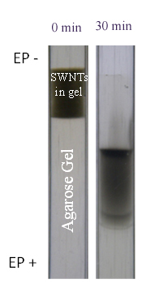

Figure S1. The photographs of SDS-SWNT-PVP gel by agarose gel electrophoresis.

Interaction of TN Molecules with SDS-SWNT Entities
In order to provide the evidence that TN molecules would interact with SWNT-SDS micelles, we did the long-term ultracentrifugation to decant excess SDS molecules and precipitate SDS-SWNT micelles. As shown in Figure S2a, via Raman characterization, we can clearly see the existence of characteristic peaks of TN molecules in the SDS-SWNT precipitate. We also prepared SDS-SWNT film by filtration, and then made it soaked in the TN solution and rinsed thoroughly. The characteristic peaks of TN molecules could be also witnessed. As a result, we can safely draw the conclusion that TN molecules not only interact with free SDS micelles but also SDS-SWNT micelles. We also check the absorption spectra of initial SDS-SWNT-TN dispersion, supernate and re-dispersed precipation solution after ultracentrifugation, as shown in Figure S2b. The strong absorbance band appearing around 600nm indicates that the majority of TN molecules have been decanted with free SDS micelles after ultracentrifugation, as SDS are pretty excessive in SWNT dispersion. In contrast, less TN molecules are left with SWNT precipitation.
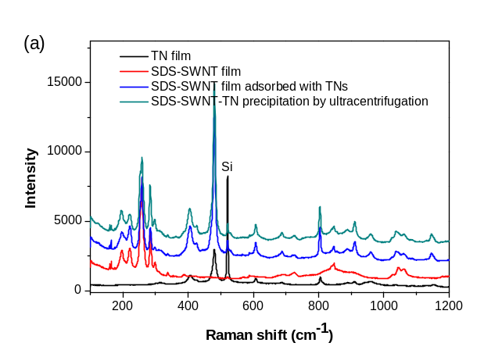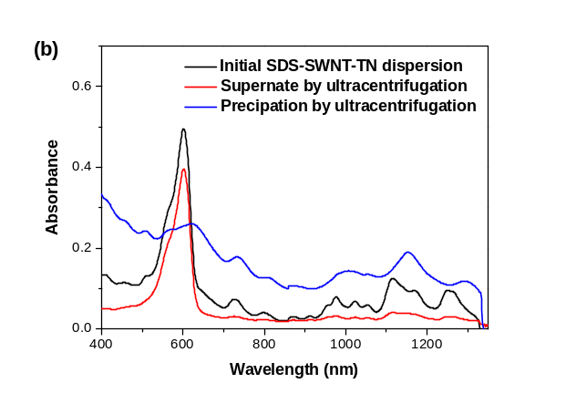With respect to the question if TN molecules selectively interact with m- or s- SWNTs, we prepared m- and s-SWNT films respectively by using our new chromagraphic separation method and investigated their interactions with TN molecules. As shown in Figure S2c, on one hand, the Raman spectra confirmed the two films were mostly composited of m- and s-SWNTs, respectively. On the other hand, it also presented the obvious bands of TNs on both of the two films, indicating that the interactions between the sorted SDS-SWNT entities and TN molecules were not selective. Such observation is reasonable, though it has been widely investigated that TN molecules may interact with pure SWNTs via the π-π stacking force. However, when SWNTs are dispersed by SDS, the negatively charged SWNT individuals, no matter whether they are m- or s-SWNTs, are prone to bind with positively charged TN dye molecules. Therefore, the SDS coverage on SWNTs basically accounts for the interaction of TN molecules, its coverage densities however, which are different on m- or s-fractions may determine interaction intensity between TNs and the sorted SWNTs.

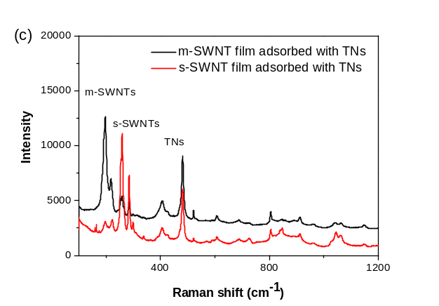

Figure S2. (a) Raman spectra (excited at 633 nm) of TN film, SDS-SWNT film, SDS-SWNT film adsorbed with TNs, SDS-SWNT-TN precipitation by ultracentrifugation, respectively; (b) UV-vis-NIR absorption spectra of initial SDS-SWNT-TN dispersion, supernate and re-dispersed precipation solution after ultracentrifugation; (c) Raman spectra (excited at 633 nm) of m- and s-SWNT films adsorbed with TNs.

Selective Interaction between s-SWNT and Agarose
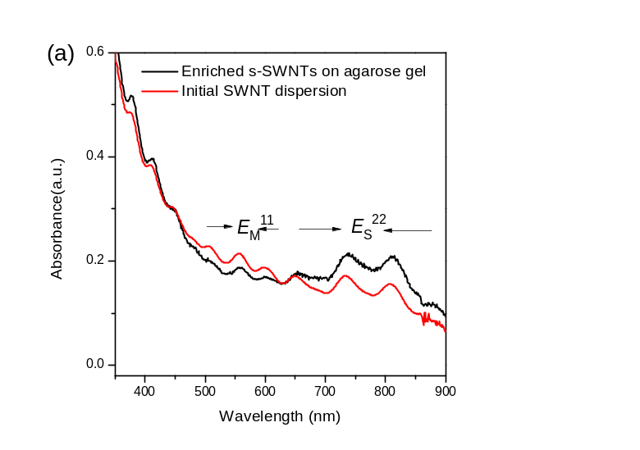In order to confirm the existence of an interaction between s-SWNTs and agraose, we intentionally prepared an agarose gel film on a glass substrate and then immersed it into SDS-SWNT dispersion for overnight. After a thorough rinsing, the agarose film became a light grey. As shown in Figure S3, both absorption and Raman bands derived from the film revealed that s-SWNTs were selectively and favorably adsorbed onto the agarose film, suggesting that there would be a strong affinity between agarose and s-SWNT rather than m-SWNT.
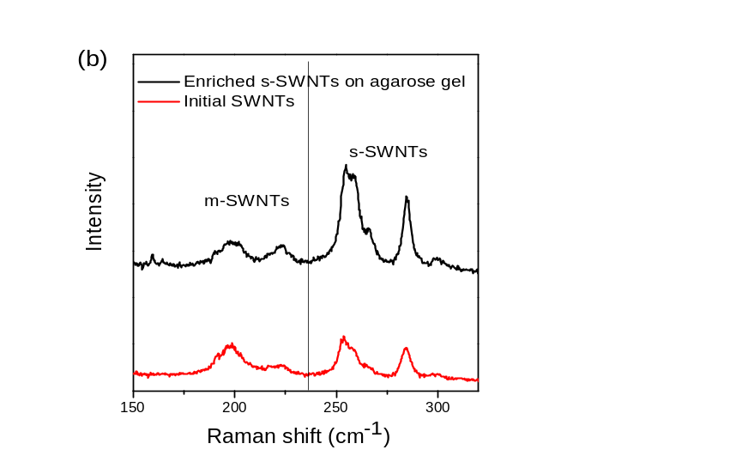

Figure S3. (a) UV-Vis-NIR absorption spectra of agarose gel film rich in s-SWNTs and initial SWNT dispersion; (b) Raman spectra (excited at 633 nm) of corresponding s-SWNT film and initial SWNTs.

Electrophoresis of SDS-SWNT-TN Gel
Figure S4a shows the photographs of SDS-SWNT-TN gel by agarose gel electrophoresis when cutting a short gel and prolonging electrophoresis time. After a long-time electrophoresis, we observed two separated bands in blue and palumbine color, clearly indicating the existence of TN molecules in free SDS micelles and SDS-m-SWNT entities, respectively, agreeing well with our explanation stated in the ms. Their corresponding absorption spectra are shown in Figure S4b. Both moving palumbine SDS-m-SWNT entities and blue SDS-TN micelles present the absorption bands of TN molecules, further supporting our conclusions.
- (b)
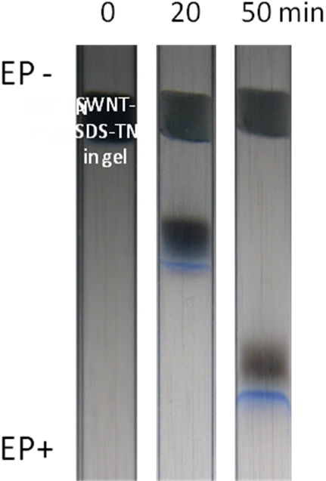
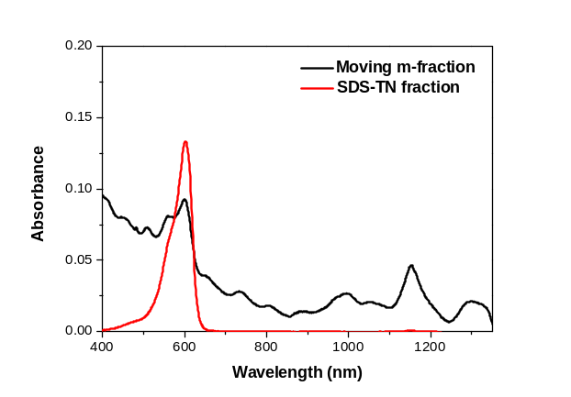

Figure S4. (a) The photographs of SDS-SWNT-TN gel by agarose gel electrophoresis when cutting a short gel and prolonging electrophoresis time; (b) the corresponding absorption spectra of moving m-fraction and blue fraction.

Comparison of Absorption Spectra of Initial SDS-SWNT Gel and Staying Fractions
Figure S5 shows UV-Vis-NIR absorption spectra of initial SDS-SWNT gel and the staying fraction enriched by s-SWNTs after agarose gel electrophoresis. Compared with absorption bands of initial SDS-SWNT gel before elelctrophoresis, red shifts for E_{S}¹¹ and E_{S}²² transitions of s-SWNTs are presented after electrophoresis.

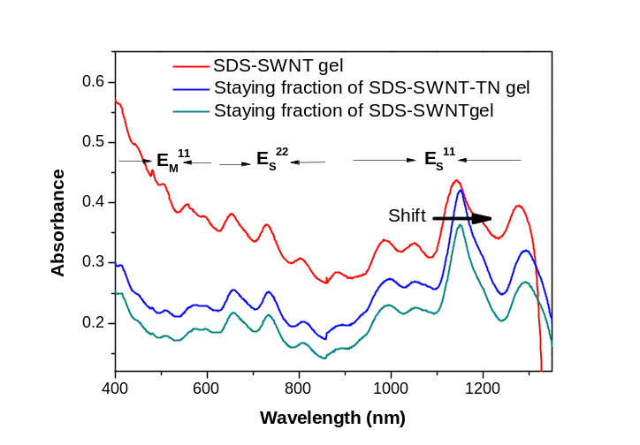

Figure S5. UV-Vis-NIR absorption spectra of SDS-SWNT gel before agarose gel electrophoresis and the staying fractions enriched by s-SWNTs after that.

Agarose Gel Centrifugation of SDS-SWNT-TN Gel
For agarose gel centrifugation, we mixed the SWNT dispersion with hot agarose to prepare SWNT gel. The preparation process is just like that described in the ms. The gel was then centrifuged (20,000×g for 8 h at 20 °C) to obtain the supernatant and precipitation, which were enriched by m-SWNTs and s-SWNTs, respectively. As shown in Figure S6, the absorption spectra of the supernatant and redispersed precipitation indicate the existence of TN molecules, very different from the case of electrophoretic separation.
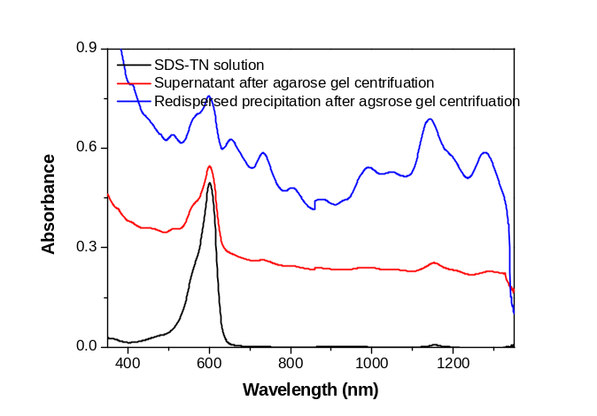

Figure S6. UV-Vis-NIR absorption spectra of SDS-TN solution, supernatant and redispersed precipitation solution after agarose gel centrifugation.

