Supporting Information

**Optimization of peptides that target human thymidylate synthase to inhibit ovarian cancer cell growth.**

Michela Pelà,1 Puneet Saxena,2 Rosaria Luciani,2 Matteo Santucci,2 Stefania Ferrari,2 Gaetano Marverti,3 Chiara Marraccini,2 Andrea Martello,2 Silvia Pirondi,2 Severo Salvadori,1,4 Domenico D’Arca,3 Glauco Ponterini,2 Maria Paola Costi,2* Remo Guerrini1,4

1Department of Chemical and Pharmaceutical Sciences, University of Ferrara, via Fossato di Mortara 17-19, 44100 Ferrara, Italy. 2Department of Life Sciences, via Campi, 183, 41125, Modena 3Department of Biomedical Sciences, Metabolic and Neurosciences, via Campi 287, 41125 Modena, Italy. 4LTTA (Laboratorio per le Tecnologie delle Terapie Avanzate) via Fossato di Mortara 17-19, 44100 Ferrara, Italy.

Contents

Page S3 Analytical HPLC profile and HRMS (high resolution mass spectrometry)of LR

Page S4 Analytical HPLC profile and HRMS of Ac-LR

Page S5 Analytical HPLC profile and HRMS of Ac-LR-NH2

Page S6 Analytical HPLC profile and HRMS of LR-NH2

Page S7 Analytical HPLC profile and HRMS of [Ala1] LR

Page S8 Analytical HPLC profile and HRMS of [Ala2] LR

Page S9 Analytical HPLC profile and HRMS of [Ala3] LR

Page S10 Analytical HPLC profile and HRMS of [Ala4] LR

Page S11 Analytical HPLC profile and HRMS of [Ala5] LR

Page S12 Analytical HPLC profile and HRMS of [Ala6] LR

Page S13 Analytical HPLC profile and HRMS of [Ala7] LR

Page S14 Analytical HPLC profile and HRMS of [Ala8] LR

Page S15 Analytical HPLC profile and HRMS of [dLeu1] LR

Page S16 Analytical HPLC profile and HRMS of [dSer2] LR

Page S17 Analytical HPLC profile and HRMS of [dCys3] LR

Page S18 Analytical HPLC profile and HRMS of [dGln4] LR

Page S19 Analytical HPLC profile and HRMS of [dLeu5] LR

Page S20 Analytical HPLC profile and HRMS of [dTyr6] LR

Page S21 Analytical HPLC profile and HRMS of [dGln7] LR

Page S22 Analytical HPLC profile and HRMS of [dArg8] LR

Page S23 Analytical HPLC profile and HRMS of LR(2-8)

Page S24 Analytical HPLC profile and HRMS of LR(3-8)

Page S25 Analytical HPLC profile and HRMS of LR(4-8)

Page S26 Analytical HPLC profile and HRMS of LR(5-8)

Page S27 Analytical HPLC profile and HRMS of LR(1-7)

Page S28 Analytical HPLC profile and HRMS of LR(1-6)

Page S29 Analytical HPLC profile and HRMS of LR(1-5)

Page S30 Analytical HPLC profile and HRMS of LR(1-4)

Page S31 Analytical HPLC profile and HRMS of LR(2-6)

Page S32 Analytical HPLC profile and HRMS of LR(3-7)

Page S33 Table 1S: hTS activity inhibition percentages (I%).

Page S35 Table 2S. Cell survival (% of control) of human ovarian cancer cell lines

Page S36 Gromacs parameter files for d-amino acids

LR

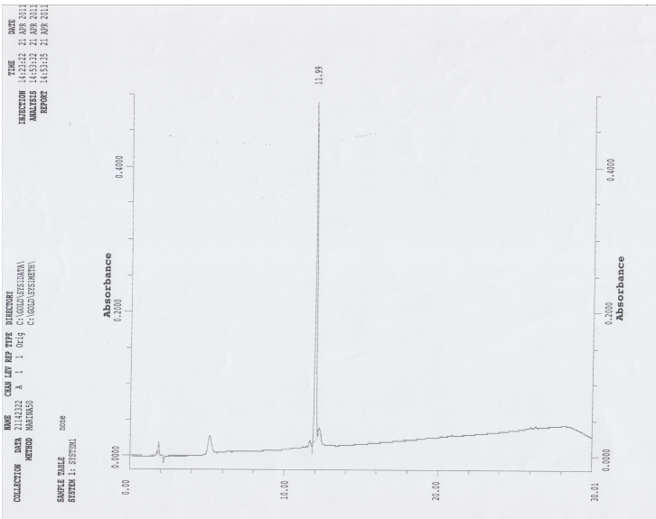

LR calculated: 1010.5088

Ac-LR

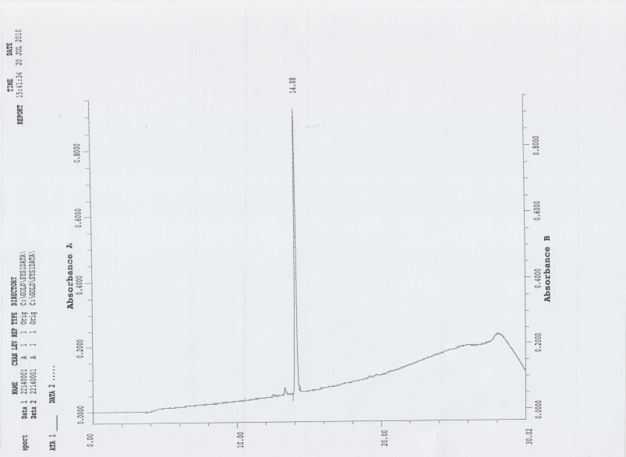

Ac-LR calculated: 1052.5193



Ac-LR-NH2

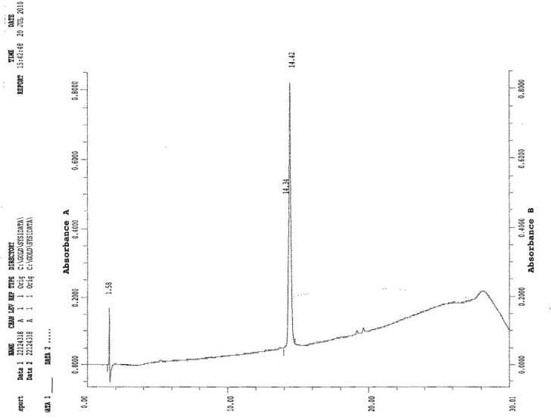

Ac-LR-NH2 calculated: 1051.5359

LR-NH2

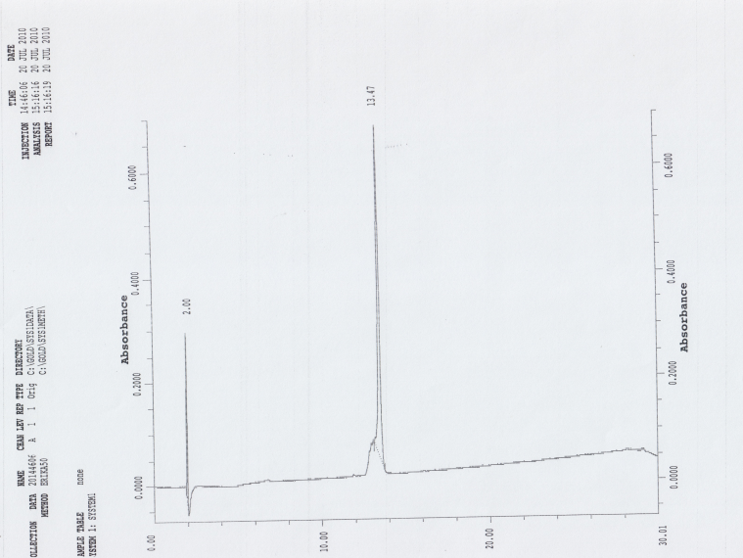

LR-NH2 calculated: 1009.5248

[Ala1] LR

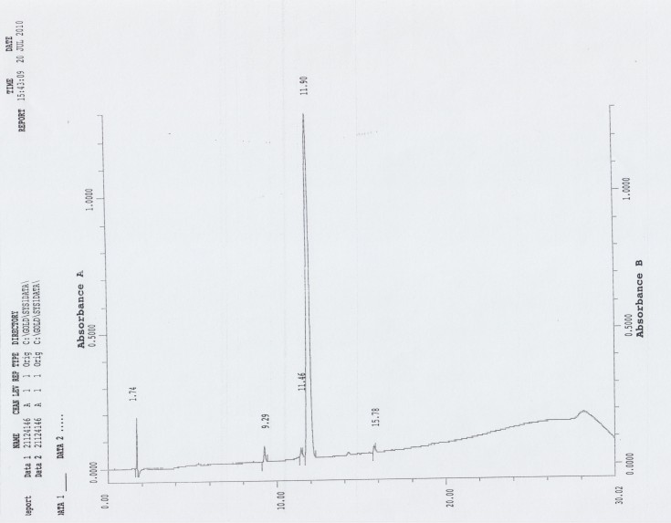

[Ala1] LR Calculated: 968.4618 

[Ala2] LR

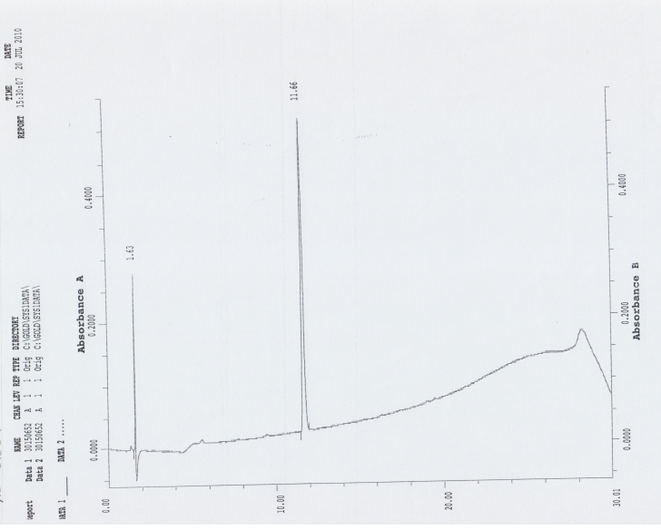

[Ala2] LR Calculated: 994.5140



[Ala3] LR

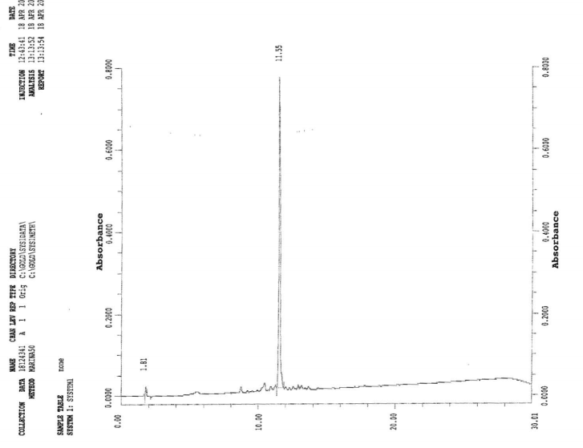[Ala3] LR Calculated: 978.5367



[Ala4] LR

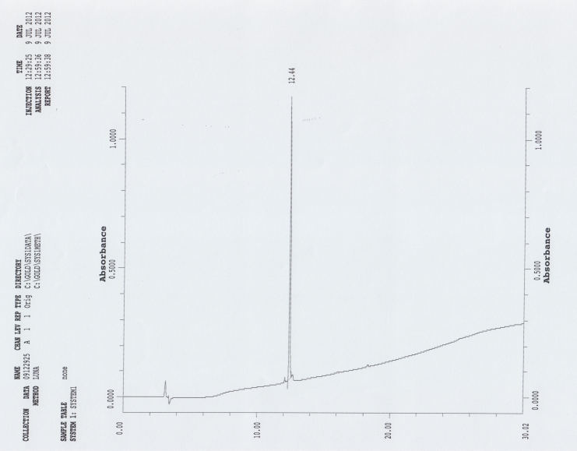

[Ala4] LR Calculated: 953.4873 

[Ala5] LR

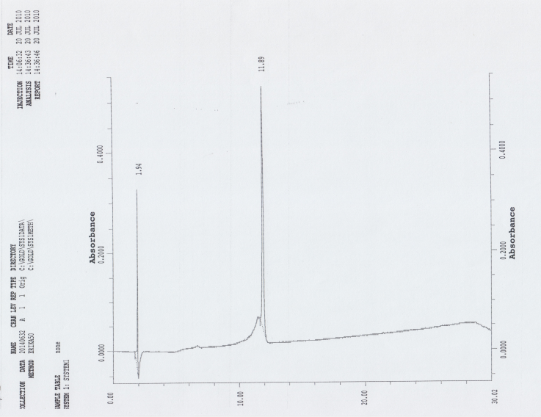

[Ala5] LR Calculated: 968.4618 

[Ala6] LR

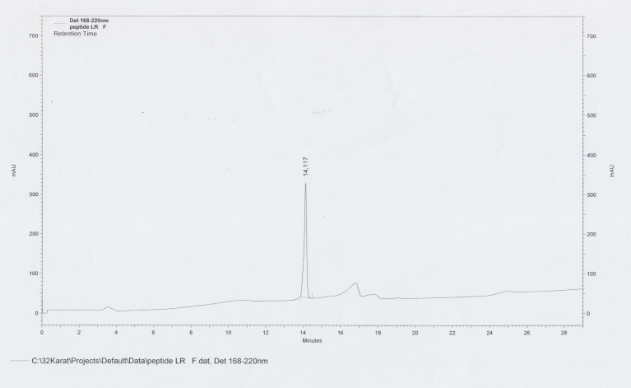

[Ala6] LR Calculated: 918.4825



[Ala7] LR



[Ala7] LR Calculated: 953.4873



[Ala8] LR

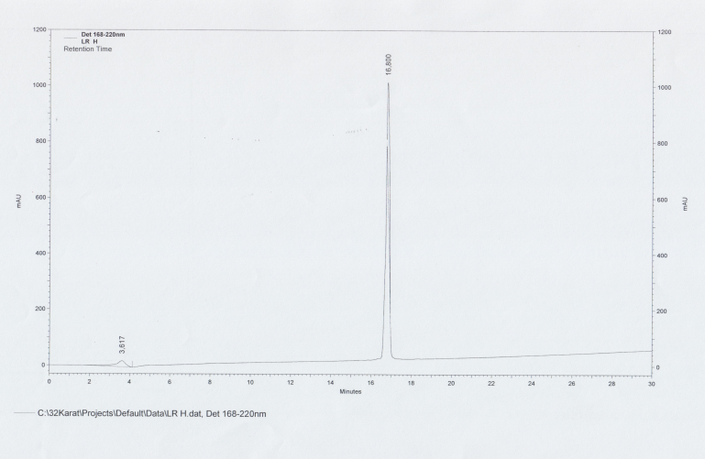

[Ala8] LR Calculated: 925.4448



[dLeu1] LR

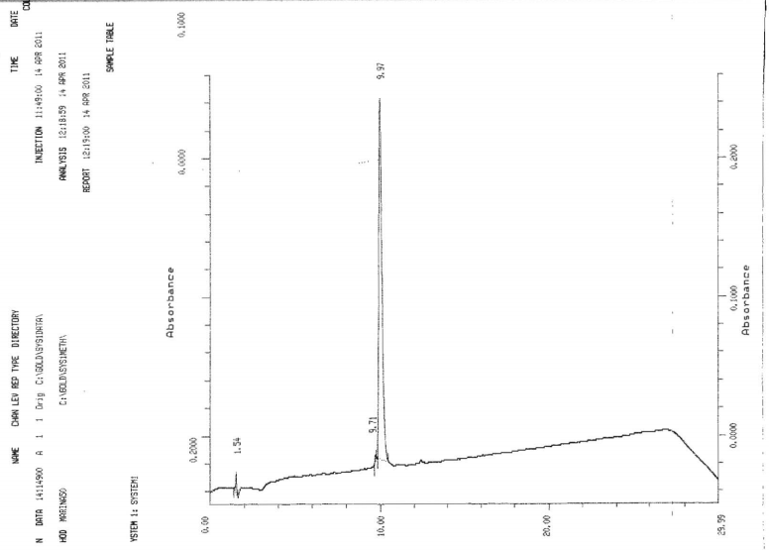

[dLeu1] LR Calculated: 1010.5088 

[dSer2] LR

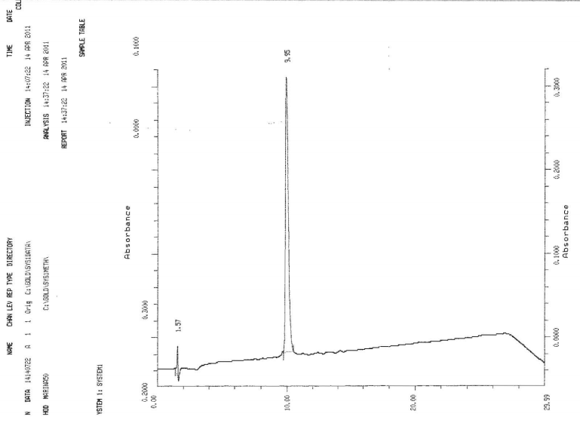

[dSer2] LR Calculated: 1010.5088 

[dCys3] LR

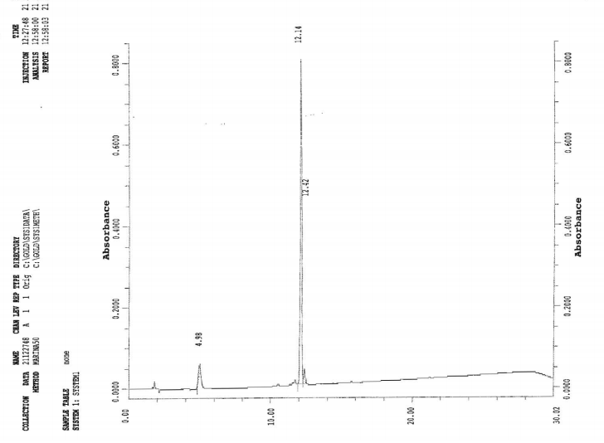

[dCys3] LR Calculated: 1010.5088 

[dGln4] LR

[dGln4] LR Calculated: 1010.5088



[dLeu5] LR

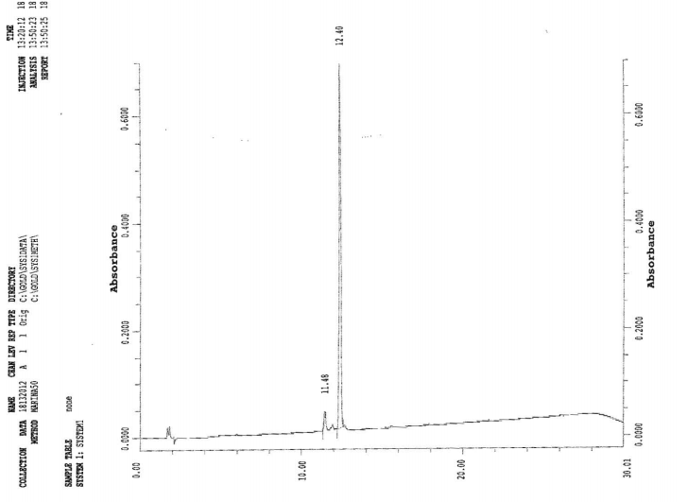

[dLeu5] LR Calculated: 1010.5088 

[dTyr6] LR

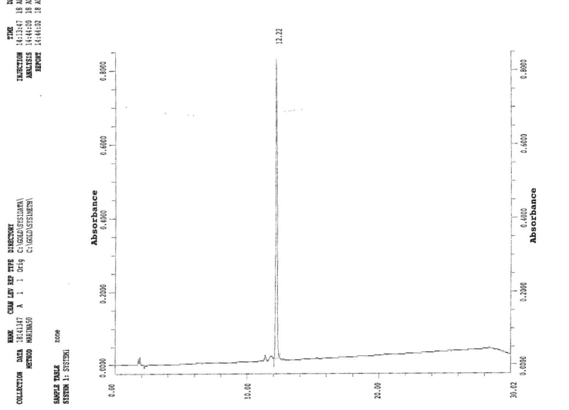

[dTyr6] LR Calculated: 1010.5088



[dGln7] LR



[dGln7] LR Calculated: 1010.5088



[dArg8] LR

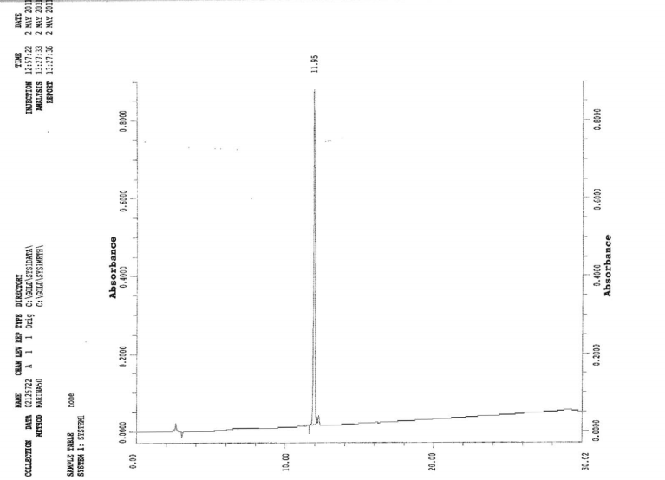

[dArg8] LR Calculated: 1010.5088



LR (2-8)

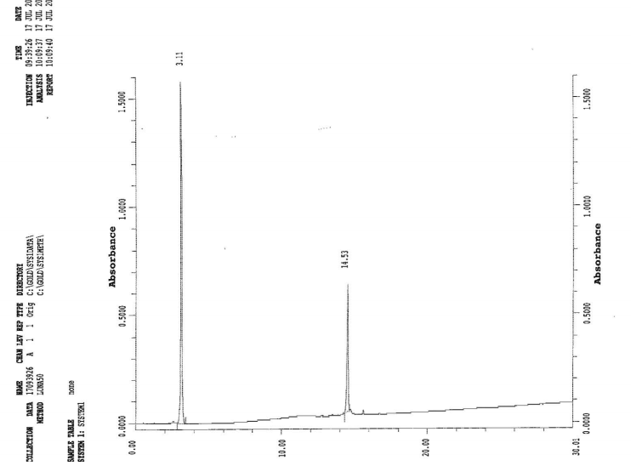

LR (2-8) Calculated: 897.4247



LR (3-8)

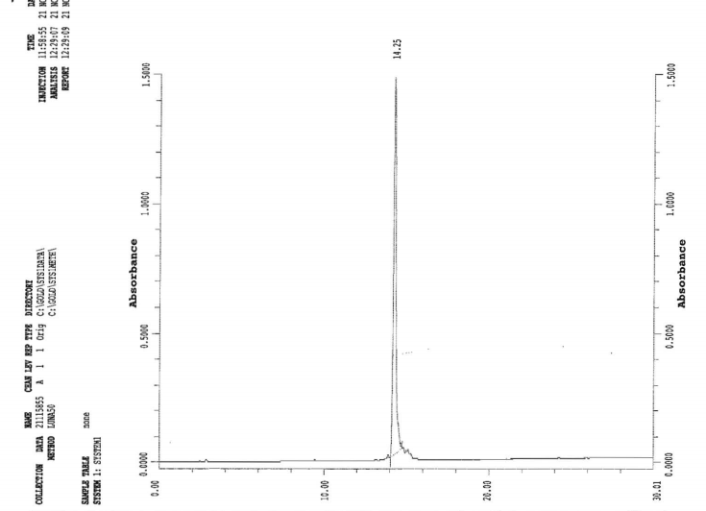

LR (3-8) Calculated: 810.3927



LR (4-8)

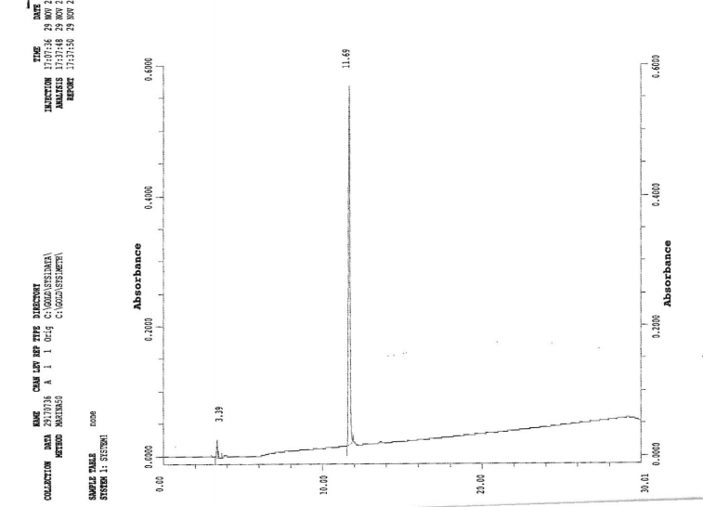

LR (4-8) Calculated: 707.3835



LR (5-8)

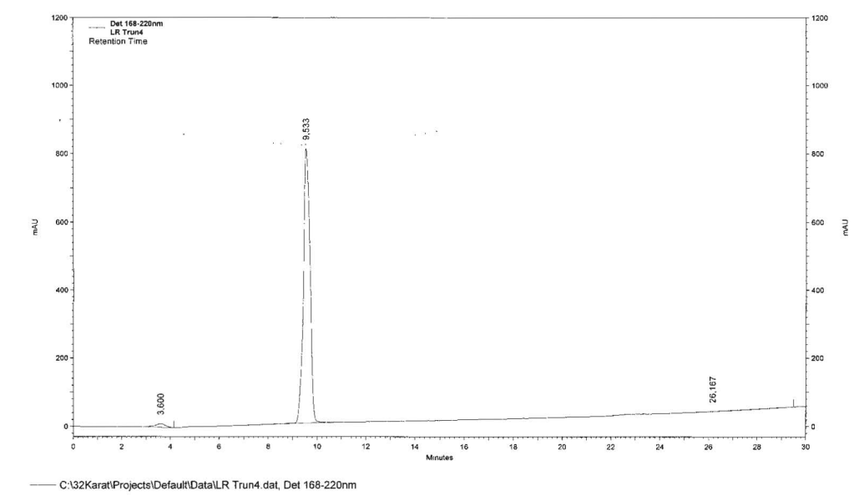

LR (5-8) Calculated: 579.3249



LR (1-7)



LR (1-7) Calculated: 854.4077



LR (1-6)

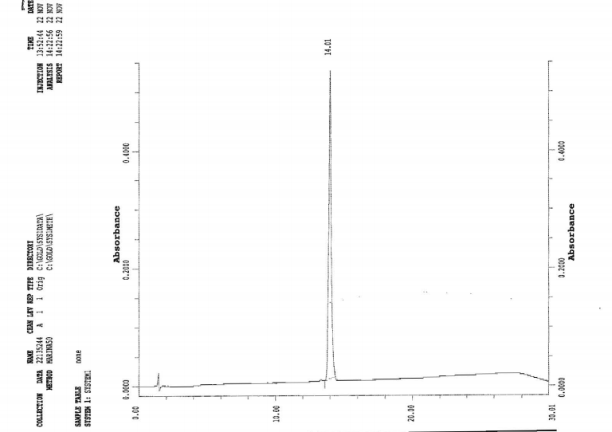

LR (1-6) Calculated: 726.3491



LR (1-5)



LR(1-5) Calculated: 563.2857



LR (1-4)

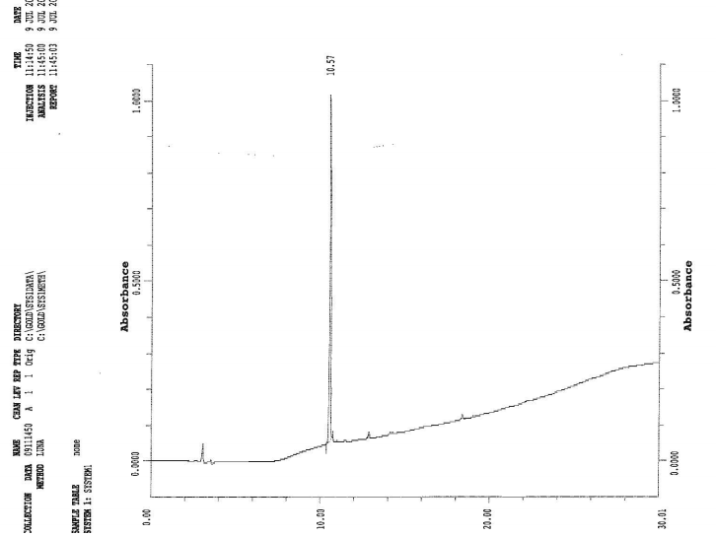

LR (1-4) Calculated: 450.2017

LR (2-6)



LR (2-6) Calculated: 613.2650



LR (3-7)



LR (3-7) Calculated: 654.2916



Table 1S: hTS activity inhibition percentages (I%) values measured at 100 M concentration of inhibitor. I% values are expressed as mean ± S:E:M:;n=3.

|  |  |
| --- | --- |
| **sequence code** | I% |
| **LSCQLYQR LR** | 65 ± 2.6 |
| **Ac-LSCQLYQR Ac-LR** | 60 ± 1.8 |
| **Ac-LSCQLYQR-NH2 Ac-LR-NH2** | 20 ± 0.05 |
| **LSCQLYQR-NH2 LR-NH2** | 5 ± 0.01 |
| **LSCQLYQR LR** | 65 ± 2.6 |
| **ASCQLYQR [Ala1]LR** | 69 ± 2.2 |
| **LACQLYQR [Ala2]LR** | 69 ± 1.6 |
| **LSAQLYQR [Ala3]LR** | 67 ± 1.7 |
| **LSCALYQR [Ala4]LR** | 56 ± 0.8 |
| **LSCQAYQR [Ala5]LR** | 67 ± 2.6 |
| **LSCQLAQR [Ala6]LR** | 57 ± 1.1 |
| **LSCQLYAR [Ala7]LR** | 100a  ± 0.8 |
| **LSCQLYQA [Ala8]LR** | 41 ± 1.1 |
| **LSCQLYQR LR** | 65 ± 2.6 |
| **lSCQLYQR [DLeu1]LR** | 42 ± 0.9 |
| **LsCQLYQR [DSer2]LR** | 61 ± 2.1 |
| **LScQLYQR [DCys3]LR** | 27 ± 0.5 |
| **LSCqLYQR [DGln4]LR** | 74 ± 1.4 |
| **LSCQlYQR [DLeu5]LR** | 51 ± 0.7 |
| **LSCQLyQR [DTyr6]LR** | 49 ± 0.9 |
| **LSCQLYqR [DGln7]LR** | 60 ± 1.6 |
| **LSCQLYQr [DArg8]LR** | 45 ± 1.1 |
| **lscqlyqr LR-D** | NI |
| **LSCQLYQR LR** | 65 ± 2.6 |
| **SCQLYQR LR(2-8)** | 100b  ± 1.1 |
| **CQLYQR LR(3-8)** | 51 ± 1.4 |
| **QLYQR LR(4-8)** | 59 ± 2.2 |
| **LYQR LR(5-8)** | 31 ± 0.4 |
| **LSCQLYQR LR** | 65 ± 2.6 |
| **LSCQLYQ LR(1-7)** | 74c  ± 0.9 |
| **LSCQLY LR(1-6)** | 61 ± 2.9 |
| **LSCQL LR(1-5)** | 58 ± 2.3 |
| **LSCQ LR(1-4)** | 78d  ± 1.7 |
| **LSCQLYQR LR** | 65 ± 2.6 |
| **LSCQL LR(1-5)** | 58 ± 2.5 |
| **SCQLY LR(2-6)** | 68 ± 2.1 |
| **CQLYQ LR(3-7)** | 69e  ± 1.2 |
| **QLYQR LR(4-8)** | 59 ± 2.1 |

a extrapolate from I%=60 at 50 M, b extrapolate from I%=54% at 50 M, c extrapolate from I%=56% at 75 M, d extrapolate from I%=59% at 75 M, e extrapolate from I%=52% at 75 M

Table 2S. Cell survival (% of control) of the 2008, C13*, A2780 and A2780/CP human ovarian cancer cell lines by 72 h-exposure to peptides (n=2/4) or to 5-FU (n=4).

|  |  |  |  |  |
| --- | --- | --- | --- | --- |
| **Peptides** | **2008 cells**  (10 µM) | **C13* cells**  (10 µM) | **A2780 cells**  (10 µM) | **A2780/CP cells**  (10 µM) |
| **5-FU** | 35.5 ± 5 | 46.5 ± 4 | 41.5 ± 4 | 56.4 ± 4 |
| **LR** | 49.8 ± 4 | 60.8 ± 8 | 47 ± 11 | 58.1 ± 11 |
| **LR-NH2** | 62.3 ± 10 | 85.2 ± 5 | 77.8 ± 4 | 65.3 ± 6 |
| **[Ala7]LR** | 75.2 ± 9 | 78 ± 11 | 60.6 ± 4 | 67 ± 6 |
| **[Ala8]LR** | 78.5 ± 6 | 76.5 ± 4 | 64 ± 3 | 68.2 ± 9 |
| **[dLeu1]LR** | 68.6 ± 4 | 74.6 ± 6 | 66.4 ± 5 | 79 ± 7 |
| **[dSer2]LR** | 82.5 ± 2 | 82.5 ± 8 | 76.6 ± 8 | 69.1 ± 5 |
| **[dGln4]LR** | **25.2 ± 5** | **48.2 ± 9** | **34.1 ± 3** | **53.3 ± 7** |
| **[dLeu5]LR** | 71.5 ± 1 | 77.1 ± 3 | 74.1 ± 7 | 81.1 ± 9 |
| **[dTyr6]LR** | 85.4 ± 4 | 83.6 ± 6 | 73.6 ± 6 | 73.2 ± 10 |
| **[dGln7]LR** | 91.2 ± 7 | 90.2 ± 5 | 61.2 ± 6 | 85.8 ± 7 |
| **[dArg8]LR** | 82.7 ± 5 | 82.4 ± 8 | 56.8 ± 5 | 82.6 ± 9 |
| **LR(1-6)** | 73.4 ± 11 | 65.5 ± 5 | 81.5 ± 3 | 82.2 ± 8 |
| **LR(1-5)** | 74.4 ± 6 | 88.2 ± 4 | 83.6 ± 8 | 81.6 ± 5 |
| **LR(2-6)** | 74.6 ± 5 | 70.2 ± 7 | 65.2 ± 4 | 63.5 ± 8 |
| **LR(3-7)** | 76 ± 7 | 80.1 ± 4 | 67.2 ± 5 | 78.5 ± 6 |

**Gromacs parameter files for d-amino acids**

In *aminoacids.dat*, the three letter codes for respective *d-* amino acids were added.

In *ffgmx.rtp*, the following lines were added

|  |  |
| --- | --- |
| for **dCys**: | for **dGln**: |
| [ atoms ]  N N -0.280 0  H H 0.280 0  CA CH1 0.000 1  CB CH2 0.000 2  SG S -0.064 3  HG HS 0.064 3  C C 0.380 4  O O -0.380 4  [ bonds ]  N H  N CA  CA C  C O  -C N  CA CB  CB SG  SG HG  [ impropers ]  N -C CA H  -C -CA N -O  CA C N CB | [ atoms ]  N N -0.280 0  H H 0.280 0  CA CH1 0.000 1  CB CH2 0.000 2  CG CH2 0.000 3  CD C 0.380 4  OE1 O -0.380 4  NE2 NT -0.830 5  HE21 H 0.415 5  HE22 H 0.415 5  C C 0.380 6  O O -0.380 6  [ bonds ]  N H  N CA  CA C  C O  -C N  CA CB  CB CG  CG CD  CD OE1  CD NE2  NE2 HE21  NE2 HE22  [ impropers ]  N -C CA H  -C -CA N -O  CA C N CB  CD OE1 NE2 CG  NE2 HE21 HE22 CD |