ELECTRONIC SUPPORTING INFORMATION

Controlling the Relative Fluxes of Protons and Oxygen to Electrocatalytic Buried Interfaces with Tunable Silicon Oxide Overlayers

Marissa E.S. Beatty¹, Eleanor I. Gillette², Alexis T. Haley¹, Daniel V. Esposito¹*

¹ Columbia University in the City of New York
Department of Chemical Engineering
Columbia Electrochemical Energy Center
Lenfest Center for Sustainable Energy
500 W. 120th St., New York, NY 10027
United States of America

² University of San Diego
Department of Chemistry and Biochemistry
5998 Alcala Park, San Diego, CA, 92110-2492
United States of America

*de2300@columbia.edu

Table of Contents
Section Page
- Physical Characterization of SiO_{x}C_{y}|Pt electrodes S2
- X-ray photoelectron spectroscopy (XPS) characterization…………………………..S4
- Description of Overlayer Density Calculations S8
- Description of Permeability Calculations S10
- Supporting Electrochemical Measurements S15
SVI. ESI References…………...………………………….……...………………………...………...…….S17

Physical Characterization of SiO_{x}C_{y}|Pt electrodes

1.1 Atomic force microscopy (AFM) and Scanning Electron Microscopy (SEM) characterization of SiO_{x}C_{y}|Pt electrodes
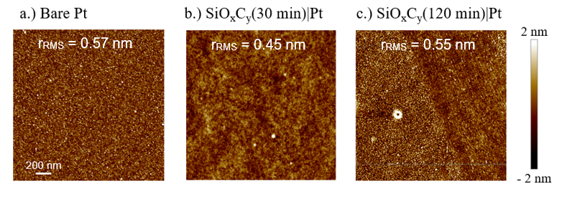
Figure S1. Representative AFM images of a.) an unencapsulated, bare Pt sample compared to encapsulated SiOxCy|Pt samples of 5 nm target thickness cured for b.) 30 minutes and c.) 120 minutes. Inset values represent the root mean squared roughness (r_{RMS}) for each individual sample.

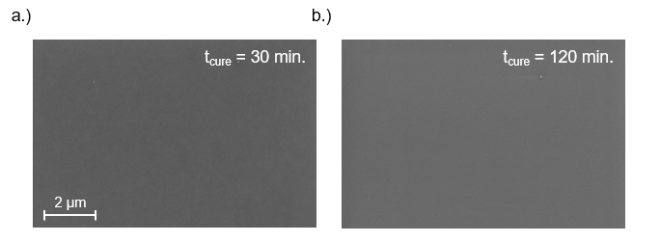
Figure S2. SEM images of Pt|SiO_{x}C_{y} samples that underwent a.) 30 minutes of and b.) 120 minutes of UV-ozone treatment. No defects or discernable differences in the surface morphology of these samples are seen in these images, further supporting that the electrodes are encapsulated by continuous SiO_{x}C_{y} overlayers. Images were acquired at 10,000X magnification using a beam voltage of 2.0 kV.

1.2 Contact Angle Measurements
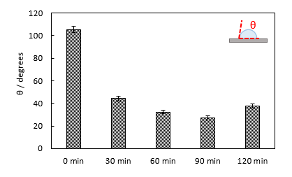
Figure S3. Contact angles with 10 µL of DI water. Inset figure depicts the measured angle relative to droplet and electrode surface.

1.3 Ellipsometry Measurements
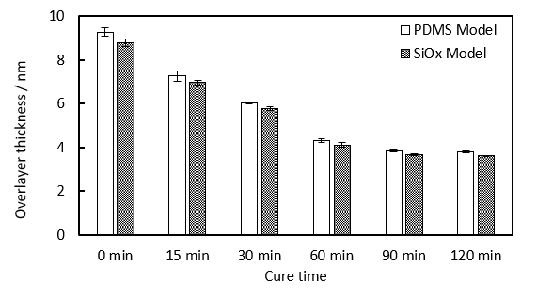
Figure S4. Ellipsometry determined thicknesses for SiO_{x}C_{y} overlayers for samples of varying cure time using models with optical constants derived for pure PDMS (n=1.39)^{[1]} and pure SiO₂ (n=1.44)^{[2]}. These results show that the SiO_{x}C_{y} thicknesses measured by ellipsometry are relatively insensitive to whether optical constants for the starting material (PDMS) or final material (SiO₂) are used to fit the raw data.

X-ray photoelectron spectroscopy (XPS) characterization

2.1 Description of XPS fitting procedures
XPS measurements were made with a Phi 5500 XPS system using a monochromatic Al Kα source (15 kV, 20 mA) with base pressure < 2x10⁻⁹ Torr. During all scans, possible surface charging was mitigated by supplying electrons via an overhead, low energy (≈1eV) electron beam to the insulating sample surface. Survey scans were first performed over the range of 0 eV to 1000 eV. Multiplex scans were then carried out over regions of interest (C 1s, O 1s, Si 2p, Pt 4f) with a step size of 0.05 eV, dwell time of 655 ms, and pass energy of 23.5 eV.
Multiplex scans were analyzed using XPSPEAK 4.1 software. A Shirley model was used to fit the background for all raw data, with peaks being fit using a Lorentzian-Gaussian profile. Pt 4f spectra was analyzed for a bare Pt control sample, with the 4f_{7/2} peak location of 71.2 eV and 4f_{5/2} peak location of 74.5 being in agreement with values reported for metallic Pt.^{[3]} All multiplex spectra for encapsulated samples were then shifted such that the Pt 4f_{7/2} peak for each respective sample was centered at 71.2 eV. Similarly, the ratios between the fitted Pt 4f_{5/2} to Pt 4f_{7/2} peak areas were confirmed to be 0.75 for the bare Pt control samples, and all subsequent fits for the encapsulated samples were then confined to this ratio. For all duplex peaks, FWHM values between were also set to be equivalent. Asymmetry factors of TS=0.2 and TL=60 were found to be suitable for fitting all multiplex spectra for all samples.
For the angle resolved XPS analysis, Si spectra were fit using 2 individual 1s peaks for the 30 min samples, with the peak location being constrained to 102.4 eV and 103.7, which is consistent with the determined peak location for an uncured PDMS sample, and the literature reported value for SiO2,^{[4]} respectively. Electrodes treated for 120 minutes were by contrast fit with only 1 peak, which provided the best fit across all sampling angles. %Lorentzian-Guassian distribution for each fitted peak at different sampling angles was found to not differ beyond 15% between the maximum and minimum %LG. Maximum full width half maximum (FWHM) values versus minimum FWHM values between all equivalent binding energy peaks also did not differ by more than 11%.
Integrated peak areas for each multiplex region were normalized by their respective atomic sensitivity factors (ASF)^{[5]} to calculate the atomic concentrations of each element in the near surface region of the SiO_{x}C_{y} electrodes. The normalized intensity of each element i was calculated as the ratio of intensity (I_{i}) divided by the element’s respective atomic sensitivity factor (ASF_{i}), which was then divided by the sum total normalized intensity $\left(\sum_{j}{\frac{I_{j}}{ASF_{j}}}\right)$ for all j elements, as shown in Equation 1.1:

$a_{i}=\frac{I_{i}/{ASF}_{i}}{\sum_{n}{I_{i}/{ASF}_{i}}}$ (1.1)

where n is the number of elements in the overlayer, I_{i} is the integrated XPS peak area for element I, and ASF_{i} is the atomic sensitivity factor for element i.^{[3]} C 1s contributions from adventitious carbonaceous adsorptions were not subtracted from the analysis, meaning that the reported atomic % C values overestimate the amount of carbon within the SiO_{x}C_{y} overlayers.

2.2 XPS Characterization of as-made SiO_{x}C_{y}|Pt Electrodes
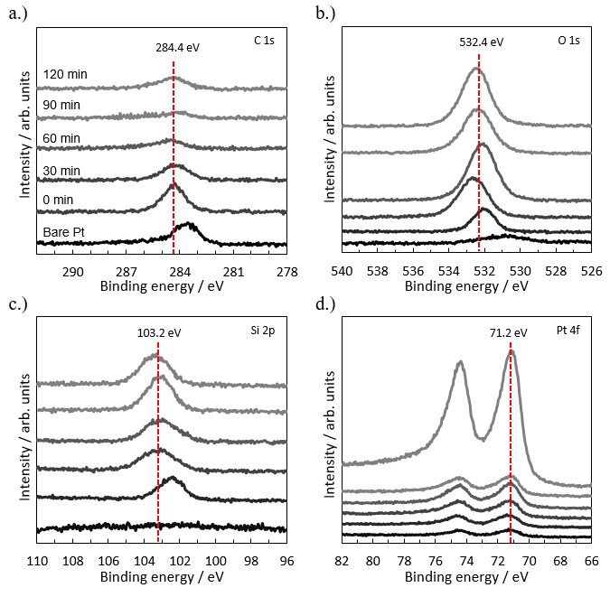
Figure S5. XPS spectra for samples undergoing UV-ozone treatment from 0 min (uncured PDMS) to 120 min (fully cured SiO_{x}). Figures depict a.) C1s spectra b.) O1s spectra c.) Si2p spectra and d.) Pt4f spectra. The color coding used for the labels for UV-ozone cure time provided in a.) also apply to the spectra in b.)-d.).

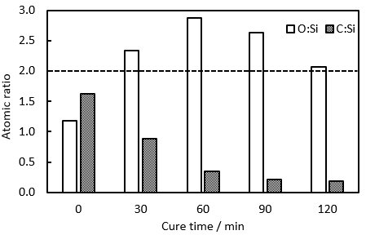

Figure S6. Atomic ratios calculated from XPS measurements of Oxygen and Carbon relative to Silicon for samples undergoing UV-ozone treatment from 0 min (uncured PDMS) to 120 min (fully cured SiO_{x}). The horizontal dashed line represents the expected O/Si ratio in pure SiO₂.

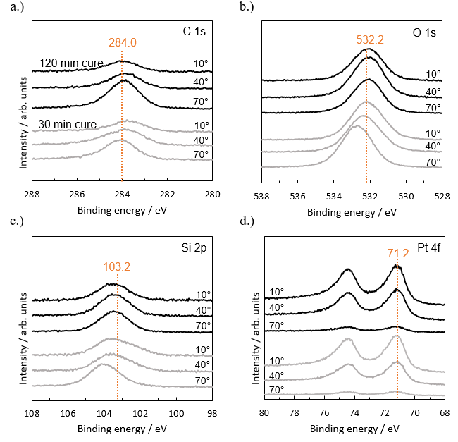
Figure S7 Angle Resolved XPS spectra for samples undergoing UV Ozone treatment for either 30 minutes (top spectra) or 120 minutes (bottom spectra) at different emission angles (70°, 40°, 10°), measured between the detector and the surface normal of the sample. Figures depict a.) C 1s spectra b.) O 1s spectra c.) Si 2p spectra and d.) Pt 4f spectra.

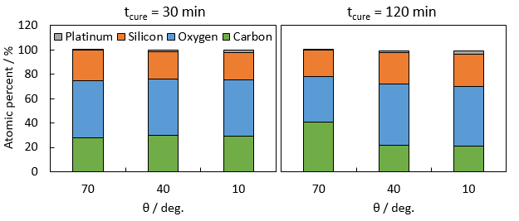
Figure S8 Atomic percent compositions of as-made SiO_{x}C_{y}|Pt electrodes calculated from ARXPS spectra, plotted for different emission angles (θ), for partially cured (t_{cure} = 30 min) and fully cured (t_{cure} = 120 min) SiO_{x}C_{y} overlayers. The emission angle is the angle between the detector and the surface normal of the sample.

Description of Overlayer Density Calculations
The gravimetric densities of SiO_{x}C_{y} overlayers were estimated based on i.) the initial and final overlayer thicknesses measured by ellipsometry and ii.) the average atomic composition of each overlayer measured by XPS using an emission angle of θ_{E} = 54.7° (described above). The atomic percentage (a_{i}) of each element i in the overlayer (i =C 1s, O 1s, or Si 2p) was calculated following the protocol outlined in section II using Equation 1.1. This calculation differs from the analysis described in ESI section 2.1 in that Pt 4f contributions were omitted to provide atomic distributions for species in the overlayer only. It should also be noted that this analysis ignores gradients in composition that exist within the overlayers. Atomic compositions were then converted to mass fractions (m_{i}) according to Equation 2.1:

$m_{i}=\frac{a_{i}∙{MW}_{i}}{\sum_{n}{a_{i}∙{MW}_{i}}}$ (2.1)

where MW_{i} is the molecular weight of element i in g mol⁻¹. Next, we assume that all Si atoms remain conserved during the UV-ozone conversion process (i.e. Si atoms in PDMS are only converted to SiO_{x} species and not volatilized), meaning that the total mass of Si in the overlayer does not change with cure time:

$m_{Si}∙M_{o }= m_{Si, 0}∙M_{o,t}$ (2.2)

where M_{o} is the total mass of the overlayer, m_{Si,0} is the initial mass fraction of Si in the PDMS precursor film, and M_{o,t} is the total mass of the PDMS precursor film. Because the total overlayer mass is related to overlayer density (ρ_{o}) and volume (V_{o}) by M_{o} = ρ_{o}∙V_{o}, and V_{o} is given by the product of the sample area and overlayer thickness (t_{o}), Equation (2.2) can be re-written as:

$m_{Si}∙ρ_{o }∙t_{o }= m_{Si, 0}∙ρ_{o,0}∙t_{o,0 }$ (2.3)

where the sample area does not show up because it does not change due to the UV-ozone process.
Finally, Equation (2.3) can be rearranged to solve for the overlayer density:

$ρ_{o }= \frac{m_{Si, 0}∙ρ_{o,0}∙t_{o,0 }}{m_{Si}∙t_{o }}$ (2.4)

where the initial (t_{o,0}) and final (t_{o}) overlayer thicknesses are measured by ellipsometry and the initial (m_{Si,0}) and final (m_{Si}) mass fractions of Si in the overlayer were determined by XPS. For this study, the initial density of the overlayer (ρ_{o}) was taken to be that of pure PDMS (ρ = 985 g cm⁻³).^{[6]}
Overlayer densities calculated using Equation (2.4) were also used to estimate average distance between nearest neighbor Si atoms within the SiO_{x}C_{y} overlayers (l_{Si-Si}). First, the average molar volume of Si within the SiO_{x}C_{y} overlayer (V_{Si}) was computed using Equation (2.5):

$V_{si}=\frac{{MW}_{Si}}{ρ_{o}∙m_{Si}}$ (2.5)

Dividing the computed molar volume of Si by Avogadro’s number (N_{A}) gives the average volume per Si atom. To compute the distance between neighboring Si atoms, we assumed that each Si atom is located at the center of a spherical volume element of volume V_{Si}/N_{A} in a simple cubic lattice arrangement. It then follows that the distance between Si atoms located in nearest-neighbor volume elements (l_{Si-Si}) is given by Equation (2.6):

$l_{Si-Si}=2{\left(\frac{πV_{Si}}{2}∙\frac{3}{4π}\right)}^{\frac{1}{3}}=\sqrt[3]{V_{Si}}$ (2.6)

The case presented above represents the minimum possible spacing between equal samples, however the closest possible spacing case was estimated for a system of spherical volume elements arranged in a hexagonal close packed lattice configuration. For this case, the total volume available for each respective Si atom was normalized by a packing factor, which represents the percentage of space occupied by spherical elements in a cubic unit cell. The diameter of each of these spherical elements was then determined in Equation 2.8, and represents a l_{Si-Si} distance 12% higher than the estimates for the cubic element packing case presented above.

$V_{si,s}=\frac{πV_{Si}}{3\sqrt{2}}$ (2.7)

$l_{Si-Si}=2∙\sqrt[3]{\frac{{3V}_{Si,s}}{4π}}$ (2.8)

As the exact orientation of the Si molecules in the overlayers were not quantitatively analyzed, Figure S9 below plots the permeability of each species (estimated using the correlations in section IV) against the average l_{Si-Si} distance from both Equation 2.6 and 2.8, with x-axis error bars representing the maximum and minimum possible spacing estimates.

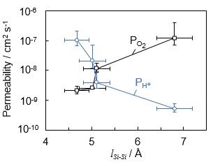
Figure S9. Calculated proton and oxygen permeabilities through SiO_{x}C_{y} overlayers plotted versus the minimum nearest neighbor Si-Si spacing (l_{Si-Si}), which was estimated based on the analysis described in the text accompanying this figure. The data points corresponding to the largest and smallest Si-Si spacing distances correspond to the samples based on the low- and high- cure time processing, respectively. X-axis error bars denote the maximum and minimum calculated Si-Si distance using, while y-axis error bars denote the estimates for permeability detailed in Section III.

Description of Permeability Calculations
The permeabilities of O₂ and H⁺ species through SiO_{x}C_{y} overlayers were determined from the mass transfer limited current density observed from the CV/LSV measurements of either HER or ORR in a standard electrochemical 3 neck flask under 200 rpm of stirring supplied by a Teflon stir bar. Electrodes were cut to be similar in size, and their location relative to the counter and reference electrode were kept consistent across all measurements. Permeability coefficients for this work were calculated following the methodology outlined in section II of reference 7,^{[7]} which is based on similar analysis from Bard and Faulkner.^{[8]} Key assumptions and equations are briefly restated in this section.

4.1 Calculating Mass Transport Coefficients for Bare Pt Electrodes
For an unencapsulated, planar bare Pt electrode, the flux of species j (N_{j}) can be described by the 1-dimensional form of the Nernst-Plank equation:

$N_{j}\left(x\right)= -D_{e,j }\frac{dC_{j}\left(x\right)}{dx}-\frac{z_{j}F}{RT}D_{e,j}C_{j} \frac{dΦ\left(x\right)}{dx}+C_{j}ν_{x}$ (4.1)

where D_{e,j} is the effective diffusion coefficient of j, C_{j}(x) is the concentration of species j at location x , z_{j} is the charge of species j, R is the ideal gas constant, T is the temperature in K, Φ(x) is the electrostatic potential at location x, and ν_{x} is the fluid velocity in the x direction. As depicted in Figure S10 below, we have defined x = 0 to correspond to the interface between the surface of the Pt catalyst and the bottom of the overlayer. When the current density is limited by mass transport across the diffusion boundary layer and there is excess supporting electrolyte, the migration and convection terms in Equation 4.1 are considered nonexistent or negligible, and Equation 4.2 can be simplified to give Fick’s law:

$N_{j}= -D_{e,j }\frac{dC_{j}}{dx}$ (4.2)

For steady state operation of the planar electrode, the differential continuity equation simplifies to give a linear concentration profile across the diffusion boundary layer such that the concentration gradient is a constant as shown in Figure S10. N_{j} can then be converted to current density using Faraday’s first law of electrolysis, as shown in Equation (4.3).^{[8]} When the current density is limited entirely by mass transfer, it is referred to as the limiting current (i_{lim}).

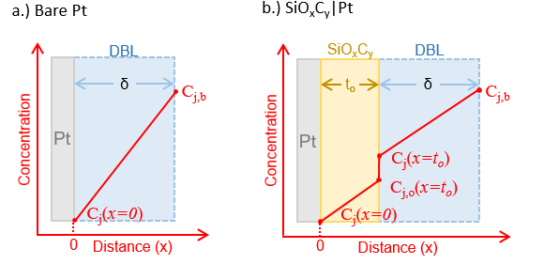

Figure S10. Schematic side-views of the steady-state concentration profiles for mass transport limiting conditions across an a.) unencapsulated, bare Pt electrode and b.) a Pt electrode encapsulated in an SiO_{x}C_{y} overlayer of thickness t_{o}. The electrodes are assumed to be planar and operated at steady state. In both schematics, δ is the thickness of the diffusion boundary layer in the bulk electrolyte.

For limiting current operation of a bare electrode, all of the concentration drop occurs across the diffusion boundary layer (DBL), and the concentration gradient term can be approximated as a finite difference that can be written in terms of the bulk concentration of species j, C_{j,b,} and the thickness of the DBL, δ:

$i_{lim}=\frac{{nFD}_{e,j}}{s_{j}}\frac{dC_{j}}{dx}≈\frac{{nFD}_{e,j}}{s_{j}}\frac{ΔC_{j}}{∆x}=\frac{nFD_{e,j}}{s_{j}}\left(\frac{C_{j}}{δ} \right)$ (4.3)

where s_{j} is the stoichiometric coefficient of species j, n is the stoichiometric number of electrons involved in the electrochemical reaction, and F is Faraday’s constant (96485 Coulombs mol⁻¹). In acidic conditions, the value for n is designated as 2 for hydrogen evolution, and 4 for oxygen reduction, assuming the complete reduction of oxygen to water, with little to current being directed towards the formation of peroxide byproducts, as is typically seen for polycrystalline Pt in acidic conditions.^{[9]} Rearranging Equation 4.3, the diffusion coefficient and δ can be combined to give the mass transfer coefficient, k_{c}, as shown in Equation 4.4:

$i_{lim}=\frac{nF}{s_{j}}\left(\frac{D_{e,j}}{δ} \right)C_{j, b}= \frac{nF}{s_{j}}∙k_{c}∙C_{j, b}$ (4.4)

In this work, experimentally-measured i_{lim} values for bare Pt electrodes, combined with the known bulk concentration of the limiting reactant, were used to compute values of k_{c}. For the experimental set-up and conditions used in this study, k_{c} values were calculated to be 7.0 ± 0.3 and 16.6 ± 0.9 × 10⁻³ cm² s⁻¹ for H⁺ (from HER experiments) and O₂ (from ORR experiments) diffusion across the DBL, respectively.

4.2 Calculating Permeability Coefficients for an SiO_{x}C_{y} Encapsulated Pt Electrode
For encapsulated electrodes, the limiting current density is affected not only by diffusion of electroactive species across the DBL, but also diffusion across the overlayer. As a result, concentration gradients develop across both layers, as depicted in Figure S10b. The flux of species j across the DBL (N_{j,DBL}) and overlayer (N_{j,o}) can be described by two different Fick’s law expressions based on the thickness and concentration drops across each respective layer:

$N_{j, DBL}=-D_{e,j}∙\frac{C_{j, b}-C_{j}\left(x=t_{O}\right)}{δ}=-k_{c}∙{(C}_{j, b}-C_{j}\left(x=t_{O}\right))$ (4.5)

$N_{j, o}=-D_{e,j}\frac{C_{j,o}\left(x=t_{O}\right)-0}{t_{O}}$ (4.6)

where c_{j,o} is the concentration of species j within the overlayer. To account for the differences in solubility of species j in the overlayer and the liquid electrolyte, a solubility parameter S_{j}, shown in Equation 4.7, can be introduced to relate C_{j}(x = t_{O}), the concentration of species j in liquid electrolyte phase at x = t_{O} to C_{j,o}(x = t_{O}), the concentration of species j within the overlayer on the other side of the interface.

$S_{j}=\frac{C_{j,o}\left(x=t_{O}\right)}{C_{j}\left(x=t_{O}\right)}$ (4.7)

Using Equation (4.7), Equation (4.6) can then be written in terms of S_{j}:

$N_{j, o}=-{S_{j}∙D}_{e,j}\frac{C_{j}\left(x=t_{O}\right)}{t_{O}}$ (4.8)

and by defining the permeability of species j as the product of S_{j} and D_{e,j}:

$N_{j, o}=-P_{j}\frac{C_{j}\left(x=t_{O}\right)}{t_{O}}$ (4.9)

At steady state, the flux of species j through the overlayer and the DBL must be equivalent, meaning that N_{j,DBL} = N_{j,o}. It then follows from Equation 4.2, 4.5, and 4.9 that the limiting current density for the encapsulated electrode, i_{lim,SiOx|Pt}, is given by:

$i_{lim,SiOx|Pt}=-\frac{nFk_{c}}{s_{j}}∙{(C}_{j, b}-C_{j}\left(x=t_{O}\right))=-\frac{nFP_{j}}{s_{j}}\frac{C_{j}\left(x=t_{O}\right)}{t_{O}}$ (4.10)

By rearranging the left-hand equality in Equation (4.10), the interfacial concentration of j in the liquid phase, C_{j}(x=t_{O}), can be calculated based on i.) the known value of C_{j,b}, ii.) the measured value of i_{lim,SiOx|Pt}, and iii.) the value of k_{c} that was determined for bare Pt as described above:

$C_{j}\left(x=t_{O}\right)=C_{j, b}+\frac{s_{j}∙i_{lim,SiOx|Pt}}{nFk_{c}}$ (4.11)

It is important to note that this analysis assumes that k_{c} is identical for both bare and encapsulated Pt electrodes, meaning that the limiting current densities for both electrodes must be measured under identical hydrodynamic conditions. Finally, the calculated value of c_{j}(x=t_{O}) is reinserted into Equation (4.10), which can be rearranged to solve for the parameter of interest, P_{j}:

$P_{j}=k_{c}∙t_{O}∙\frac{{(C}_{j, b}-C_{j}\left(x=t_{O}\right))}{C_{j}\left(x=t_{O}\right)}$ (4.12)

For all calculations reported in this study, the experimentally measured limiting current densities were taken as the difference between the limiting current densities recorded for the reaction of interest (i.e. ORR or HER) and the background current densities recorded with an identical ample in supporting electrolyte lacking the reactant species of interest. Limiting current densities were taken as an average across a potential range of 0.5 V to 0.2 V vs. RHE for ORR measurements and -0.2 V to -0.5 V vs. RHE for HER measurements. Species permeability was then calculated for samples of all different cure times, with the results presented below in Table S1.

Table S1. Calculated permeability coefficients for overlayers of various cure times. The given uncertainties represent 95% confidence intervals based on measurements for 3 different samples and obtained from error propagation analysis contributed by average estimates for limiting current densities as well as overlayer thicknesses.

Cure time / min | P_{O2} / cm² s⁻¹ | P_{H+} / cm² s⁻¹ | P_{H+/}P_{O2}
22.5 | 1.79 ± 0.06 × 10⁻⁷ | 5.91 ± 4.34 × 10⁻¹⁰ | 3.3 × 10⁻³
30 | 1.21 ± 0.84 × 10⁻⁷ | 5.22 ± 1.59 × 10⁻¹⁰ | 4.3 × 10⁻³
60 | 1.15 ± 0.40 × 10⁻⁸ | 3.88 ± 2.25 × 10⁻⁹ | 3.4 × 10⁻¹
90 | 2.52 ± 0.13 × 10⁻⁹ | 2.09 ± 1.46 × 10⁻⁸ | 8.3 × 10⁰
120 | 2.10 ± 0.59 × 10⁻⁹ | 1.03 ± 0.53 × 10⁻⁷ | 4.9 × 10¹

Supporting Electrochemical Measurements
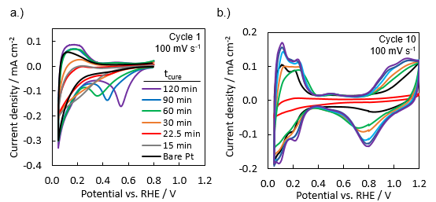
Figure S11. CV curves of SiO_{x}C_{y}|Pt electrodes of varying UV-ozone cure times taken in 0.5 M sulfuric acid for a.) the first cycle and b.) 10th cycles recorded at 100 mV s⁻¹ scan rate. The bare Pt sample did not undergo any UV-ozone treatment.

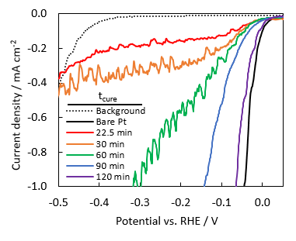
Figure S12. LSVs taken at 10 mV s⁻¹ in 5 mM H₂SO₄+ 495 mM Na₂SO₄ electrolyte stirred at 200 rpm, showing the mass transport limiting currents for Hydrogen evolution on SiO_{x}C_{y}|Pt electrodes of varying treatment times, specifically highlighting performance at low current densities. The dotted line represents a bare Pt electrode in the absence of protons (in pH 7 500 mM Na₂SO₄).
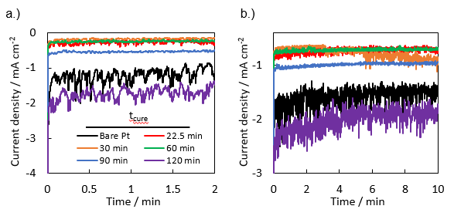
Figure S13. Chronoamperometry measurements showing steady state HER current at -0.1 V vs. RHE in 5 mM H₂SO₄ with 495 mM Na₂SO₄ supporting electrolyte under 200 rpm of stirring for samples of various curing time for a.) the first 2 minutes and b.) the full 10 minutes of measurement.

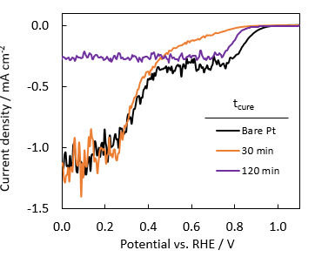
Figure S14. ORR LSVs taken at 10 mV s⁻¹ for the in O₂-sat. 0.1 mM H₂SO₄ + 499.9 mM Na₂SO₄ under 200 rpm of stirring for partially cured (t_{cure} = 30 minutes) and fully cured (t_{cure} = 120 minutes) SiO_{x}C_{y}|Pt electrodes.

5.1 Description and Analysis of Proton Limited Oxygen Reduction Experiments
To further examine the relative differences in O₂ and H⁺ transport between the partially and fully cured overlayers, oxygen reduction LSVs were performed in O₂-saturated 0.1 mM H2SO4 + 499.9 Na2SO4 electrolyte. This proton concentration was selected in order to induce a visible proton transport limited current by decreasing the diffusive flux across the diffusion boundary layer and the SiO_{x}C_{y} overlayer. As the overlayers that are fully cured display very different permeabilities for both oxygen and protons (Figures S12 & S13) compared to their partially cured counterparts, proton-limited ORR was characterized for a partially cured electrode (t_{cure} = 30 minutes) and a fully cured electrode (t_{cure} = 120 minutes).
In weakly acidic electrolyte, two different limiting regions will emerge in the LSV for a bare Pt electrode where oxygen reduction is limited by the availability of two different co-reactants. The first region occurs for potentials more negative than 0.8 V vs. RHE where proton-facilitated ORR, shown in Equation 5.1, becomes limited by proton transport in the high pH electrolyte.

$4H^{+}+4e^{-}+O_{2}↔{2H}_{2}O$ Eº = 1.23 V vs. NHE (5.1)

The second limiting current plateau can be observed for potentials less than 0.4 V vs. RHE, which is the standard reduction potential for water mediated ORR (Equation 5.2).:

$2H_{2}O+4e^{-}+O_{2}→4OH^{-}$ Eº = 0.40 V vs. NHE (5.2)

As water is ubiquitously supplied in the electrolyte, this second limiting current is reflective of the low oxygen solubility, which makes O₂ the limiting co-reactant for this reaction.
If ORR is not limited by the flux of water or proton mediators, and is instead limited by oxygen flux, only one limiting current will be observed, as both reactions are limited by the flux of the same co-reactant - oxygen. In Figure S14, both the unencapsulated and partially cured electrodes show two distinct limiting regions, with the partially cured electrode reaching the proton-limited current plateau more gradually than the bare Pt, as is similarly seen during proton limited HER. By contrast, the fully cured, 120-minute sample reaches a similar limiting current to that of bare Pt at higher potentials, but instead sustains this same value to more negative potentials without the emergence of a second limiting region. This indicates that the fully cured sample is not limited by the transport of co-reactants like protons and water, and instead the reaction rate is confined by the slow oxygen transport through the dense, SiO_{x}-like overlayer during ORR - even when proton availability in the electrolyte is scarce. Such a result demonstrates that the longer cured overlayers introduce much more substantial transport resistance for oxygen than for protons, where the opposite trend is observed for the partially cured overlayers

ESI References
[1] T. Roychowdhury, C. V. Cushman, R. A. Synowicki, M. R. Linford, Surf. Sci. Spectra 2018, 25, 026001.
[2] J. Kischkat, S. Peters, B. Gruska, M. Semtsiv, M. Chashnikova, M. Klinkmüller, O. Fedosenko, S. MacHulik, A. Aleksandrova, G. Monastyrskyi, Y. Flores, W. T. Masselink, Appl. Opt. 2012, 51, 6789.
[3] J. F. Moulder, W. F. Stickle, P. E. Sobol, K. D. Bomben, Handbook of X-Ray Photoelectron Spectroscopy, Physical Electronics, Inc., Eden Prairie, MN, 1995.
[4] R. Alfonsetti, L. Lozzi, P. Passacantando, P. Picozzi, S. Santucci, Appl. Surf. Sci. 1993, 70/71, 222.
[5] C. D. Wagner, L. E. Davis, M. V Zeller, J. A. Taylor, R. H. Raymond, L. H. Gale, Surf. Interface Anal. 1981, 3, 211.
[6] A. C. M. Kuo, in Polym. Data Handb., Oxford University Press, 1999, pp. 411–435.
[7] D. V. Esposito, ACS Catal. 2018, 8, 457.
[8] A. Bard, L. Faulkner, Electrochemical Methods, John Wiley & Sons, Inc., 2001.
[9] A. Gómez-Marín, J. Feliu, T. Edson, ACS Catal. 2018, 8, 7931.

