Arguing from Spectroscopic Evidence

Ryan L. Stowe*† and Melanie M. Cooper‡

† Department of Chemistry, University of Wisconsin – Madison, 1101 University Ave, Madison, Wisconsin 53706, United States

‡ Department of Chemistry, Michigan State University, 578 South Shaw Lane, East Lansing, Michigan 48824, United States

* Correspondence to: rstowe@chem.wisc.edu

Demographic and academic measures

Our threshold for significance in this study was a *p*-value ≤ 0.01

Table S1. Statistical analysis of academic measures for the three cohorts

|  |  |  |  |  |  |  |  |  |
| --- | --- | --- | --- | --- | --- | --- | --- | --- |
| Measure | Cohort | N | Mean | Median | Mann-Whitney U | z | p-value | Effect Size (r) |
| OC 1 Course Grade | Cohort A*i* | 100 | 3.6 | 4.0 | 4687.5 | -0.882 | 0.378 | - |
| Cohort B*ii* | 100 | 3.6 | 4.0 |
| Cohort A | 100 | 3.6 | 4.0 | 4304.5 | -1.858 | 0.063 | - |
| Cohort C*iii* | 100 | 3.4 | 3.5 |
| Cohort B | 100 | 3.6 | 4.0 | 4023.5 | -2.655 | 0.008 | 0.18 |
| Cohort C | 100 | 3.4 | 3.5 |
| ACT | Cohort A | 100 | 26.4 | 27 | 4661.5 | -0.233 | 0.816 | - |
| Cohort B | 100 | 26.2 | 27 |
| Cohort A | 100 | 26.4 | 27 | 3960.0 | -2.237 | 0.025 | - |
| Cohort C | 100 | 25.6 | 26 |
| Cohort B | 100 | 26.2 | 27 | 3864.5 | -2.370 | 0.018 | - |
| Cohort C | 100 | 25.6 | 26 |
| GPA prior to OC1 | Cohort A | 100 | 3.6 | 3.7 | 4846.0 | -0.377 | 0.706 | - |
| Cohort B | 100 | 3.6 | 3.7 |
| Cohort A | 100 | 3.6 | 3.7 | 4450.5 | -1.344 | 0.179 | - |
| Cohort C | 100 | 3.5 | 3.6 |
| Cohort B | 100 | 3.6 | 3.7 | 4618.0 | -0.934 | 0.350 | - |
| Cohort C | 100 | 3.5 | 3.6 |
| *i* Cohort A: Students who enrolled in two semesters of OCLUE during the 2016-2017 academic year *ii* Cohort B: Students who enrolled in two semesters of OCLUE during the 2017-2018 academic year *iii* Cohort C: Students who enrolled in two semesters of OCLUE during the 2018-2019 academic year | | | | | | | | |

prompts meant to engage students in analysis, interpretation, and use of spectroscopic evidence corresponding to unknowns a and b

The prompts below were meant to engage students in analysis, interpretation, and use of spectroscopic evidence to propose claims as to the identity of two unknowns. As part of addressing Research Question 4, students were randomly placed into two groups with one group receiving 3 spectroscopic traces corresponding to Unknown A (1H NMR, 13C NMR, and IR) and 2 traces corresponding to Unknown B (13C NMR, and IR), and the second group receiving 2 spectroscopic traces corresponding to Unknown A (13C NMR, and IR) and 3 traces corresponding to Unknown B (1H NMR, 13C NMR, and IR). We have reproduced the 3-trace variant of prompts related to both unknowns. The proton NMR spectrum was eliminated from the 2-trace version of each prompt, but they were otherwise identical.



**Figure S1.** A prompt meant to engage students in analysis, interpretation, and use of spectroscopic evidence corresponding to Unknown A.

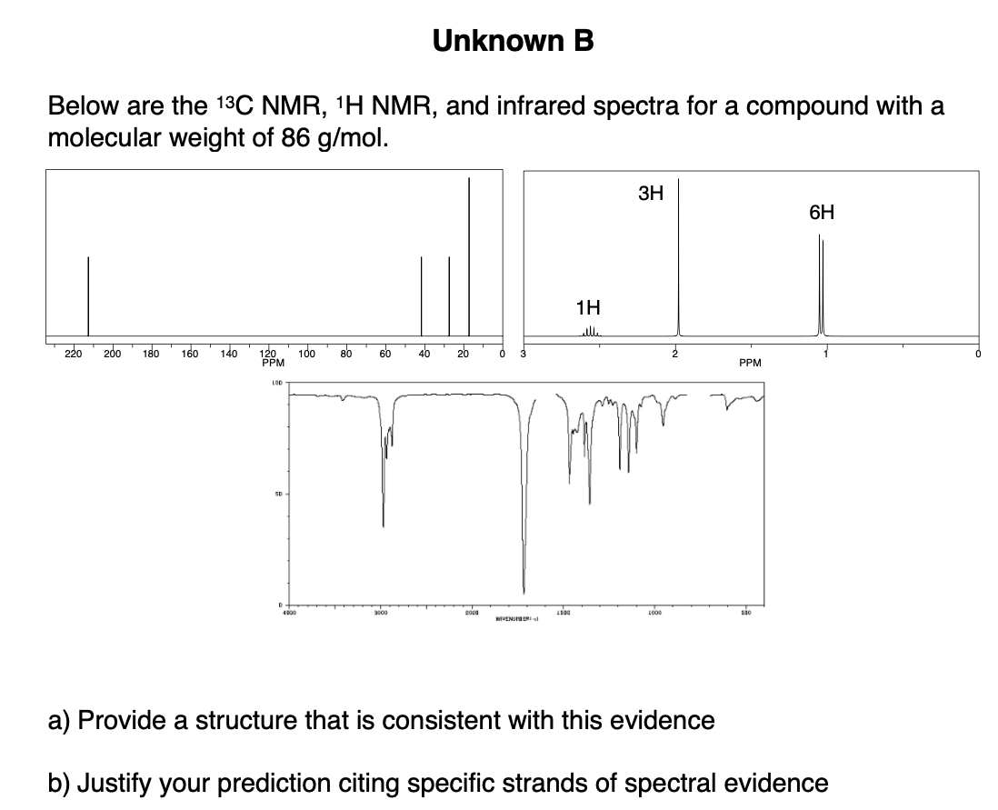

**Figure S2.** A prompt meant to engage students in analysis, interpretation, and use of spectroscopic evidence corresponding to Unknown B.