Azaphilone Alkaloids with Anti-inflammatory Activity from Fungus Penicillium sclerotiorum cib-411

Jia-Lin Tang,†,‡,§ Zong-Yuan Zhou,†,‡,§ Tao Yang,†,§ Can Yao,† Lin-Wei Wu,† and Guo-You Li†,*
†Key Laboratory of Environmental and Applied Microbiology, Environmental Microbiology Key Laboratory of Sichuan Province, Chengdu Institute of Biology, Chinese Academy of Sciences, Chengdu 610041, China.
‡University of Chinese Academy of Sciences, Beijing 100049, China.
* Telephone/Fax: +86-28-82890829. E-mail: ligy@cib.ac.cn (G.-Y. L.).

CONTENTS

Figure S1. The HRESIMS spectrum of penazaphilone A (1) .............................................................4
Figure S2. The ¹H NMR spectrum of penazaphilone A (1) ...............................................................5
Figure S3. The ¹³C NMR spectrum of penazaphilone A (1) ..............................................................6
Figure S4. The HSQC spectrum of penazaphilone A (1) ...................................................................7
Figure S5. The HMBC spectrum of penazaphilone A (1) ..................................................................8
Figure S6. CD spectrum of penazaphilone A (1) ................................................................................9
Figure S7. The HRESIMS spectrum of penazaphilone B (2) ...........................................................10
Figure S8. The ¹H NMR spectrum of penazaphilone B (2) ...............................................................11
Figure S9. The ¹³C NMR spectrum of penazaphilone B (2) .............................................................12
Figure S10. The HSQC spectrum of penazaphilone B (2) ................................................................13
Figure S11. The HMBC spectrum of penazaphilone B (2) ...............................................................14
Figure S12. CD spectrum of penazaphilone B (2) ............................................................................15
Figure S13. The HRESIMS spectrum of penazaphilone C (3) .........................................................16
Figure S14. The ¹H NMR spectra of penazaphilone C (3), (S)-, (R)-Mosher’s ester of 3..................17
Figure S15. The ¹³C NMR spectrum of penazaphilone C (3) ...........................................................18
Figure S16. The HSQC spectrum of penazaphilone C (3) ..............................................................19
Figure S17. The HMBC spectrum of penazaphilone C (3) ..............................................................20
Figure S18. The CD spectrum of penazaphilone C (3) .....................................................................21
Figure S19. The HRESIMS spectrum of penazaphilone D (4) .........................................................22
Figure S20. The ¹H NMR spectrum of penazaphilone D (4) ...........................................................23
Figure S21. The ¹³C NMR spectrum of penazaphilone D (4) ...........................................................24
Figure S22. The HSQC spectrum of penazaphilone D (4) ..............................................................25
Figure S23. The HMBC spectrum of penazaphilone D (4) ..............................................................26
Figure S24. The CD spectrum of penazaphilone D (4) .....................................................................27
Figure S25. The HRESIMS spectrum of penazaphilone E (5) ..........................................................28
Figure S26. The ¹H NMR spectrum of penazaphilone E (5) .............................................................29
Figure S27. The ¹³C NMR spectrum of penazaphilone E (5) ............................................................30
Figure S28. The HSQC spectrum of penazaphilone E (5) ................................................................30
Figure S29. The HMBC spectrum of penazaphilone E (5) ...............................................................32
Figure S30. The CD spectrum of penazaphilone E (5) .....................................................................33
Figure S31. The HRESIMS spectrum of penazaphilone F (6) ..........................................................34
Figure S32. The ¹H NMR spectrum of penazaphilone F (6) .............................................................35
Figure S33. The ¹³C NMR spectrum of penazaphilone F (6) ............................................................36
Figure S34. The HSQC spectrum of penazaphilone F (6) ................................................................37
Figure S35. The HMBC spectrum of penazaphilone F (6) ...............................................................38
Figure S36. The CD spectrum of penazaphilone F (6) ......................................................................39
Figure S37. The HRESIMS spectrum of penazaphilone G (7) .........................................................40
Figure S38. The ¹H NMR spectrum of penazaphilone G (7) ............................................................41
Figure S39. The ¹³C NMR spectrum of penazaphilone G (7) ...........................................................42
Figure S40. The HSQC spectrum of penazaphilone G (7) ................................................................43
Figure S41. The HMBC spectrum of penazaphilone G (7) ...............................................................44
Figure S42. The CD spectrum of penazaphilone G (7) .....................................................................45
Figure S43. The HRESIMS spectrum of penazaphilone H (8) .........................................................46
Figure S44. The ¹H NMR spectrum of penazaphilone H (8) ............................................................47
Figure S45. The ¹³C NMR spectrum of penazaphilone H (8) ...........................................................48
Figure S46. The HSQC spectrum of penazaphilone H (8) ................................................................49
Figure S47. The HMBC spectrum of penazaphilone H (8) ...............................................................50
Figure S48. The CD spectrum of penazaphilone H (8) .....................................................................51
Figure S49. The HRESIMS spectrum of penazaphilone I (9) ..........................................................52
Figure S50. The ¹H NMR spectrum of penazaphilone I (9) .............................................................53
Figure S51. The ¹³C NMR spectrum of penazaphilone I (9) ............................................................54
Figure S52. The HSQC spectrum of penazaphilone I (9) ................................................................55
Figure S53. The HMBC spectrum of penazaphilone I (9) ...............................................................56
Figure S54. The CD spectrum of penazaphilone I (9) ......................................................................57
Single Crystal X-ray Diffraction Data for Compound 8.................................................................58

Figure S1. The HRESIMS spectrum of penazaphilone A (1)

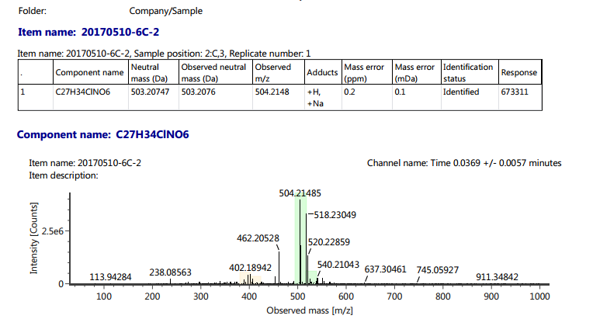

Figure S2. The ¹H NMR spectrum of penazaphilone A (1)

Figure S3. The ¹³C NMR spectrum of penazaphilone A (1)

Figure S4. The HSQC spectrum of penazaphilone A (1)

Figure S5. The HMBC spectrum of penazaphilone A (1)

Figure S6. CD spectrum of penazaphilone A (1)
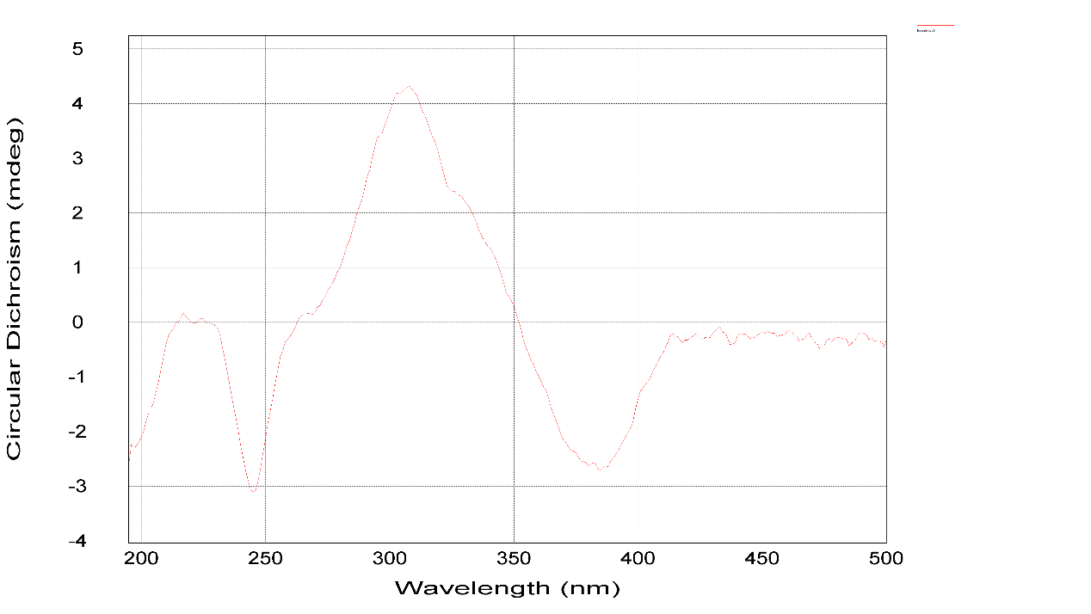
Figure S7. The HRESIMS spectrum of penazaphilone B (2)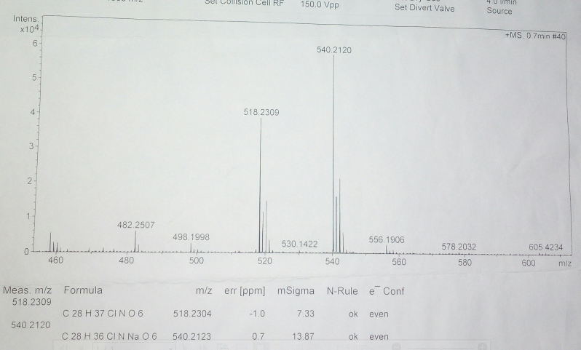
Figure S8. The ¹H NMR spectrum of penazaphilone B (2)

Figure S9. The ¹³C NMR spectrum of penazaphilone B (2)

Figure S10. The HSQC spectrum of penazaphilone B (2)

Figure S11. The HMBC spectrum of penazaphilone B (2)

Figure S12. CD spectrum of penazaphilone B (2)
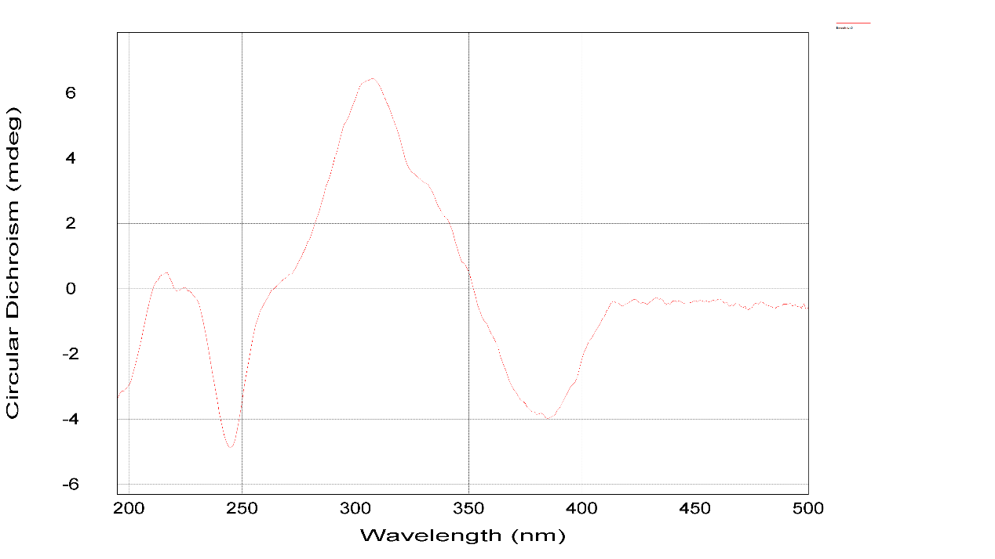
Figure S13. The HRESIMS spectrum of penazaphilone C (3)

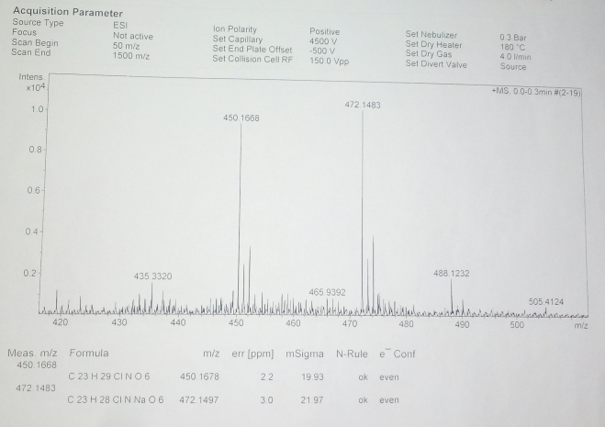

Figure S14. The ¹H NMR spectrum of penazaphilone C (3)
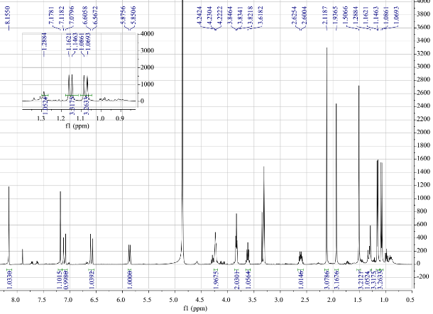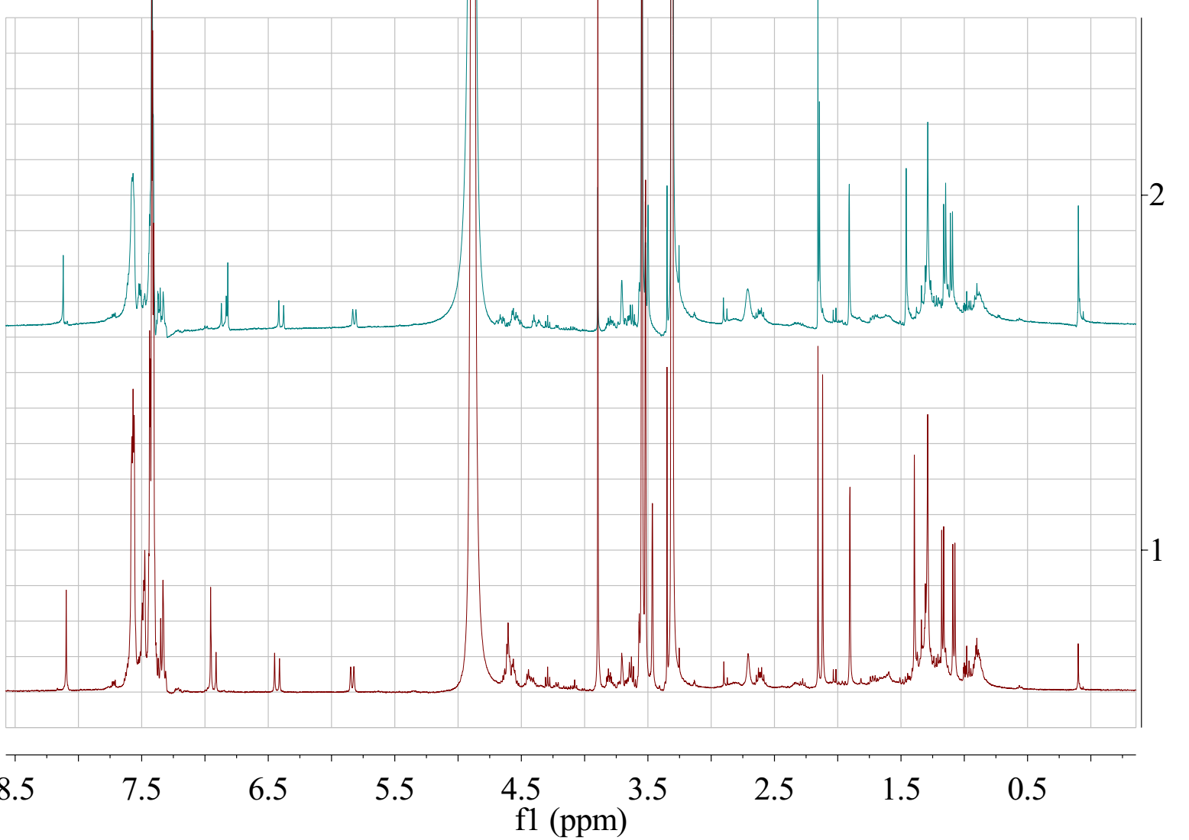
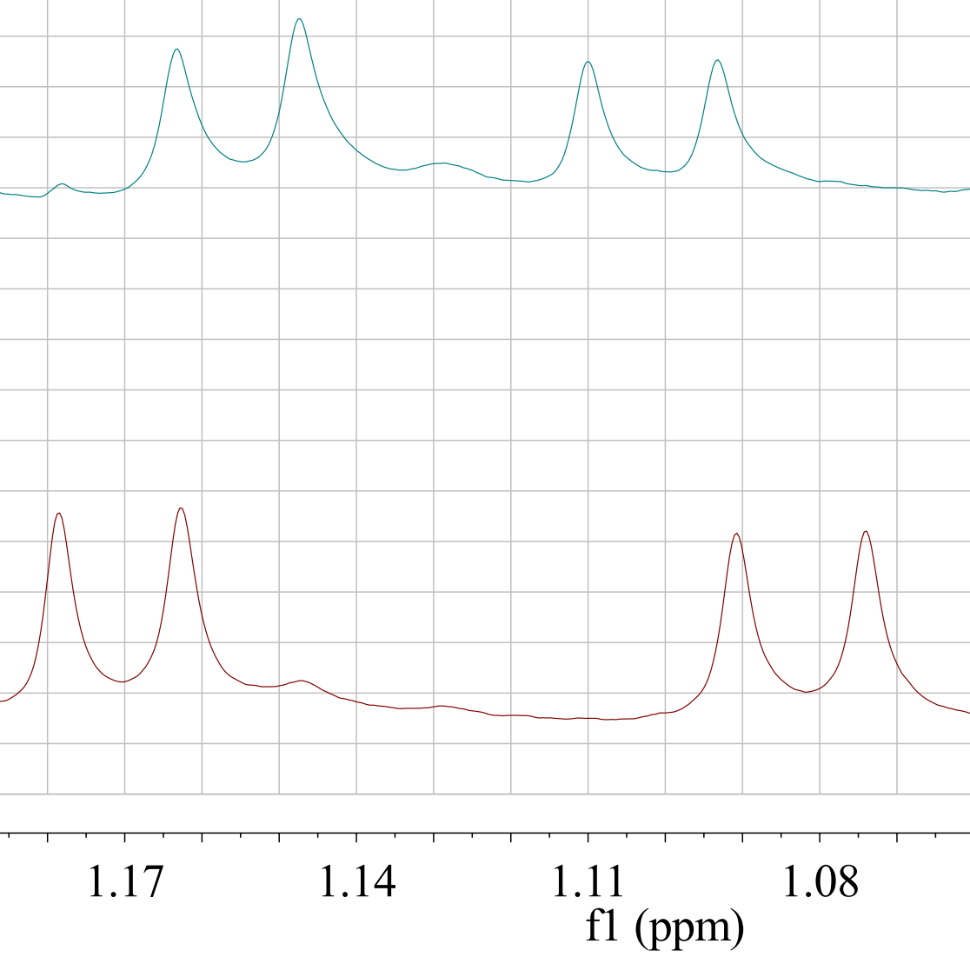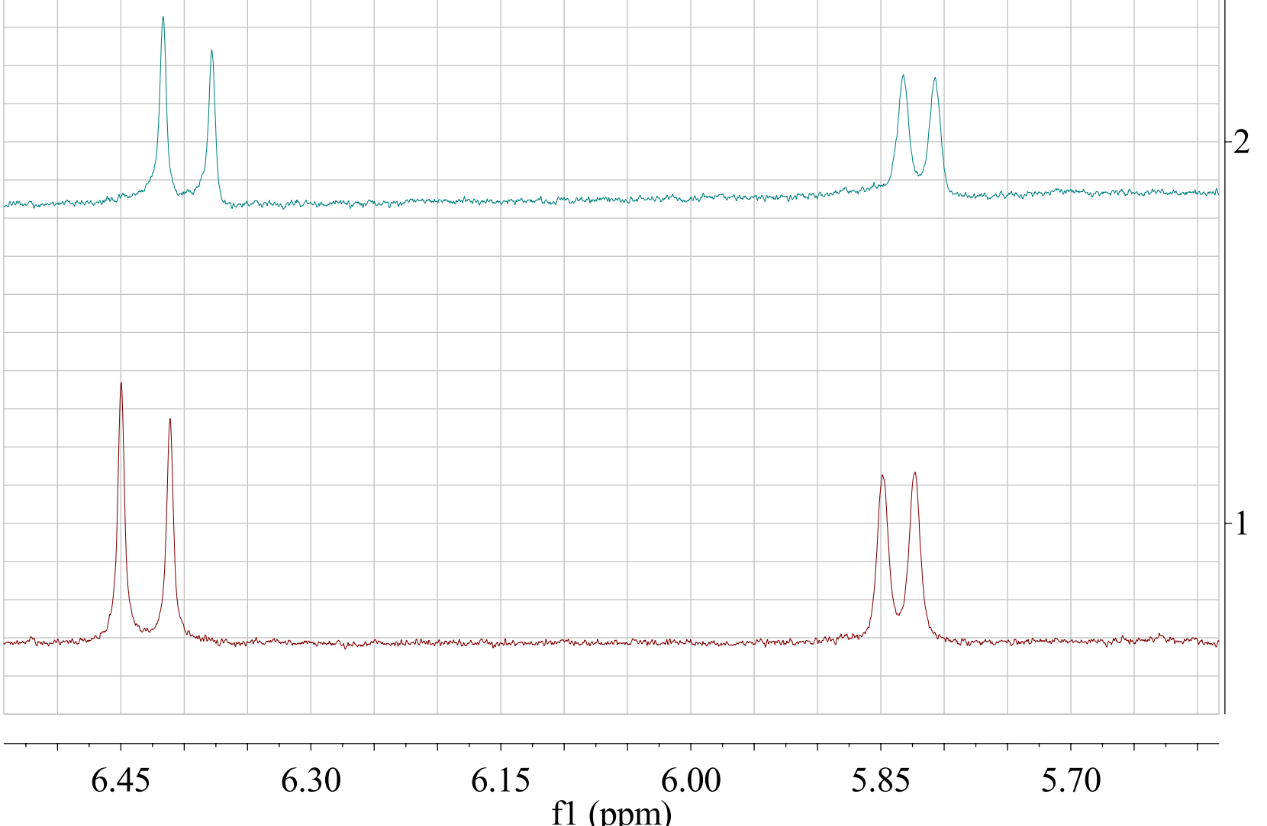

Figure S15. The ¹³C NMR spectrum of penazaphilone C (3)

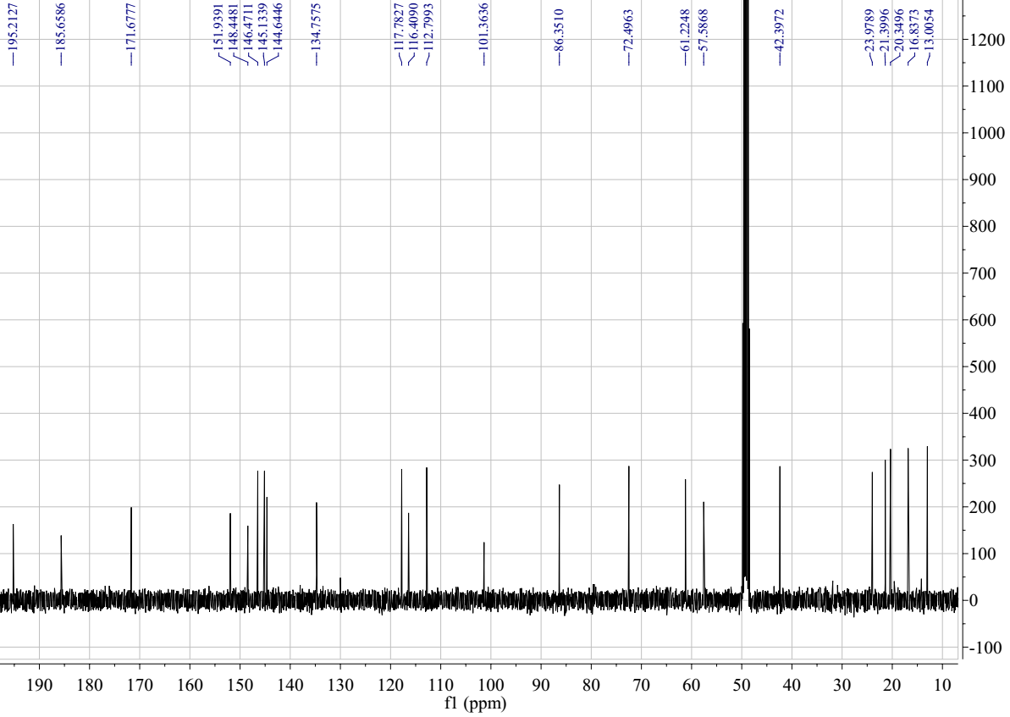

Figure S16. The HSQC spectrum of penazaphilone C (3)

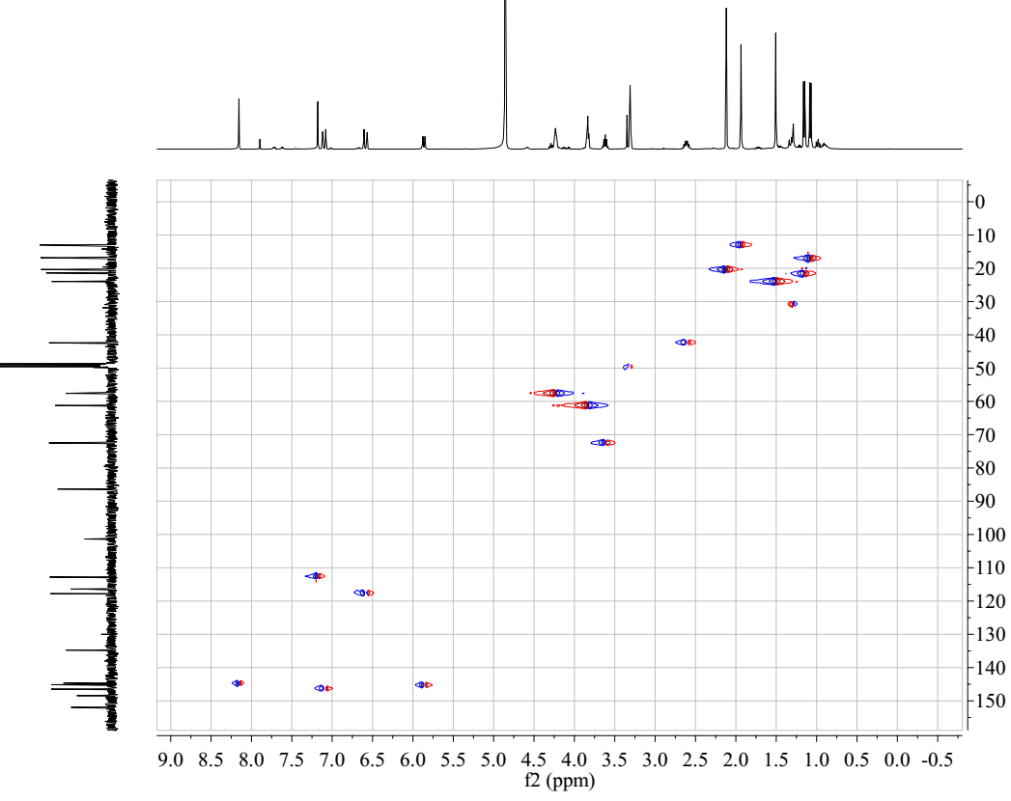

Figure S17. The HMBC spectrum of penazaphilone C (3)

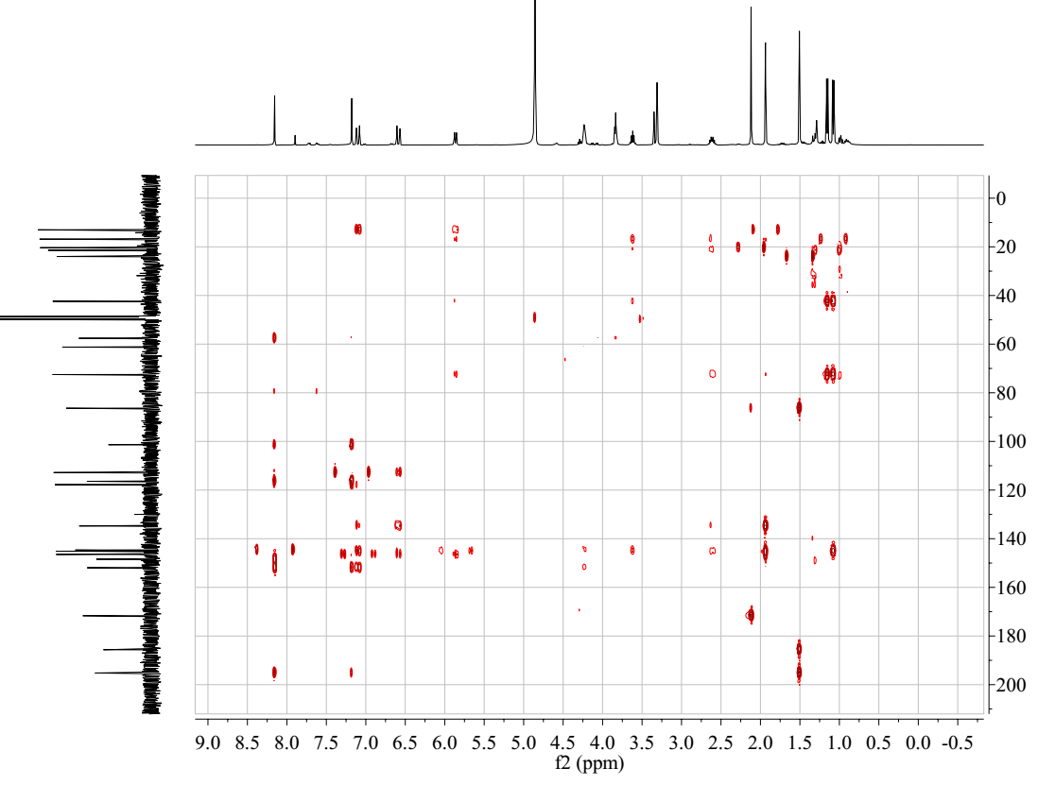

Figure S18. The CD spectrum of penazaphilone C (3)
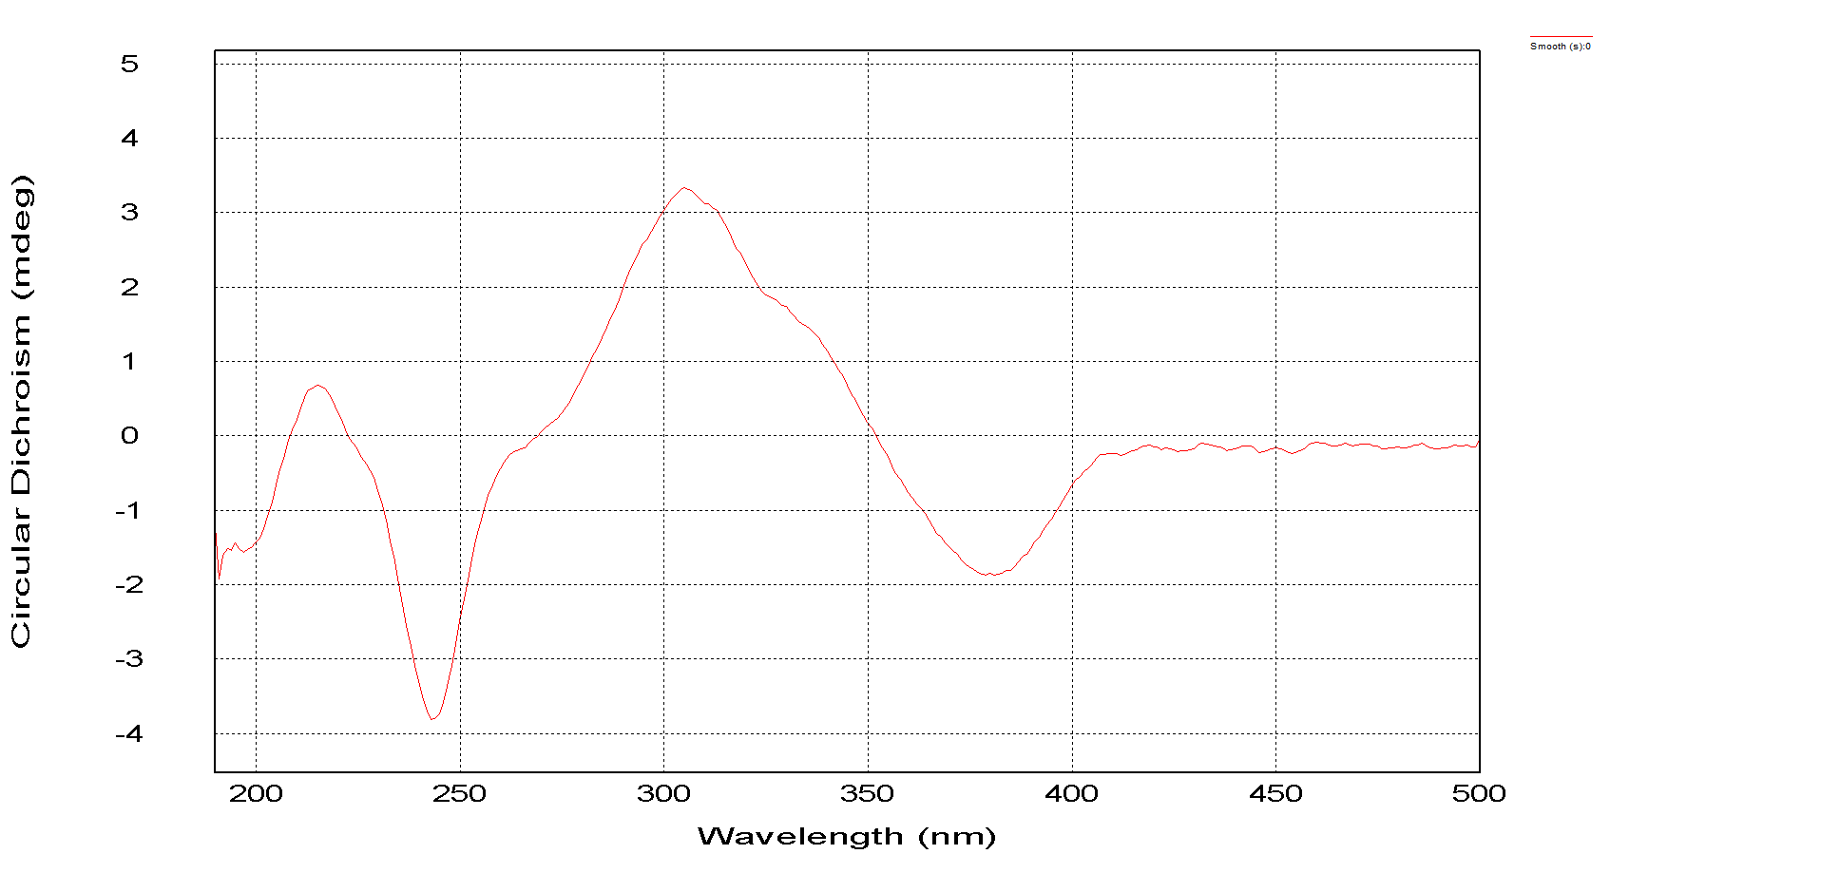
Figure S19. The HRESIMS spectrum of penazaphilone D (4)

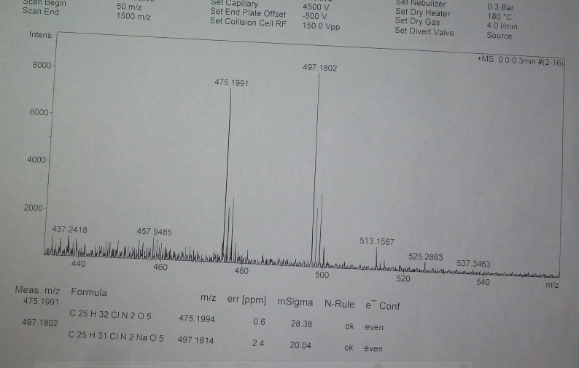

Figure S20. The ¹H NMR spectrum of penazaphilone D (4)

Figure S21. The ¹³C NMR spectrum of penazaphilone D (4)

Figure S22. The HSQC spectrum of penazaphilone D (4)

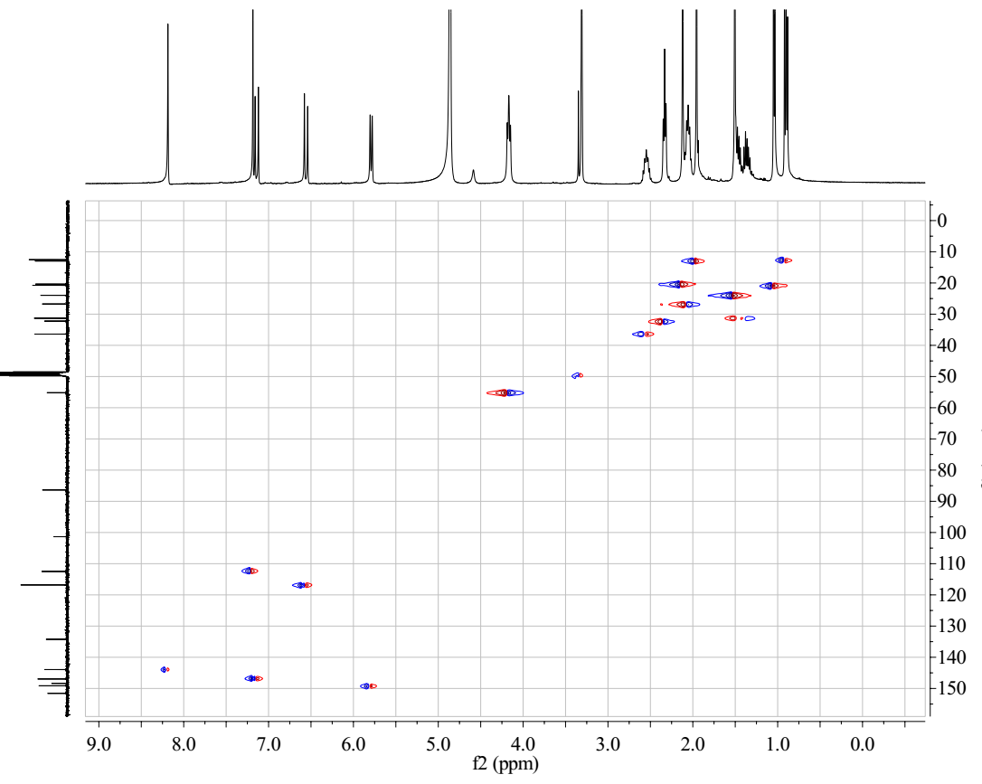

Figure S23. The HMBC spectrum of penazaphilone D (4)

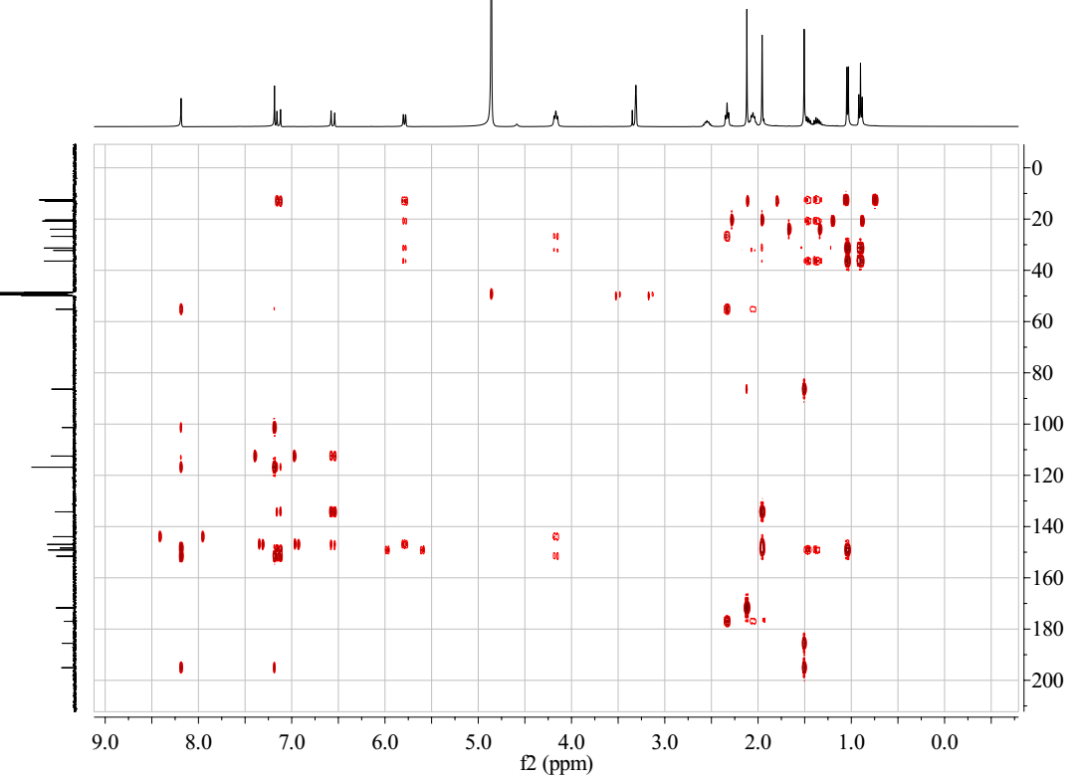

Figure S24. The CD spectrum of penazaphilone D (4)
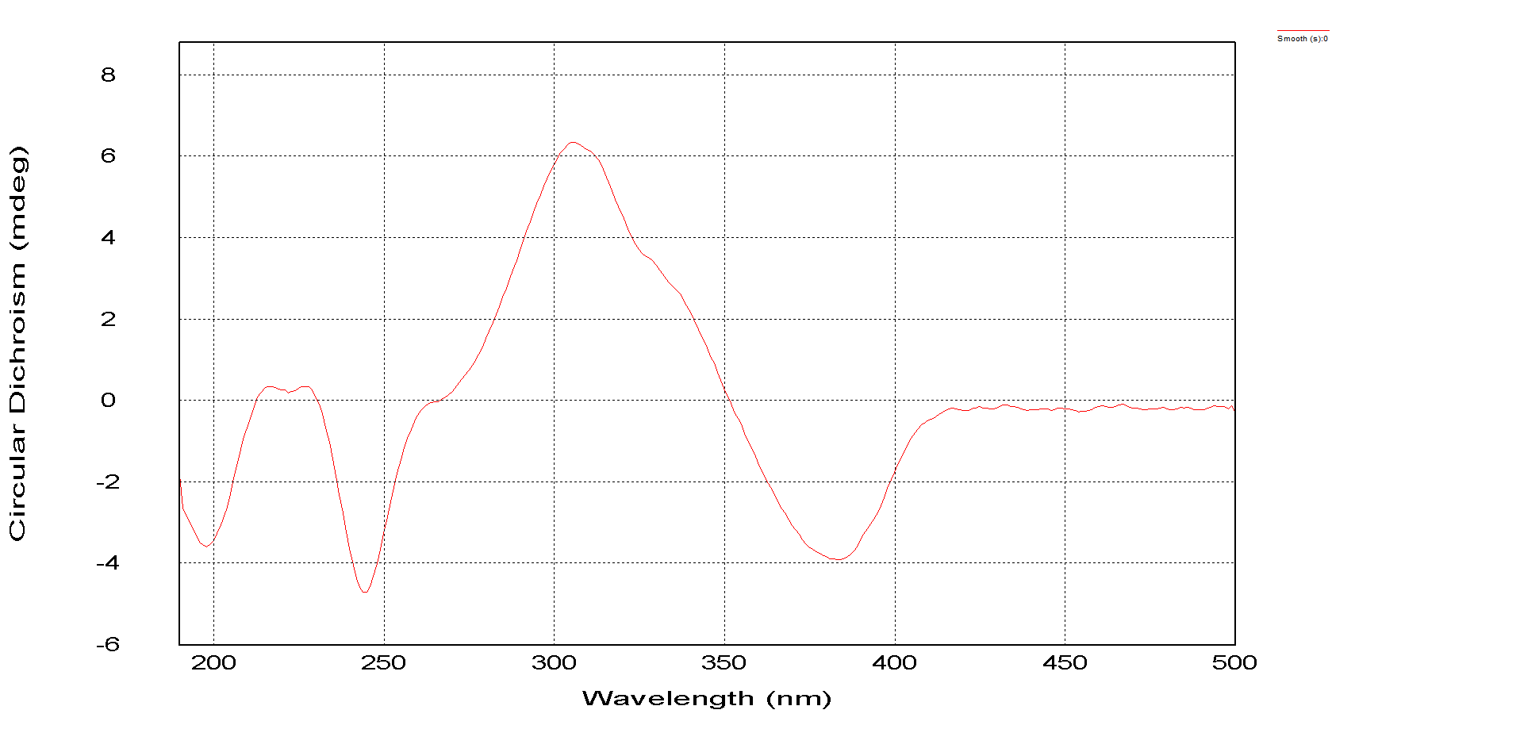
Figure S25. The HRESIMS spectrum of penazaphilone E (5)

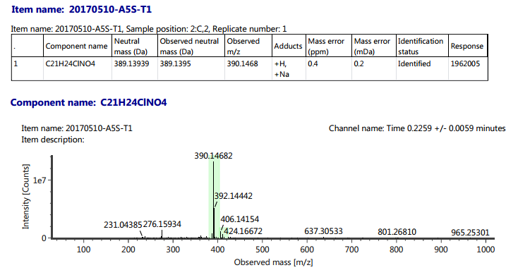

Figure S26. The ¹H NMR spectrum of penazaphilone E (5)

Figure S27. The ¹³C NMR spectrum of penazaphilone E (5)

Figure S28. The HSQC spectrum of penazaphilone E (5)

Figure S29. The HMBC spectrum of penazaphilone E (5)

Figure S30. The CD spectrum of penazaphilone E (5)
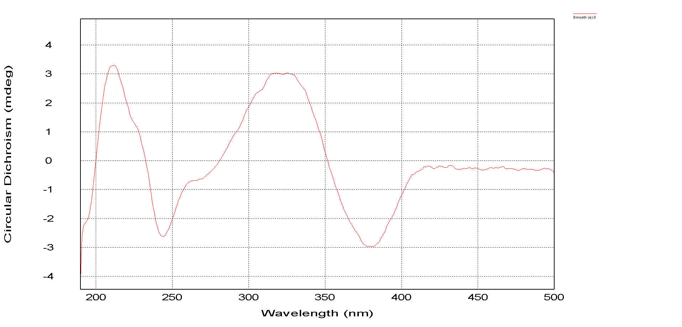
Figure S31. The HRESIMS spectrum of penazaphilone F (6)

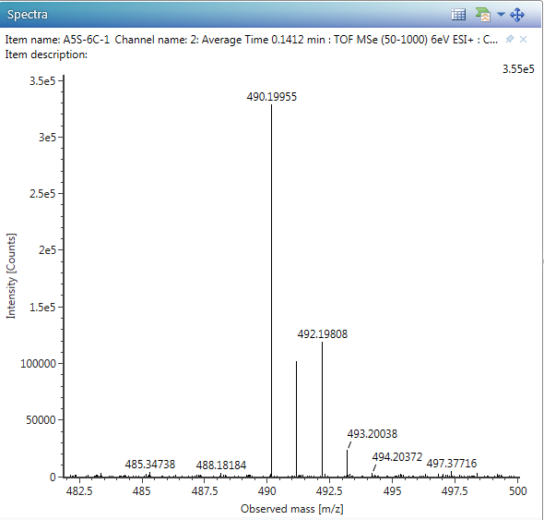
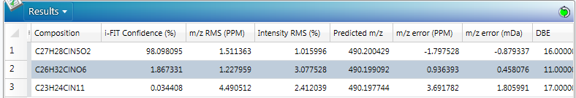

Figure S32. The ¹H NMR spectrum of penazaphilone F (6)

Figure S33. The ¹³C NMR spectrum of penazaphilone F (6)

Figure S34. The HSQC spectrum of penazaphilone F (6)

Figure S35. The HMBC spectrum of penazaphilone F (6)

Figure S36. The CD spectrum of penazaphilone F (6)
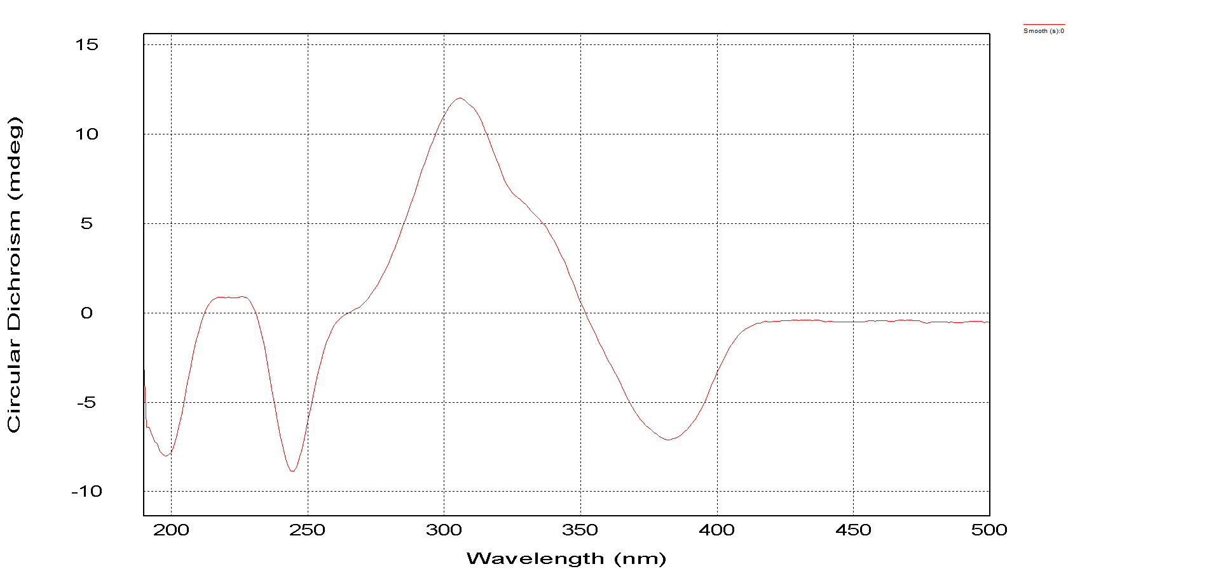
Figure S37. The HRESIMS spectrum of penazaphilone G (7)
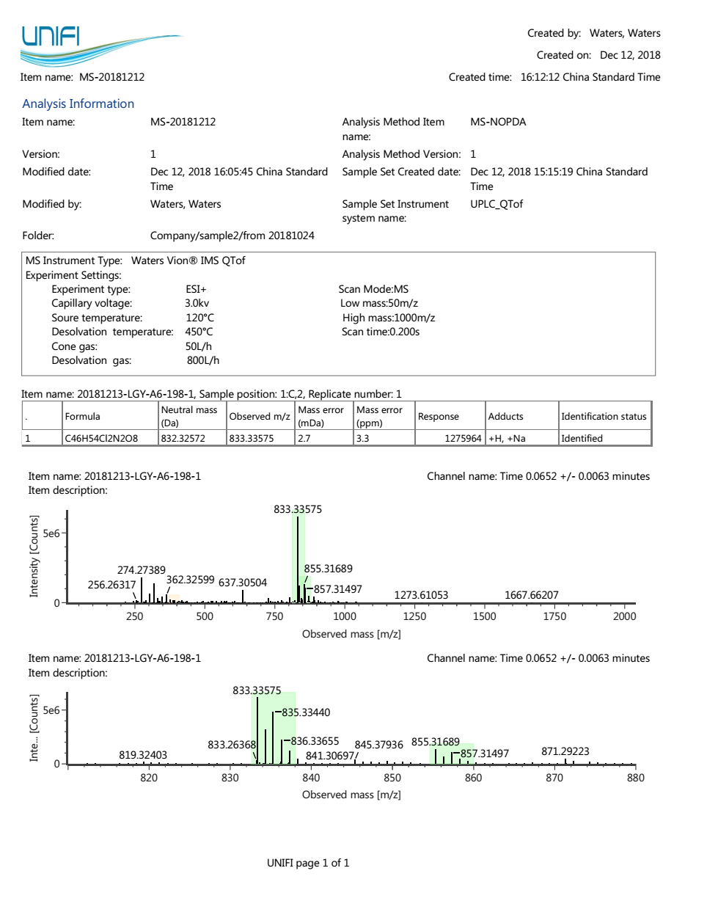

Figure S38. The ¹H NMR spectrum of penazaphilone G (7)
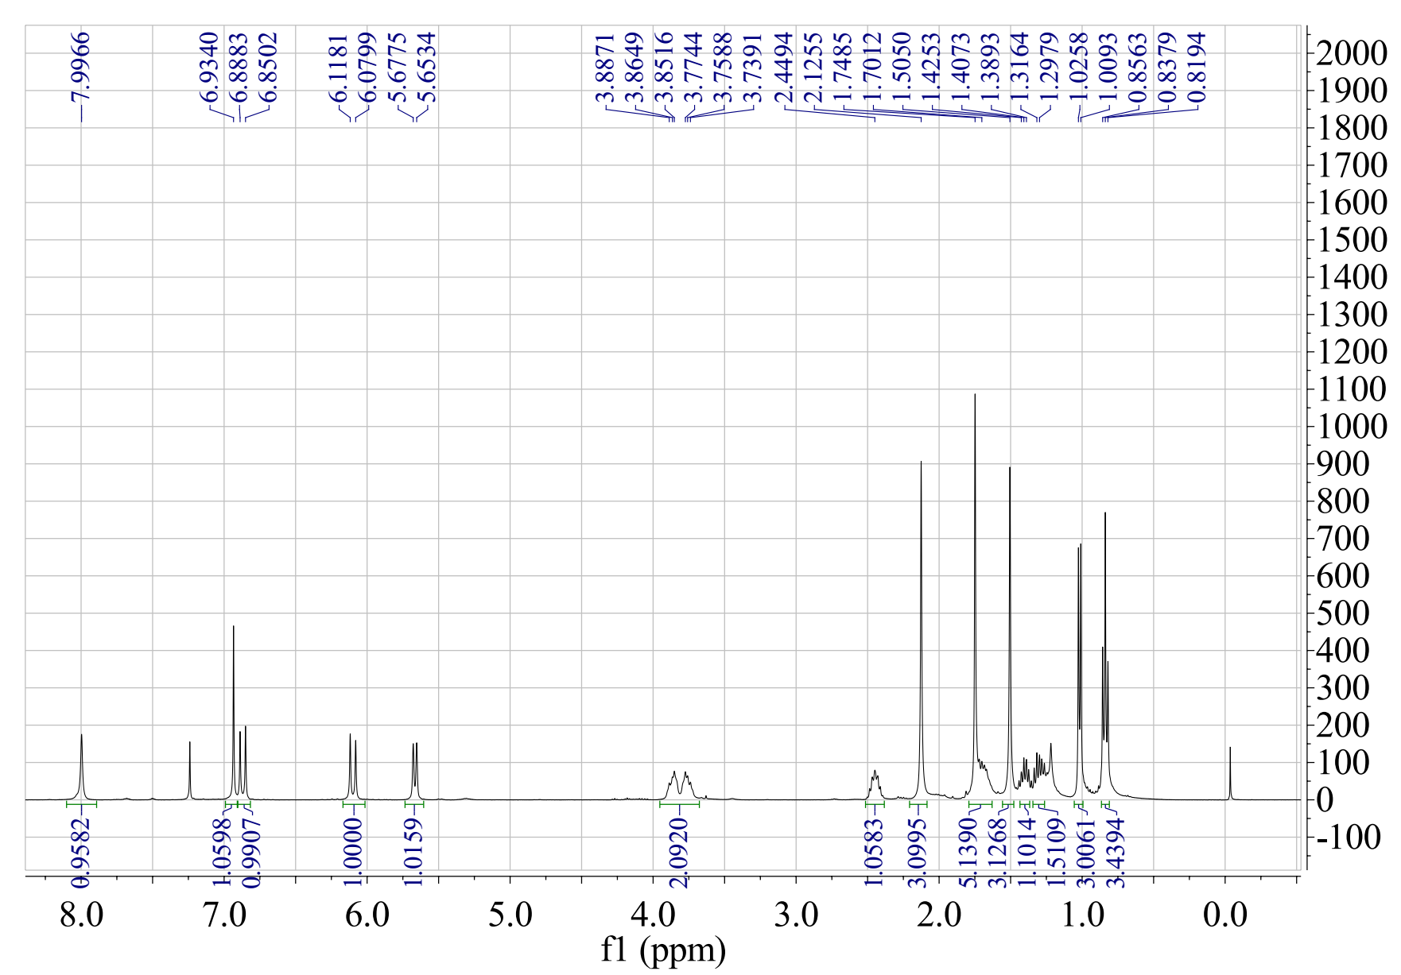

Figure S39. The ¹³C NMR spectrum of penazaphilone G (7)
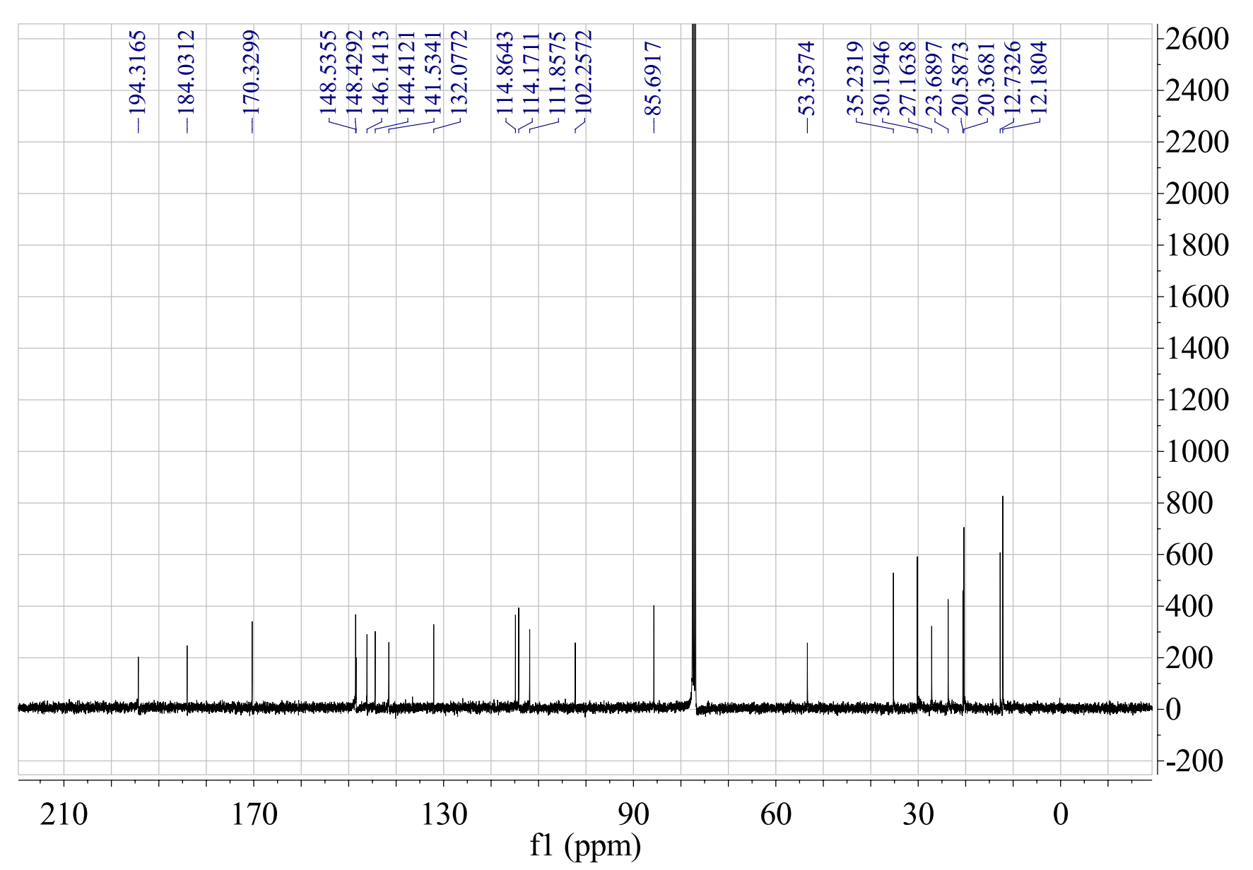

Figure S40. The HSQC spectrum of penazaphilone G (7)
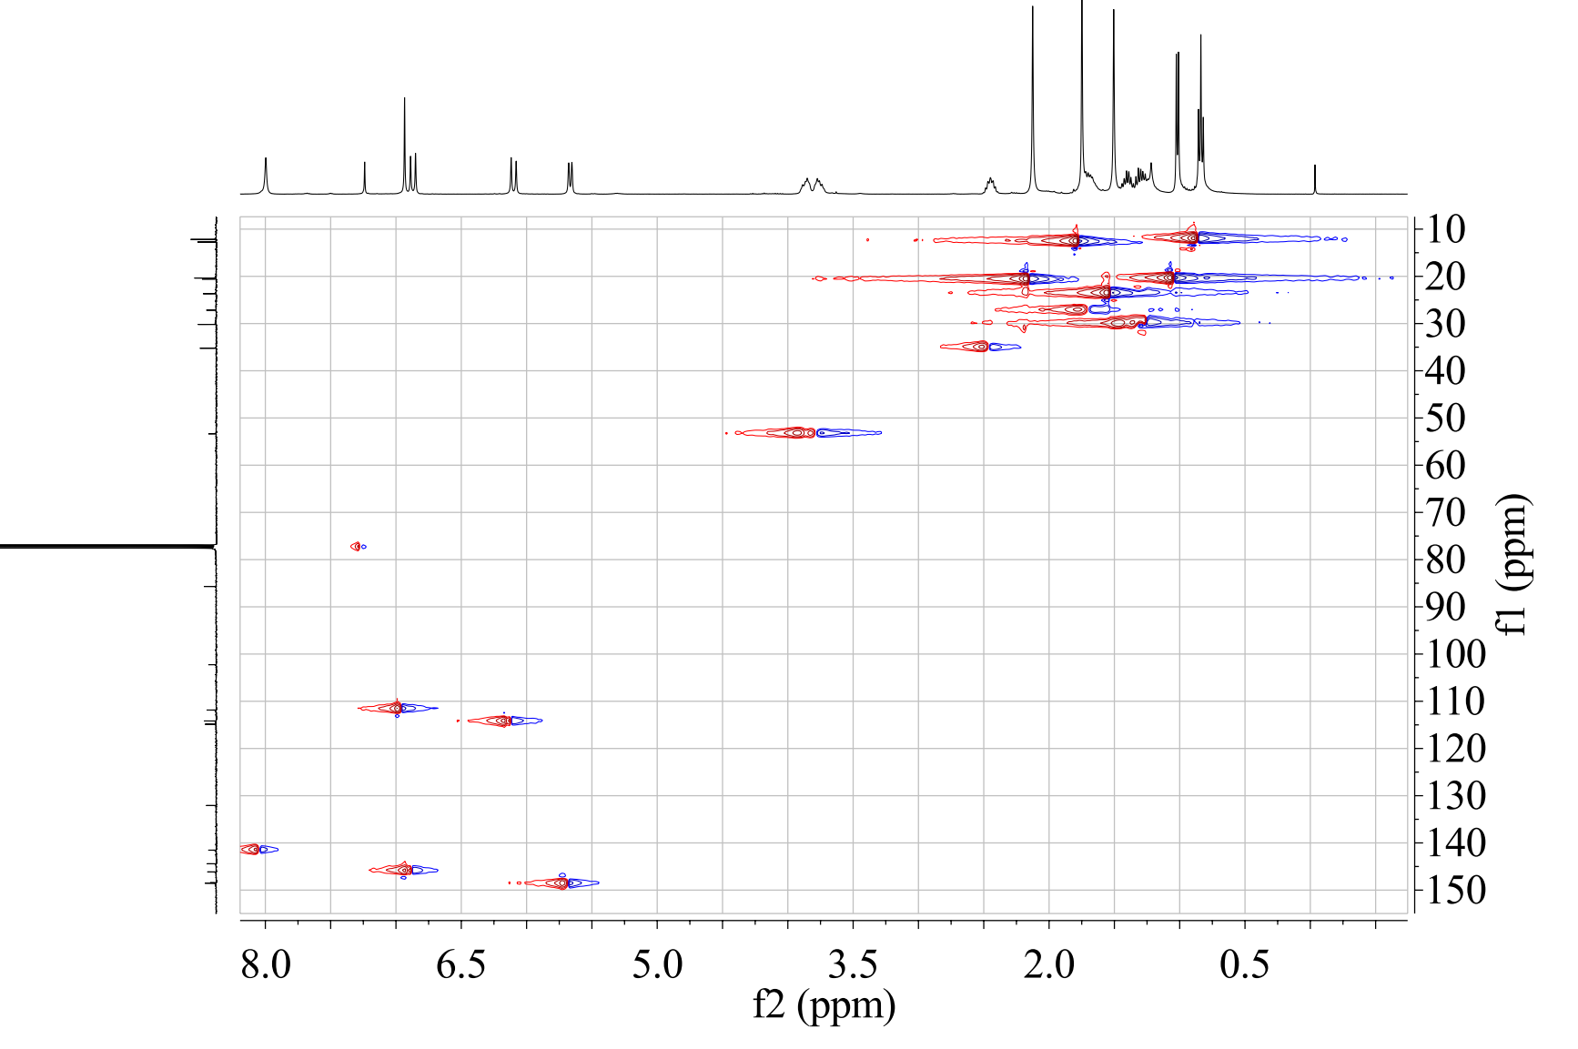

Figure S41. The HMBC spectrum of penazaphilone G (7)
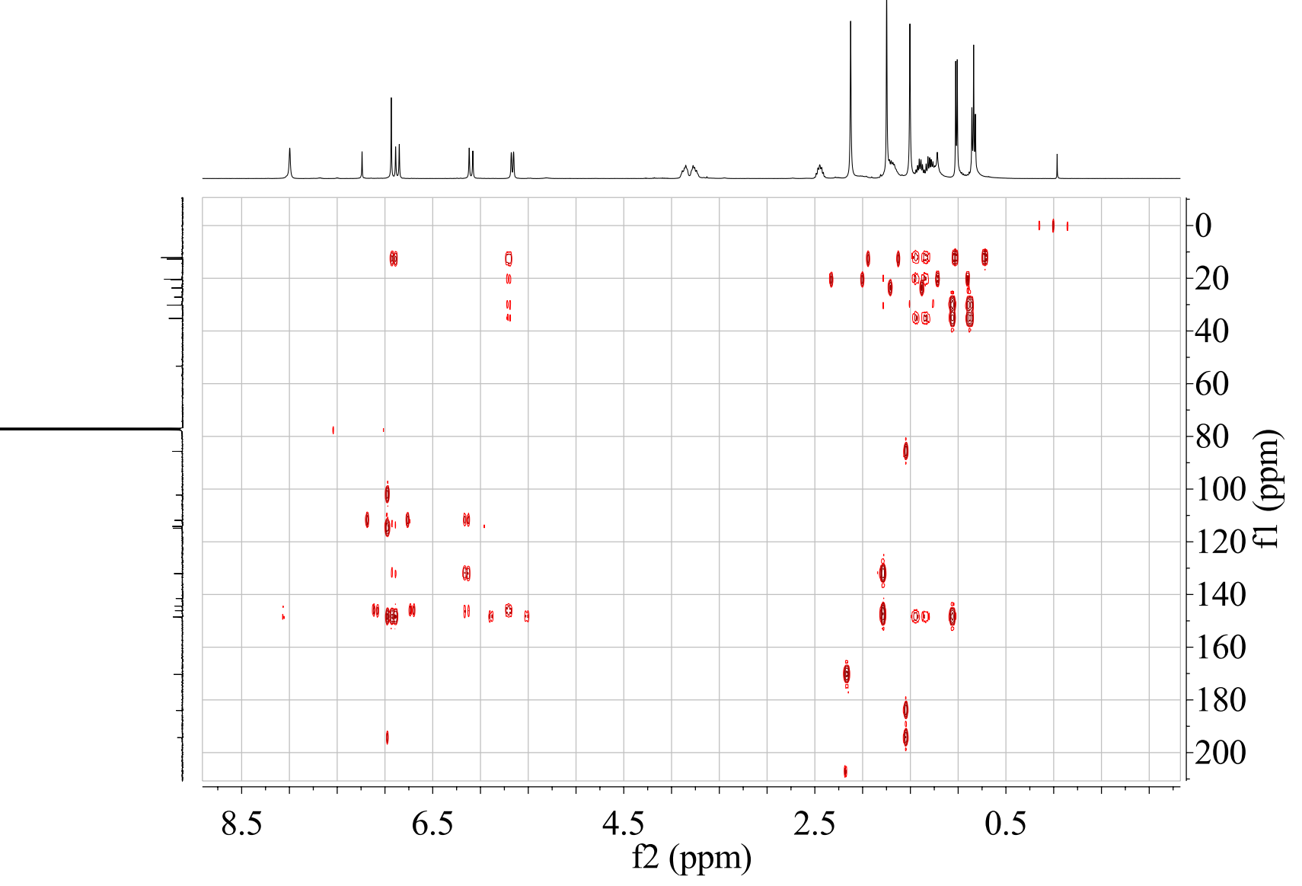

Figure S42. The CD spectrum of penazaphilone G (7)
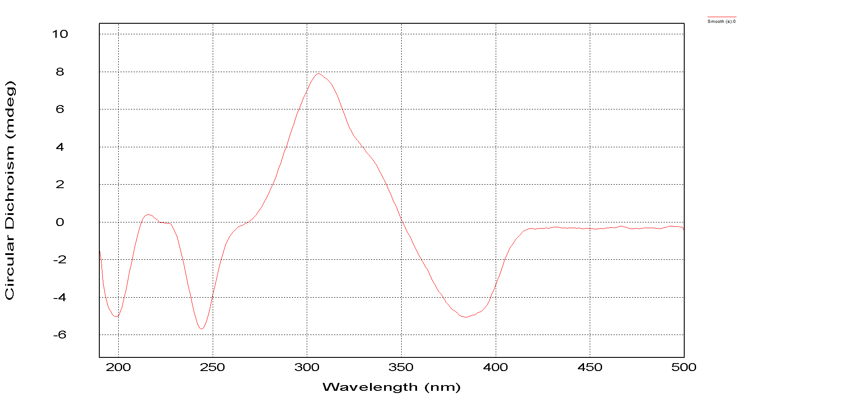

Figure S43. The HRESIMS spectrum of penazaphilone H (8)
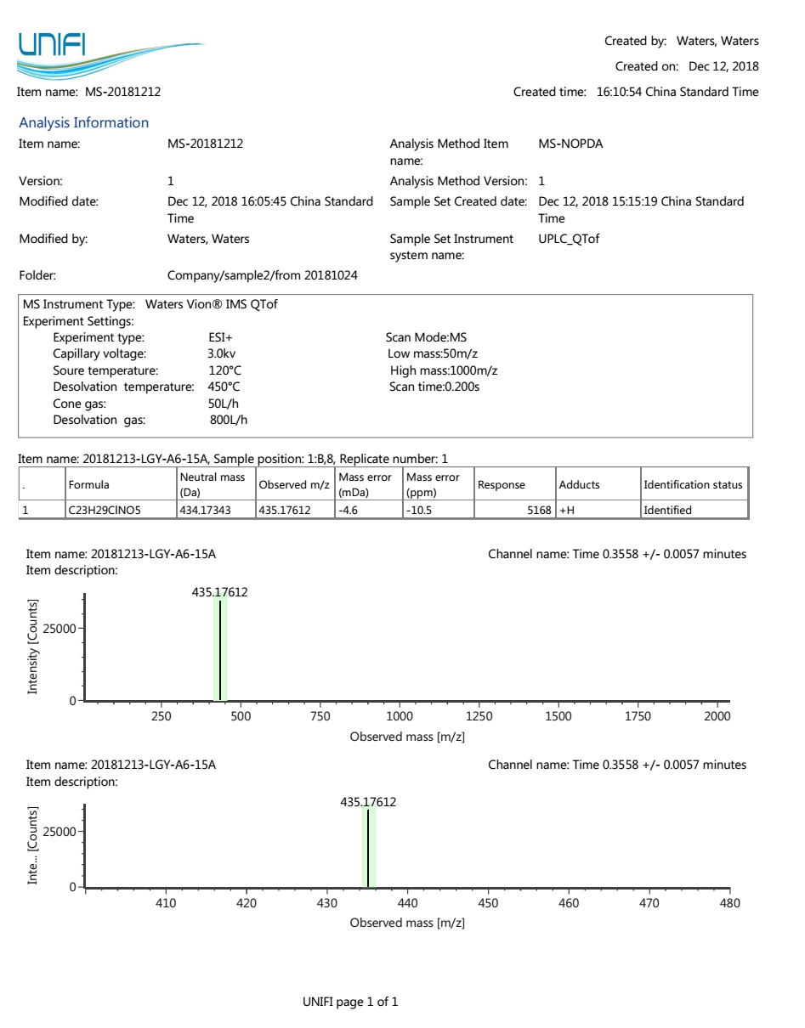
Figure S44. The ¹H NMR spectrum of penazaphilone H (8)
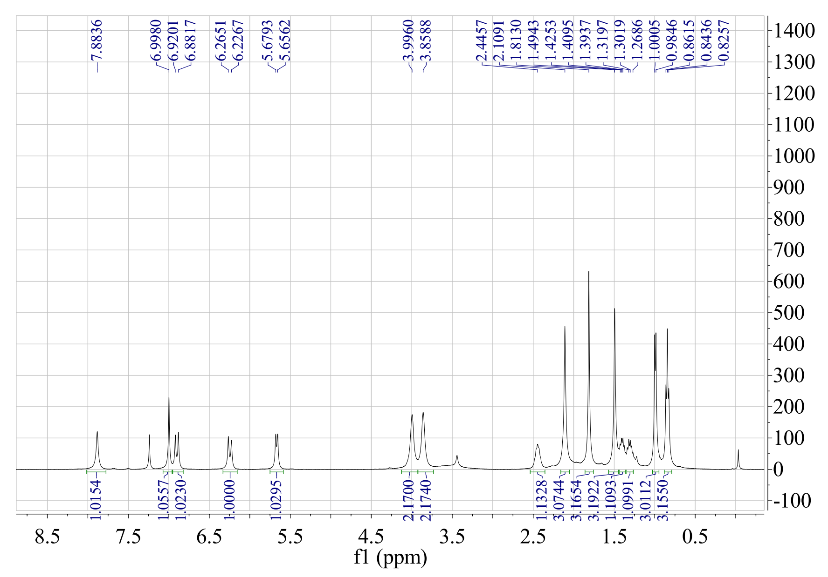

Figure S45. The ¹³C NMR spectrum of penazaphilone H (8)
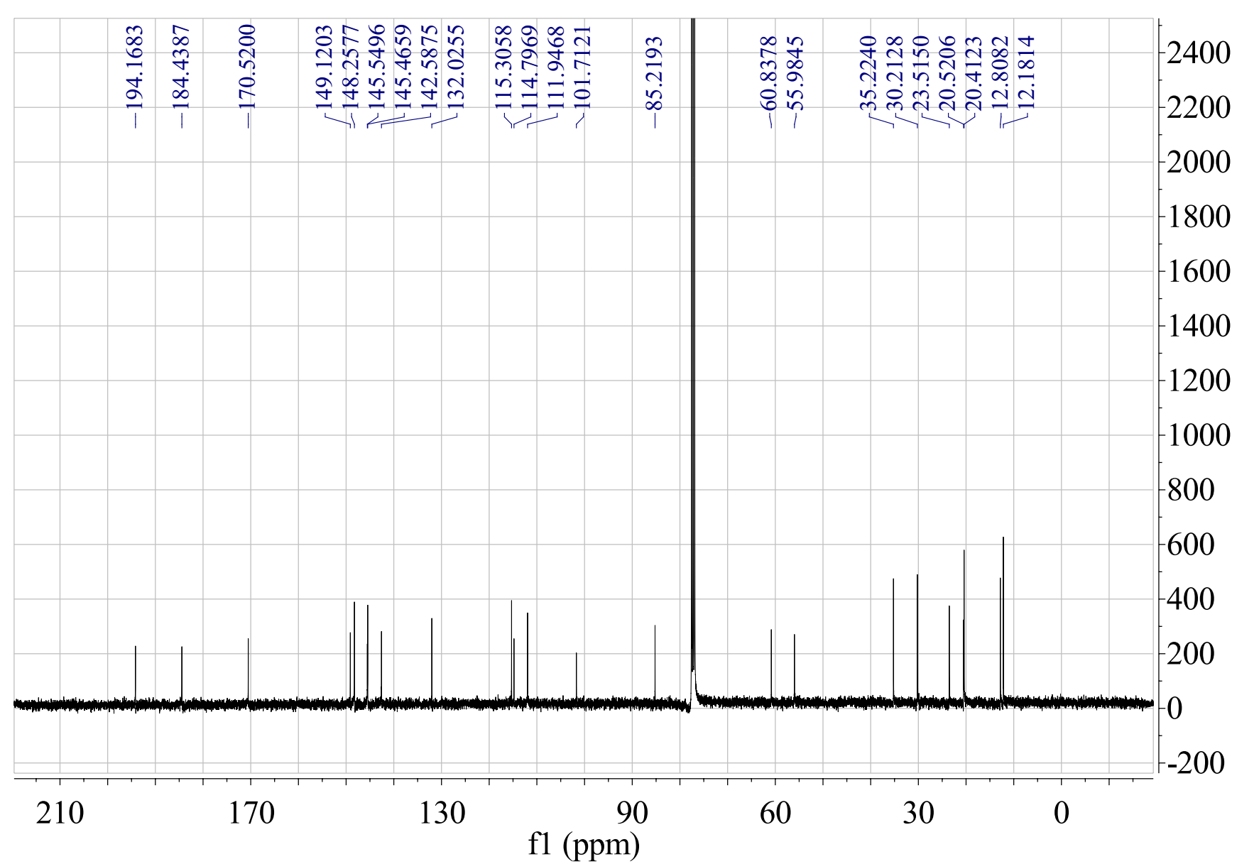

Figure S46. The HSQC spectrum of penazaphilone H (8)
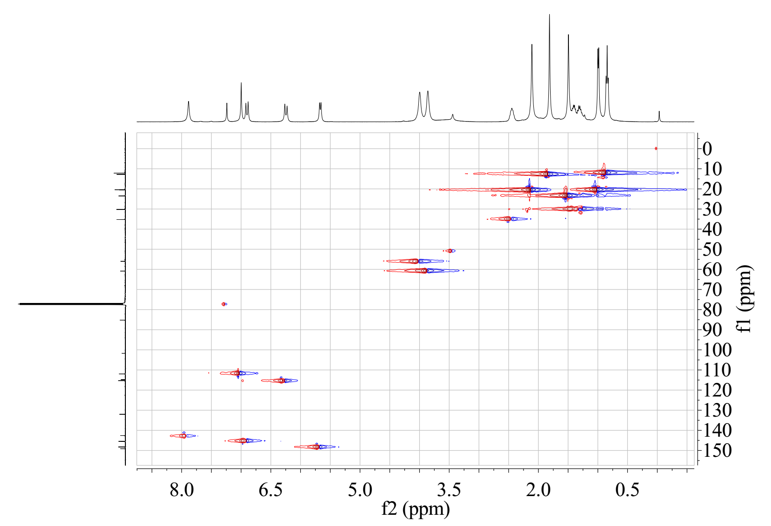

Figure S47. The HMBC spectrum of penazaphilone H (8)
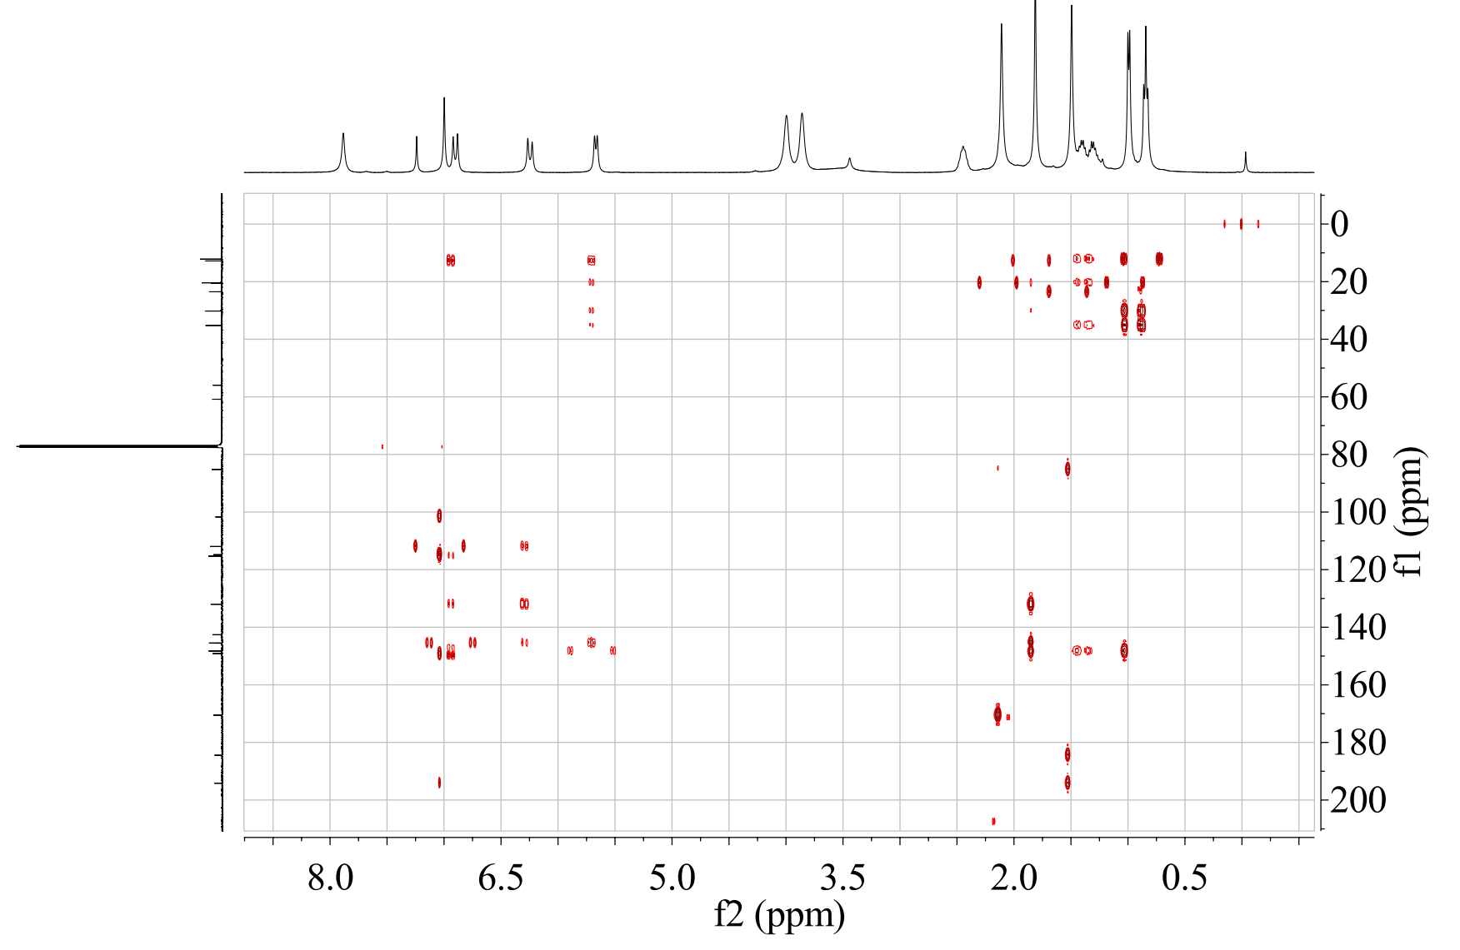

Figure S48. The CD spectrum of penazaphilone H (8)
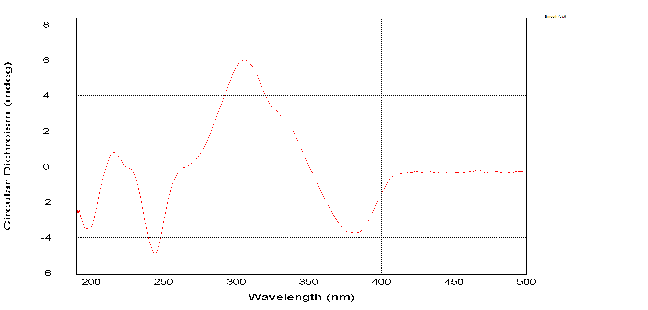

Figure S49. The HRESIMS spectrum of penazaphilone I (9)
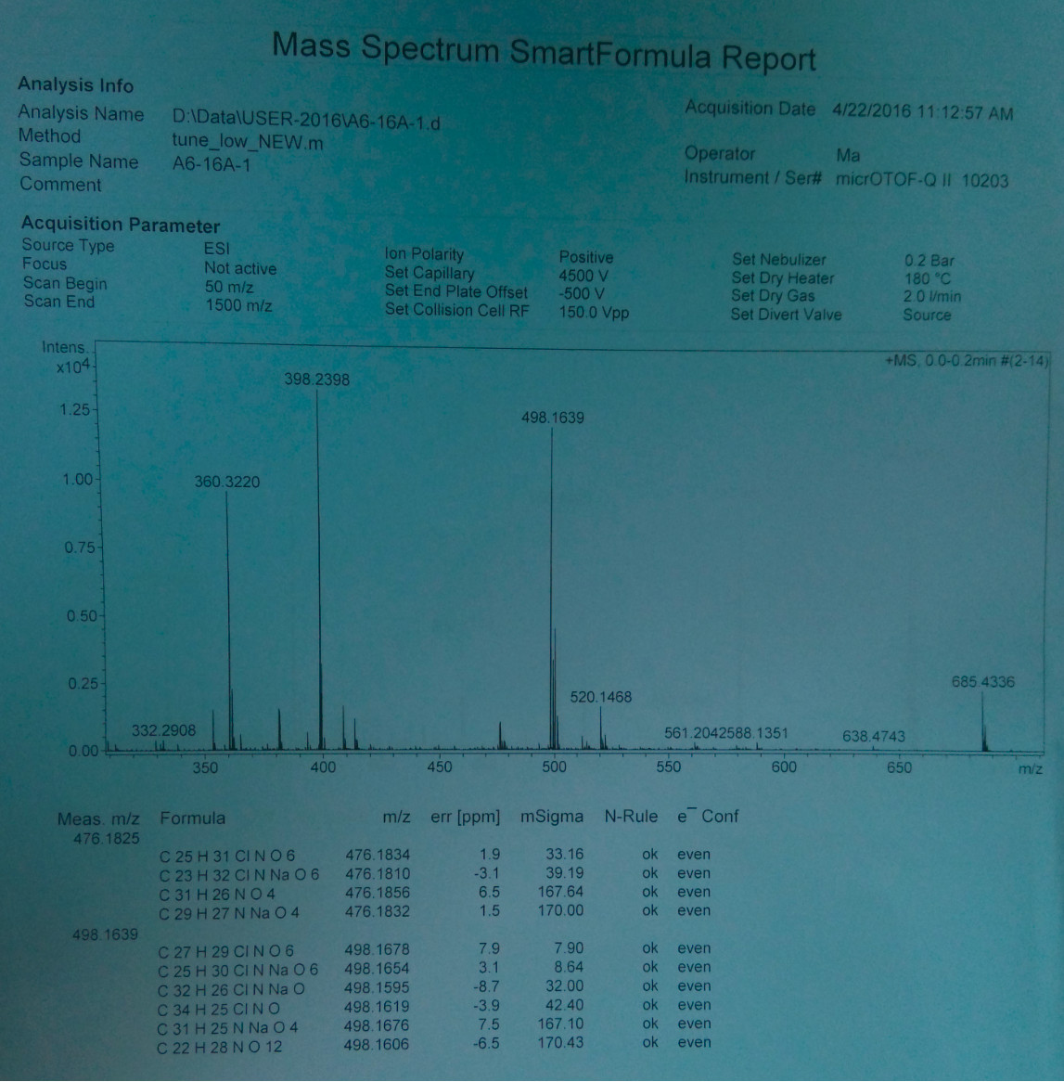

Figure S50. The ¹H NMR spectrum of penazaphilone I (9)
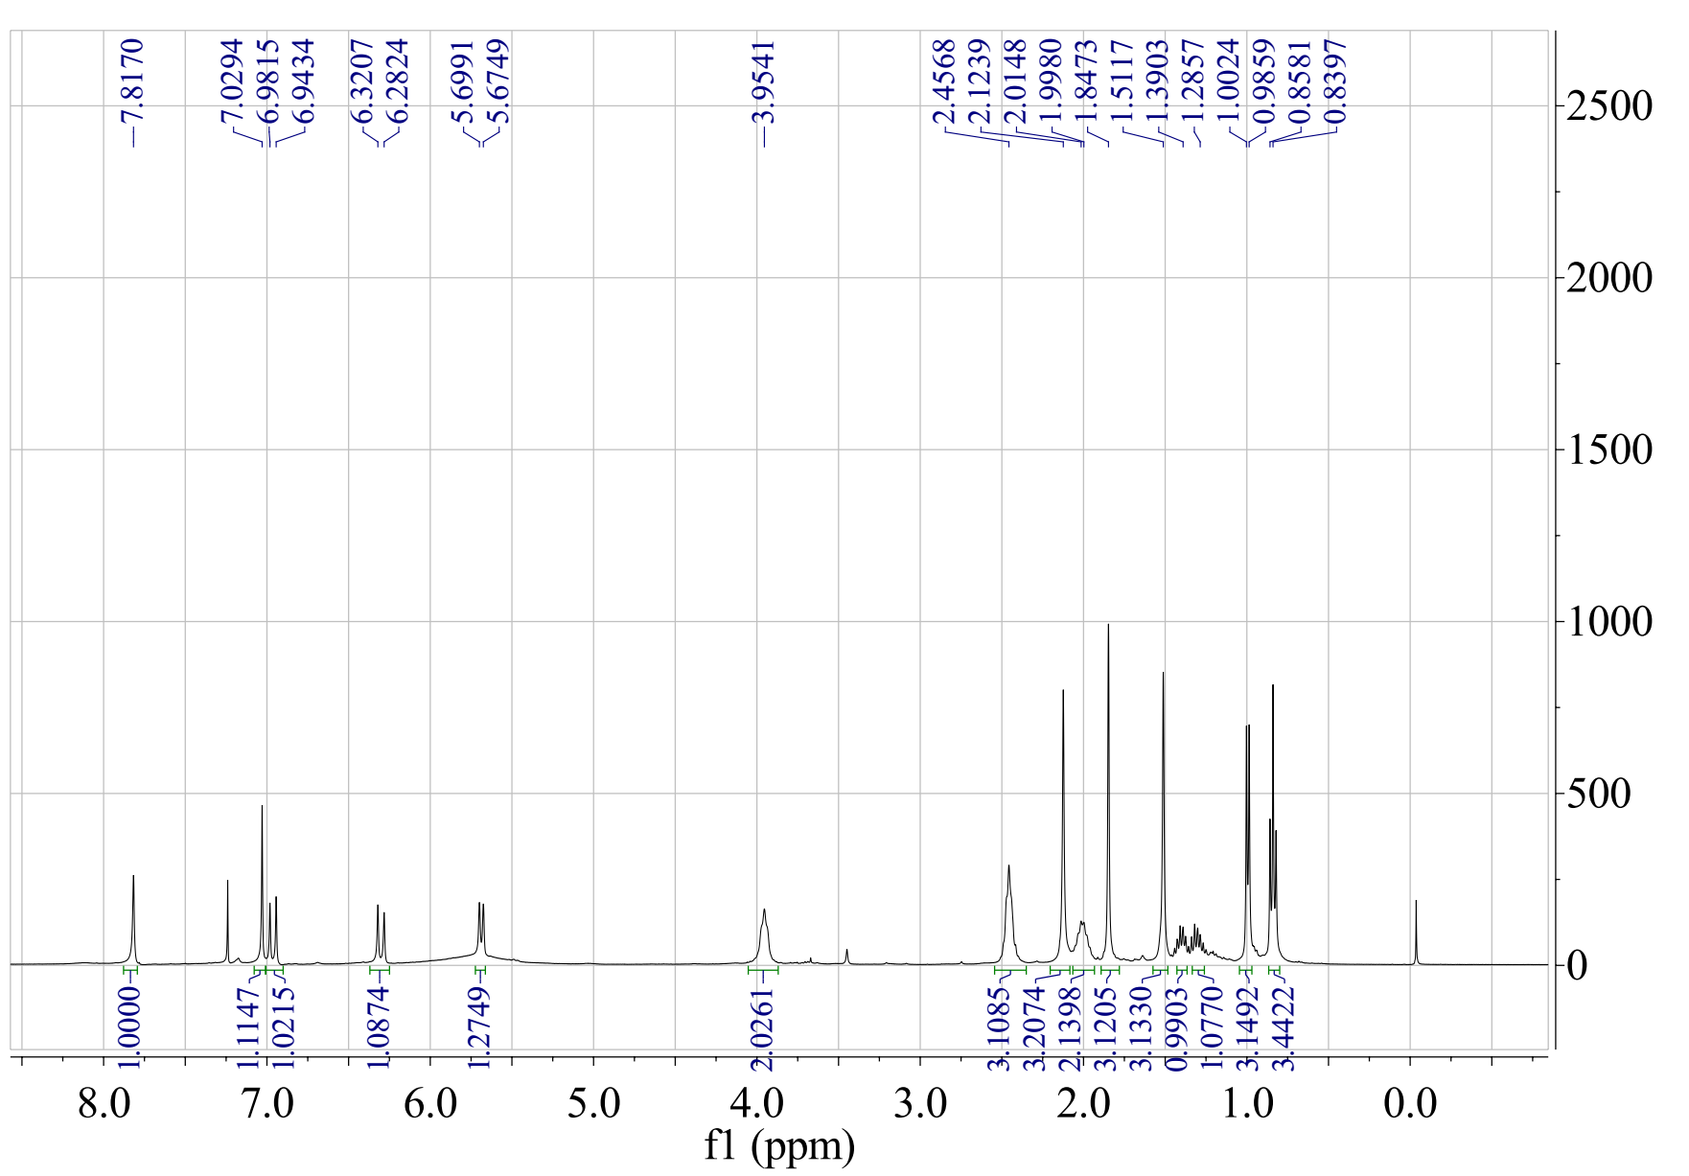

Figure S51. The ¹³C NMR spectrum of penazaphilone I (9)
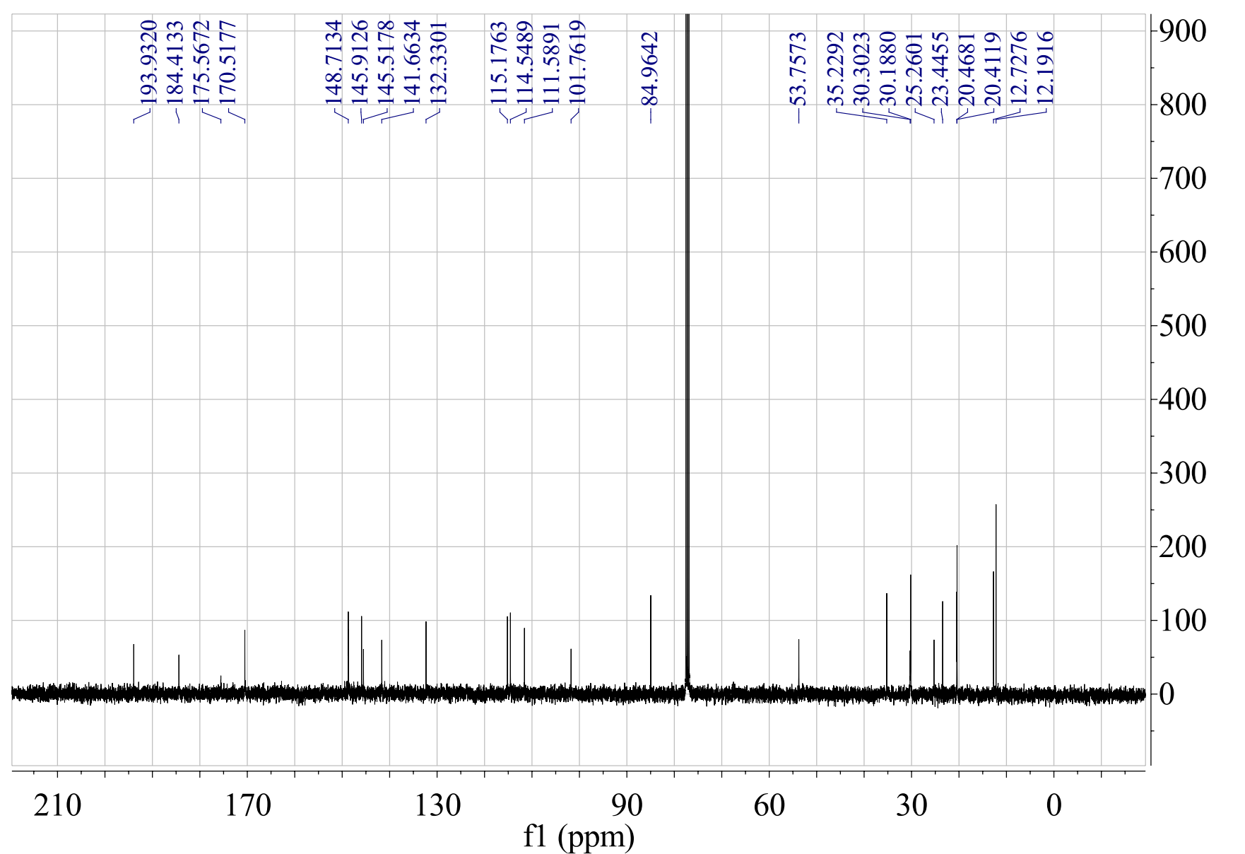

Figure S52. The HSQC spectrum of penazaphilone I (9)
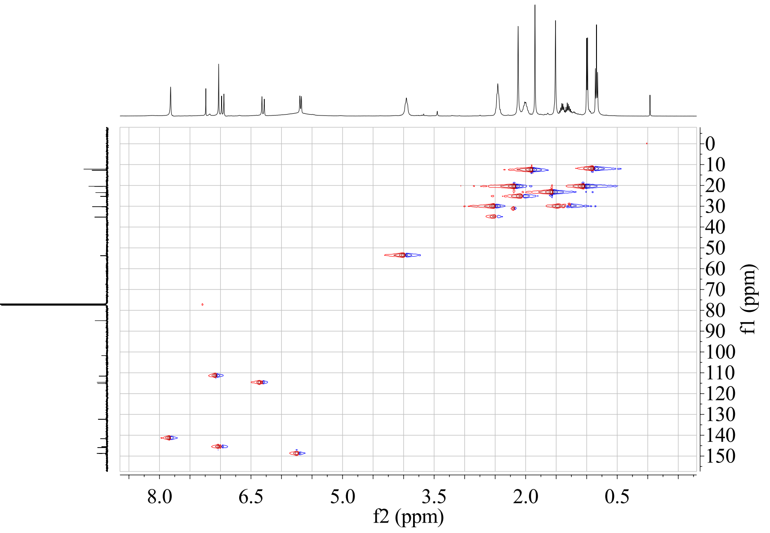

Figure S53. The HMBC spectrum of penazaphilone I (9)
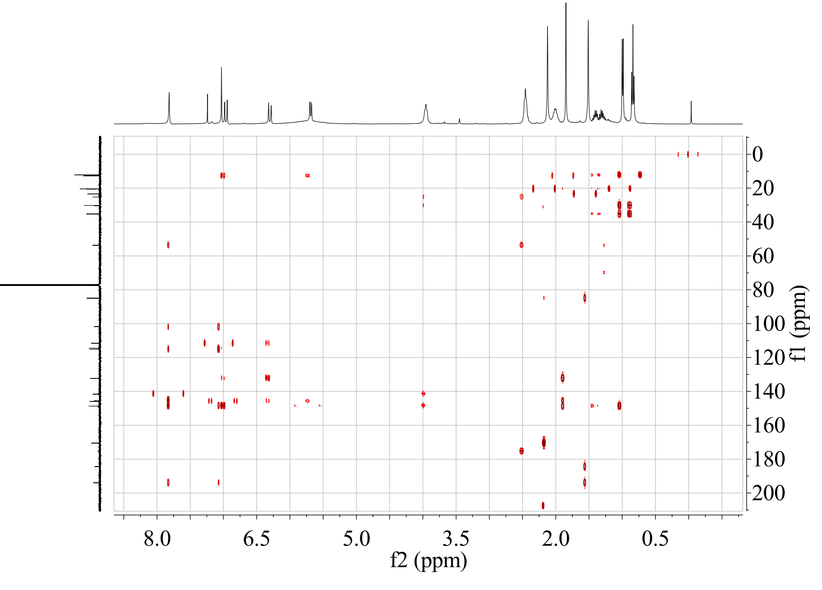

Figure S54. The CD spectrum of penazaphilone I (9)
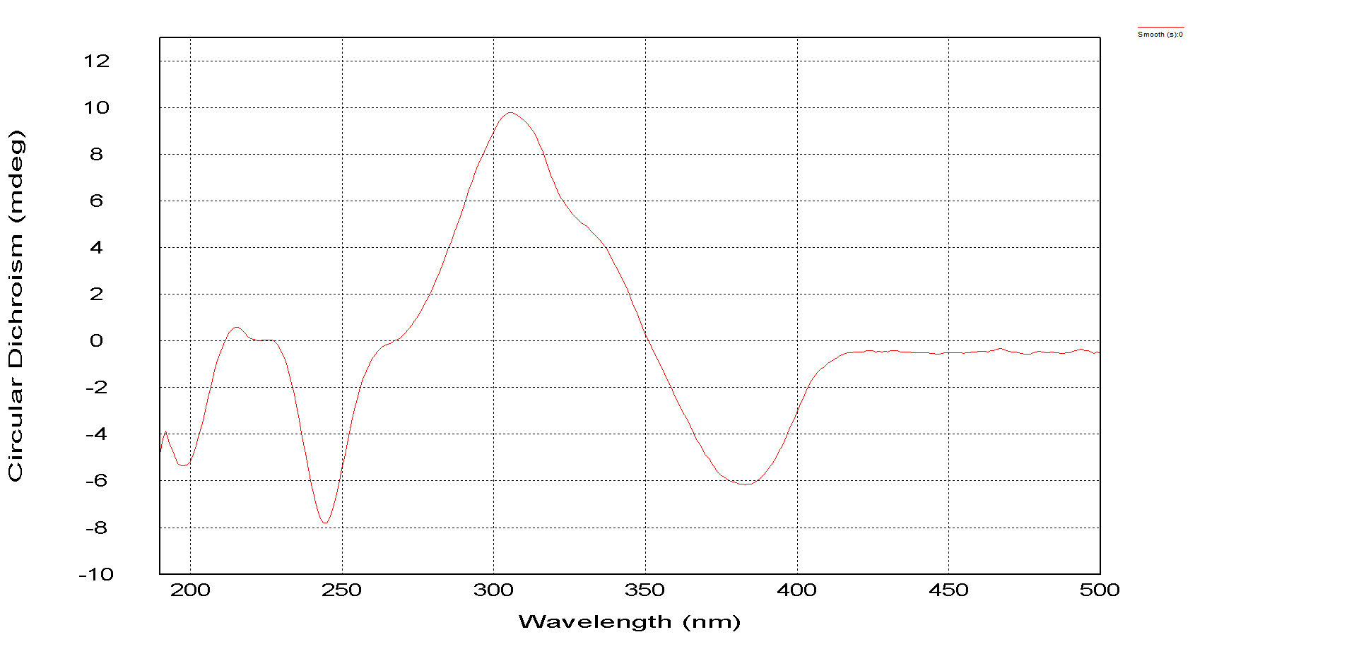
Single Crystal X-ray Diffraction Data for Compound 8: C₂₃H₂₇NO₅Cl; M_{r} = 432.90; orthorhombic, space group P2₁2₁2₁, a = 6.4844 (6) Å, b = 8.7749 (8) Å, c = 39.690 (4) Å, α = 90°, β = 90°, γ =90°, V = 2258.4 (4) Å³, Z = 4, D_{calc} = 1.273 g/cm³, λ = 0.71073 Å, μ (Mo Kα) = 0.202 mm⁻¹, F (000) = 916.0, T = 170 K. Of the 3139 reflections that were collected, 2663 were unique (R_{int} = 0.0412). The structure was solved by direct methods with SHELXL-97 and refined by full-matrix least-squares on F². Final refinement: data/restraints/parameters = 4495/199/282; R₁ = 0.1441 (3910), wR₂ = 0.3645 (4495). GOF = 1.075. Crystallographic data (including structure factors) for compound 8 (CCDC 1886405) reported in this paper have been deposited at the Cambridge Crystallographic Data Center. Copies of the data can be obtained, free of charge, on application to CCDC, 12 Union Road, CB2 1EZ, UK [fax: +44-0-1223-336033 or e-mail: deposit@ccdc.cam.ac.uk].

