Applying Chemistry Knowledge To Code, Construct, and Demonstrate an Arduino-Carbon Dioxide Fountain
-Supporting Information-

Experimental Overview
The Arduino-carbon dioxide fountain is made up of pressure sensor, solenoid valve, Arduino Uno board, and bread board to measure the pressure in the round bottom flask and to control the solenoid valve.

Experiment
The experiment process for the Arduino-carbon dioxide fountain consists of three phases of electrical circuit construction, code, and performing experiment.

Electrical circuit construction
First of all, connect the Arduino Uno board, bread board, Vernier pressure sensor, Analog protoboard adaptor, solenoid valve, and relay module: The overall device connections are as follows (See Figure 1).

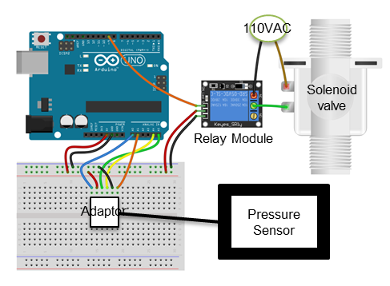
Figure 1. Schematic of the electrical circuit

A Vernier pressure sensor or an atmospheric pressure sensor could be used to measure gas pressure. In this experiment, a Vernier pressure sensor was used for convenience. A Vernier pressure sensor is used to measure the gas pressure inside a round bottom flask. In addition, an Analog protoboard adaptor is used to connect the pressure sensor to the Arduino Uno board. The adapter is designed to be connected from the bread board to the Arduino Uno board using jumper wires.
A solenoid valve is used to control the flow of water from the beaker to the round bottom flask. The solenoid valve is a device that allows the flange to rise when electricity is applied and the valve to be closed when electricity is cut. The solenoid valve is operated at 110V, and relay module is used because the Arduino Uno board can provide only 5V voltage. A relay module is a type of switch that can be switched on and off automatically and can be adjusted to 110V using a 5V voltage. The detailed electrical connections are as follows:
- Connect one of the two wires inside the electric plug to the solenoid valve and the other to the NC of the relay module (See Figure 2).
- Connect the COM of the relay module to the other pole of the solenoid valve using a copper wire.
- Insert two plastic tube to the two holes in the solenoid valve.
- Connect +, -, signal pin of the relay module to 5V, gnd, pin9 of the Arduino Uno board.
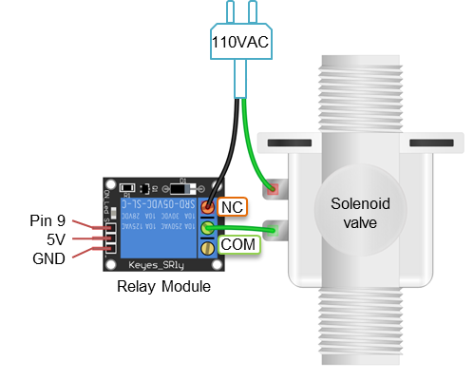
Figure 2. Schematic of wiring the relay
- Connect the pressure sensor to the Analog protoboard adapter and connect the six pins of the adapter to the Arduino Uno board using the breadboard as follows (see Figure 3).
SIG2 (Vernier BTA pin 1) to Arduino pin A1 (+/-10V output used by just a few Vernier analog sensors)
GND (Vernier BTA pin 2) to Arduino pin GND (ground)
Vres (Vernier BTA pin 3) to Arduino pin A4 (resistance reference)
ID (Vernier BTA pin 4) to Arduino pin A5 (not used by all sensors)
5V (Vernier BTA pin 5) to Arduino pin 5V (power)
SIG1 (Vernier BTA pin 6) to Arduino pin A0

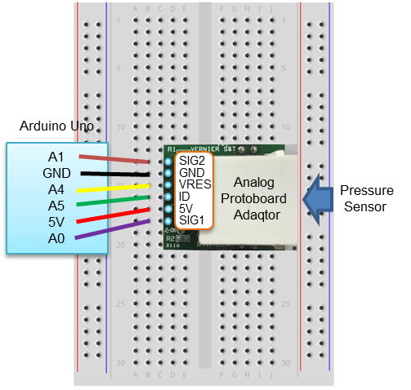
Figure 3. Schematic of wiring the Analog protoboard adaqtor

Code
The Arduino is controlled by code written with the microcontroller’s own programming tool known as the ‘Integrated Development Environment (IDE)’. The following code implies to open the solenoid valve when the gas pressure drops below 0.25 atm.
To use the Vernier sensor, select “Include Library-Manage Libraries” from the Sketch menu of the Arduino IDE and then install VernierLib. The PLX-DAQ program was used to transmit pressure data from the Arduino to the Excel spreadsheet. The PLX-DAQ can be downloaded from https://www.parallax.com/downloads/plx-daq.

#include "VernierLib.h" //include Vernier functions in this sketch
VernierLib Vernier; //create an instance of the VernierLib library
int valve=9;
int count=0;

void setup() { // setup the initial condition
Serial.begin(9600);
Vernier.autoID(); //identify the sensor being used
pinMode(valve, OUTPUT);
Serial.println("CLEARDATA");
Serial.println("LABEL, TIME, time, Pressure");
digitalWrite(valve, HIGH);
}
void loop() { //code in which the valve opens when the pressure drops below 0.25atm
count ++;
float Pressure = Vernier.readSensor()/103.325; // convert pressure units from kPa to atm
Serial.print("DATA, TIME, ");
Serial.print(count*0.1); //count the time in 0.1 second intervals
Serial.print(",");
Serial.println(Pressure);
if (Pressure < 0.25) {
digitalWrite(valve, LOW);
}
delay(100);
}

Performing experiment
The experiment was conducted in the similar way as the previously known carbon dioxide fountain experiment. The experimental steps are as follows and Figure 4 is a schematic of the Arduino-carbon dioxide fountain.
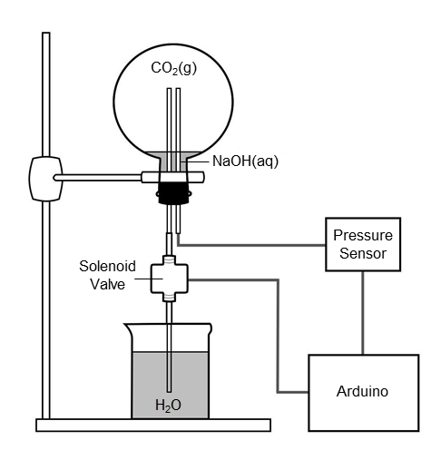
Figure 4. Schematic of the Arduino-carbon dioxide fountain
- Prepare a two-hole rubber septum to close the round bottom flask. The plastic tube connected to pressure sensor is inserted into one hole of the rubber septum, and the plastic tube connected to solenoid valve is inserted to the other hole of the rubber septum.
- Press the connect button of the PLX-DAQ program. When the PLX-DAQ program is executed, pressure data collected are transmitted to Excel spreadsheet.
- Insert one end of a rubber tube on the sidearm of the Erlenmeyer flask, and the other end in a round bottom flask. Add 100 mL of water followed by four Alka-Seltzer tablets into a 500 mL Erlenmeyer flask. Put a rubber stopper on the mouth of the Erlenmeyer flask.
- Remove the rubber tube after the round bottom flask is filled with carbon dioxide.
- Then add 50 mL of a 2.0 M sodium hydroxide solution into the round bottom flask and immediately close the mouth of the round bottom flask with the rubber septum of experimental step (1).
- Shake the round bottom flask so that CO₂ (g) can be dissolved well in a sodium hydroxide solution.
- Flip the round bottom flask of experimental step (6) over and fix it to the stand. Ensure that the plastic tube connected to the solenoid valve is sufficiently immersed in a 1000 mL beaker containing BTB (Bromothymol Blue) aqueous solution.
- As soon as the pressure inside the round bottom flask is lower than the setting pressure, the solenoid valve is immediately opened and the carbon dioxide fountain is observed. Figure 5 shows the graph of pressure change over time in the Arduino-carbon dioxide fountain. Figure 6 shows the photograph of the experiment.
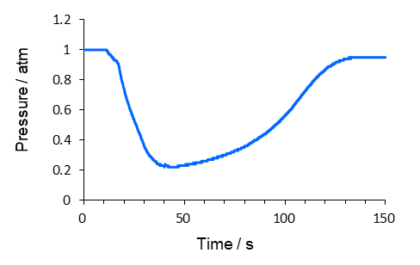
Figure 5. A pressure versus time curve in the Arduino-carbon dioxide fountain

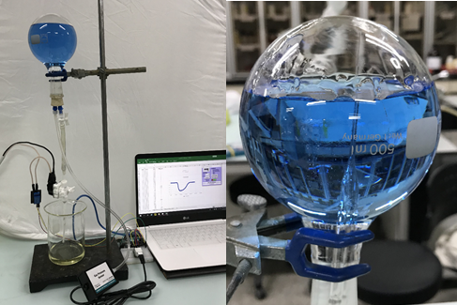
Figure 6. Demonstration of Arduino-carbon dioxide fountain

Information for experimental equipment
The information on the experimental equipment is as follows (see Table 1).

Table 1. The information for experimental equipment
equipment | manufacturer | model name | price | Purchased online site
Arduino Uno Board | Arduino | Arduino  UNO REV3 | $22 | https://store.arduino.cc/usa/
Gas Pressure seonsor | Vernier Software & Technology | GPS-BTA | $83 | https://www.sparkfun.com/products/12874
 | Adafruit | BMP280 | $9 | https://www.adafruit.com/product/2651
Analog protoboard adapter | Vernier Software & Technology | BTA-ELV | $14 | https://www.vernier.com/products/accessories/protoboard-adapters/bta-elv/
Solenoid valve | - | 1/4" solenoid valve | $7 | https://www.ebay.com/itm/DC6-14V-AC110-220V-Electric-Solenoid-Valve-Water-Air-1-4-Brass-Normal-Closed-N-C/302732827262?hash=item467c485a7e:g:TXcAAOSw7UJa8mjv:rk:14:pf:0
Relay module | TOLAKO | BJ-DT0Y-001 | $5 | https://www.amazon.com/

