### Supporting Information for

### *Othro*-Imide and Allyl Groups Effect on Highly Thermally Stable Polybenzoxazine/Double-Decker–Shaped Polyhedral Silsesquioxane Nanocomposites

**Wei-Cheng Chen, and Shiao-Wei Kuo\***

Department of Materials and Optoelectronic Science, Center for Supramolecular Materials and Functional Polymers, National Sun Yat-Sen University, Kaohsiung, 804, Taiwan.

E-mail: [kuosw@faculty.nsysu.edu.tw](mailto:kuosw@faculty.nsysu.edu.tw)



Scheme S1: Peak assignment in the 1H NMR spectra of the DDSQ-functionalized BZ monomers of (a) DDSQ, (b) DDSQ-ND, (c) DDSQ-ND-*p*-OH, and (d) *p*BDDSQ-R.



Figure S1: FTIR spectra of (a) DDSQ, (b) DDSQ-ND, (c) DDSQ-ND-*o*-OH, (d) *o*BDDSQ-AN, and (e) *o*BDDSQ-AL.



Figure S2: 1H NMR spectra of (a) DDSQ, (b) DDSQ-ND, (c) DDSQ-ND-*o*-OH, (d) *o*BDDSQ-AN, and (e) *o*BDDSQ-AL.



### Figure S3: MALDI-TOF mass spectra of (a) *p*BDDSQ-AN and (b) *p*BDDSQ-AL.



Figure S4: (A) DSC traces and (B) FTIR spectra of the uncured *o*BDDSQ-AL, recorded after each curing stage: (a) uncured, (b) 150 °C, (c) 180 °C, (d) 210 °C, (e) 240 °C, and (f) 270 °C.

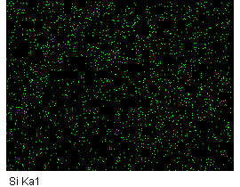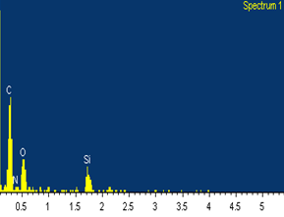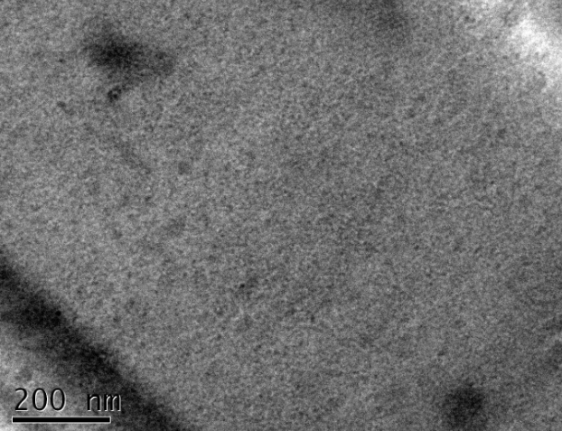

(a)

(d)

(e)

(c)

(b)

(f)

Figure S5: (a) TEM, (b) SEM, (c) Si-mapping, (d) N-mapping, (e) O-mapping, and (f) EDX analyses of the *p*BDDSQ-AL BZ monomer after thermal curing.

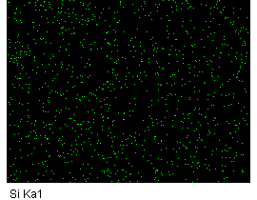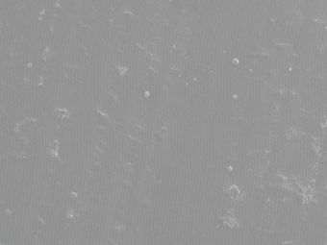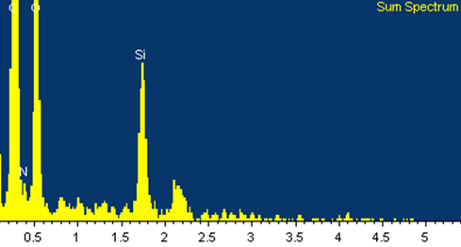

(a)

(d)

(e)

(c)

(b)

(f)

Figure S6: (a) TEM, (b) SEM, (c) Si-mapping, (d) N-mapping, (e) O-mapping, and (f) EDX analyses of the *o*BDDSQ-AN BZ monomer after thermal curing.

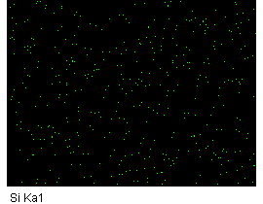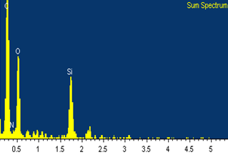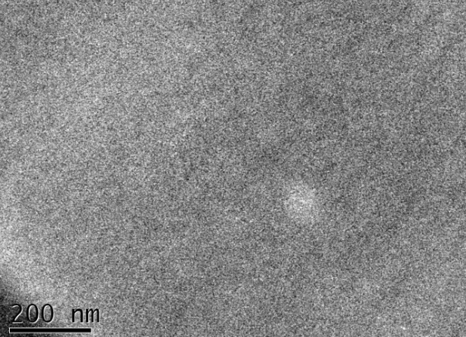

(a)

(d)

(e)

(c)

(b)

(f)

Figure S7: (a) TEM, (b) SEM, (c) Si-mapping, (d) N-mapping, (e) O-mapping, and (f) EDX analyses of the *o*BDDSQ-AL BZ monomer after thermal curing.



Figure S8: FTIR spectra of the *o*BDDSQ-AN (a) after curing at 270 °C and (b) after TGA measurement at 450 °C.