**Supporting information for**

**Mechanical Reactivity of Two Different Spiropyran Mechanophores in Polydimethylsiloxane**

*Tae Ann Kim,†,‡ Maxwell J. Robb,‖,‡,˩ Jeffrey S. Moore,‖,‡ Scott R. White,§,‡ Nancy R. Sottos*,†,‡*

†Department of Materials Science and Engineering, ‖Department of Chemistry, §Department of Aerospace Engineering, and ‡Beckman Institute for Advanced Science and Technology, University of Illinois at Urbana-Champaign, Urbana, Illinois 61801, United States. ˩Division of Chemistry and Chemical Engineering, California Institute of Technology, Pasadena, CA, 91125, United States.

**Table of Contents**

1. General experimental procedures 2

1.1 Materials 2

1.2 Characterization 2

2. Synthetic procedures 3

2.1 Synthetic scheme of **SP1** 3

2.2 Synthetic scheme of **SP2** 7

3. Computational calculations 10

4. Mechanical behavior of SP-PDMS 11

4.1 Engineering stress/strain calculation and tensile properties of SP-PDMS 11

4.2 Normalization of fluorescence under tensile deformation 11

5. Mechanical response combined with normalized fluorescence intensity 13

6. Mechanical response and change in normalized fluorescence at a strain rate of 0.005 s-1 in tension 14

7. A monotonic increase in fluorescence above a threshold strain 15

8. Kinetic study of **SP1**-PDMS and **SP2**-PDMS under tension 16

8.1 Rate constant measurements 16

8.2 Forward reaction kinetics 18

8.3 Reverse reaction kinetics 20

9. References 23

# 1. General experimental procedures

## 1.1 Materials

Unless otherwise states, all reagents were purchased from commercial sources and used as received. Deuterated solvents (chloroform-d, dimethyl sulfoxide-d6) were purchased from Cambridge Isotope Laboratories, Inc. Dry tetrahydrofuran was obtained from an Anhydrous Engineering Solvent Delivery System equipped with activated alumina columns.

## 1.2 Characterization

NMR spectra were measured using a Varian 400 or 500 MHz spectrometer. Spectra were referenced to the residual DMSO (1H NMR: 2.50 ppm, 13C NMR: 39.52 ppm) or chloroform (1H NMR: 7.24 ppm, 13C NMR: 77.23 ppm) in deuterated solvent. Coupling constants (*J*) are reported in Hz, and splitting patterns were assigned as s (singlet), d (doublet), t (triplet), q (quartet) dd (doublet of doublets), m (multiplet), or br (broad). Mass spectra were obtained from the Mass Spectrometry Laboratory, University of Illinois. UV-vis spectra were acquired on an Agilent 8453 photodiode array spectrometer. Photoluminescence spectra were measured with a Horiba Jobin Yvon FluoroMax-3 fluorometer with an excitation wavelength of 510 nm.

# 2. Synthetic procedures

## 2.1 Synthetic scheme of **SP1**

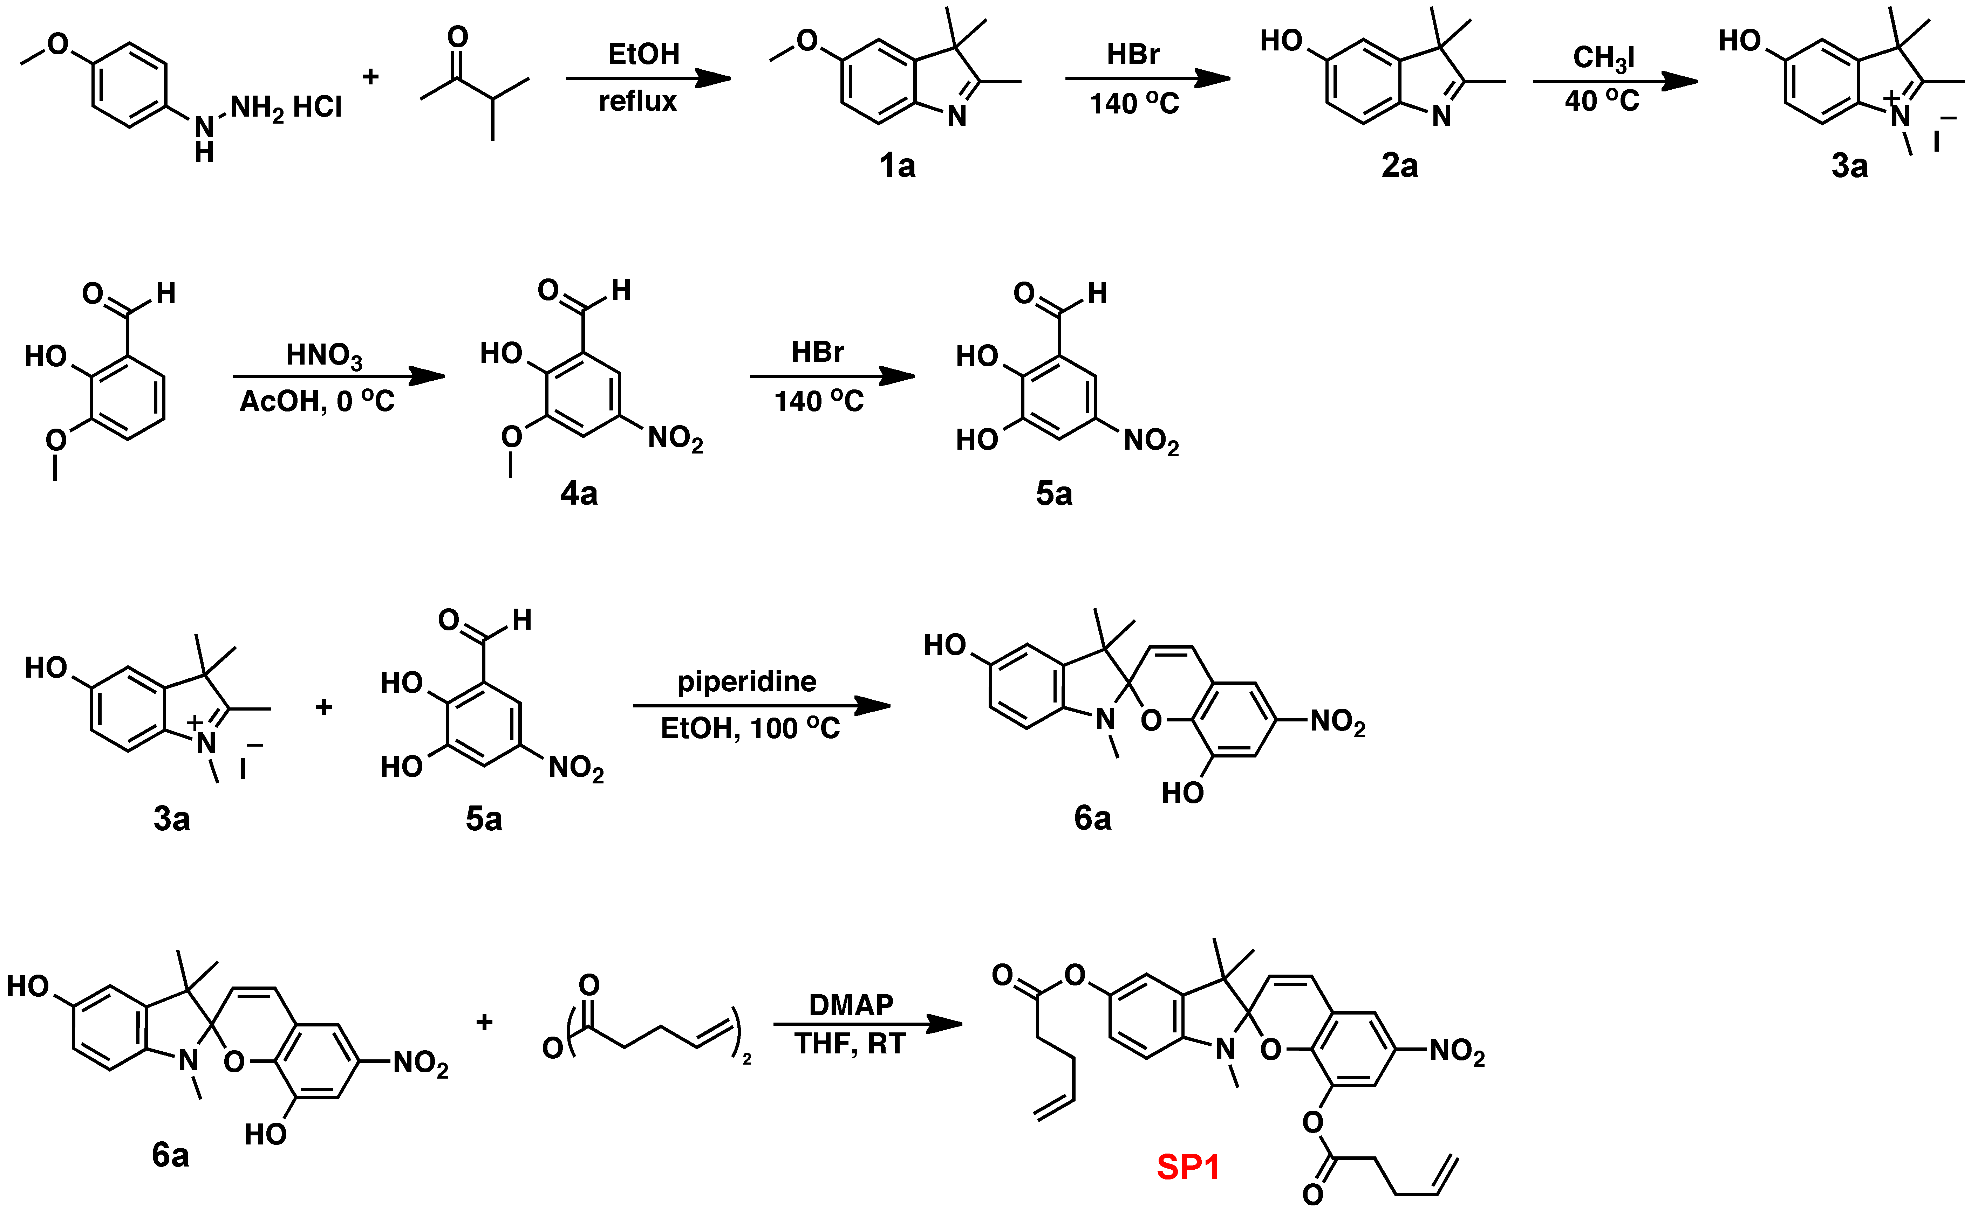

All the compounds were prepared according to literature procedure1 or with some modification.

Synthesis of 5-methoxy-2,3,3-trimethyl-*3H*-indole (**1a**)

(4-Methoxy)-phenyl hydrazine hydrochloride (10.0 g, 72.3 mmol, 1 equiv) and methyl isopropyl ketone (6.13 mL, 72.3 mmol, 1 equiv) were dissolved in 250 mL absolute EtOH and heated to reflux under N2. After refluxing for 4 h, the solution was concentrated *in vacuo*. The crude product was purified by column chromatography eluting with 5% MeOH/CH2Cl2 to yield **1a** (11.5 g, 60.7 mmol, 84%) as a reddish-orange solid.

1H NMR (400 MHz, CDCl3): δ 7.46 (d, *J* = 8.0 Hz, 1H), 6.84 (dd, *J* = 2.4, 0.4, 2H), 6.82 (dd, *J* = 8.6, 2.4, 1H), 3.82 (s, 3H), 2.30 (s, 3H), 1.30 (s, 6H). 13C NMR (126 MHz, CDCl3): δ 186.0, 158.0, 147.6, 147.4, 120.2, 112.1, 108.4, 55.9, 53.9, 23.2, 15.5. HRMS-ESI (m/z): [M+H]+ calcd for C12H16NO, 190.1232; found, 190.1233.

Synthesis of 5-hydroxy-2,3,3-trimethyl-*3H*-indole (**2a**)

**1a** (9.00 g, 47.5 mmol, 1 equiv) was dissolved in 48% aqueous HBr (160 mL, 141 mmol, 30 equiv) and heated to reflux for 3 h. The solution was diluted with 650 ml of distilled water and neutralized with solid NaHCO3 until the solution became basic. The aqueous solution was extracted with CH2Cl2. Combined organics were washed with brine, dried over Na2SO4. After filtering, the filtrate was concentrated *in vacuo* to yield **2a** as a brown solid (6.58g, 37.6 mmol, 79%). No further purification was required.

1H NMR (400 MHz, CDCl3): δ 10.59 (br, 1H), 7.34 (d, *J* = 8.4 Hz, 1H), 6.82 (d, *J* = 2.4 Hz, 1H), 6.76 (dd, *J* = 8.4, 2.4 Hz, 1H), 2.25 (s, 3H), 1.29 (s, 6H). 13C NMR (126 MHz, CDCl3): δ 186.0, 156.0, 147.3, 144.9, 120.0, 114.3, 110.0, 53.8, 23.3, 15.0. HRMS-ESI (m/z): [M+H]+ calcd for C11H14NO, 176.1075; found, 176.1074.

Synthesis of 5-hydroxy-1,2,3,3-tetramethyl-*3H*-indolium iodide (**3a**)

**2a** (6.58 g, 37.6 mmol, 1 equiv) was dissolved in methyl iodide (35.1 mL, 564 mmol, 15 equiv) and heated to reflux. After 24 h, the solution was filtered and the solid was washed with benzene. The precipitate was recrystallized from hot ethanol to yield **3a** as brown needles (8.34 g, 26.3 mmol, 70 %).

1H NMR (400 MHz, d6-DMSO): δ 10.26 (s, 1H), 7.68 (d, *J* = 8.0 Hz, 1H), 7.12 (d, *J* = 2 Hz, 1H), 6.93 (dd, *J* = 8.8, 2.6 Hz, 1H), 3.89 (s, 3H), 2.67 (s, 3H), 1.46 (s, 6H) 13C NMR (101 MHz, d6-DMSO): δ 191.9, 159.0, 143.7, 134.2, 116.1, 115.0, 110.2, 53.5, 34.6, 21.9, 13.8. HRMS-ESI (m/z): [M+H-I]+ calcd for C12H16NO, 190.1232; found, 190.1233.

Synthesis of 2-hydroxy-3-methoxy-5-nitro-benzaldehyde (**4a**)

*o*-Vanillin (20.0 g, 131 mmol, 1 equiv) was dissolved in 126 ml of glacial acetic acid and 6 ml of distilled water. The solution was cooled to 0 °C, followed by adding nitric acid (9.21 ml, 145 mmol, 1.1 equiv) in 39 ml of glacial acetic acid. After stirring for 1.5 h, the solution was diluted with 150 ml of distilled water and filtered. The precipitate was washed with water and dried completely under vacuum. **4a** was obtained as light yellow powder (8.34 g, 69.1 mmol, 70 %).

1H NMR (400 MHz, CDCl3): δ 11.75 (s, 1H), 10.00 (s, 1H), 8.23 (d, *J* = 2.4 Hz, 1H), 7.93 (d, *J* = 2.8 Hz, 1H), 4.02 (s, 3H). 13C NMR (101 MHz, CDCl3): δ 195.6, 156.9, 149.1, 140.5, 120.5, 118.9, 111.4, 56.9. HRMS-EI (m/z): [M]+ calcd for C8H7NO5, 197.0324; found, 197.0322

Synthesis of 2,3-dihydroxy-5-nitro-benzaldehyde (**5a**)

A solution of **4a** (24 g, 120 mmol, 1 equiv) in 48 % aqueous HBr (400 mL, 3660 mmol, 30 equiv) was heated to reflux. After 4 h, the solution was diluted with 450 ml of water and cooled to 0 °C. The solution was filtered and the collected solid was washed with water and allowed to dry. The filtrate was extracted with 1:1 ethyl acetate/CH2Cl2, dried over Na2SO4, filtered, and concentrated in vacuo. The combined crude solids were dissolved in ethyl acetate and activated carbon was added for decolorizing. After filtering, the filtrate was recrystallized in boiling ethyl acetate to yield **5a** as light yellow needles (19.0 g, 104 mmol, 85 %).

1H NMR (400 MHz, d6-DMSO): δ 11.19 (br, 2H), 10.29 (s, 1H), 7.97 (d, *J* = 2.8 Hz, 1H), 7.76 (d, *J* =3.2 Hz, 1H). 13C NMR (126 MHz, d6-DMSO): δ 189.8, 156.0, 147.2, 139.2, 121.8, 114.6, 113.2. HRMS-EI (m/z): [M]+ calcd for C7H5NO5, 183.0168; found, 183.0164.

Synthesis of 1',3',3'-trimethyl-6-nitrospiro[chromene-2,2'-indoline]-5',8-diol (**6a**)

A round-bottom flask equipped with a condenser, and N2 inlet adapter was charged with **3a** (3.00 g, 9.46 mmol, 1 equiv), **5a** (1.73 g, 9.46 mmol, 1 equiv), and 93 ml of ethanol. The solution was heated to reflux for 2h. Then, it was cooled down, filtered, and the solid washed with cold ethanol. The precipitate was dried under high vacuum to yield **6a** (3.23 g, 9.12 mmol, 96%) as a dark green powder.

1H NMR (400 MHz, d6-DMSO, HCl(g)): δ 8.56 (d, *J* = 2.4 Hz, 1H), 8.33 (d, *J* = 16.4 Hz, 1H), 7.86 (d, *J* = 2.8 Hz, 1H), 7.80 (d, *J* = 16.8Hz, 1H), 7.74 (d, *J* = 8.8 Hz, 1H), 7.22 (d, *J* = 2 Hz, 1H), 7.04 (dd, *J* = 8.4, 2.4 Hz, 1H), 4.09 (s, 3H), 1.71 (s, 6H). 13C NMR (126 MHz, d6-DMSO): δ 178.4, 159.8, 153.3, 146.4, 145.9, 143.8, 139.7, 133.9, 121.1, 116.6, 116.0, 115.8, 114.7, 111.8, 109.8, 51.78, 34.64, 25.72. HRMS-EI (m/z): [M]+ calcd for C19H18N2O5, 354.1216; found, 354.1219.

Synthesis of 1',3',3'-trimethyl-6-nitrospiro[chromene-2,2'-indoline]-5',8-diyl bis(pent-4-enoate) (**SP1**)

To a solution of **6a** (382 mg, 1.08 mmol, 1 equiv) and 4-dimethylaminopyridine (238 mg, 1.94 mmol, 1.8 equiv) in 12 ml of THF was added 4-pentenoic anhydride (0.512 ml, 2.80 mmol, 2.6 equiv) dropwise. After stirring for 3h at room temperature, the reaction was quenched with 1 ml of methanol and stirred for 10 min. The solvent was completely removed and the crude product was purified by column chromatography eluting with dichloromethane. The separated purple solution was concentrated and recrystallized from boiling hexane to yield **SP1** (175 mg, 0.337 mmol, 31%) as yellow needles.

1H NMR (500 MHz, CDCl3): δ 7.94 (d, *J* = 2.6 Hz, 1H), 7.83 (d, *J* = 2.6 Hz, 1H), 6.97 (d, *J* = 10.4 Hz, 1H), 6.85 (dd, *J* = 8.3, 2.3 Hz, 1H), 6.80 (d, *J* = 2.2 Hz, 1H), 6.48 (d, *J* = 8.3 Hz, 1H), 5.91 (m, 2H), 5.62 (m, 1H), 5.15 (dd, *J* = 17.1, 1.5 Hz, 1H), 5.10-5.05 (m, 1H), 4.97-4.92 (m, 2H), 2.66 (s, 3H), 2.66-2.62 (m, 2H), 2.50 (q, *J* =7.0 Hz, 2H), 2.23-2.15 (m, 2H), 1.95 (q, J=7.6Hz, 2H), 1.25 (s, 3H), 1.21 (s, 3H). 13C NMR (126 MHz, CDCl3): δ 172.1, 170.6, 151.1, 145.3, 144.5, 140.2, 137.7, 137.3, 136.6, 136.5, 128.6, 121.1, 120.3, 120.2, 119.5, 119.3, 116.0, 115.5, 107.8, 107.5, 52.0, 33.8, 32.9, 29.1, 29.0, 29.0, 25.7, 19.6. HRMS-ESI (m/z): [M+H]+ calcd for C29H31N2O7, 519.2131; found, 519.2129.

## 2.2 Synthetic scheme of **SP2**

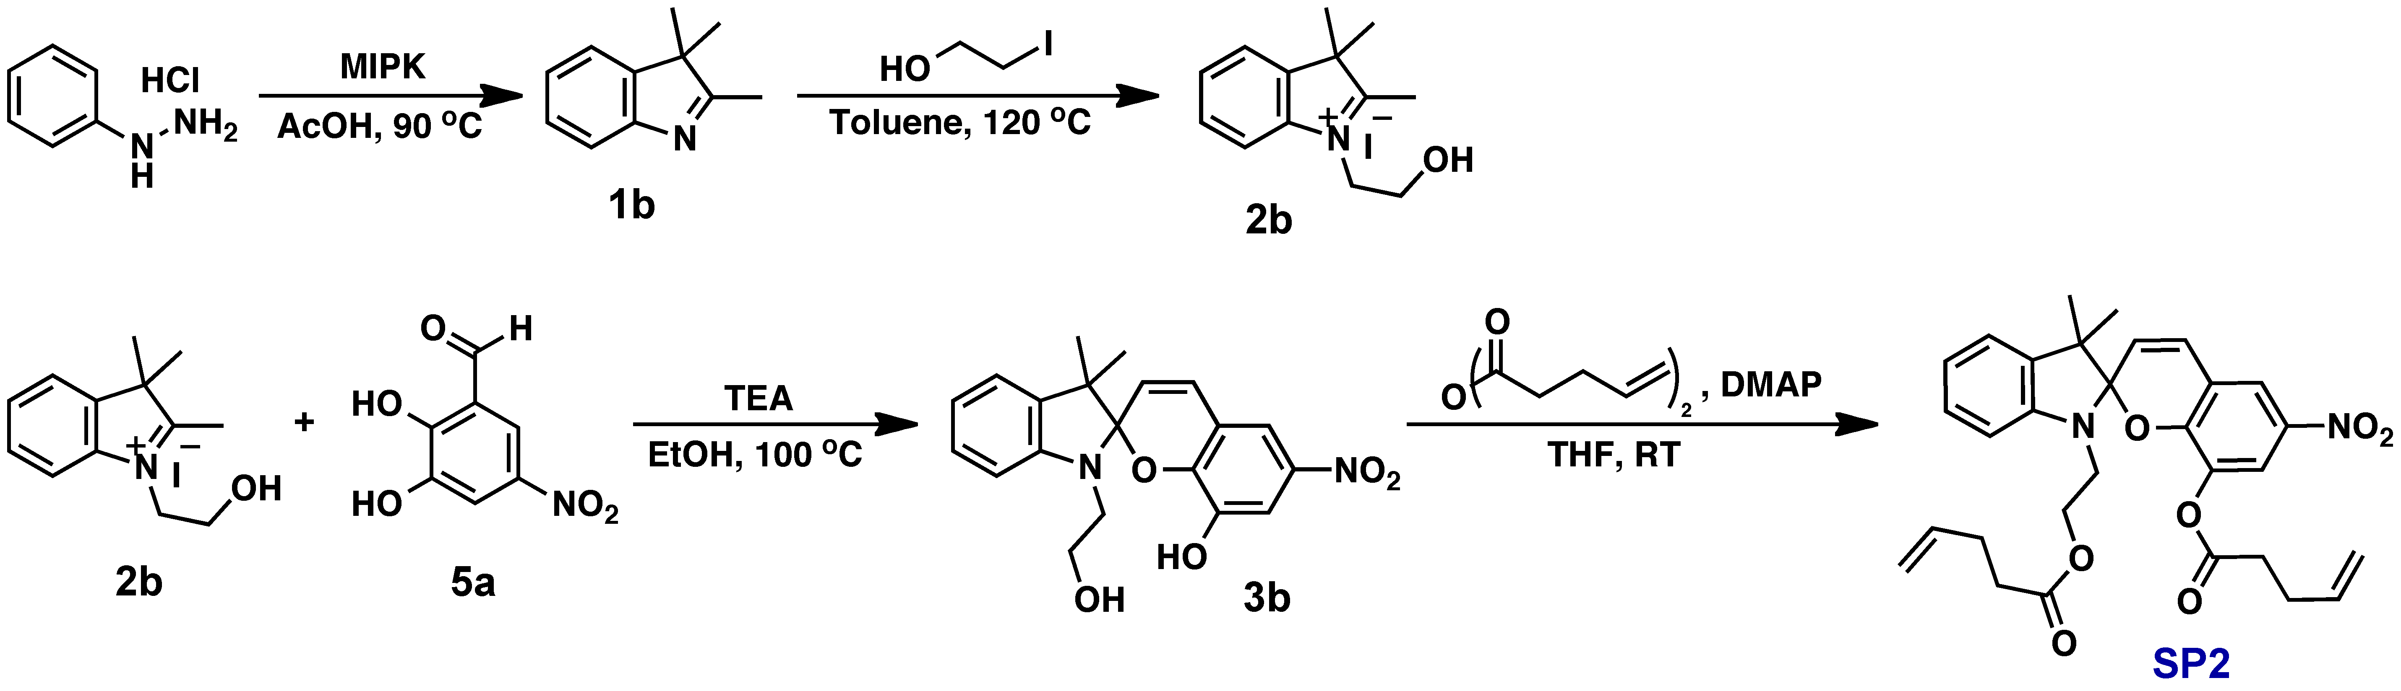

All the compounds were prepared according to literature procedure.2

Synthesis of 2,3,3-trimethyl-*3H*-indole (**1b**)

Phenylhydrazine hydrochloride (30.0 g, 208 mmol, 1 equiv) and 3-methyl-2-butanone (26.6 mL, 248 mmol, 1.2 equiv) were dissolved in 450 mL of acetic acid and heated to 90 ℃. After stirring 8 h, solvents were removed under vacuum. The solid was dissolved in 200 mL of distilled water and basified by adding 2M NaOH until the pH became 11. The product was extracted with diethyl ether, dried with Mg2SO4, and concentrated to yield a viscous red oil. The crude oil was purified by vacuum distillation (60~63 oC, <0.001 Torr) to yield **1b** as a light brownish oil (20.1g, 126 mmol, 61%).

1H NMR (500 MHz, CDCl3): δ 7.53 (d, *J* = 7.6 Hz, 1H), 7.32­7.25 (m, 2H), 7.19 (t, *J* = 7.3 Hz, 1H), 2.27 (s, 3H), 1.29 (s, 6H). 13C NMR (126 MHz, CDCl3): δ 188.1, 153.8, 145.8, 127.7, 125.2, 121.4, 120.0, 53.7, 23.2, 15.6. HRMS-ESI (m/z): [M+H]+ calcd for C11H14N, 160.1126; found, 160.1133.

Synthesis of 2-hydroxyethyl-2,3,3-trimethyl-*3H*-indolium iodide (**2b**)

**1b** (5 g, 31.4 mmol, 1 equiv) and 2-iodoethanol (3.67 mL, 47.1 mmol, 1.5 equiv) were dissolved in 50 ml of toluene and heated to reflux at 120 oC. After 19 h, the suspension was cooled to 0 oC, filtered, and washed with 2% (v/v) solution of ethanol in diethyl ether. The precipitate was dried under high vacuum to yield **2b** as a light brown solid (9.46 g, 28.6 mmol, 91%).

1H NMR (400 MHz, d6-DMSO): δ 8.00 – 7.91 (m, 1H), 7.91 – 7.81 (m, 1H), 7.70 – 7.57 (m, 2H), 4.70 – 4.53 (m, 2H), 4.00 – 3.82 (m, 2H), 2.82 (s, 3H), 1.55 (s, 6H). 13C NMR (126 MHz, d6-DMSO): δ 197.8, 141.8, 141.1, 129.3, 128.8, 123.5, 115.6, 57.8, 54.3, 50.3, 22.0, 14.4. HRMS-ESI (m/z): [M+H-I]+ calcd for C13H18NO, 204.1388; found, 204.1391.

Synthesis of 1'-(2-hydroxyethyl)-3',3'-dimethyl-6-nitrospiro[chromene-2,2'-indolin]-8-ol (**3b**)

**2b** (5.00 g, 15.1 mmol, 1 equiv) and **5a** (2.77 g, 15.1 mmol, 1 equiv) were dissolved in 150 ml of ethanol, followed by adding triethylamine (4.21 mL, 30.2 mmol, 2 equiv). After refluxing for 2 h, the solution was cooled in the freezer, filtered, and washed with cold ethanol. The precipitate was dried under high vacuum to yield **3b** as a dark green solid (3.10 g, 8.4 mmol, 56%).

1H NMR (500 MHz, d6-DMSO, HCl(g)): δ 8.55 (d, *J* = 2.5 Hz, 1H), 8.51 (d, *J* = 16.6 Hz, 1H), 8.02 – 7.95 (m, 2H), 7.93 – 7.85 (m, 2H), 7.68 – 7.60 (m, 2H), 4.82 (br, 2H), 3.94 – 3.86 (m, 2H) (s, 3H), 1.80 (s, 6H). 13C NMR (126 MHz, d6-DMSO): δ 183.3, 153.7, 146.5, 146.3, 143.7, 140.9, 139.7, 129.5, 129.0, 123.0, 121.0, 116.0, 115.8, 115.0, 112.2, 58.5, 52.4, 49.7, 26.2. HRMS-ESI (m/z): [M+H]+ calcd for C20H21N2O5, 369.1450; found, 369.1449.

Synthesis of 3',3'-dimethyl-6-nitro-1'-(2-(pent-4-enoyloxy)ethyl)spiro[chromene-2,2'-indolin]-8-yl pent-4-enoate (**SP2**)

**3b** (400 mg, 1.08 mmol, 1 equiv) and 4-dimethylaminopyridine (238 mg, 1.94 mmol, 1.8 equiv) were dissolved in 12 ml of THF, followed by adding 4-pentenoic anhydride (0.512 ml, 2.80 mmol, 2.6 equiv) dropwise. After stirring for 3h at room temperature, the reaction was quenched with 1 ml of methanol and stirred for 10 min. The solvent was completely removed and the crude product was purified by column chromatography eluting with dichloromethane. The separated purple solution was concentrated and recrystallized from boiling hexane to yield **SP2** (291 mg, 0.547 mmol, 51%) as yellow solids.

1H NMR (500 MHz, CDCl3): δ 7.94 (d, *J* = 2.7 Hz, 1H), 7.82 (d, *J* = 2.6 Hz, 1H), 7.15 (t, *J* = 7.8 Hz, 1H), 7.06 (d, *J* = 7.3 Hz, 1H), 6.96 (d, *J* = 10.4 Hz, 1H), 6.91 – 6.82 (m, 1H), 6.65 (d, *J* = 7.8 Hz, 1H), 5.96 (d, *J* = 10.4 Hz, 1H), 5.84 – 5.70 (m, 1H), 5.60 – 5.50 (m, 1H), 5.08 – 4.79 (m, 3H), 4.31 – 4.09 (m, 2H), 3.33 (t, *J* = 6.6 Hz, 2H), 2.42 – 2.10 (m, 4H), 1.91 – 1.80 (m, 2H), 1.26 (s, 3H), 1.18 (s, 3H). 13C NMR (126 MHz, CDCl3): δ 173.0, 170.0, 149.9, 146.7, 140.3, 137.8, 136.8, 136.4, 135.9, 128.5, 127.9, 121.7, 121.6, 120.3, 120.2, 119.3, 115.8, 115.6, 107.5, 107.2, 62.6, 52.3, 42.6, 33.6, 33.0, 28.9, 28.5, 25.9, 19.5. HRMS-ESI (m/z): [M+H]+ calcd for C30H33N2O7, 533.2288; found, 533.2279.

# 

# 3. Computational calculations

CoGEF calculations were performed using Spartan 16 Parallel Suite according to previously reported methods. Ground state energies were calculated using DFT at the B3LYP/6-31G* level of theory.3,4 Starting from the equilibrium geometry of the unconstrained molecules (Energy = 0 kJ/mol), the distance between the terminal methyl groups of the truncated structures (**Table S1**) was increased in increments of 0.05 Å and the energy was minimized at each interval. The maximum force associated with each covalent transformation was calculated from the slope of the curve immediately prior to bond cleavage.

**Table S1.** Results of CoGEF calculations on truncated structures of **SP1** and **SP2**. The distance between the terminal methyl carbon atoms of the acetyl groups was constrained.

|  |  |  |
| --- | --- | --- |
| **Chemical Structure** | **CoGEF**  **(Equilibrium Geometry)** | **CoGEF**  **(Immediately After Cleavage)** |
| Fmax = 4.3 nN | Distance = 8.051 Å | Distance = 16.601 Å |
| Fmax = 2.6 nN | Distance = 8.867 Å | Distance = 14.517 Å |

# 4. Mechanical behavior of SP-PDMS

## 4.1 Engineering stress/strain calculation and tensile properties of SP-PDMS

|  |  |  |
| --- | --- | --- |
|  | dfd | (1) |
|  | dfd | (2) |

Collected force (*F*) and displacement (Δ*l*) data were changed into strain (**) and normal stress (*σn*) with the following relations:

where *t0* is the initial thickness, *w0* is the initial width, and *l0* is the initial length of the specimen.

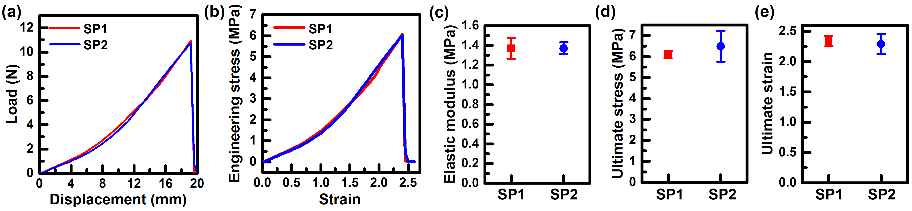

**Figure S1**. Mechanical behavior of SP-PDMS under tensile tests at the strain rate of 0.5 s-1. (a) Representative load–displacement and (b) stress–strain curves for SP-PDMS. (c) Average elastic modulus, (d) tensile stress at break, and (e) strain at break for SP-PDMS. Error bars represent one standard deviation of the data for at least 8 specimens.

## 4.2 Normalization of fluorescence under tensile deformation

The raw fluorescence intensity (*Iraw*) was averaged for all pixels within the bounds of the sample images using ImageJ®. During stretching, the thickness of the specimen is reduced, leading to a decrease in SP concentration in the field of view. This effect is corrected with respect to the measured dimensional change in the specimen.5 Dimensional change in the thickness direction (*λT*) was assumed to be the same as the dimensional change in the width direction (*λW*), since both of those directions were unconstrained during the uniaxial loading. Assuming incompressible behavior, the *λT* was represented as:

|  |  |  |
| --- | --- | --- |
|  |  | (3) |

The thickness-correction was applied by dividing the *Iraw* by *λT*.

|  |  |  |
| --- | --- | --- |
|  |  | (4) |

The thickness-corrected fluorescence (*Icorr*) was normalized with respect to the maximum and minimum intensities. The normalized fluorescence (*I*´) was calculated as:

|  |  |  |
| --- | --- | --- |
|  | dfd | (5) |

where *Icorr*(**) is the fluorescence intensity of a sample at a given strain, *Icorr*(* *= 0) is the intensity of the sample at zero strain, *Icorr*,max and *Icorr*,max are the maximum and minimum intensity of the sample.

## 

# 5. Mechanical response combined with normalized fluorescence intensity

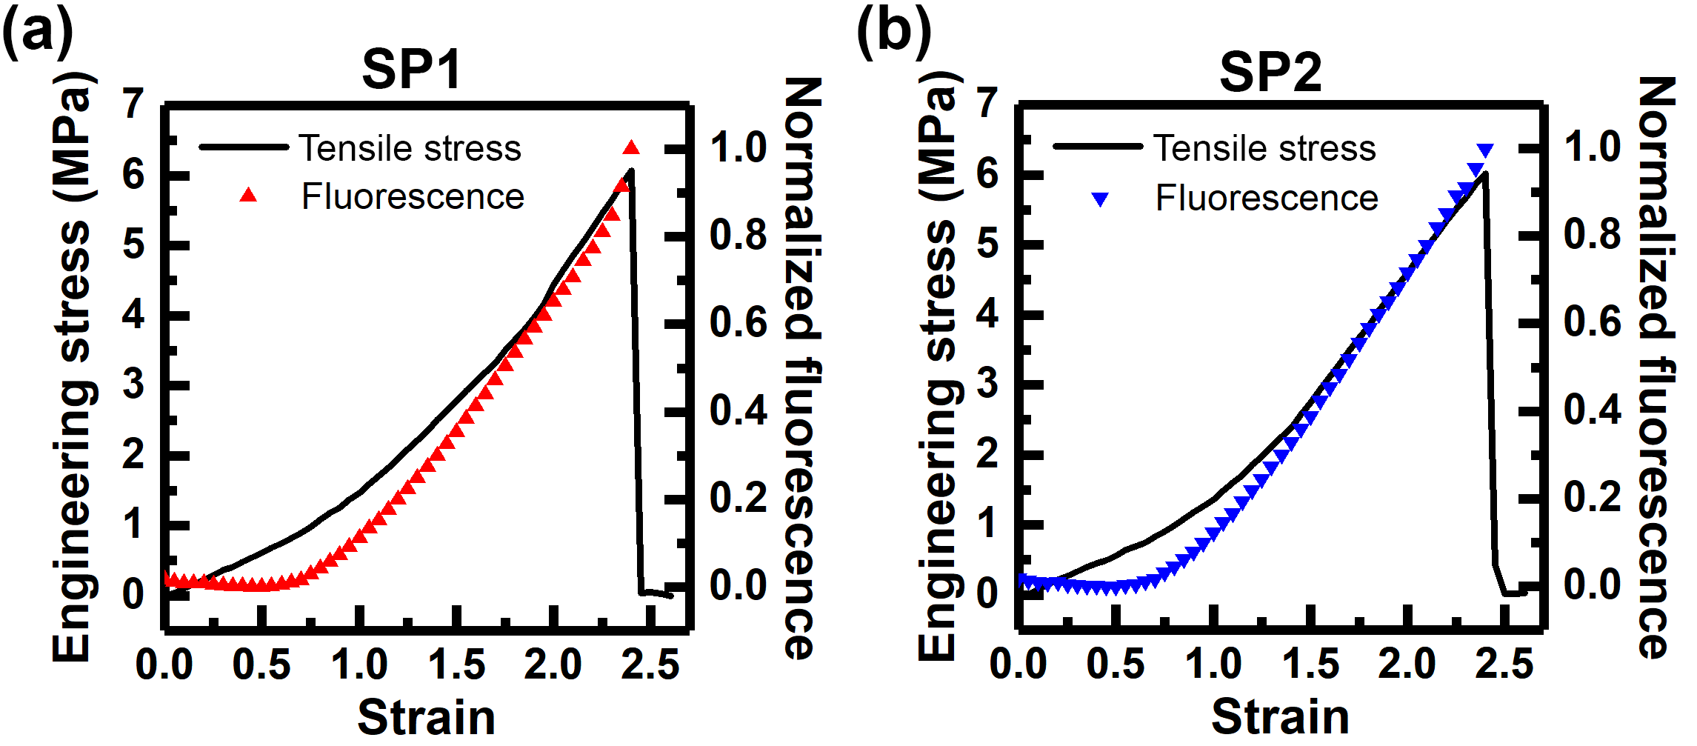

**Figure S2.** Combined stress and normalized fluorescence data as a function of applied strain for (a) **SP1**-PDMS and (b) **SP2**-PDMS.

# 6. Mechanical response and change in normalized fluorescence at a strain rate of 0.005 s-1 in tension

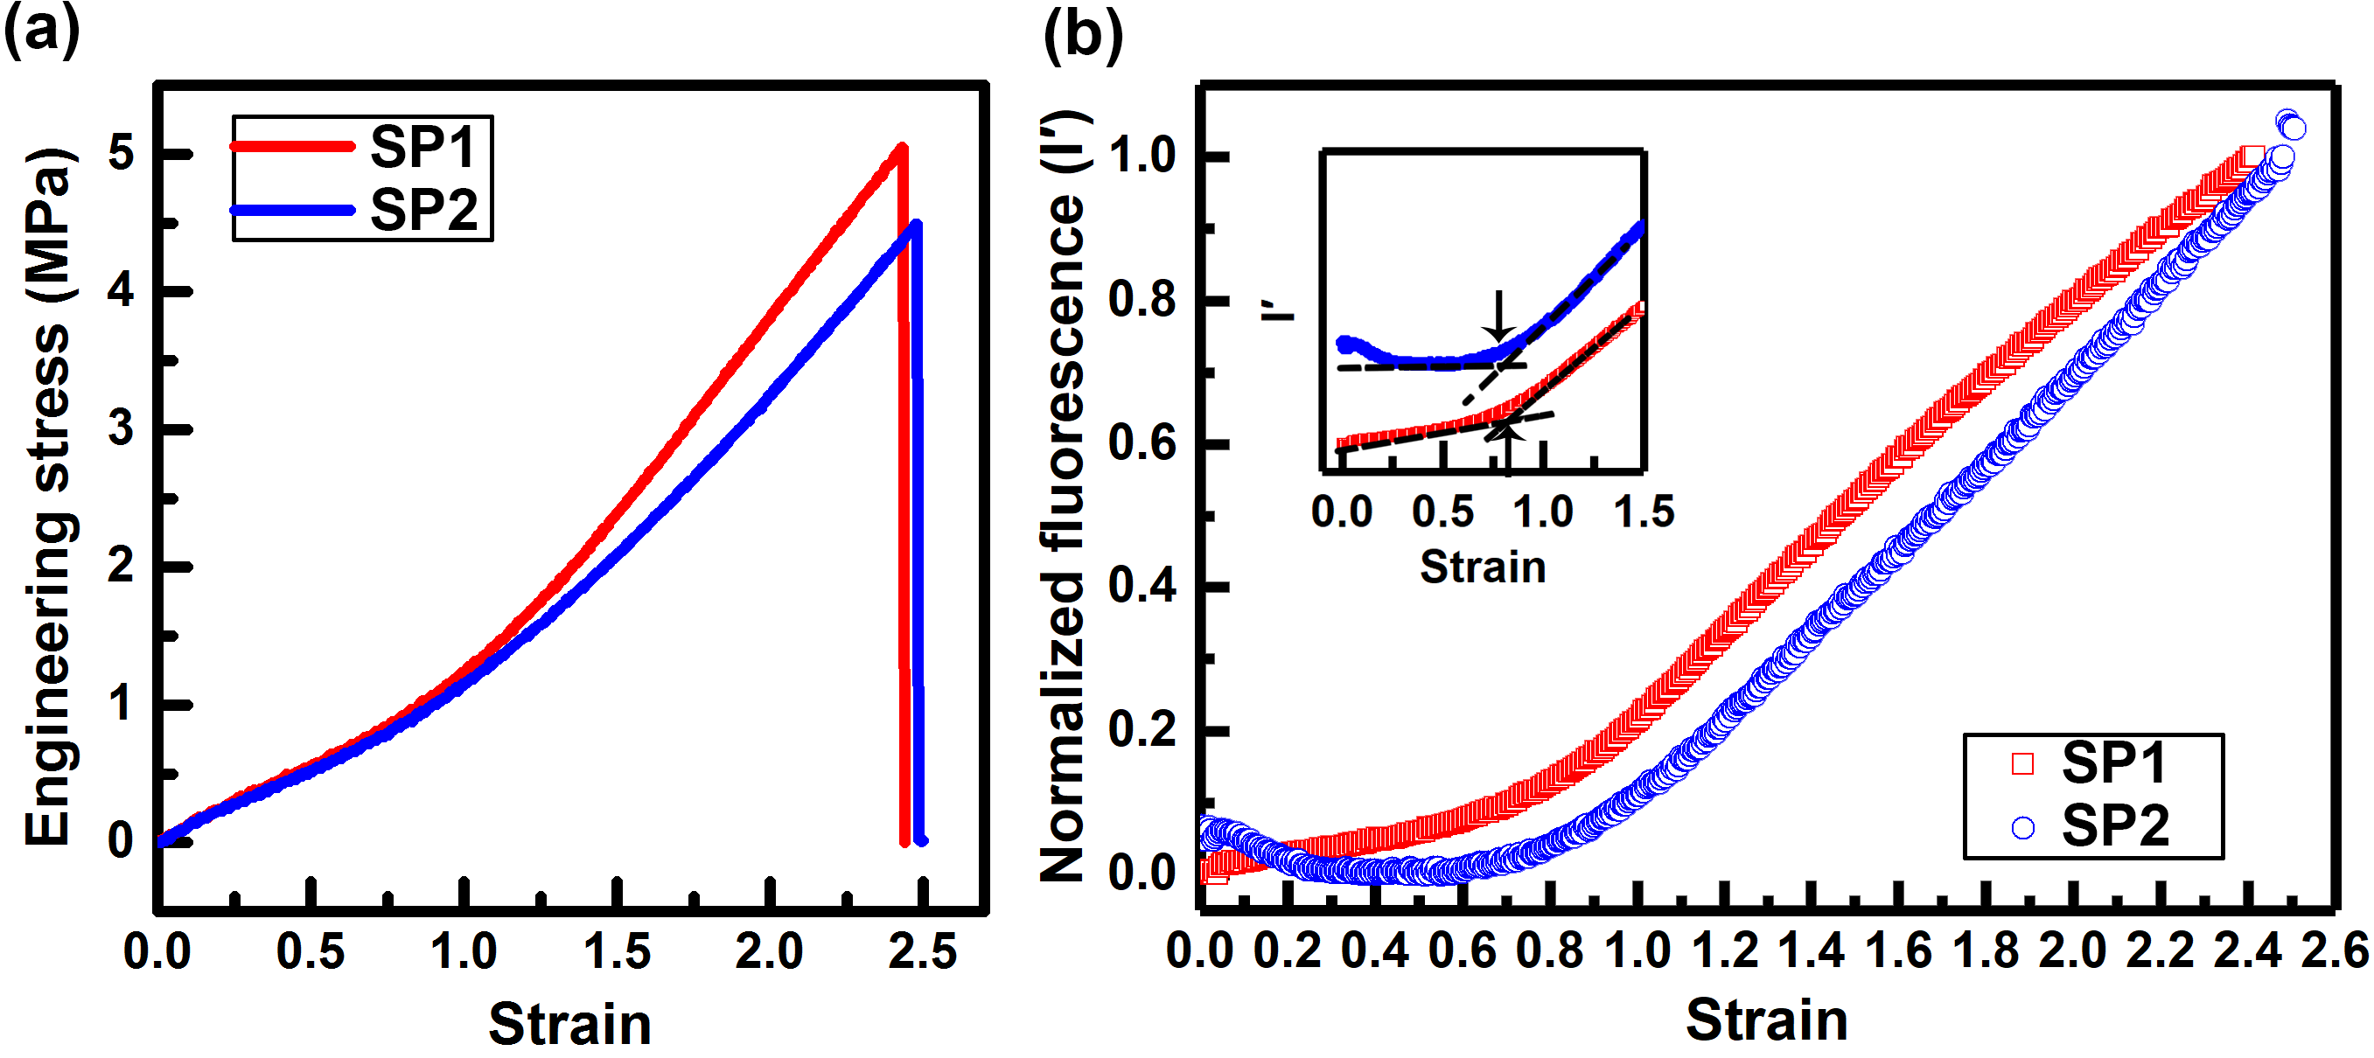

**Figure S3.** Behavior of SP-PDMS loaded in tension at the strain rate of 0.005 s-1. (a) Representative stress-strain curve. (b) The change in normalized fluorescence intensity according to applied strain.

# 7. A monotonic increase in fluorescence above a threshold strain

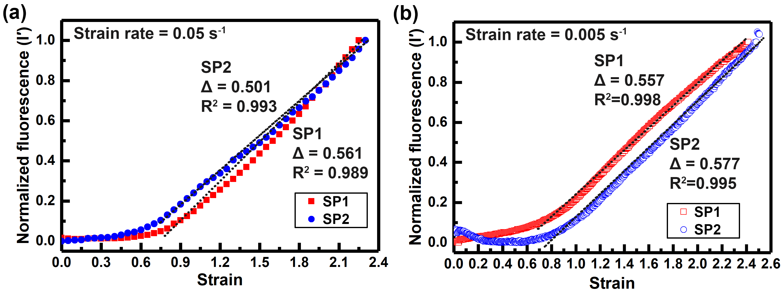

**Figure S4.** Linear regression above a threshold strain. (a) At the strain rate of 0.05 s-1. (b) At the strain rate of 0.005 s-1. Black dots indicate linear fit.

**Table S2**. Comparison of slopes (Δ) for **SP1** and **SP2** from I′ versus strain.

|  |  |  |  |
| --- | --- | --- | --- |
| Strain rate  (s-1) | Δ for **SP1** | Δ for **SP2** | Statistical  difference |
| 0.05 | 0.553 ± 0.032 | 0.539 ± 0.055 | none |
| 0.005 | 0.571 ± 0.013 | 0.563 ± 0.027 | none |

# 8. Kinetic study of SP1-PDMS and SP2-PDMS under tension

## 8.1 Rate constant measurements

The forward and reverse reaction rate constants of **SP1** and **SP2** were determined using a previously reported method.6

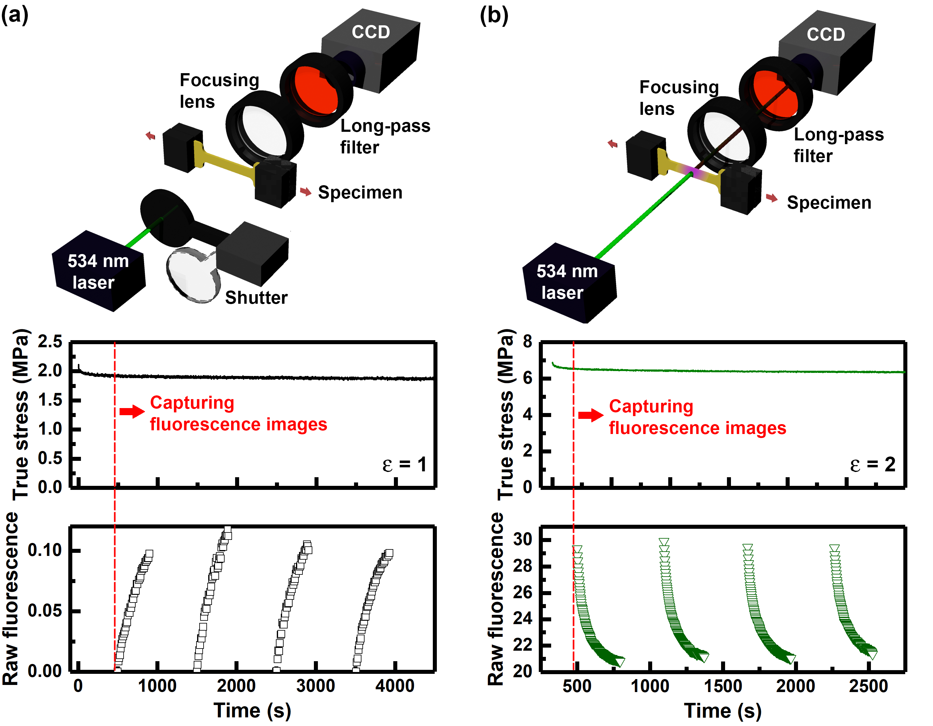

**Figure S5.** Characterization of reaction kinetics for SP-PDMS. Experimental setups and representative data for measuring (a) the forward rate constant and (b) the reverse rate constant. True stress (middle) and corresponding fluorescence intensity (bottom) as a function of time for a constant applied strain for both the forward (increasing fluorescence) and reverse (decreasing fluorescence) reactions. The shutter operates only for measuring forward kinetics. All fluorescence measurements were acquired under dark conditions.

The forward reaction (from SP to MC) rate constant was measured with the combined mechanical and optical testing setup as shown in **Figure S5a**. To minimize photo-bleaching of the MC from the excitation laser, a mechanical shutter was placed in front of the light source that opened only when acquiring images. With this setup, SP-PDMS dog-bone shaped specimens were loaded to a fixed strain value and then exposed to the green laser (0.6 mW) for 5 min to convert the MC back to SP form. After 5 min (denoted by the vertical red line in **Figure S5a**), the stress relaxed to a constant value. Once this equilibrium was reached, fluorescence images were captured every 10 second under dark conditions. After the measurement was finished, the shutter was opened to revert the MC to SP by continuous exposure of the green laser. Then, the shutter operated again to capture the evolution of fluorescence intensity at the same strain. At least 3 measurements were performed at each strain.

The reverse reaction (from MC to SP) rate constant was characterized by a similar procedure shown in **Figure S5b**. The exposure of the green laser drives an equilibrium toward SP from MC and the reverse reaction rates are significantly affected by the laser intensity.

7 In this measurement, the laser intensity was set to 2.5 mW to accelerate the MC to SP conversion. Fluorescence images were captured on every 2 seconds after the sample was held at a constant strain for 5 min under dark conditions. When the fluorescence intensity reached a constant value, the green laser was blocked to revert the SP to MC form under stress relaxation. After 5 min, the fluorescence images were acquired while the sample was fully exposed to the green laser. At least 3 measurements were performed at each strain.

## 8.2 Forward reaction kinetics

The fluorescence intensity changes were measured at four different strain values. True stress was calculated from the final dimensions of the deformed samples. The representative stress at each strain value was calculated by averaging the true stress values over 480 s.

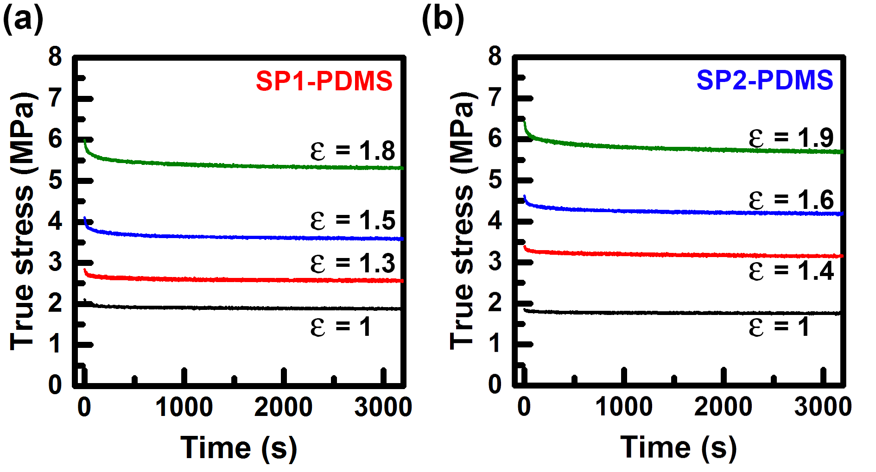

**Figure S6.** Stress relaxation behavior of (a) **SP1**-PDMS and (b) **SP2**-PDMS for different strains.

Assuming the SP—MC transition is a unimolecular reaction, the kinetics of SP activation can be described by:

|  |  |  |
| --- | --- | --- |
|  | dfd | (6) |

where [MC(*t*)] is MC concentration at a certain time *t*, *A*0 is a pre-exponential factor, and *kf* is forward rate constant. The rate constants at each stress value are extracted by fitting the measured data to Eq. (6).

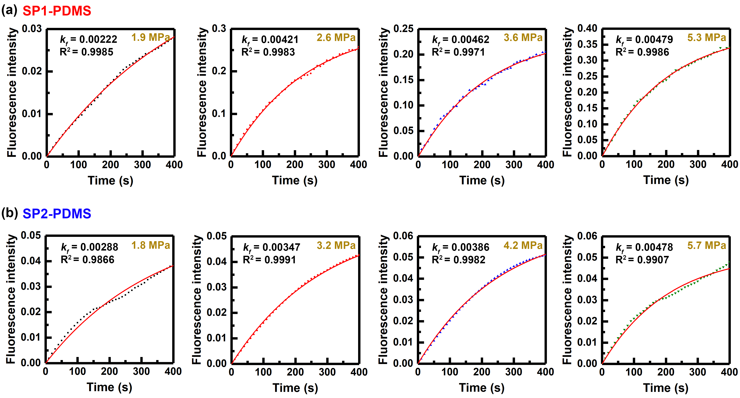

**Figure S7.** Representative change in fluorescence intensity (SP to MC) and corresponding fit to equation (6) (red line) for (a) **SP1**-PDMS and (b) **SP2**­PDMS.

**Table S3**. *kf* values for **SP1** and **SP2** under different stress levels.

|  |  |  |  |  |
| --- | --- | --- | --- | --- |
| True stress  (MPa) | *kf* for **SP1**  (s-1) |  | True stress  (MPa) | *kf* for **SP2**  (s-1) |
| 1.9 | 0.0037 ± 0.0005 | 1.8 | 0.0023 ± 0.0008 |
| 2.6 | 0.0042 ± 0.0002 | 3.2 | 0.0030 ± 0.0005 |
| 3.6 | 0.0046 ± 0.0002 | 4.2 | 0.0033 ± 0.0006 |
| 5.3 | 0.0054 ± 0.0008 | 5.7 | 0.0047 ± 0.0006 |

## 8.3 Reverse reaction kinetics

The fluorescence intensity changes were measured at five different strain values. True stress was calculated from the final dimensions of the deformed samples.

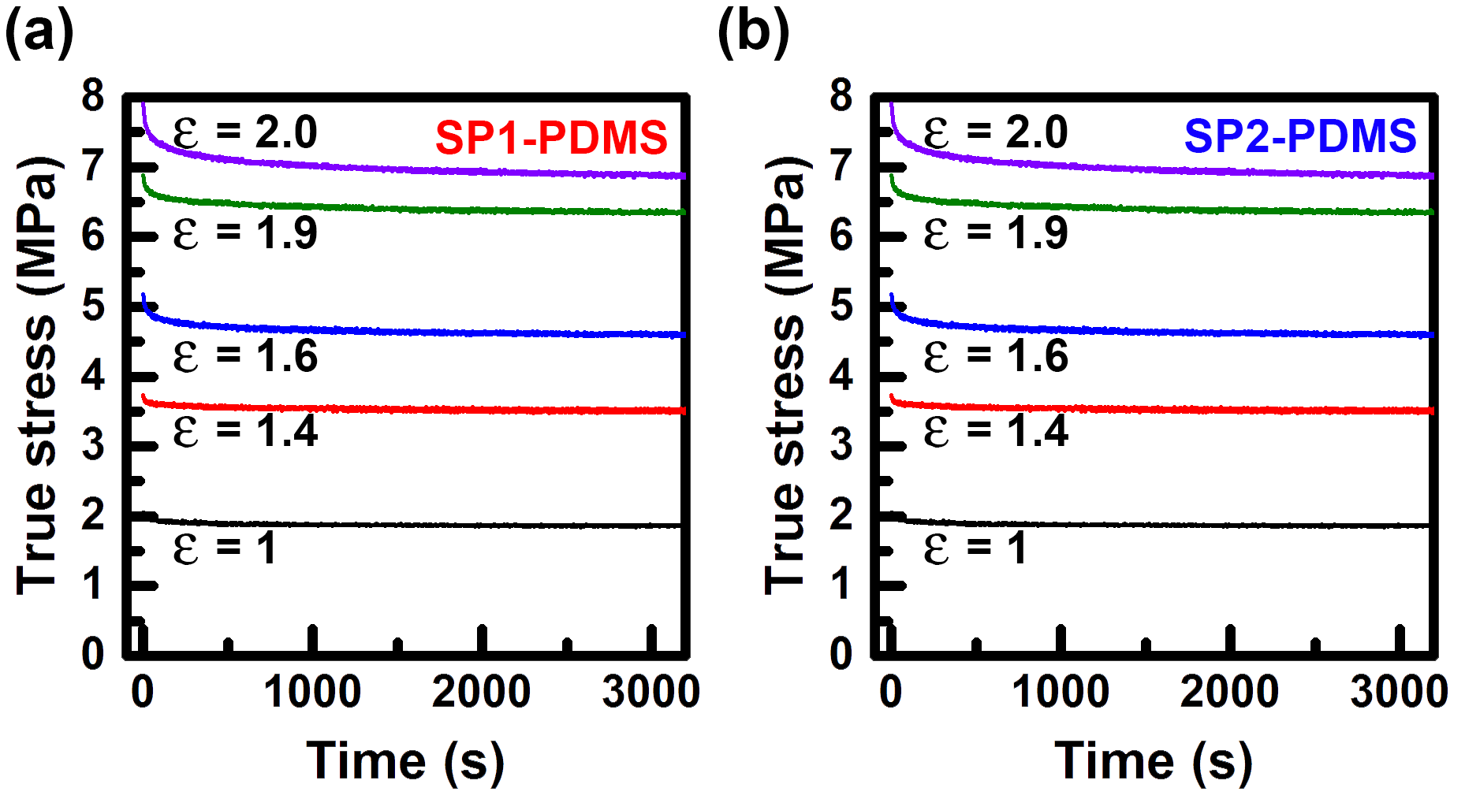

**Figure S8.** Stress relaxation behavior of (a) **SP1**-PDMS and (b) **SP2**-PDMS for different strains.

We obtained the reverse rate constant as a function of true stress by fitting the results to a bi-exponential decay equation at each stress value:

|  |  |  |
| --- | --- | --- |
|  |  | (7) |

where [MC(*t*)]0 is MC concentration at a certain time *t*, *A*1 and *A*2 are pre-exponential factors, and *kr,1* and *kr,2* are reverse rate constants.

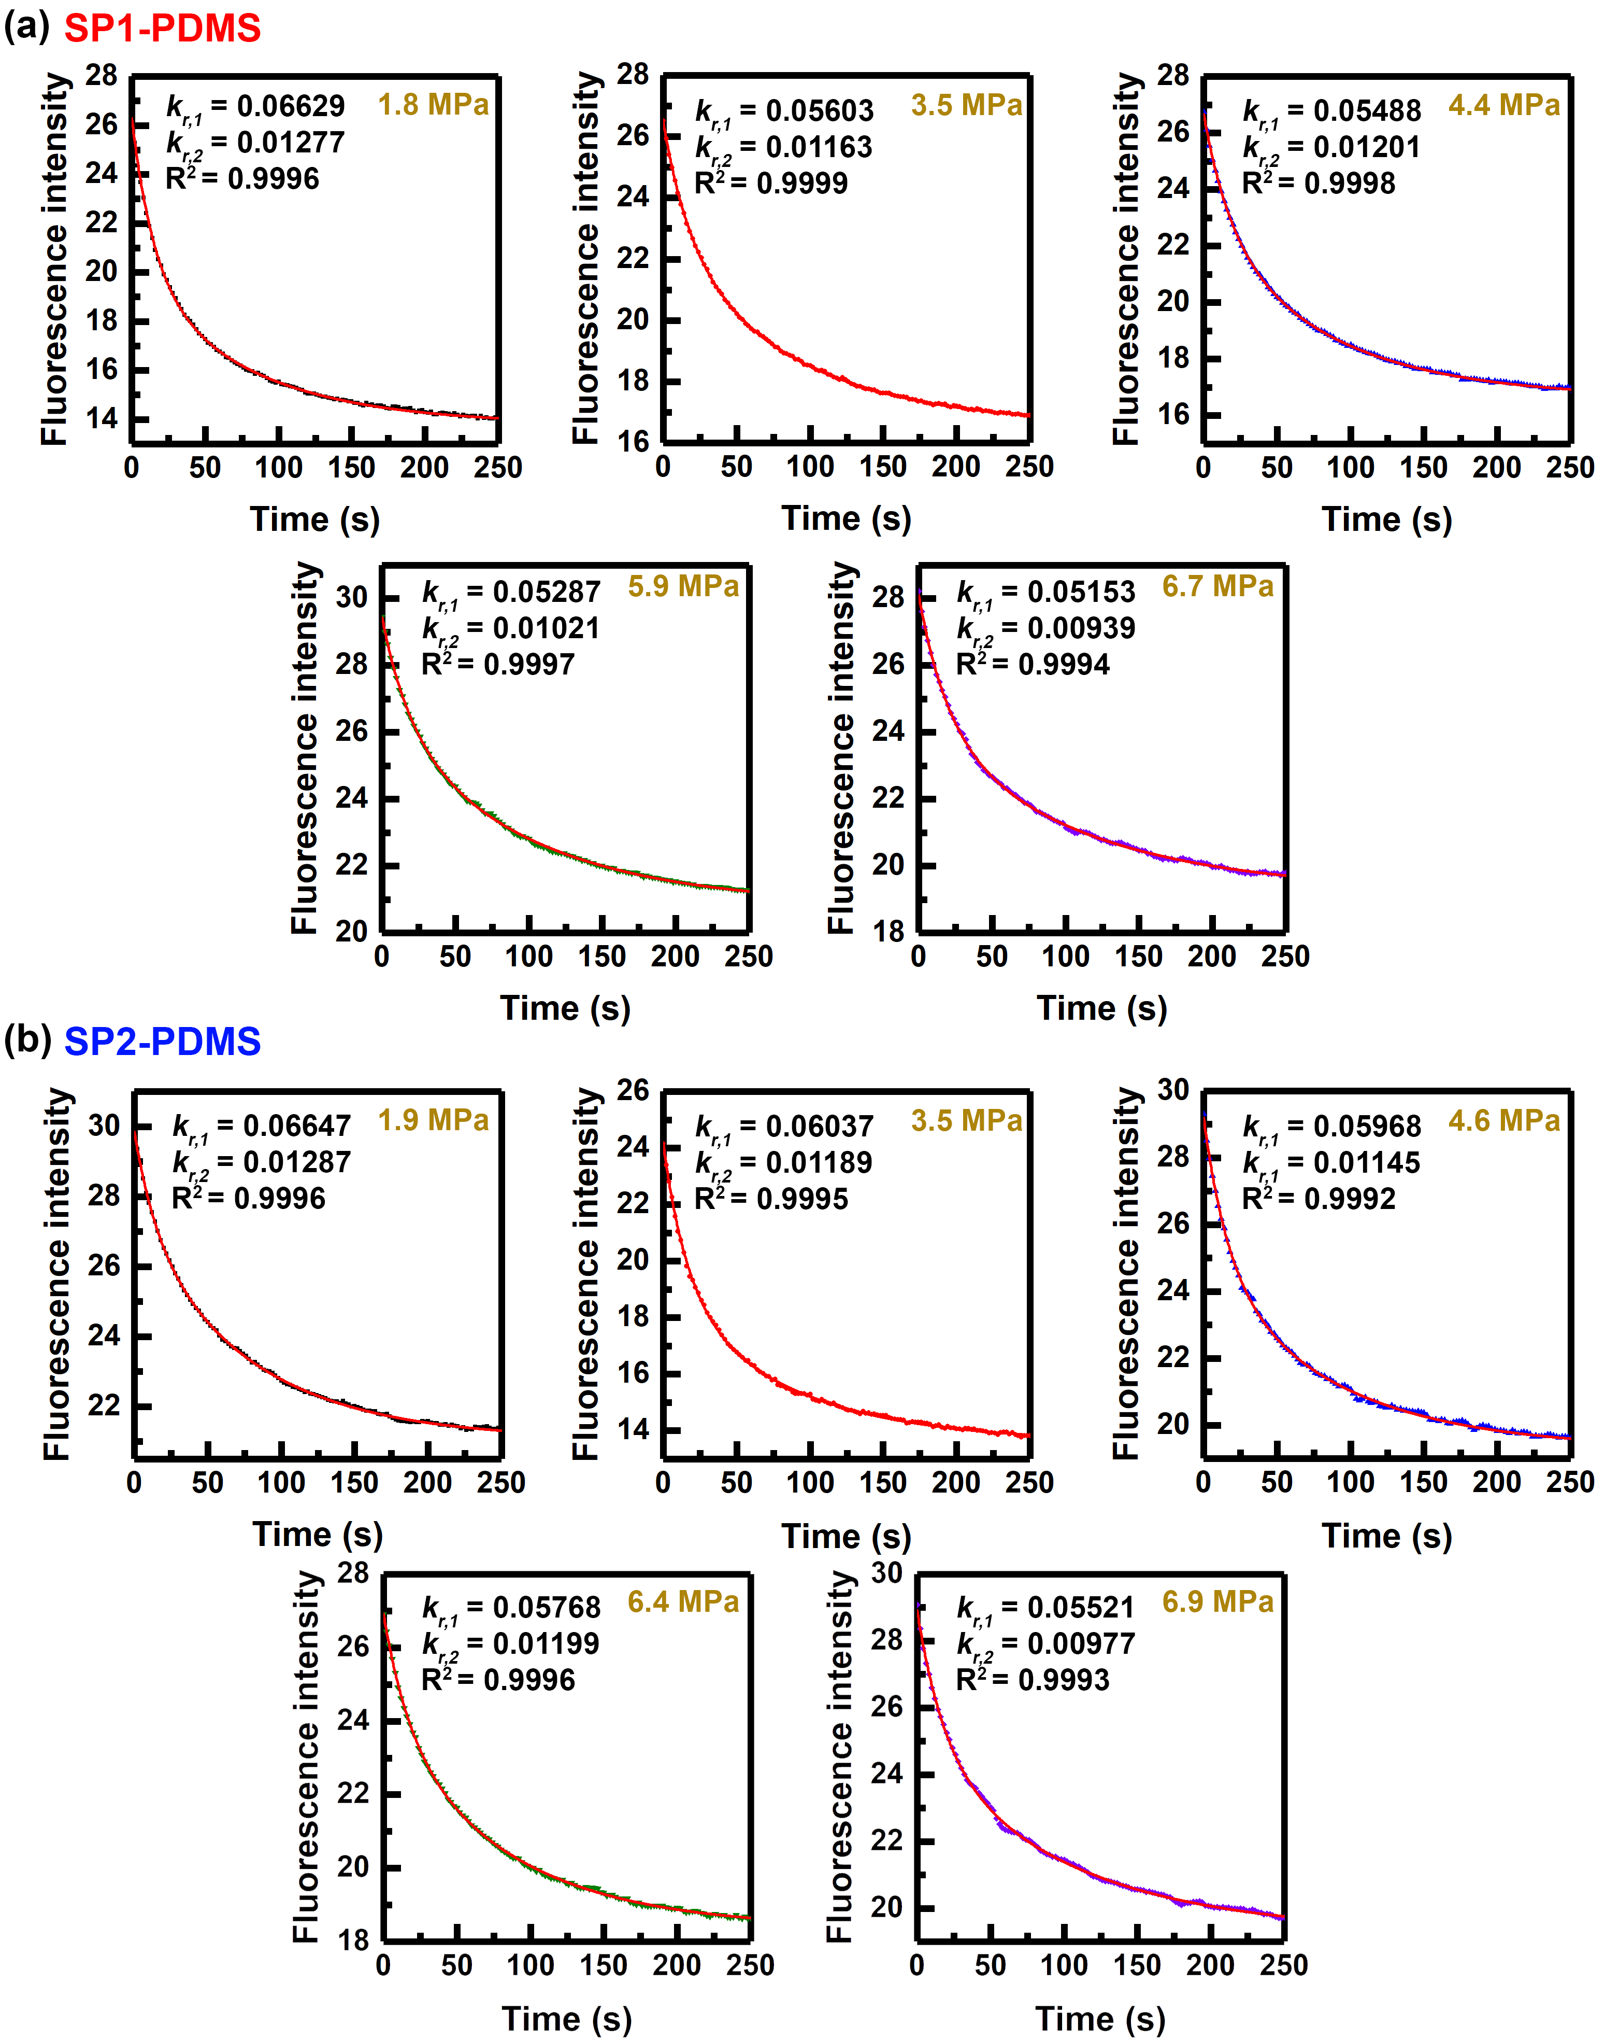

**Figure S9.** Representative change in fluorescence intensity (MC to SP) and corresponding fit to equation (7) (red line) for (a) **SP1**-PDMS and (b) **SP2**-PDMS.

**Table S4**. *kr,1* values for **SP1** and **SP2** under different stress levels.

|  |  |  |  |  |
| --- | --- | --- | --- | --- |
| True stress  (MPa) | *kr,1* for **SP1**  (s-1) |  | True stress  (MPa) | *kr,1* for **SP2**  (s-1) |
| 1.8 | 0.064 ± 0.003 | 1.9 | 0.067 ± 0.002 |
| 3.5 | 0.058 ± 0.002 | 3.5 | 0.063 ± 0.003 |
| 4.4 | 0.057 ± 0.002 | 4.6 | 0.059 ± 0.002 |
| 5.9 | 0.052 ± 0.001 | 6.4 | 0.058 ± 0.002 |
| 6.8 | 0.051 ± 0.002 | 6.9 | 0.054 ± 0.002 |

**Table S5**. *kr,2* values for **SP1** and **SP2** under different stress levels.

|  |  |  |  |  |
| --- | --- | --- | --- | --- |
| True stress  (MPa) | *kr,2* for **SP1**  (s-1) |  | True stress  (MPa) | *kr,2* for **SP2**  (s-1) |
| 1.8 | 0.012 ± 0.0004 | 1.9 | 0.013 ± 0.0001 |
| 3.5 | 0.012 ± 0.0002 | 3.5 | 0.012 ± 0.0005 |
| 4.4 | 0.012 ± 0.0005 | 4.6 | 0.011 ± 0.0003 |
| 5.9 | 0.011 ± 0.0009 | 6.4 | 0.011 ± 0.0005 |
| 6.8 | 0.010 ± 0.0007 | 6.9 | 0.009 ± 0.0006 |

# 9. References

(1) Davis, D. A.; Hamilton, A.; Yang, J.; Cremar, L. D.; Van Gough, D.; Potisek, S. L.; Ong, M. T.; Braun, P. V.; Martinez, T. J.; White, S. R.; et al. Force-Induced Activation of Covalent Bonds in Mechanoresponsive Polymeric Materials. *Nature* **2009**, *459* (7243), 68–72.

(2) Gossweiler, G. R.; Hewage, G. B.; Soriano, G.; Wang, Q.; Welshofer, G. W.; Zhao, X.; Craig, S. L. Mechanochemical Activation of Covalent Bonds in Polymers with Full and Repeatable Macroscopic Shape Recovery. *ACS Macro Lett.* **2014**, *3* (3), 216–219.

(3) Beyer, M. K. The Mechanical Strength of a Covalent Bond Calculated by Density Functional Theory. *J. Chem. Phys.* **2000**, *112* (17), 7307.

(4) Kryger, M. J.; Munaretto, A. M.; Moore, J. S. Structure-Mechanochemical Activity Relationships for Cyclobutane Mechanophores. *J. Am. Chem. Soc.* **2011**, *133* (46), 18992–18998.

(5) Beiermann, B. A.; Kramer, S. L. B.; May, P. A.; Moore, J. S.; White, S. R.; Sottos, N. R. The Effect of Polymer Chain Alignment and Relaxation on Force-Induced Chemical Reactions in an Elastomer. *Adv. Funct. Mater.* **2014**, *24* (11), 1529–1537.

(6) Kim, T. A.; Beiermann, B. A.; White, S. R.; Sottos, N. R. Effect of Mechanical Stress on Spiropyran-Merocyanine Reaction Kinetics in a Thermoplastic Polymer. *ACS Macro Lett.* **2016**, *5*, 1312–1316.

(7) Beiermann, B. A. Mechanical and Optical Characterization of Force Induced Chemical Reactions in Solid State Linear Polymers, Ph.D. Dissertation, University of Illinois Urbana-Champaign, IL, 2013.