Supporting Information

Highly Emissive Cycloplatinated(II) Complexes Obtained by the Chloride Abstraction from the Complex [Pt(ppy)(PPh₃)(Cl)]: Employing Various Silver Salts

Hamid R. Shahsavari,ª* Reza Babadi Aghakhanpour,ª Mahshid Nikravesh,ª John Ozdemir,^{b} Mohsen Golbon Haghighi,^{c} Behrouz Notash^{c} and M. Hassan Beyzavi*^{b}
ªDepartment of Chemistry, Institute for Advanced Studies in Basic Sciences (IASBS), Zanjan 45137-66731, Iran.
^{b}Department of Chemistry and Biochemistry, University of Arkansas, Fayetteville, Arkansas 72701, United States.
^{c}Department of Chemistry, Shahid Beheshti University, Evin, Tehran 19839-69411, Iran.
*Email: shahsavari@iasbs.ac.ir (H.R.S.), beyzavi@uark.edu (M.H.B.).

Contents: | Page
Figure S1. ¹HNMR spectrum of the complex 4a in CDCl₃. | S3
Figure S2. ³¹P{H}NMR spectrum of the complex 4a in CDCl₃. | S4
Figure S3. ¹⁹⁵PtNMR spectrum of the complex 4a in CDCl₃. | S5
Figure S4. ¹HNMR spectrum of the complex 4b in CDCl₃. | S6
Figure S5. ³¹P{H}NMR spectrum of the complex 4b in CDCl₃. | S7
Figure S6. ¹⁹⁵PtNMR spectrum of the complex 4b in CDCl₃. | S8
Figure S7. ¹HNMR spectrum of the complex 5a in CDCl₃. | S9
Figure S8. ³¹P{H}NMR spectrum of the complex 5a in CDCl₃. | S10
Figure S9. ¹⁹⁵PtNMR spectrum of the complex 5a in CDCl₃. | S11
Figure S10. ¹HNMR spectrum of the complex 5b in CDCl₃. | S12
Figure S11. ³¹P{H}NMR spectrum of the complex 5b in CDCl₃. | S13
Figure S12. ¹⁹⁵PtNMR spectrum of the complex 5b in CDCl₃. | S14
Figure S13. Crystal packing of the complex 4a. | S15
Figure S14. Crystal packing of the complex 4b. | S16
Figure S15. Crystal packing of the complex 5a. | S17
Figure S16. Normalized emission spectra for the complexes 4a, 4b, 5a and 5b in PMMA films at 298 K. | S18
Table S1. Selected geometrical parameters (Å, °) for the complexes 4a and 5a in gas phase and CH₂Cl₂ solution. | S19
Table S2. The energies of the selected molecular orbitals of complexes 4a and 5a together with their compositions in CH₂Cl₂. | S20
Figure S17. Selected molecular orbital plots of the complex 4a. | S21
Figure S18. Selected molecular orbital plots of the complex 5a. | S22
Table S3. Wavelengths and nature of transitions for the complex 4a where M = Pt, L = ppy, Lʹ = PPh₃ and Lʹʹ = NO₃. | S23
Table S4. Wavelengths and nature of transitions for the complex 5a where M = Pt, L = ppy, Lʹ = PPh₃ and Lʹʹ = CH₃CN. | S24
Table S5. Crystallographic and structure refinement data for the complexes 4a, 4b and 5a. | S25

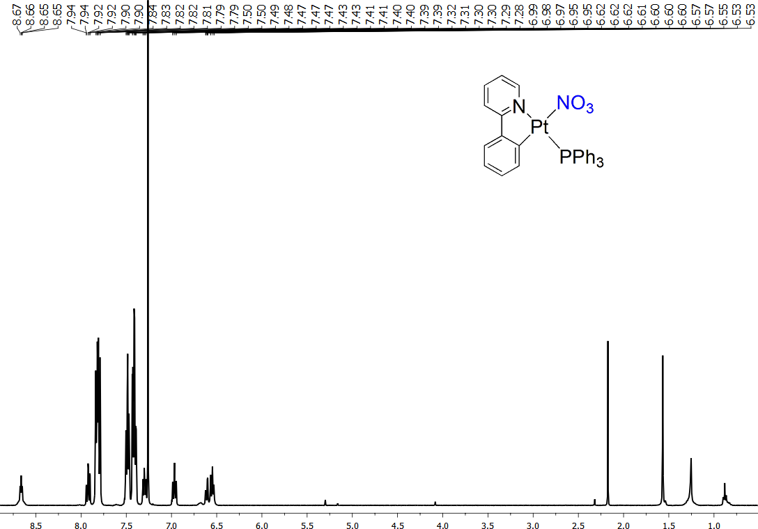
Figure S1. ¹HNMR spectrum of the complex 4a in CDCl₃.
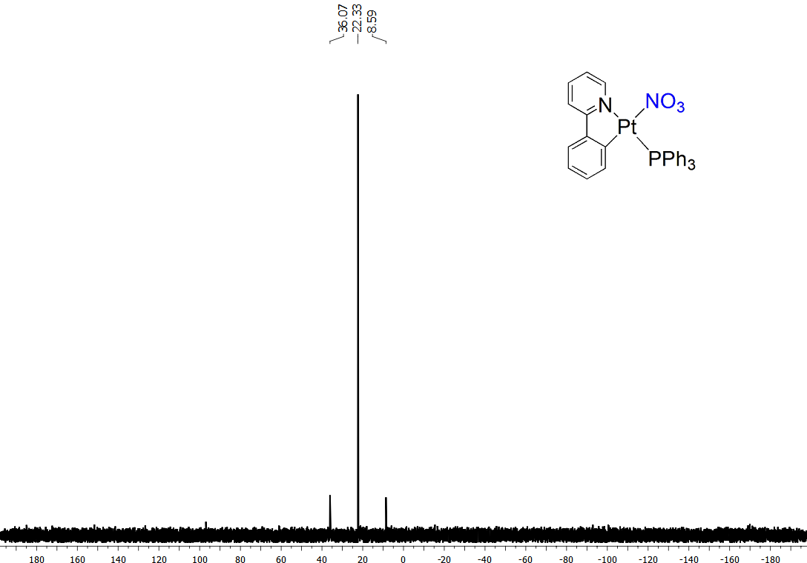
Figure S2. ³¹P{H}NMR spectrum of the complex 4a in CDCl₃.
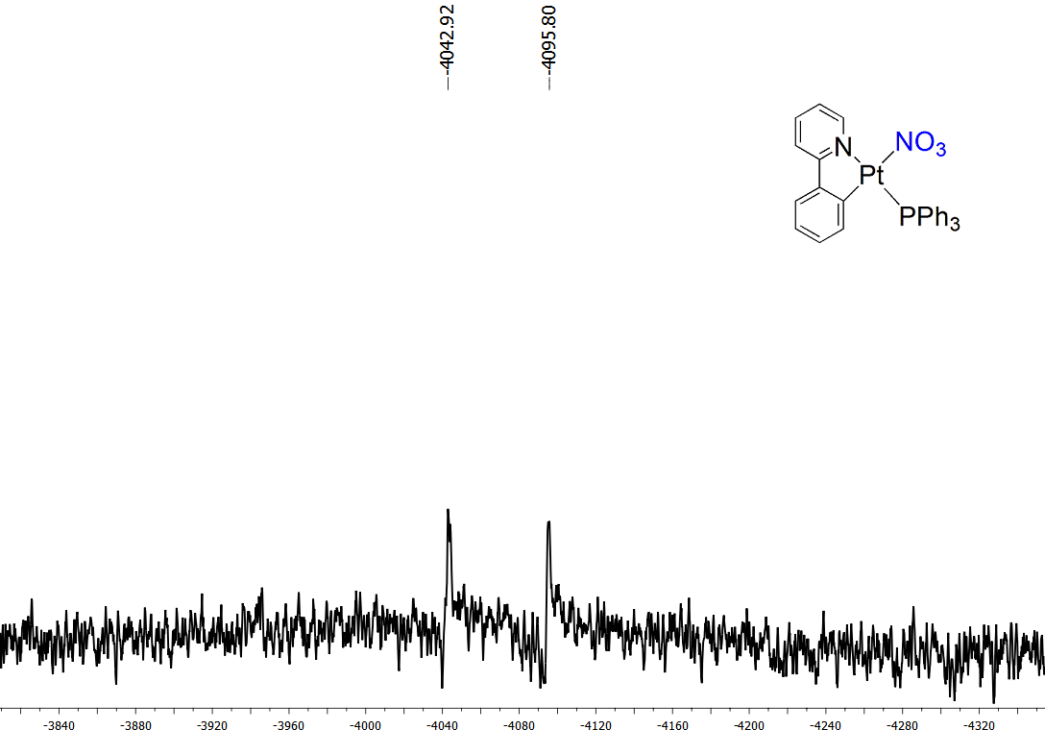
Figure S3. ¹⁹⁵PtNMR spectrum of the complex 4a in CDCl₃.
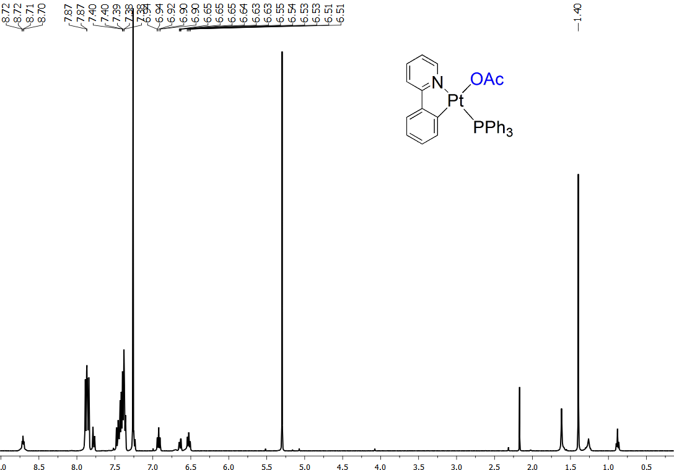
Figure S4. ¹HNMR spectrum of the complex 4b in CDCl₃.
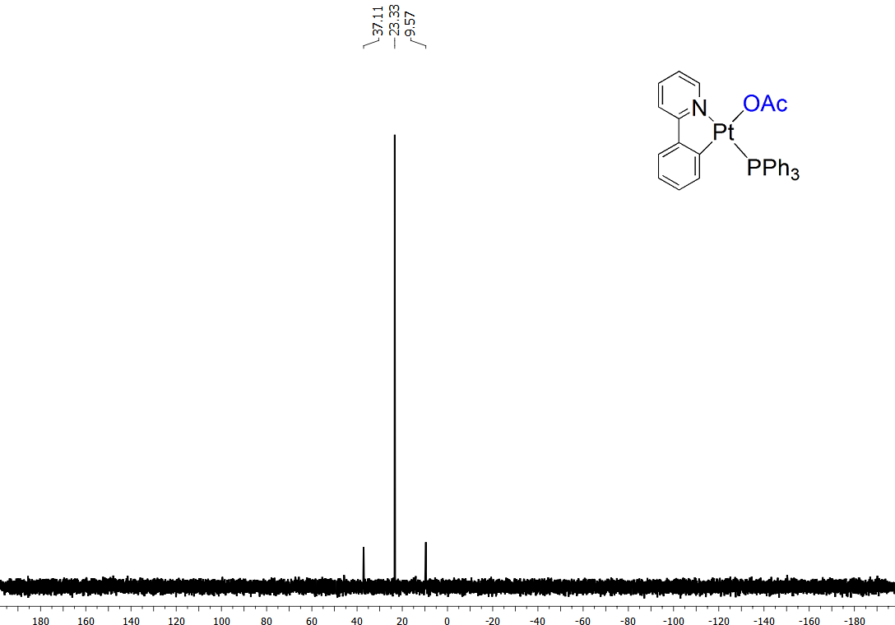
Figure S5. ³¹P{H}NMR spectrum of the complex 4b in CDCl₃.
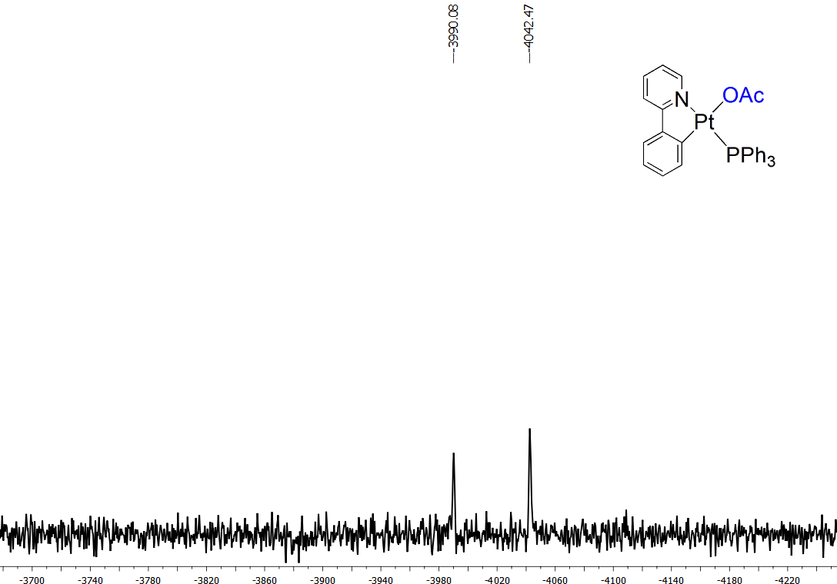
Figure S6. ¹⁹⁵PtNMR spectrum of the complex 4b in CDCl₃.
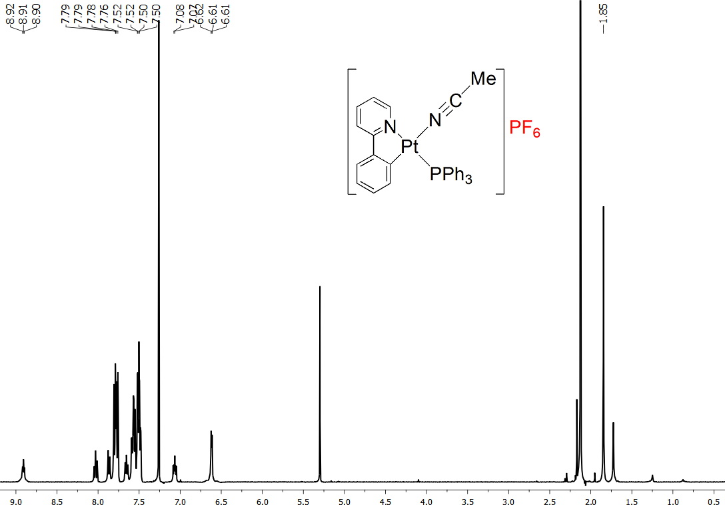
Figure S7. ¹HNMR spectrum of the complex 5a in CDCl₃.
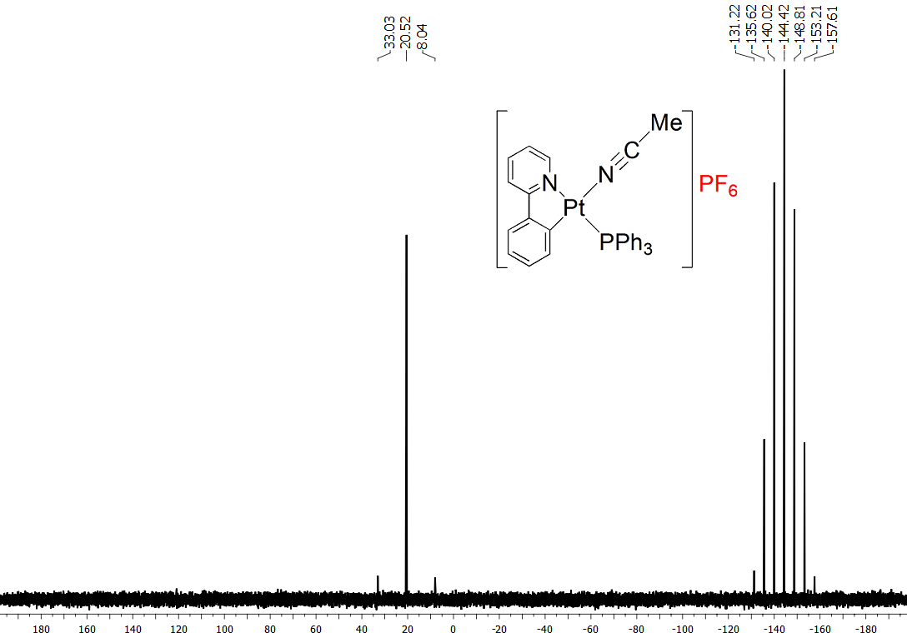
Figure S8. ³¹P{H}NMR spectrum of the complex 5a in CDCl₃.
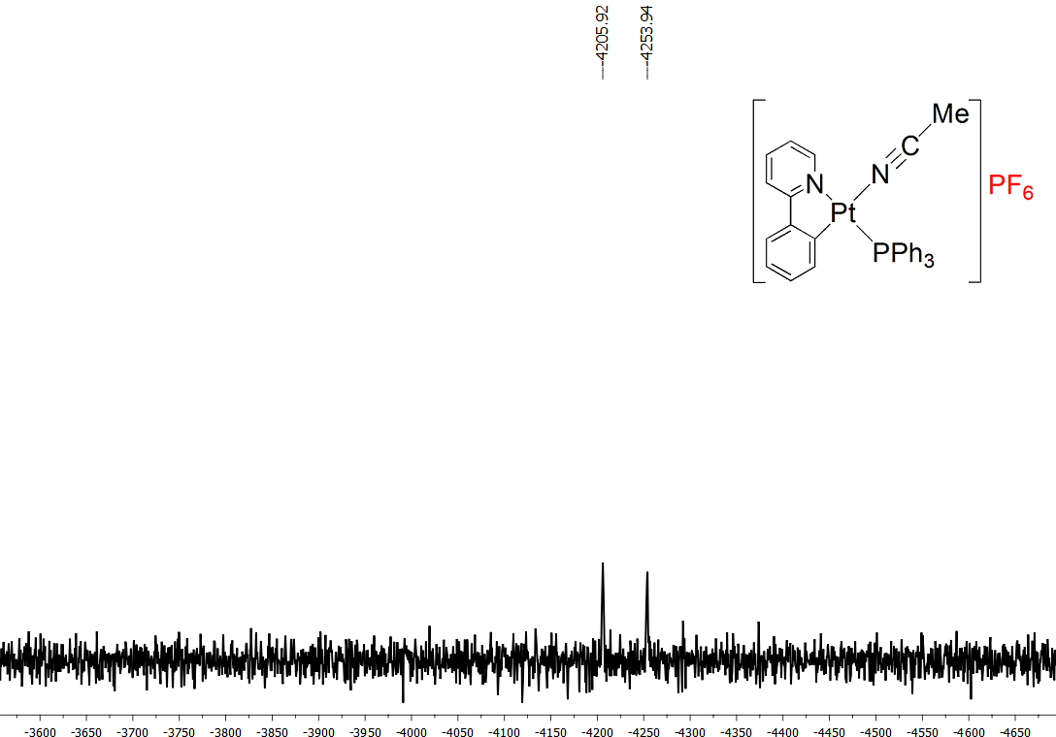
Figure S9. ¹⁹⁵PtNMR spectrum of the complex 5a in CDCl₃.
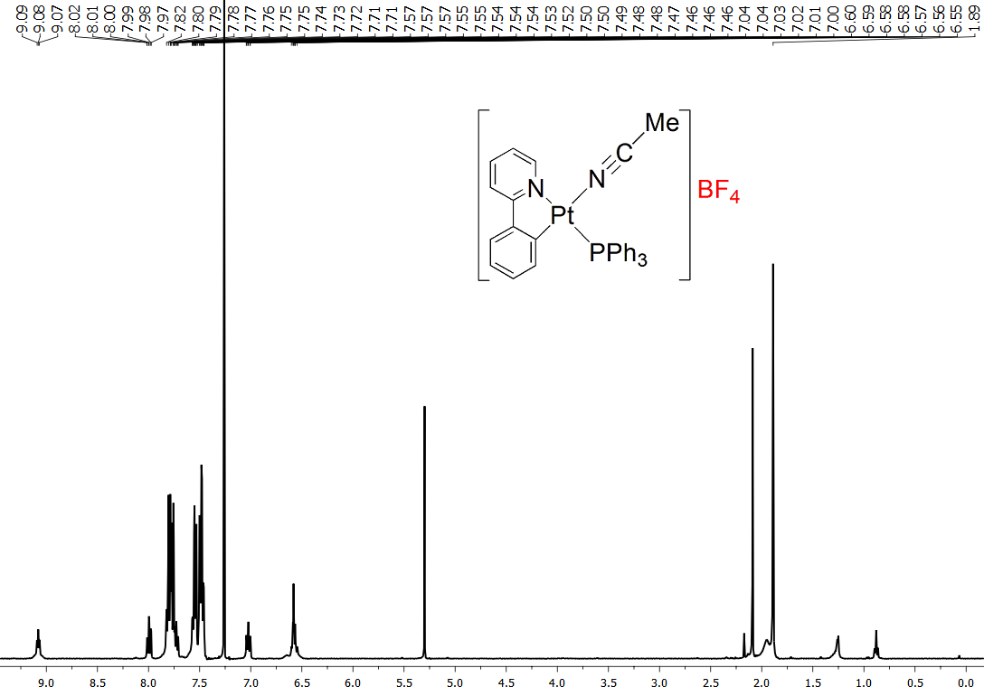
Figure S10. ¹HNMR spectrum of the complex 5b in CDCl₃.
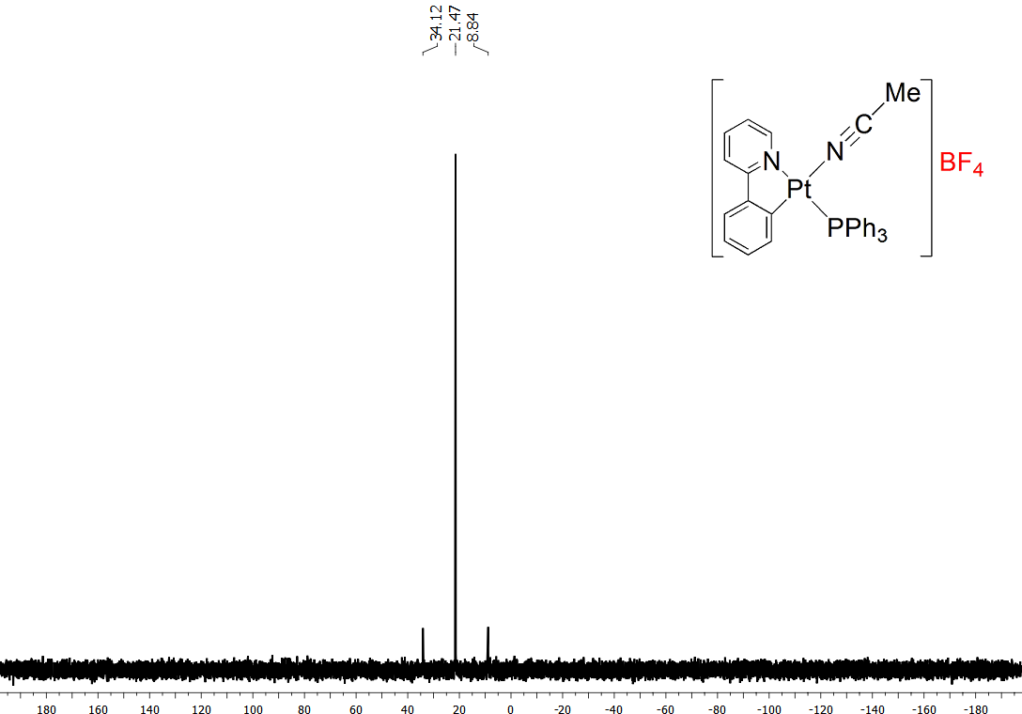
Figure S11. ³¹P{H}NMR spectrum of the complex 5b in CDCl₃.
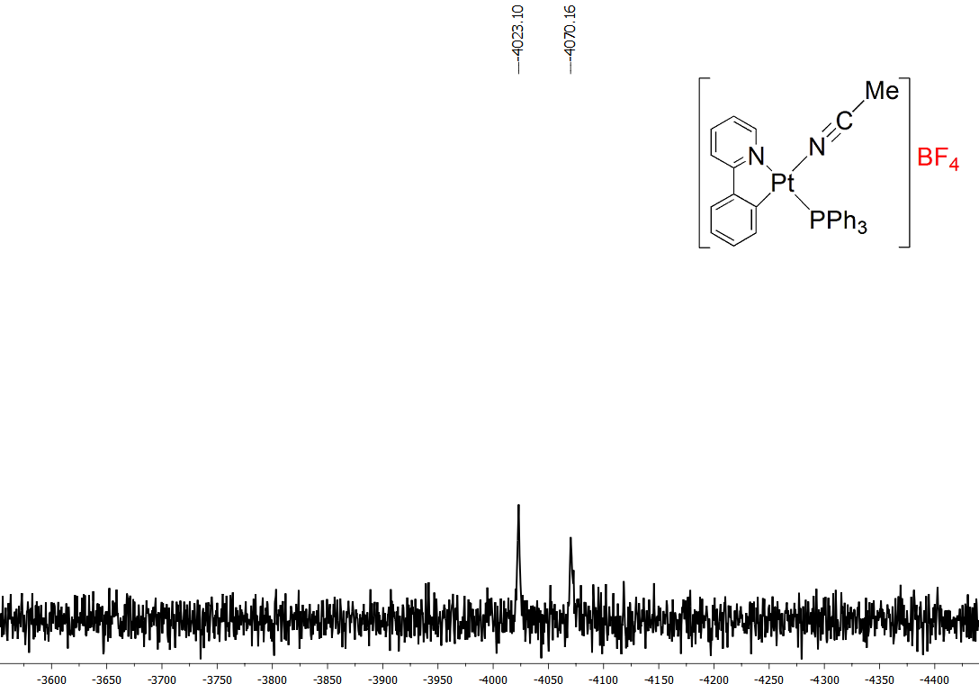
Figure S12. ¹⁹⁵PtNMR spectrum of the complex 5b in CDCl₃.
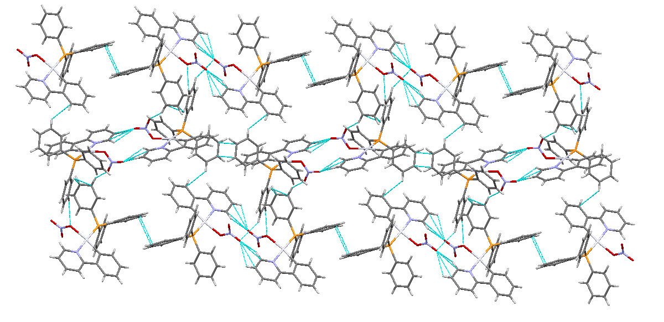
Figure S13. Crystal packing of the complex 4a.

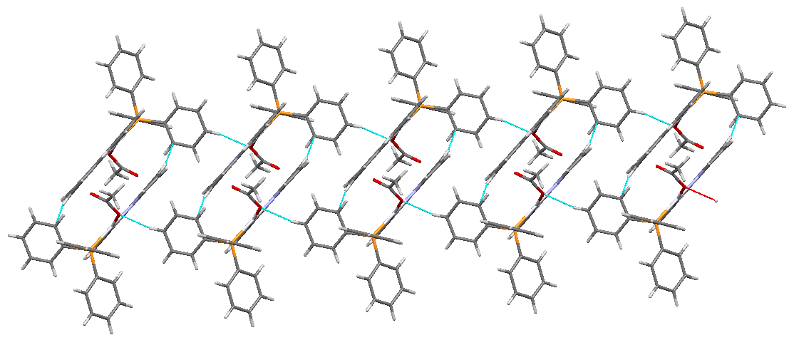
Figure S14. Crystal packing of the complex 4b.

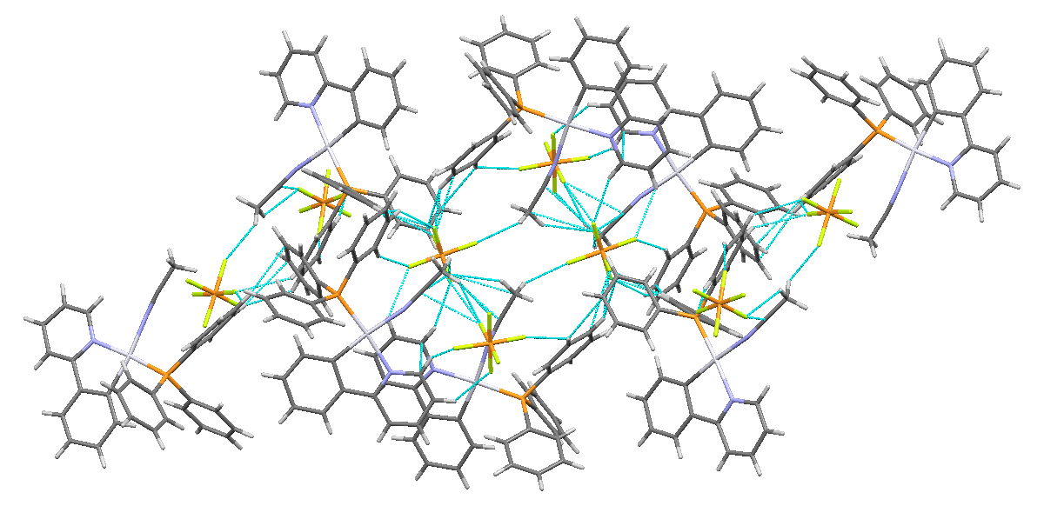
Figure S15. Crystal packing of the complex 5a.

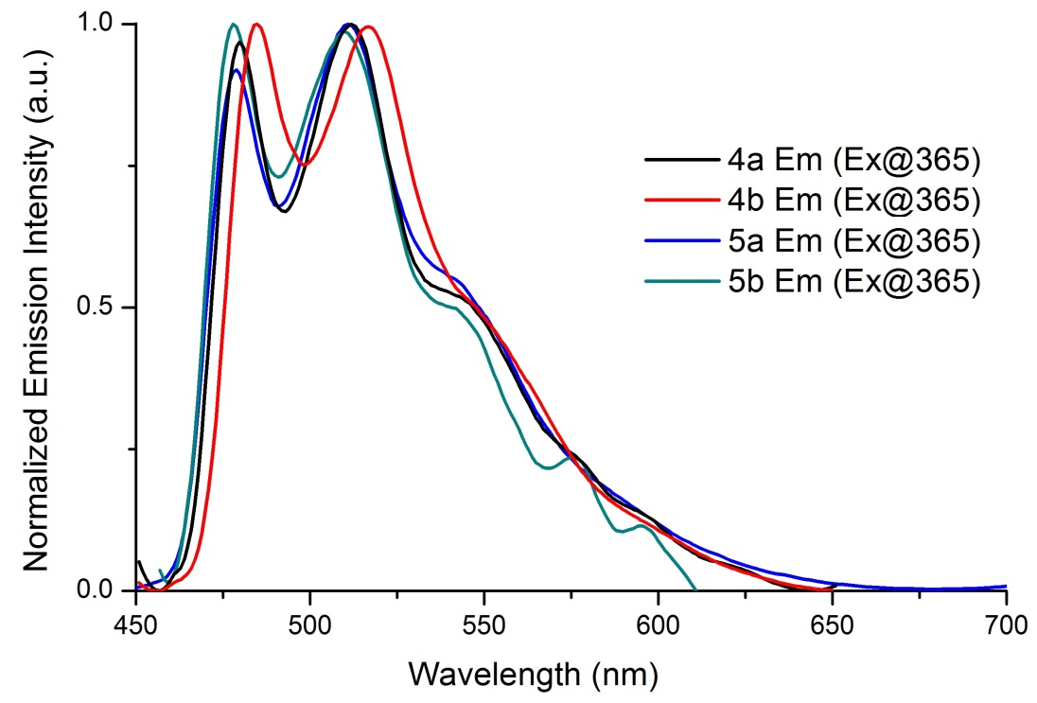
Figure S16. Normalized emission spectra for the complexes 4a, 4b, 5a and 5b in PMMA films at 298 K.

Table S1. Selected geometrical parameters (Å, °) for the complexes 4a and 5a in gas phase and CH₂Cl₂ solution.
Complex 4a |  |  | Complex 5a
Bond distances and angles | Gas phase | CH₂Cl₂ | Bond distances and angles | Gas phase | CH₂Cl₂
Pt1-P1 | 2.31070 | 2.31891 | Pt1-P1 | 2.34392 | 2.34235
Pt1-C1 | 2.01854 | 2.01484 | Pt1-C1 | 2.02047 | 2.02165
Pt1-N1 | 2.10089 | 2.10913 | Pt1-N1 | 2.11820 | 2.11873
Pt1-O1 | 2.17076 | 2.20380 | Pt1-N2 | 2.16009 | 2.15186
P1-C12 | 1.84517 | 1.84599 | P1-C12 | 1.84665 | 1.84486
P1-C18 | 1.84616 | 1.84389 | P1-C18 | 1.83545 | 1.83702
P1-C24 | 1.83783 | 1.83773 | P1-C24 | 1.83791 | 1.84013
N2-O1 | 1.32290 | 1.30908 | N2-C30 | 1.15702 | 1.15698
N2-O2 | 1.24321 | 1.24294 | C30-C31 | 1.45690 | 1.45493
N2-O3 | 1.22780 | 1.23565 | P1-Pt1-C1 | 96.59953 | 96.88339
P1-Pt1-C1 | 99.50941 | 98.87025 | C1-Pt1-N1 | 80.43856 | 80.38248
C1-Pt1-N1 | 80.53301 | 80.49588 | N1-Pt1-N2 | 92.48777 | 92.39304
N1-Pt1-O1 | 87.73111 | 88.92951 | N2-Pt1-P1 | 90.48867 | 90.34251
O1-Pt1-P1 | 92.22709 | 91.63043 | P1-Pt1-N1 | 176.98078 | 177.26112
P1-Pt1-N1 | 176.47798 | 176.30621 | N2-Pt1-C1 | 172.75787 | 172.75439
O1-Pt1-C1 | 168.25822 | 169.39360 | Pt1-N2-C30 | 176.42784 | 179.23936
Pt1-O1-N2 | 115.78547 | 117.57872 | N2-C30-C31 | 178.94206 | 179.48706
O1-N2-O2 | 118.71986 | 119.47292
O2-N2-O3 | 124.36731 | 123.35855
O1-N2-O3 | 116.91236 | 117.16831

Table S2. The energies of the selected molecular orbitals of complexes 4a and 5a together with their compositions in CH₂Cl₂.
 |  | Complex 4a |  |  |  |  | Complex 5a
 |  | Energy  (eV) | Components(%) |  |  |  | Energy  (eV) | Components(%)
 | MO |  | Pt | ppy | PPh₃ | NO₃ |  | Pt | ppy | PPh₃ | CH₃CN
 | LUMO+10 | +0.037 | 20 | 26 | 50 | 3 | -0.306 | 5 | 8 | 13 | 74
 | LUMO+9 | -0.098 | 11 | 47 | 40 | 2 | -0.424 | 16 | 19 | 55 | 10
 | LUMO+8 | -0.168 | 3 | 7 | 89 | 1 | -0.541 | 2 | 4 | 89 | 5
 | LUMO+7 | -0.357 | 3 | 8 | 88 | 1 | -0.619 | 4 | 7 | 74 | 15
 | LUMO+6 | -0.540 | 4 | 7 | 88 | 1 | -0.760 | 5 | 12 | 71 | 12
 | LUMO+5 | -0.696 | 8 | 4 | 21 | 67 | -0.982 | 6 | 10 | 75 | 8
 | LUMO+4 | -0.718 | 4 | 6 | 80 | 10 | -1.099 | 6 | 15 | 73 | 6
 | LUMO+3 | -1.063 | 3 | 6 | 90 | 1 | -1.403 | 3 | 11 | 85 | 1
 | LUMO+2 | -1.091 | 6 | 77 | 16 | 1 | -1.454 | 2 | 79 | 19 | 0
 | LUMO+1 | -1.180 | 29 | 19 | 49 | 3 | -1.639 | 32 | 16 | 48 | 4
 | LUMO | -1.817 | 5 | 88 | 6 | 1 | -2.234 | 6 | 84 | 8 | 3
 | HOMO | -6.000 | 43 | 54 | 1 | 3 | -6.468 | 32 | 65 | 1 | 2
 | HOMO-1 | -6.255 | 72 | 2 | 7 | 18 | -6.900 | 17 | 75 | 7 | 1
 | HOMO-2 | -6.558 | 11 | 84 | 4 | 1 | -6.966 | 77 | 11 | 12 | 0
 | HOMO-3 | -6.845 | 13 | 14 | 13 | 60 | -7.285 | 13 | 5 | 81 | 1
 | HOMO-4 | -6.899 | 16 | 7 | 71 | 6 | -7.390 | 2 | 1 | 97 | 0
 | HOMO-5 | -7.003 | 3 | 1 | 95 | 1 | -7.444 | 16 | 5 | 79 | 0
 | HOMO-6 | -7.065 | 58 | 11 | 27 | 3 | -7.464 | 10 | 6 | 83 | 1
 | HOMO-7 | -7.132 | 8 | 5 | 84 | 3 | -7.534 | 18 | 4 | 78 | 0
 | HOMO-8 | -7.156 | 27 | 5 | 64 | 4 | -7.657 | 33 | 7 | 60 | 0
 | HOMO-9 | -7.231 | 13 | 3 | 81 | 3 | -7.748 | 41 | 11 | 48 | 0
 | HOMO-10 | -7.317 | 44 | 7 | 17 | 32 | -8.268 | 63 | 29 | 3 | 5

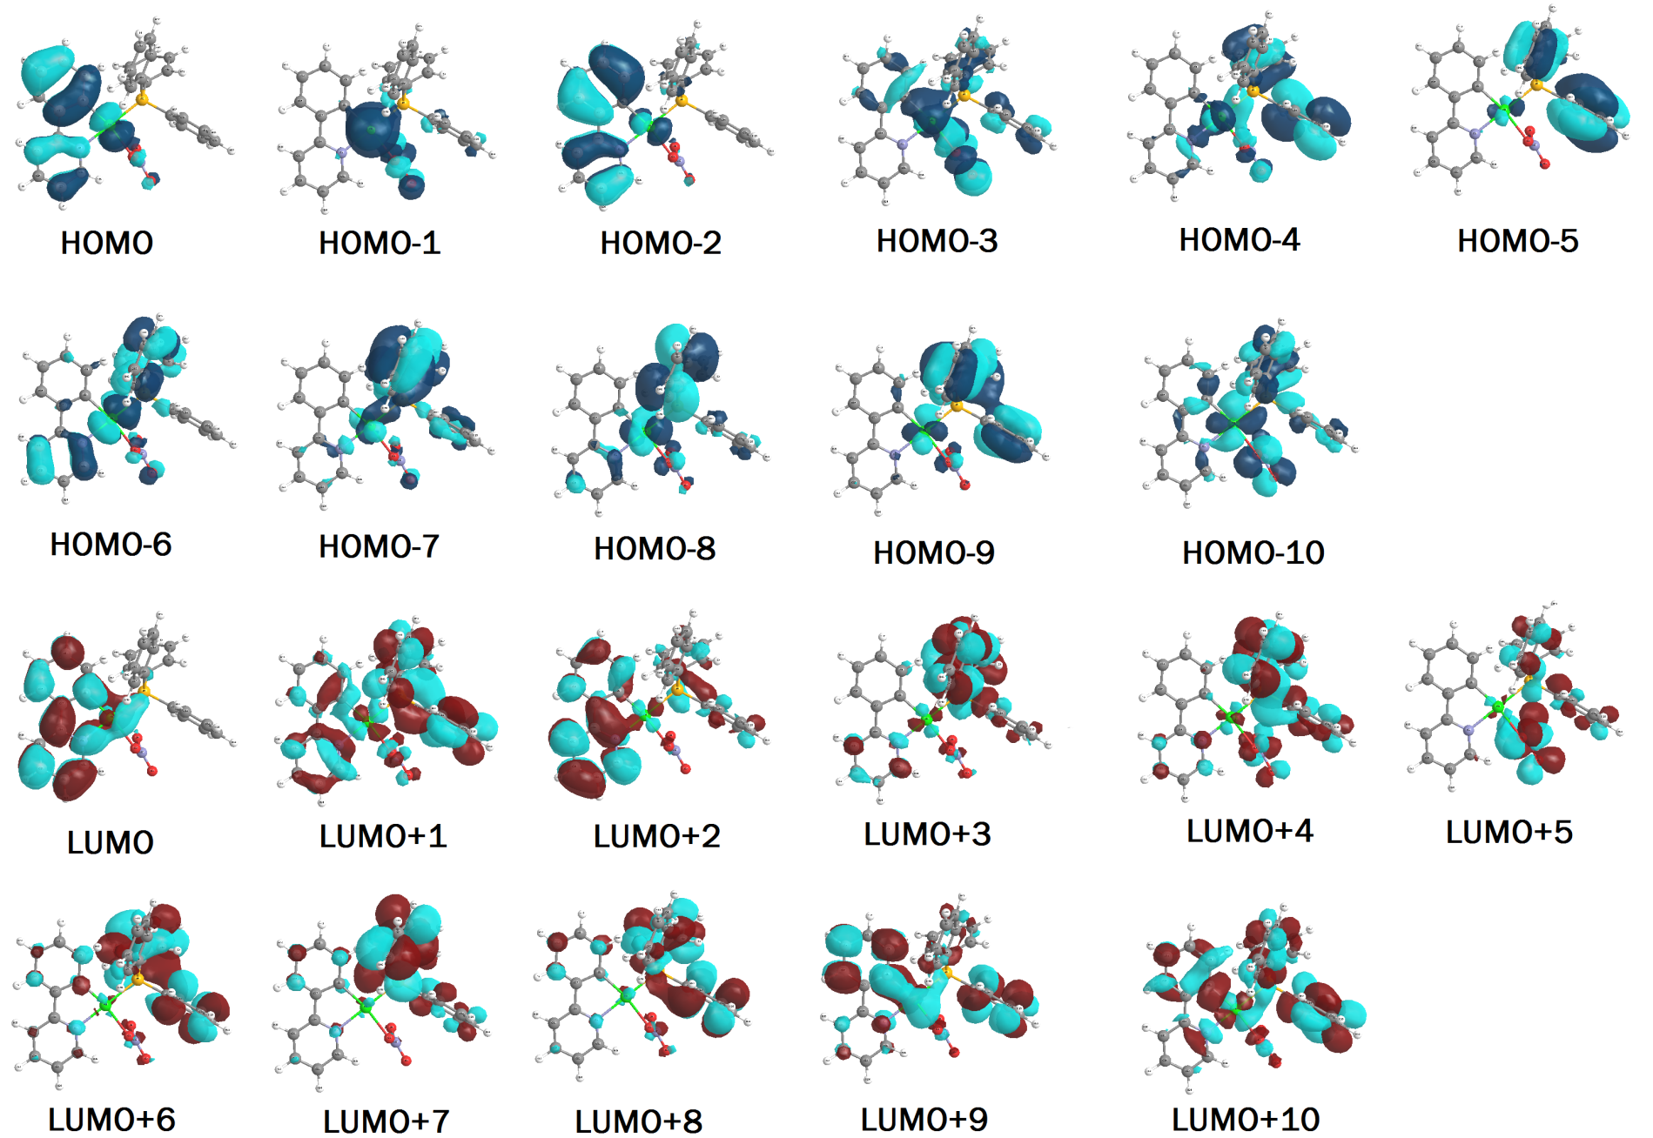
Figure S17. Selected molecular orbital plots of the complex 4a.
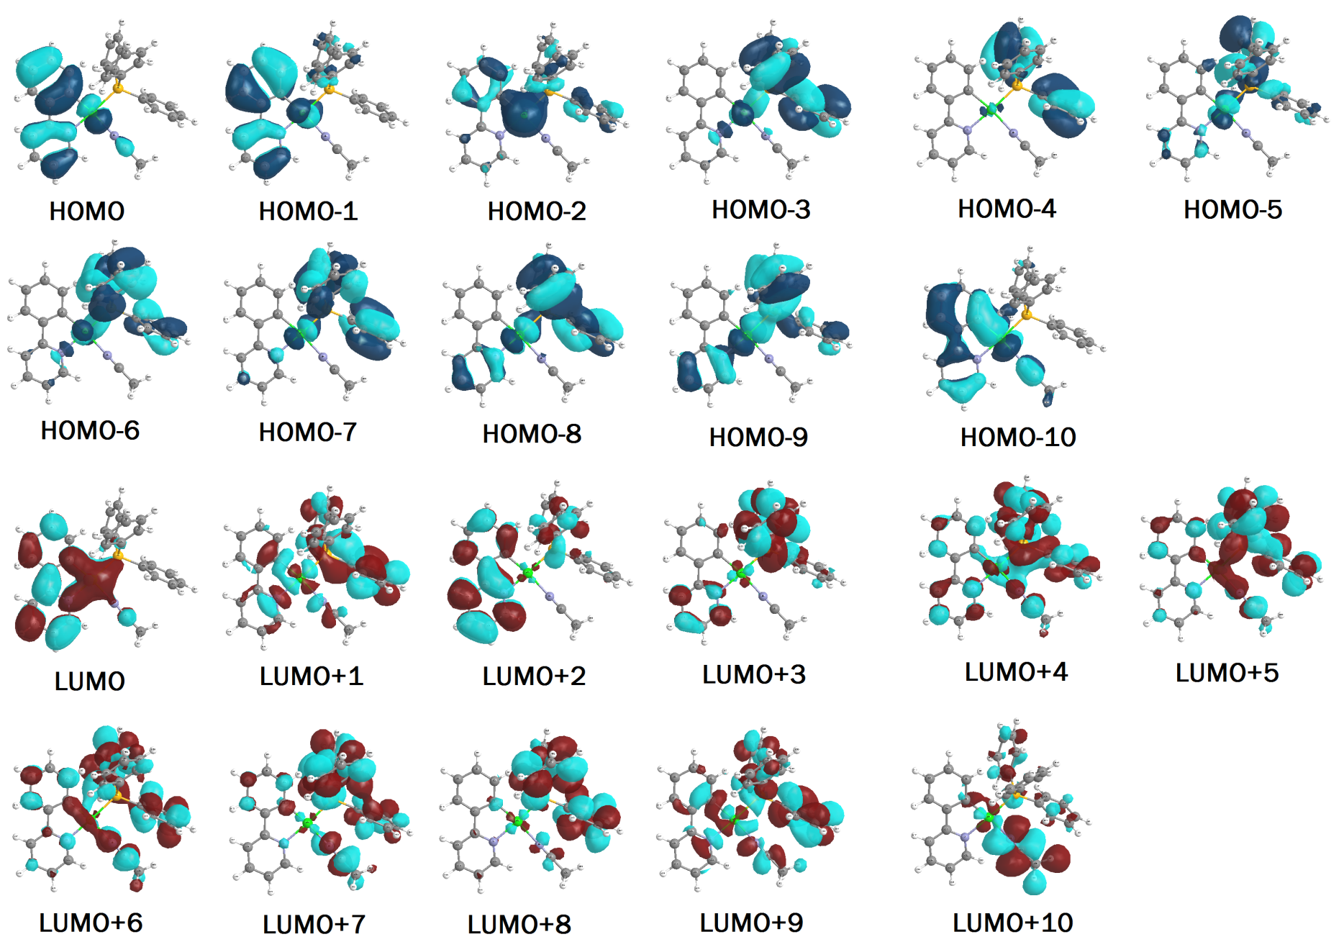
Figure S18. Selected molecular orbital plots of the complex 5a.
Table S3. Wavelengths and nature of transitions for the complex 4a where M = Pt, L = ppy, Lʹ = PPh₃ and Lʹʹ = NO₃.
Excited state | Oscillator strength | Calculated λ (nm) | Transitions  (Major Contribution) | Assignment
S₀→S₁ | 0.0620 | 362 | HOMO→LUMO (96%) | ILCT/MLCT
S₀→S₅ | 0.0696 | 302 | H-2→LUMO (57%)  HOMO→L+2 (30%) | ILCT/MLCT  ILCT/MLCT/MLʹCT
S₀→S₇ | 0.0943 | 290 | H-2→LUMO (27%)  HOMO→L+2 (46%) | ILCT/MLCT  ILCT/MLCT/MLʹCT
S₀→S₁₁ | 0.0431 | 275 | H-1→L+3 (73%) H-6→LUMO (8%) H-6→LUMO (8%) | MLCT/LʹʹLʹCT
S₀→S₁₂ | 0.1923 | 274 | H-6→LUMO (38%)  H-1→L+3 (18%) | MLCT/LʹLCT/ILCT  MLCT/LʹʹLʹCT
S₀→S₁₇ | 0.0232 | 264 | HOMO→L+4 (72%)  HOMO→L+5 (19%) | MLCT/LLʹCT/MLʹʹCT  LMCT/MLʹʹCT/MLʹCT
S₀→S₂₅ | 0.0663 | 253 | HOMO→L+6 (51%)  H-2→L+2 (20%) | MLʹCT/LLʹCT  ILCT/MLʹCT
S₀→S₂₆ | 0.1253 | 251 | H-2→L+2(48%)  HOMO→L+6 (33%) | ILCT/MLʹCT  MLʹCT/LLʹCT

Table S4. Wavelengths and nature of transitions for the complex 5a where M = Pt, L = ppy, Lʹ = PPh₃ and Lʹʹ = CH₃CN.
Excited state | Oscillator strength | Calculated λ (nm) | Transitions  (Major Contribution) | Assignment
S₀→S₁ | 0.067 | 354 | HOMO→LUMO (96%) | ILCT/MLCT
S₀→S₄ | 0.074 | 306 | H-1→LUMO (60%)  HOMO→L+2 (7%) | ILCT/MLCT  ILCT/MLCT/MLʹCT
S₀→S₅ | 0.052 | 303 | H-2→L+1 (58%)  H-1→LUMO (14%) | MLʹCT/ILCT  ILCT/MLCT
S₀→S₆ | 0.074 | 282 | HOMO→L+2 (66%) | ILCT/MLCT/MLʹCT
S₀→S₁₀ | 0.274 | 269 | H-5→LUMO (39%)  H-8→LUMO (12%)  H-7→LUMO (11%)  H-9→LUMO (11%) | LʹLCT/MLCT  LʹLCT/MLCT  LʹLCT/MLCT  MLCT/LʹLCT
S₀→S₁₃ | 0.095 | 261 | HOMO→L+4 (52%)  H-6→LUMO (17%)  H-5→LUMO (11%) | LLʹCT/MLʹCT  LʹLCT/MLCT  LʹLCT/MLCT
S₀→S₁₅ | 0.066 | 260 | H-2→L+2 (36%)  HOMO→L+4 (19%)  H-5→LUMO (15%)  H-7→LUMO (10%) | MLCT/MLʹCT  LLʹCT/MLʹCT  LʹLCT/MLCT  LʹLCT/MLCT
S₀→S₁₉ | 0.058 | 252 | HOMO→L+5 (38%)  H-8→LUMO (18%)  H-7→LUMO (15%)  H-1→L+2 (10%) | LLʹCT/MLʹCT  LʹLCT/MLCT  LʹLCT/MLCT  ILCT/MLʹCT/MLCT
S₀→S₂₁ | 0.149 | 250 | H-1→L+3 (31%)  HOMO→L+5 (27%)  H-1→L+2 (16%)  H-8→LUMO (10%) | LLʹCT/MLʹCT  LLʹCT/MLʹCT  ILCT/MLʹCT/MLCT  LʹLCT/MLCT

Table S5. Crystallographic and structure refinement data for the complexes 4a, 4b and 5a.
 | 4a | 4b | 5a
Empirical formula | C₂₉H₂₃N₂O₃PPt | C₃₃H₃₀C_{l4}NO₂PPt | C₆₃H₅₃Cl₃F₁₂N₄P₄Pt₂
Formula weight | 673.54 | 840.43 | 1714.50
Temperature | 298(2) K | 298(2) K | 120(2) K
Wavelength | 0.71073 A | 0.71073 A | 0.71073 A
Crystal system, space group | Monoclinic, P 21/c | Triclinic, P -1 | Monoclinic, P 21/c
Unit cell dimensions | a = 9.5709(19) A  alpha = 90 deg.  b = 15.243(3) A  beta = 90.86(3) deg.  c = 17.427(4) A  gamma = 90 deg. | a = 9.839(2) A  alpha = 99.84(3) deg.  b = 12.558(3) A  beta = 94.66(3) deg.  c = 14.419(3) A  gamma = 109.04(3) deg. | a = 16.538(3) A  alpha = 90 deg.  b = 15.168(3) A  beta = 122.59(2) deg.  c = 30.380(9) A  gamma = 90 deg.
Volume | 2542.0(9) A³ | 1641.3(6) A³ | 6421(3) A³
Z, Calculated density | 4, 1.760 Mg/m³ | 2, 1.701 Mg/m³ | 4, 1.774 Mg/m³
Absorption coefficient | 5.617 mm⁻¹ | 4.680 mm⁻¹ | 4.655 mm⁻¹
F(000) | 1312 | 824 | 3336
Crystal size | 0.30 x 0.20 x 0.18 | 0.45 x 0.30 x 0.20 mm | 0.20 x 0.12 x 0.10 mm
Theta range for data collection | 2.13 to 25.00 deg. | 2.21 to 25.00 deg. | 2.41 to 25.00 deg.
Limiting indices | -11<= h <=11  -17<= k <=18  -18<= l <=20 | -11<= h <=11  -14<= k <=12  -17<= l <=17 | -19<= h <=19  -18<= k <=15  -32<= l <=36
Reflections collected / unique | 18213 / 4477 [R(int) = 0.1309] | 11934 / 5749 [R(int) = 0.0986] | 26614 /11299 [R(int) = 0.1796]
Completeness to theta = 25.00 | 99.8 % | 99.4 % | 99.9 %
Absorption correction | Numerical | Numerical | Numerical
Max. and min. transmission | 0.4313 and 0.2836 | 0.4546 and 0.2272 | 0.6532 and 0.4562
Refinement method | Full-matrix least-squares on F² | Full-matrix least-squares on F² | Full-matrix least-squares on F²
Data / restraints / parameters | 4477 / 0 / 325 | 5749 / 0 / 380 | 11299 / 0 / 471
Goodness-of-fit on F² | 0.927 | 0.989 | 0.998
Final R indices [I>2sigma(I)] | R1 = 0.0499, wR2 = 0.0983 | R1 = 0.0588, wR2 = 0.1383 | R1 = 0.1047, wR2 = 0.1915
R indices (all data) | R1 = 0.0886, wR2 = 0.1075 | R1 = 0.0797, wR2 = 0.1497 | R1 = 0.1923, wR2 = 0.2218
Largest diff. peak and hole | 2.074 and -1.221 e.A⁻³ | 2.269 and -2.961 e.A⁻³ | 2.574 and -2.621 e.A⁻³

