The Cleavage of Organosiloxanes with Dimethyl Carbonate: A Mild Approach to Graft-To-Surface Modification

Iryna Protsak^{a,d,e}, Ian M. Henderson^{b}, Valentyn Tertykh^{c}, Wen Dong^{a,e*}, Zi-Chun Le^{d}

ª College of Environment, Zhejiang University of Technology, Hangzhou 310023, China
^{b} Omphalos Bioscience, LLC, Albuquerque, NM, USA 87110
^{c} Chuiko Institute of Surface Chemistry of National Academy of Sciences of Ukraine, 03164 Kiev, Ukraine
^{d} College of Science, Zhejiang University of Technology, Hangzhou 310023, China
^{e} Key Laboratory of Microbial Technology for Industrial Pollution Control of Zhejiang Province, Hangzhou, 310014, China

*Corresponding author: Wen Dong
E-mail address: dongwen@zjut.edu.cn
Tel: +86 571 88871576

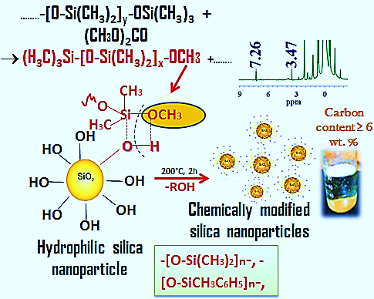

Viscosity measurements S1. Depolymerization was performed with the use of 99.8 % ethanol solution. The polymer solution efflux time was measured with the use of a stopwatch by means of VPG–1 viscometer with the internal capillary diameter of 2.10 mm. Kinematic viscosity of the solution (η, m²/s) was calculated using the formula:
η = $\frac{k×g×τ}{9.807}$, (1)
where k – the viscometer constant that equaled 0.825 mm2/sec², g − free-fall acceleration corresponding to 9.807 m/sec² and τ − efflux time time, sec.
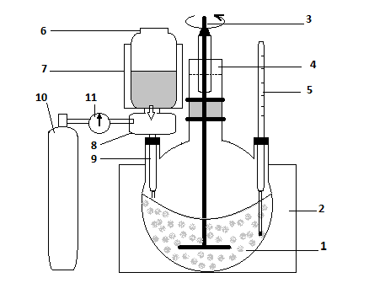
Figure S2. Apparatus for synthesis of high disperse materials with high content of the grafted organic groups:
1 – glass reactor, 2,7 – heating mantle, 3 – stirrer, 4 – glass stopper, 5 – glass laboratory thermometer, 6 – container mixing modifying reagent, 8 – batcher, 9 – injection system, 10 – inert gas cylinder, 11 – inert gas valve.

Equation S3. The modification degree (Θ) of the silica surface was estimated from the ratio of the optical density of a band of free silanols at 3742 cm⁻¹ of modified and unmodified silicas:
$θ=100 (1-\frac{D}{D_{o}})$, (2)
where D_{o} and D are the optical density of the mentioned band of the unmodified and modified silicas, respectively.
Equation S4. The apparent bonding density of the attached layers was calculated using the formula 3:
ρ =$\frac{6×{10}^{5 }(\% C)}{\left[1200×n_{c}-M_{w}×(\% C)\right]}\frac{1}{S(BET)},$ (3)
where M_{W} is the molecular weight of the methylphenylsiloxy group (131 g/mol), % C is the carbon weight percentage of the modified silica, and S(BET) is the surface area of the original silica (m²/g), n_{c} is a number of carbon atoms in the grafted group. Equation 3 gives the number of [-Si(CH₃C₆H₅)O-] repeat units per 1 nm² of the surface (ρ).
Figure S5. 90 MHz ¹H NMR spectrum of neat PDMS–100; the inset shows the methyl group shifts of parent PDMS–100.

Equation S6. Typically we conducted End-Group Analysis using formula of total siloxane repeats (R_{t}) (1) and formula of number of monomers per chain (N) (2). Total siloxane repeats (R_{t}) was calculated using the formula:
$R_{t=\frac{NMR signal for PDMS-100}{existing end groups ×protons per repeats}}$ (1)
Number of monomers per chain (N) was calculated using the formula:
N=$\frac{R_{t}}{N_{e}}$, (2)
where N_{e} – number of end groups which was calculated using ¹H NMR integration data, N_{E}= (N_{methoxy} + N_{ethoxy}).

Figure S7. 90 MHz ¹H NMR spectrum of depolymerizied PMPS; the inset shows the alkoxy groups shifts of depolymerized PMPS at 200 °C.

Figure S8. ¹³C CP/MAS NMR spectra of silica modified with neat PMPS and their mixture with DMC (1.8 mmol) at 200 °C for 2 h; the inset shows shifts of the grafted organic groups for both samples.

a | 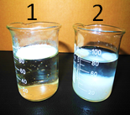b
Figure S9. Contact angle of SiO₂ nanoparticles, modified with mixture of PMPS/DMC at 200 °C for 2 h (a) and photograph showing hydrophobic properties of SiO₂/PMPS+DMC (b, 1) and unreacted SiO₂ nanoparticles (b, 2).

