**Supporting Information**

***S,N*-Heteroacene-Based Conjugated Microporous Polymers as Fluorescent Sensors and Effective Antimicrobial Carriers**

*Mengjiao Wu†,§, Yi Han†,§, Bo Wang‡, Yuan Yuan†,§, Chengfen Xing*,‡ and Yulan Chen*,†,§*

†Tianjin Key Laboratory of Molecular Optoelectronic Science, Department of Chemistry, Tianjin University, Tianjin 300354, China

‡Hebei Province Key Laboratory of Molecular Biophysics, Institute of Biophysics, Hebei University of Technology, Tianjin 300401, China

§Collaborative Innovation Center of Chemical Science and Engineering, Tianjin 300072, China

*E-mail: xingc@hebut.edu.cn; yulan.chen@tju.edu.cn

**Materials.** *S,N*-Heteroacenes (**SN-1**, **SN-2**, **SN1-Br**, **SN2-Br**), tetrakis(4-ethynylphenyl)methane (**TPM**) and 3,8-dibromo-1,10-phenanthroline (**N-Br**) were prepared according to the previous literatures.[S1-S4] Unless otherwise noted, all starting materials and reagents were purchased from commercial available sources and used without further purification.

**Characterization Methods.** Liquid 1H NMR spectra were recorded in deuterated solvents on a Bruker AVANCE III-400 spectrometer. Fourier transform infrared (FT-IR) spectra were collected on a Bruker Alpha spectrometer. The UV-vis absorption and diffuse reflectance spectra were recorded on a PerkinElmer Lambda 750 spectrophotometer. Fluorescence spectra were measured by a Hitachi F-7000 fluorescence spectrophotometer. Solid-state 13C cross-polarization magic-angle spinning (CP/MAS) NMR experiments were performed on a VARIAN Infinityplus 300 NMR spectrometer. The thermogravimetric analysis (TGA) measurements were performed on a TA Instruments Q-50 under nitrogen atmosphere (20 ~ 800 oC, 10 oC/min). Powder X-ray diffraction (PXRD) experiment was acquired from 1.5 to 60° with 0.02o increment by a Rigaku SmartLab (9 kW) X-ray diffractometer. Field emission scanning electron microscopies (FE-SEM) were carried out using a Hitachi Limited model S-4800 microscope operating at an accelerating voltage of 3.0 kV. High resolution transmission electron microscopies (HR-TEM) were carried out using a JEOL model JEM-2100F microscope. Nitrogen sorption isotherms were measured at 77 K with a Bel Japan Inc. model BELSOPR-mini II analyzer. Elemental analyses were measured by Elementar model Vario EL CUBE. The Ag content in **SN-CMPs** was determined by ICP-MS techniques using Agilent 7700X ICP-MS model. X-ray photoelectron spectroscopy (XPS) was performed on a Perkin-Elmer PHI-1600 ESCA spectrometer using Al Kα as the excitation source.



**Scheme S1.** Synthesis of CMPs.

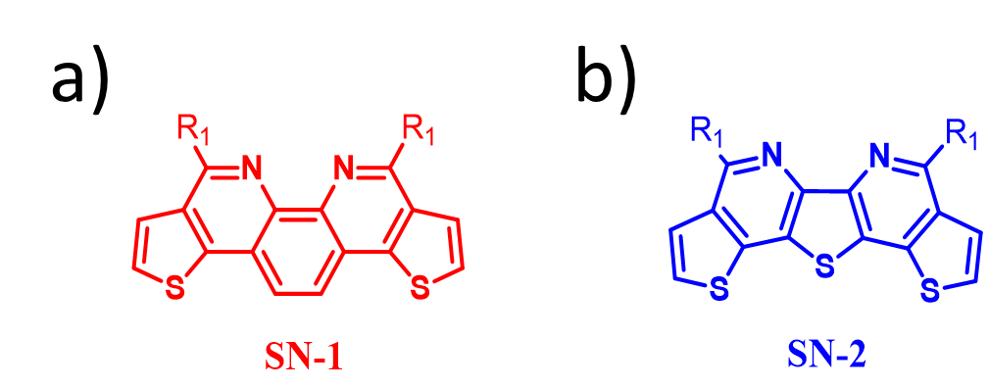

**Figure S1.** The structures of *S,N*-heteroacenes (a) **SN-1** and (b) **SN-2** (R1 = *t*-Butyl).

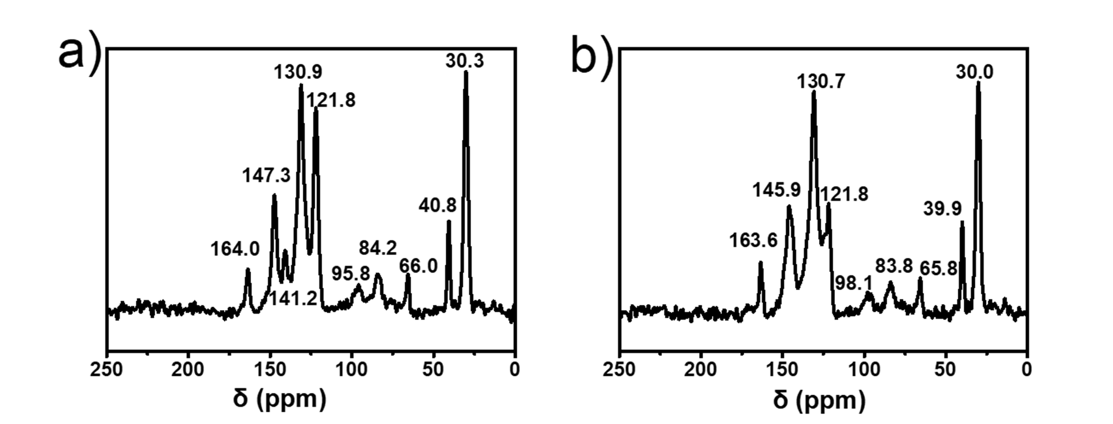

**Figure S2.** Solid-state 13C CP/MAS NMR spectra of the polymer networks of (a) **SN1-CMP** and (b) **SN2-CMP**.

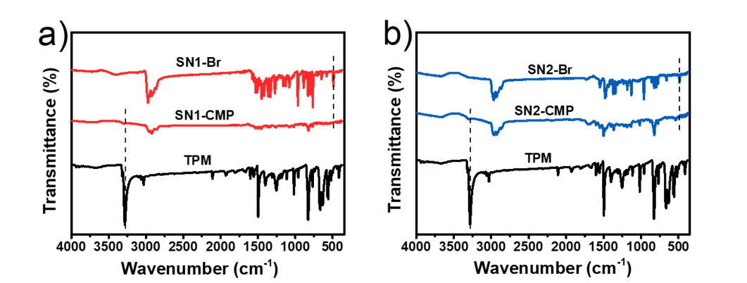

**Figure S3.** FT-IR spectra of (a) **SN1-CMP** and (b) **SN2-CMP** compared with their monomers.

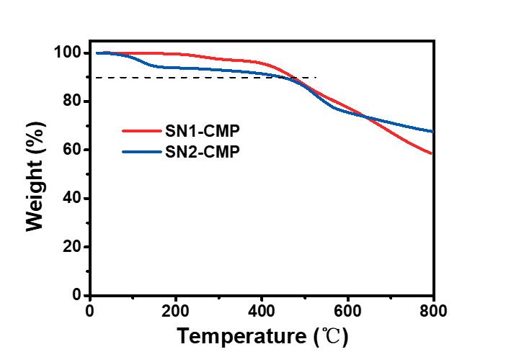

**Figure S4.** TGA curves of the polymer networks of **SN1-CMP** and **SN2-CMP**.

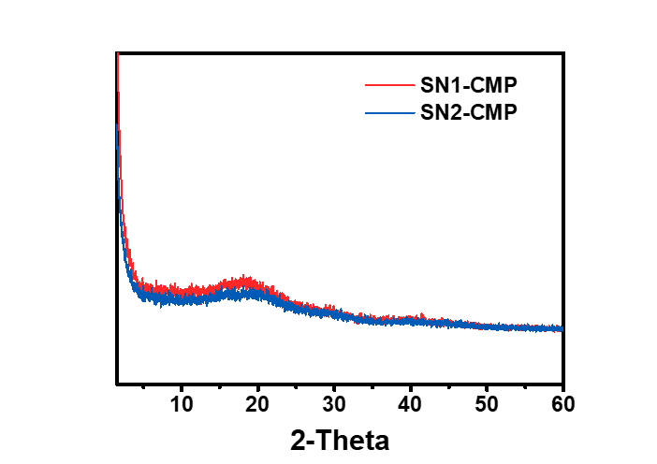

**Figure S5.** Powder X-ray diffraction patterns of **SN1-CMP** and **SN2-CMP**.

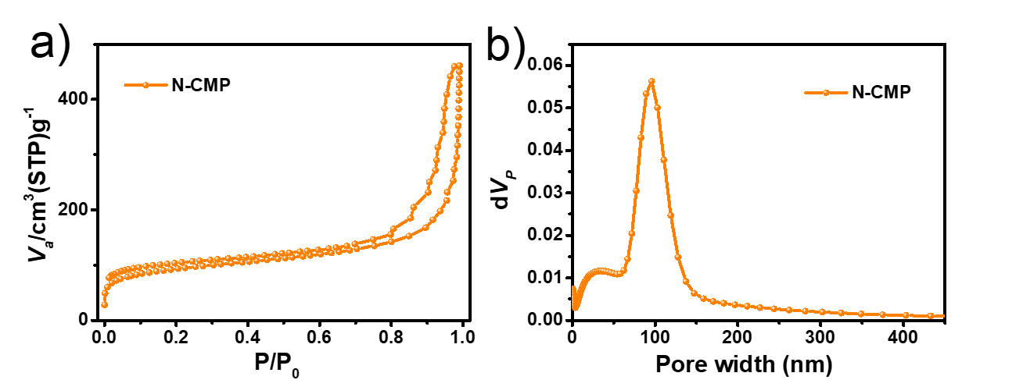

**Figure S6.** (a) Nitrogen sorption isotherm measured at 77 K and (b) pore size distribution profile of **N-CMP** calculated using the NLDFT method.

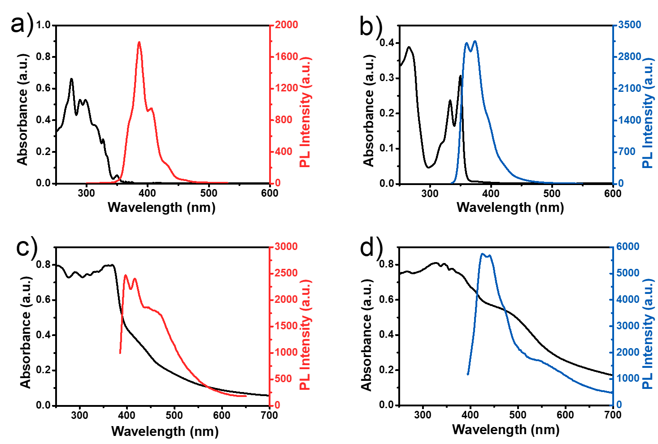

**Figure S7.** UV-vis absorption spectra and fluorescence spectra of (a) **SN-1** and (b) **SN-2** in chloroform solution (10−5 M). UV-vis diffuse reflectance spectra and fluorescence spectra of (c) **SN-1** and (d) **SN-2** in solid state.

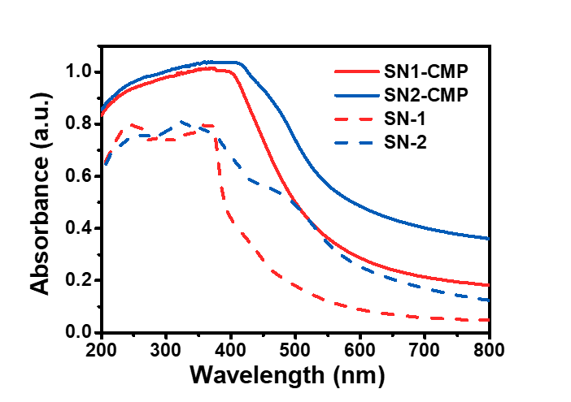

**Figure S8.** The UV-vis diffuse reflectance spectra of **SN-1**, **SN-2**, **SN1-CMP** and **SN2-CMP**.

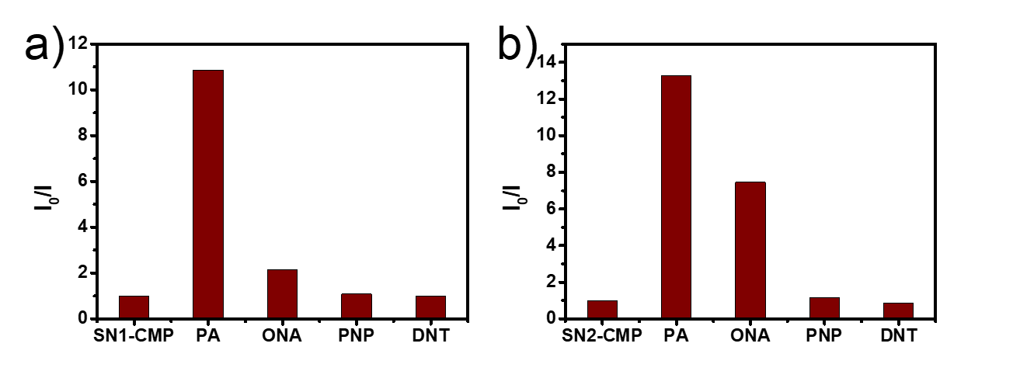

**Figure S9.** The fluorescence intensity changes of (a) **SN1-CMP** (0.05 mg/mL) and (b) **SN2-CMP** (0.05 mg/mL) in the presence of different nitroaromatics (a) 110 *μ*M (b) 238 *μ*M in methanol solution.

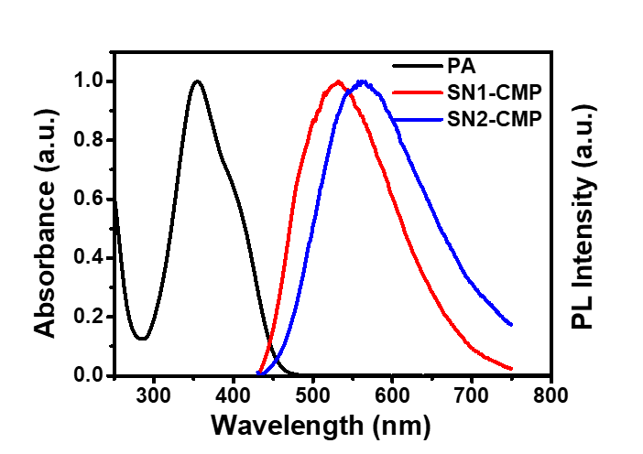

**Figure S10.** UV-vis spectrum of PA (5 x 10-5 M) and PL spectra of **SN1-CMP** (0.05 mg/mL) and **SN2-CMP** (0.05 mg/mL) in methanol solution.

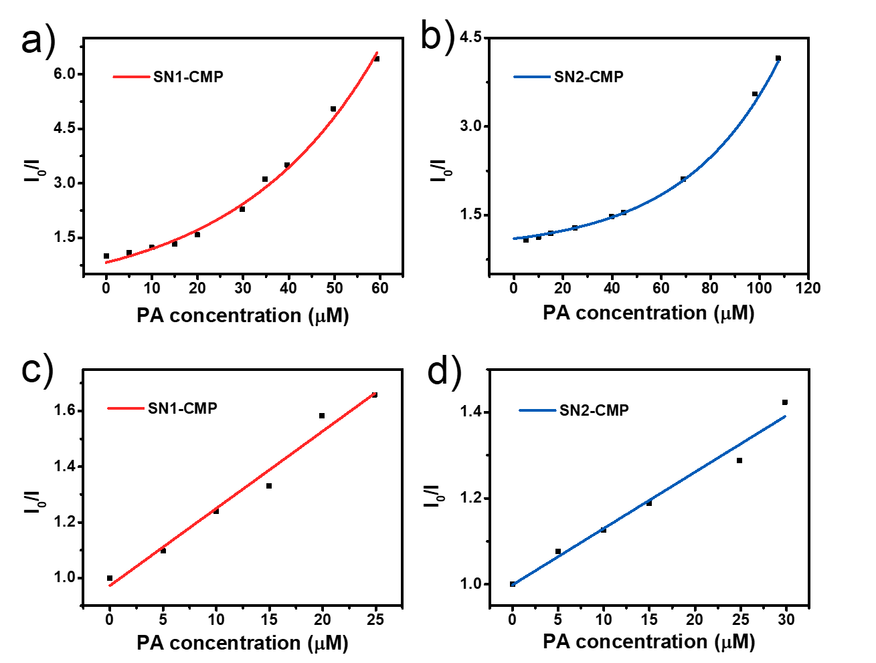

**Figure S11.** Stern-Volmer plots of I0/I versus [PA] for (a) **SN1-CMP** and (b) **SN2-CMP** in methanol at high concentration of PA. The linear Stern-Volmer plots of (c) **SN1-CMP** and (d) **SN2-CMP** upon titration with PA in methanol at low concentration of PA (concentration of **SN-CMPs**: 0.05 mg/mL; excitation wavelength: 401 nm for **SN1-CMP** and 411 nm for **SN2-CMP**).

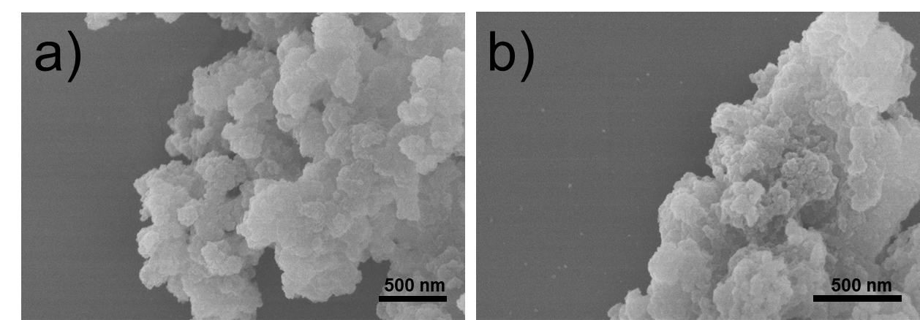

**Figure S12.** FE-SEM images of polymer networks of (a) **Ag-SN1-CMP** and (b) **Ag-SN2-CMP**.

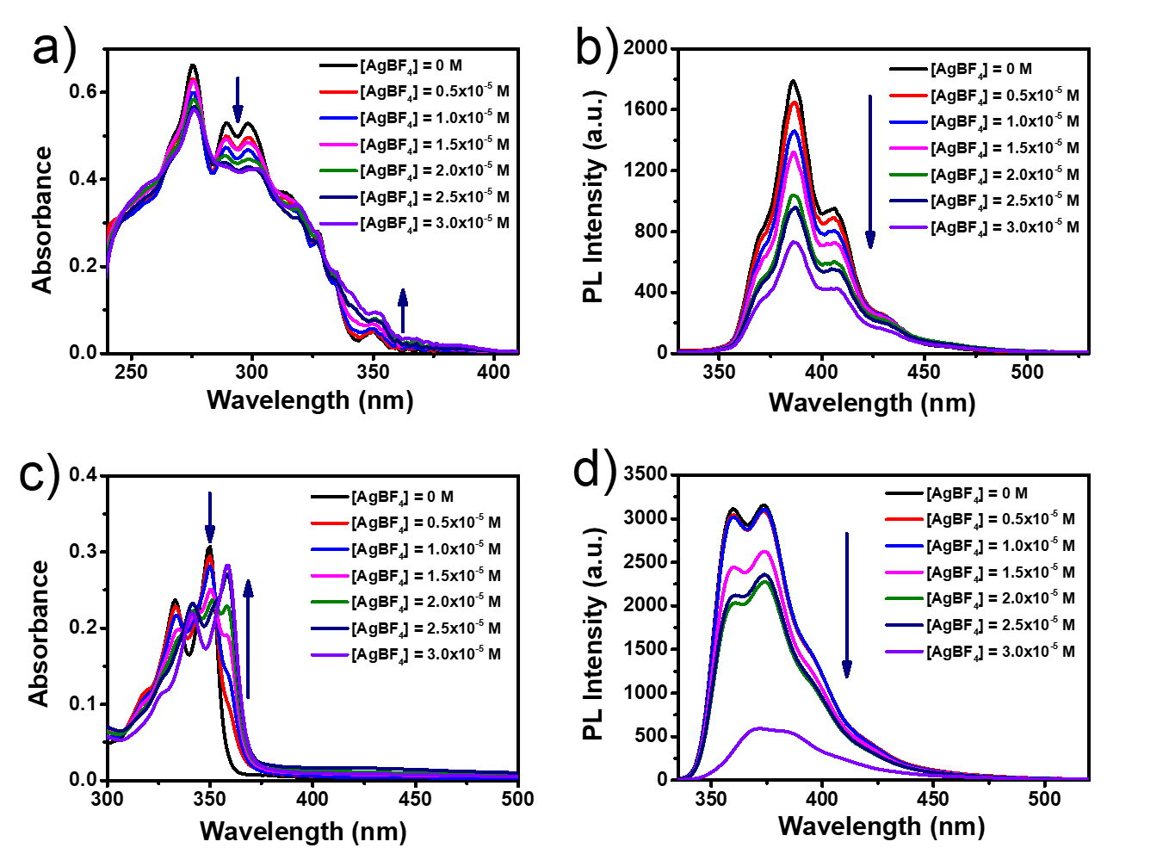

**Figure S13.** Changes in (a) (c) UV-vis absorption and (b) (d) PL spectra of **SN-1** and **SN-2** (10−5 M) in chloroform upon adding various concentrations of AgBF4 in methanol.

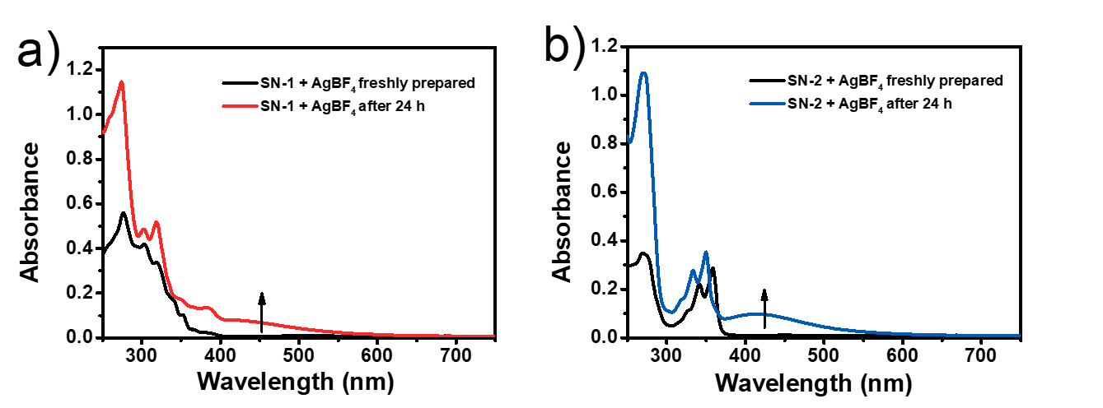

**Figure S14.** UV-vis absorption spectra of (a) **SN-1**, (b) **SN-2** (10−5 M) in chloroform with AgBF4 (2.5 x 10-5 M) in methanol. For the freshly prepared mixtures and samples analyzed after 24 h (protected from light at room temperature).

**References**

(S1) Wang, T.; Wang, H.; Li, G.; Li, M.; Bo, Z.; Chen, Y. Thiophene-Fused 1,10-Phenanthroline and Its Conjugated Polymers. *Macromolecules* **2016**, *49*, 4088-4094.

(S2) Guo, H. S.; Liu, M. F.; Han, Y.; Han, S.; Chen, Y. Synthesis and Characterization of S,N-Heteroacenes by Bischler-Napieralski Reaction. *Chin. J. Polym. Sci*. **2016**, *34*, 1319-1329.

(S3) Wang, X.; Lu, S. M.; Li, J.; Liu, Y.; Li, C. Conjugated Microporous Polymers with Chiral BINAP Ligand Built-in as Efficient Catalysts for Asymmetric Hydrogenation. *Catal. Sci. Technol*. **2015**, *5*, 2585-2589.

(S4) Yu, X. G.; Jin, X. L.; Tang, G. P.; Zhou, J.; Zhang, W.; Peng, D. H.; Hu, J. M.; Zhong, C. F. D–π–A Dye Sensitizers Made of Polymeric Metal Complexes Containing 1,10-Phenanthroline and Alkylfluorene or Alkoxybenzene: Synthesis, Characterization and Photovoltaic Performance for Dye-Sensitized Solar Cells. *Eur. J. Org. Chem*. **2013**, 5893-5901.