Supporting Information
Water-Assisted Transfer Patterning of Nanomaterials
Maryam Aghajamali, I Teng Cheong, and Jonathan G. C. Veinot*
Department of Chemistry, University of Alberta, Edmonton, Alberta T6G 2G2, Canada
*E-mail: jveinot@ualberta.ca

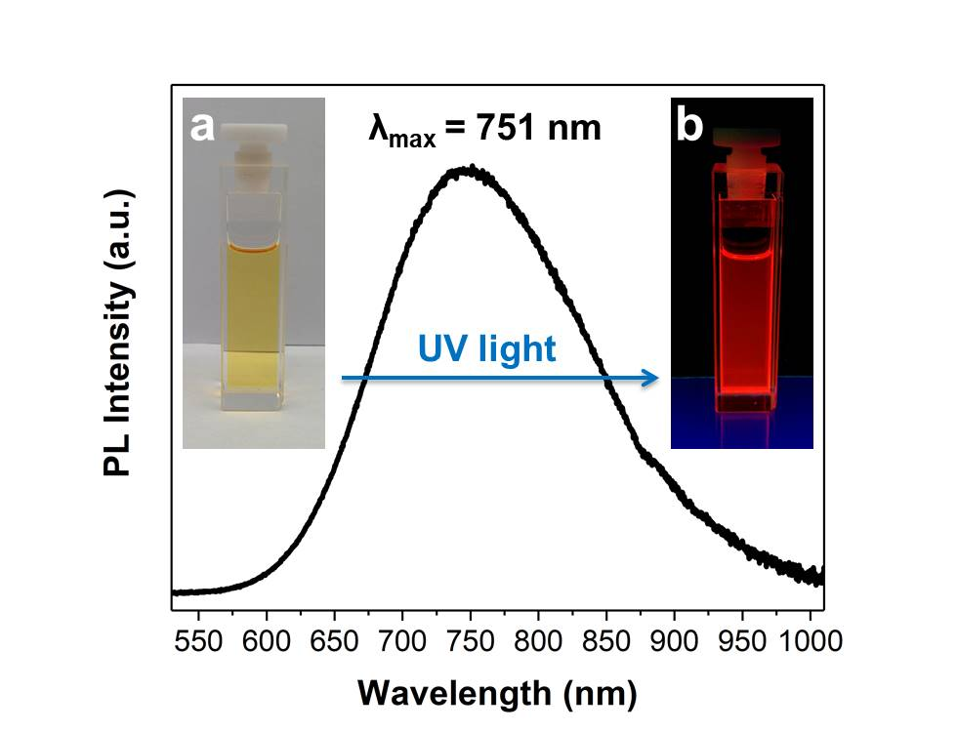
Figure S1. PL spectrum of a solution containing dodecyl-functionalized SiNCs (d ~ 3 nm) upon excitation at 405 nm. The insets show a SiNC solution (a) before and (b) after exposure to UV light (λ ~ 350 nm).
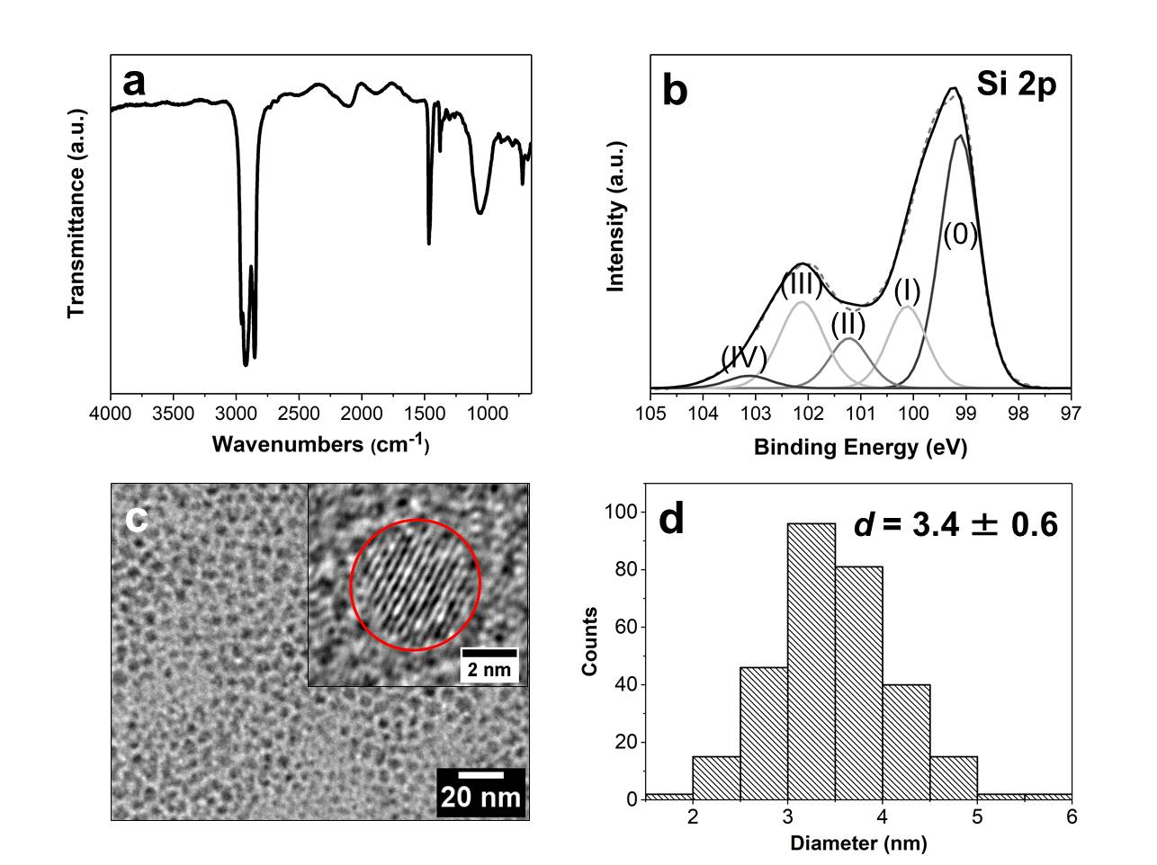
Figure S2. Characterization of dodecyl-functionalized SiNCs (d ~ 3 nm) (a) FTIR spectrum, (b) high-resolution XP spectrum of Si 2p region (fitting is shown for the Si 2p_{3/2} components, and Si 2p_{1/2} components are omitted for clarity), (c) bright-field TEM image (HRTEM image is shown as inset), and (d) size distribution.
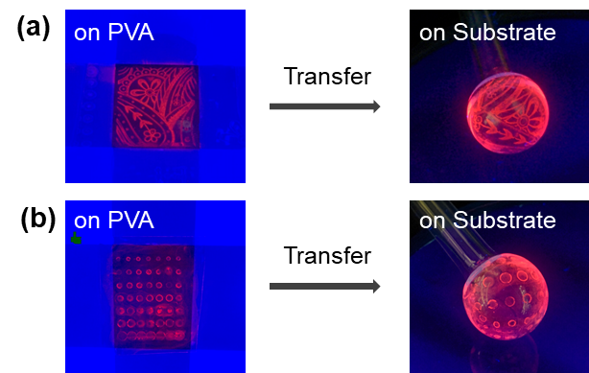
Figure S3. Photographs of patterns of SiNCs (d ~ 3 nm) on poly(vinyl alcohol) films (before transfer) and on non-flat quartz substrates (after transfer) under UV light.

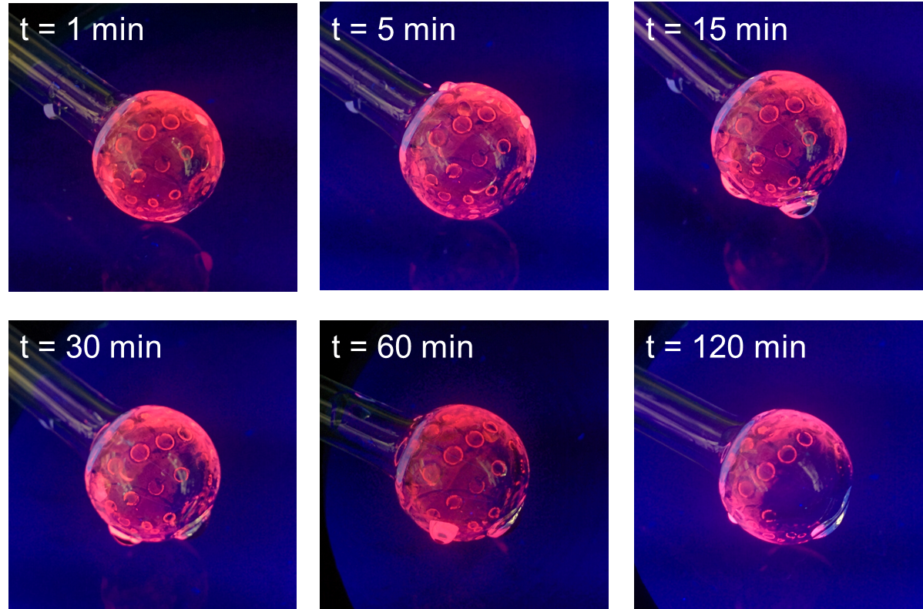
Figure S4. Photographs of a pattern of SiNCs (d ~ 3 nm) on a non-flat quartz substrate after 1, 5, 15, 30, 60, and 120 min exposure to an ultrasonication bath under UV light.

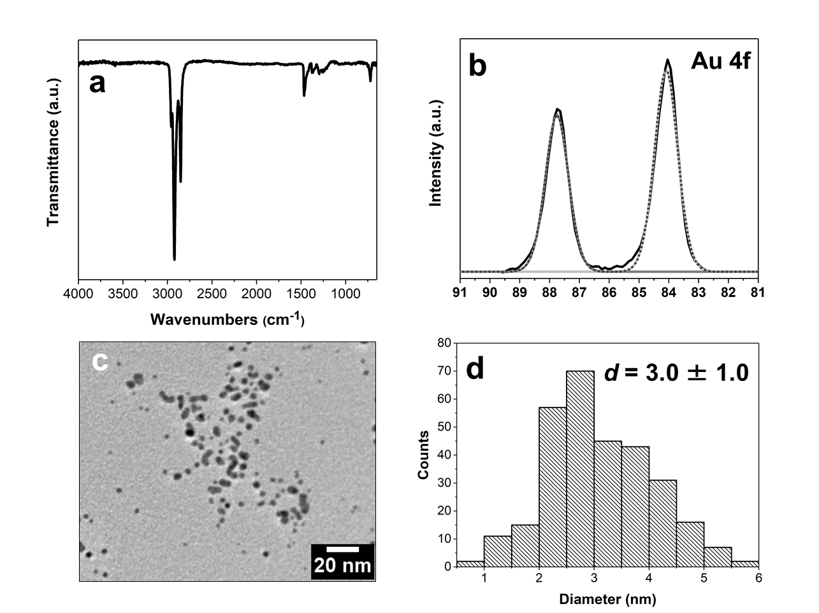
Figure S5. Characterization of dodecanethiol-capped AuNPs (d ~ 3 nm) (a) FTIR spectrum, (b) high-resolution XP spectrum of Au 4f region, (c) bright-field TEM image, and (d) size distribution.
Table S1. Widths (W) and pitches (P) of line-patterned silicon substrates (microplates).
W (µm) | 2 | 10 | 50 | 100 | 200
P (µm) | 50 | 100 | 200 | 400 | 600
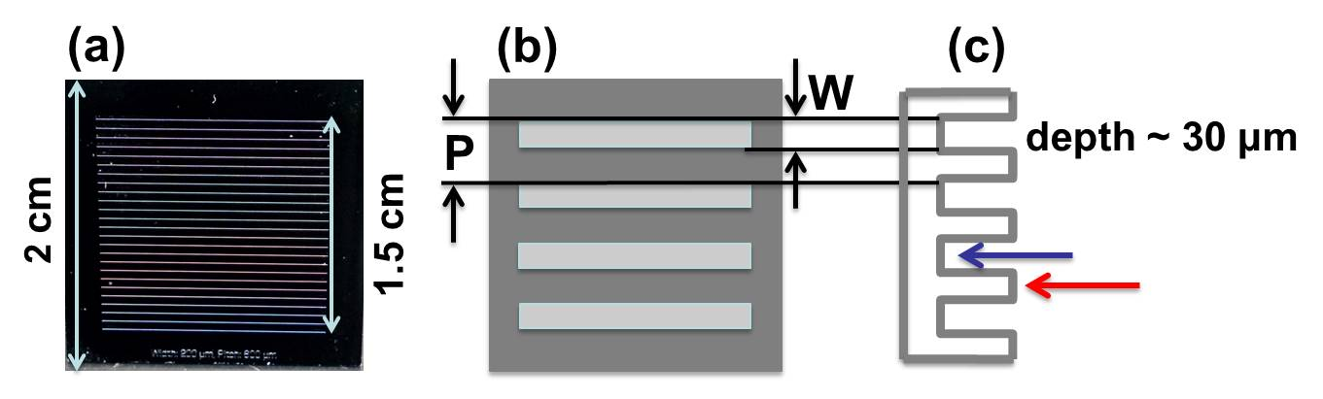
Figure S6. (a) Photograph of a 2×2 cm line-patterned silicon substrate (i.e., W200μ-P600μ). (b,c) Schematic representation of a microplate defining width (W) and pitch (P); (b) top view and (c) cross-sectional view (blue arrow for when NPs deposit in the troughs and red arrow for when they deposit on the crests).
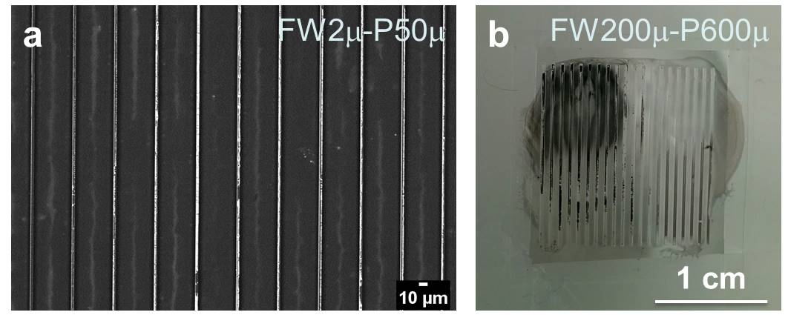
Figure S7. (a) BSE image of drop-coated AuNPs on a PVA film (FW2μ-P50μ), and (b) photograph of drop-coated AuNPs on a PVA film (FW200μ-P600μ). The brighter areas in BSE image correspond to AuNPs.

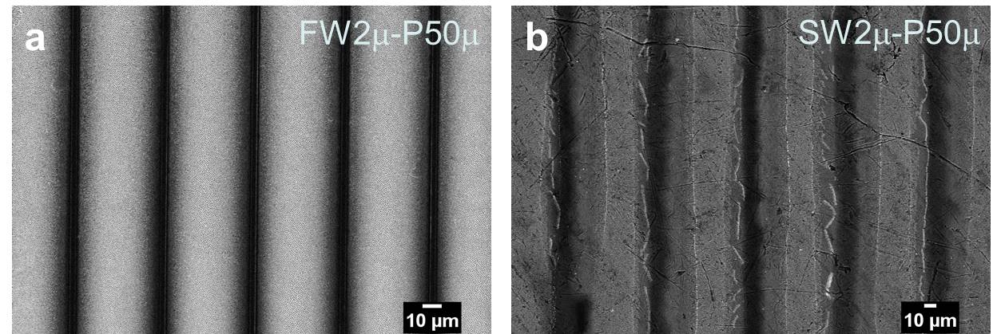
Figure S8. BSE images of AuNPs on (a) PVA film (FW2μ-P50μ) and (b) aluminum substrate (SW2μ-P50μ). The brighter areas correspond to AuNPs.
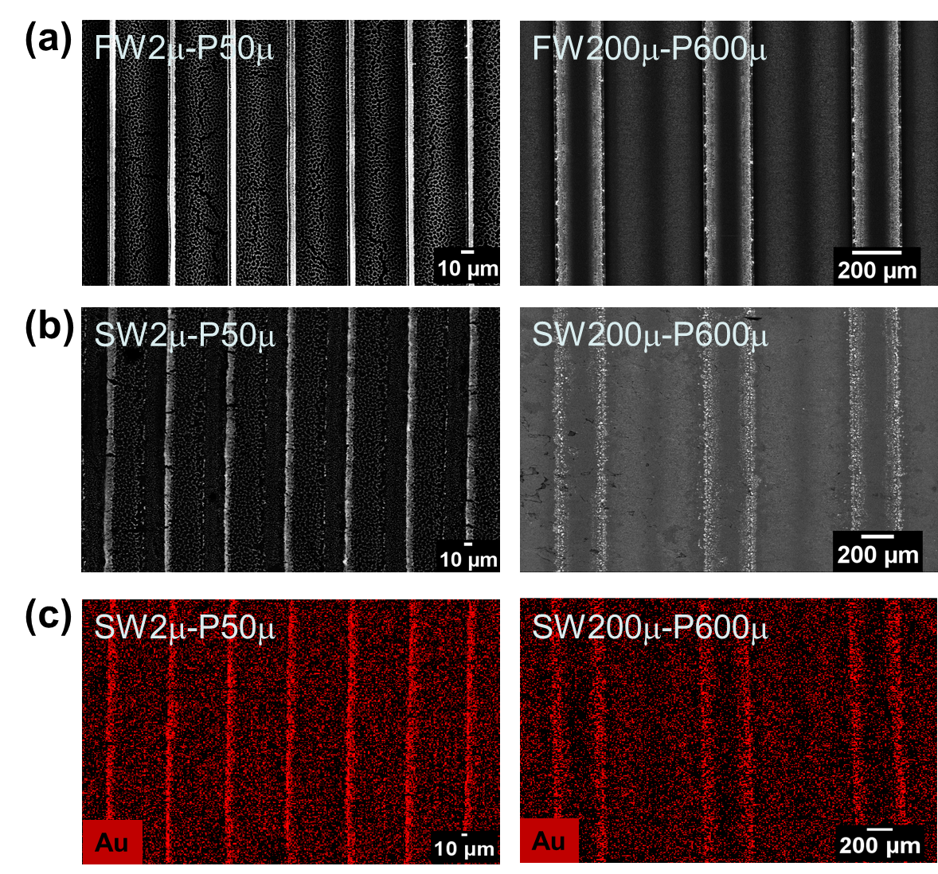
Figure S9. (a) BSE images of AuNPs on PVA films, (b) BSE images of AuNPs on aluminum substrates, and (c) EDX mapping of AuNPs on aluminum substrates.

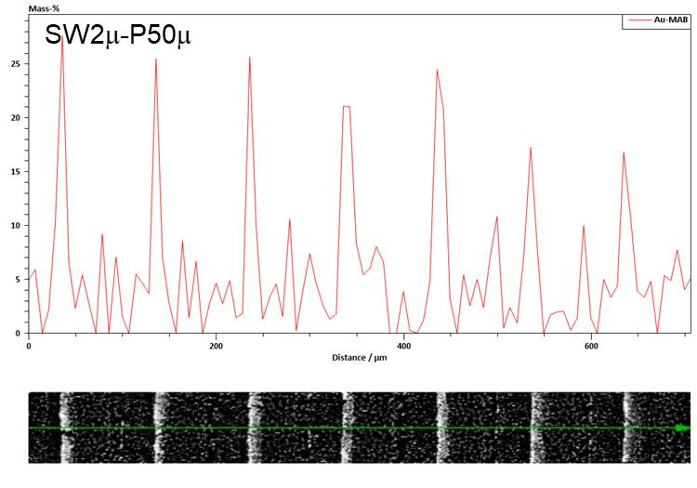

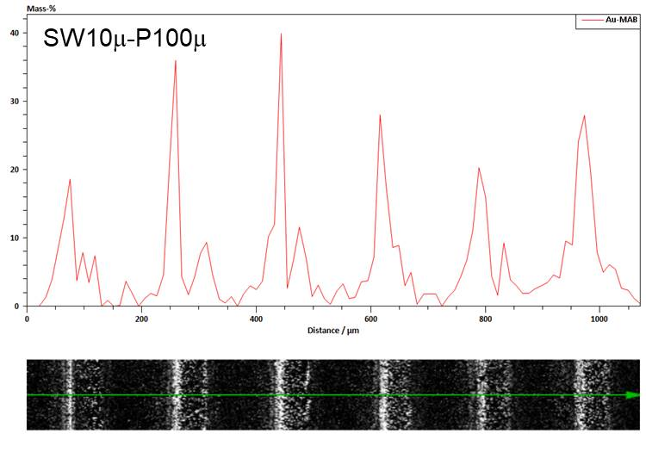

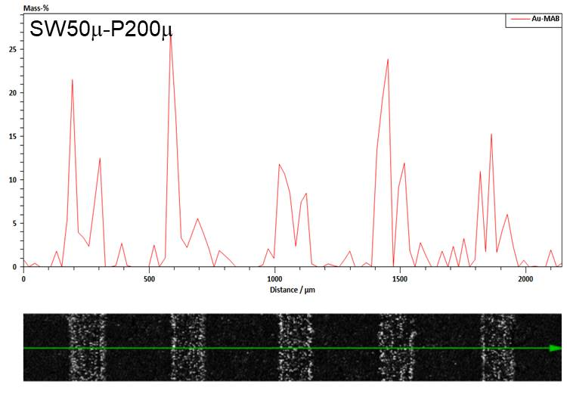

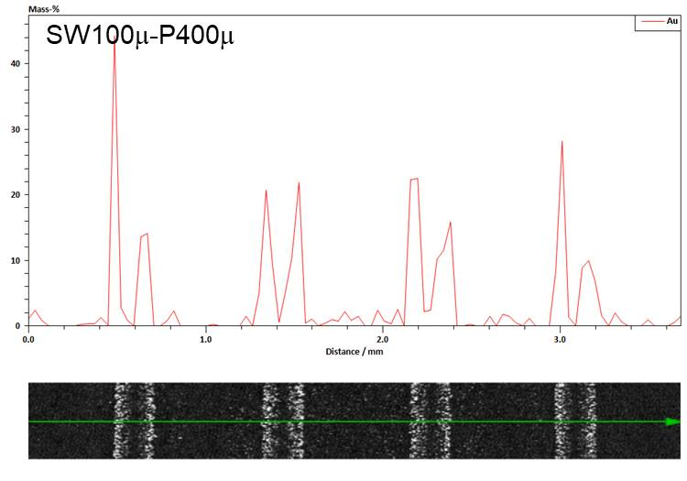

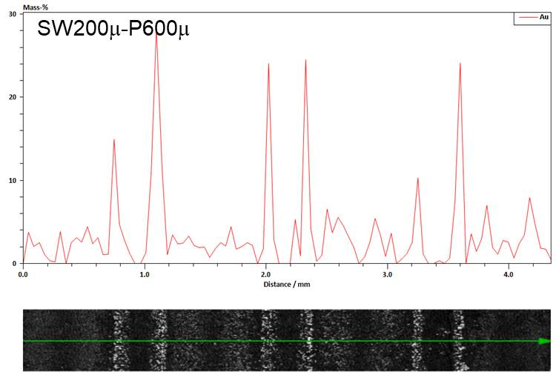
Figure S10. EDX line scans of AuNPs on aluminum substrates (i.e., SW2μ-P50μ).

