Ionic strength responsive binding between nanoparticles and proteins

Xiaohan Wangª, Shi Zhangª, Yisheng Xu^{a,b}*, Xiaotao Zhaoª, Xuhong Guo^{a,b}*

- State Key Laboratory of Chemical Engineering, East China University of Science and Technology, 200237 Shanghai, P.R. China
- Engineering Research Center of Materials Chemical Engineering of Xinjiang Bingtuan, Shihezi University, 832000 Xinjiang, P.R. China

Keywords: Magnetic nanoparticles; Protein binding; Ionic strength; Surface hydrophobicity

.

Figure S1. Zeta potential values of the functionalized MNP0 (a), MNP1 (b), MNP2 (c), MNP3 (d), MNP4 (e)

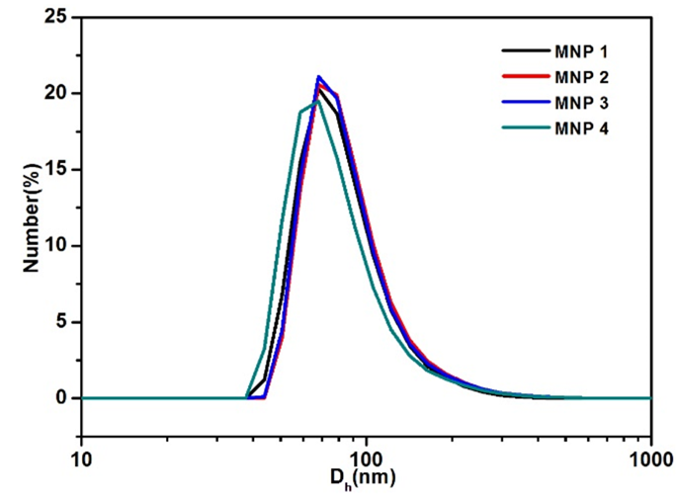
Figure S2. Hydrodynamic size of magnetic nanoparticles with different surface hydrophobicity, MNP1-MNP4 as monitored by DLS.
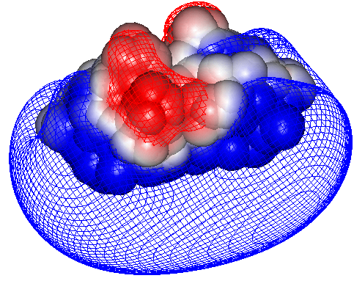
Figure S3. Potential surfaces (-0.1 kT/e (red) and 0.1 kT/e (blue) around BLG at I = 5 mM and pH = 4.84. Potentials close to the protein surface (5 Å) are colored blue (positive) and red (negative).

Figure S4. Turbidimetric titrations for blank BLG solutions at I=5 mM , 20 mM , 50 mM and 100 mM . [BLG]=0.05mg/mL

Figure S5. Hydrodynamic diameter of MNP1-MNP4 as a function of pH at I=5 mM.
Figure S6. Typical turbidimetric titration curve for BLG-MNP1 bindings at I=5 mM. [BLG]=0.05mg/mL, [MNP]=0.02mg/mL. Blue and pink areas indicate the selective complexation and coacervation stages, respectively. Inset image is the enlarged local version for identification of the second stage as well as pH_{c}.

Figure S7. Isothermal titration calorimetry data for the binding of MNP1 (a) to MNP4 (d) on BLG in PB buffer at ionic strength of 20 mM and pH of 7.5.. 200 μL aliquot of 3.5 × 10⁻⁵ mM MNP solution was titrated with injections of BLG solution (40 μL of 0.2 mM).
Figure S8. Isothermal titration calorimetry data for the binding of MNP1 (a) to MNP4 (d) on BLG in PB buffer at ionic strength of 50 mM and pH of 7.5.. 200 μL aliquot of 3.5 × 10⁻⁵ mM MNP solution was titrated with injections of BLG solution (40 μL of 0.2 mM)
Figure S9. Isothermal titration calorimetry data for the binding of MNP1 (a) to MNP4 (d) on BLG in PB buffer at ionic strength of 100 mM and pH of 7.5. 200 μL aliquot of 3.5 × 10⁻⁵ mM MNP solution was titrated with injections of BLG solution (40 μL of 0.2 mM)

Table S1. Thermodynamic parameters for MNP-BLG binding at I = 20 mM, 50 mM and 100 mM
I(mM) | NP | N | K_{b}×10⁶ (M⁻¹) | △H(cal/mol) | △S(cal/mol/K)
20mM | MNP1 | 858±6.02 | 6.02±1.14 | (7.718±0.097) ×10³ | 56.9
 | MNP2 | 393±5.37 | 4.43±0.879 | (9.412±0.195) ×10³ | 61.1
 | MNP3 | 234±2.77 | 4.23±0.525 | (1.289±0.199) ×10⁴ | 73.6
 | MNP4 | 228±4.83 | 4.05±0.957 | (1.417±0.035) ×10⁴ | 77.7
50mM | MNP1 | 809±10.3 | 2.49±0.394 | (5.279±0.075) ×10³ | 47.0
 | MNP2 | 818±10.8 | 2.59±0.440 | (6.452±0.095) ×10³ | 51.0
 | MNP3 | 209±3.71 | 2.64±0.512 | (1.002±0.025) ×10⁴ | 63.9
 | MNP4 | 150±2.45 | 2.80±0.506 | (1.131±0.026) ×10⁴ | 68.4
100mM | MNP1 | 571±10.5 | 0.272±0.0809 | (3.520±0.374) ×10³ | 36.7
 | MNP2 | 435±34.4 | 0.301±0.0546 | (7.344±0.524) ×10³ | 49.7
 | MNP3 | 171±5.26 | 0.804±0.0882 | (8.385±0.342) ×10³ | 55.1
 | MNP4 | 235±4.02 | 1.02±0.0927 | (9.108±0.207) ×10⁴ | 58.0

